Economics Assessment Framework
Because the knowledge structure in economics looks like this:
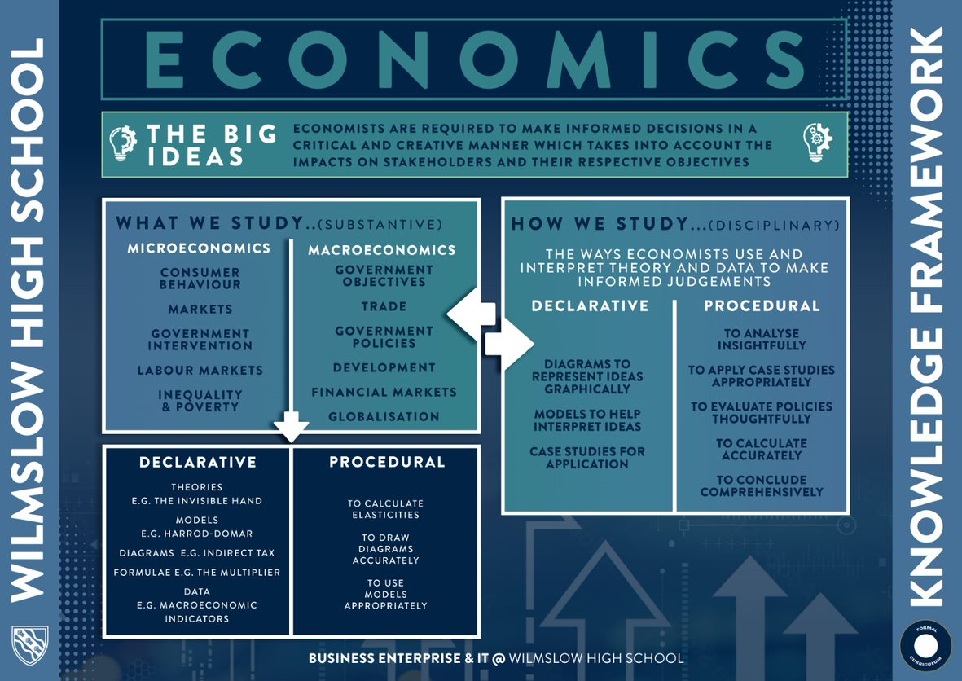
What skills are tested?
Knowledge
Application
Analysis
Evaluation
How are the skills examined?
There are three examination papers:

Paper one – Markets and Market Failure
2, 4, 9, 25 marks questions based on extracts
15 and 25 marks essay questions

Paper two – National and International Economy
2, 4, 9, 25 marks questions based on extracts
15 and 25 marks essay questions

Paper three – Economic Principles and Issues
30 MCQs
10, 15, 25 marks essay questions

Short cycle
Each lesson begins with a low-stakes knowledge retrieval activity in the form of a “5-a-day quiz”. This task assesses the students’ recall of previously taught knowledge. Plenaries are used throughout lessons as a form of formative assessment to gauge the pupils’ understanding of the content and to provide us with immediate feedback on progress and potential misconceptions. We also utilize various questioning strategies such as “cold calling” and “hinge questions” in order to gain an insight into how well the pupils are learning the new content. We frequently use examination-style questions in order to challenge the pupils’ procedural knowledge and application of the content that they have been taught.

Medium cycle
So as to avoid “Construct Irrelevant Variance”, there will be frequent knowledge quizzes, key terms quizzes, and essays completed during each term, both in microeconomics and macroeconomics. The variety of assessment methods will aid us in determining where the misconceptions of the pupils lie. As well as consolidating declarative knowledge, essays will also be used to assess the procedural knowledge of the pupils. These assessment methods are sequenced in a specific order to aid knowledge recall through spaced retrieval. Research tasks will also be completed for homework as this will assist the pupils with their skills of application – this is a key assessment objective in the final examination.
Long cycle
The pupils will complete end of unit assessments and mock examinations throughout years 12 and 13. The data obtained from these tests will provide us with an overview of how the pupil is performing and how they fare in examination conditions. The assessments will comprise of past paper examination-style questions so they will test both the procedural knowledge and declarative knowledge of the pupils.
Year 12
 | Half Term 1 | Half Term 2 | Half Term 3 | Half Term 4 | Half Term 5 | Half Term 6
Year 12 Microeconomics - Procedural | Progress test  - Economic problem  - Demand and supply  - Elasticities  - PPFs  Essay  PPF | Essay  Equilibrium/price mechanism | Mock  - Supply and demand equilibrium  - Elasticities  - Behavioral economics  - PPFs  Essay  Externalities | Progress test  - Market failure  Essay  Government intervention - | Progress test  - Government intervention  - Market failure  Essay  Market failure | Mock  - Government intervention  - Market failure  - Supply and demand equilibrium  - Behavioral economics  - Elasticities  - Economic problem  - PPFs  Essay  Government intervention
Year 12 Microeconomics – Declarative | Knowledge quizzes and key terms tests based on demand  Retrieval quizzes based on PPFs | Knowledge quizzes and key terms tests based on supply and demand  Retrieval quizzes based on elasticities | Knowledge quizzes and key terms tests based on market failure  Retrieval quizzes based on supply and demand | Knowledge quizzes and key terms tests based on government intervention  Retrieval quizzes based on market failure | Knowledge quizzes and key terms tests based on costs and economies of scale  Retrieval quizzes based on government intervention and supply and demand | Knowledge quizzes and key terms tests based on profit and efficiency  Retrieval quizzes based on market failure
Year 12 Macroeconomics – Procedural | Progress test  - Macroeconomic objectives and indicators  - National income data  - Circular flow of income  - Multiplier  - Aggregate Demand  Essay  Macroeconomic objectives | Essay  Equilibrium | Mock  - Aggregate demand and aggregate supply  - Economic growth and economic cycle  - Inflation  - Macroeconomic objectives  - Circular flow of income  - Multiplier  Essay  Unemployment and inflation | Progress test  - Balance of payments  - Employment  - Inflation  - Economic growth  - Aggregate demand and aggregate supply  - Macroeconomic objectives  Essay  Supply side policies | Progress test  - Fiscal Policy  - Supply slide policy  - Monetary policy  - Macro conflicts  Essay  Trade | Mock  - Fiscal Policy  - Supply slide policy  - Monetary policy  - Macro conflicts  - Balance of payments  - Employment  - Inflation  - Economic growth  - Aggregate demand and aggregate supply  - Macroeconomic objectives  - Circular flow of income  - Multiplier  Essay  Balance of Payments
Year 12 Macroeconomics – Declarative | Knowledge quizzes and key terms tests based on Macroeconomic objectives  Retrieval quizzes based on Macroeconomic indicators | Knowledge quizzes and key terms tests based on aggregate supply and aggregate demand  Retrieval quizzes based on macroeconomic objectives | Knowledge quizzes and key terms tests based on unemployment and inflation  Retrieval quizzes based on aggregate supply and aggregate demand | Knowledge quizzes and key terms tests based on governmental policies  Retrieval quizzes based on macroeconomic objectives | Knowledge quizzes and key terms tests based on trade  Retrieval quizzes based on AS/AD and Multiplier | Knowledge quizzes and key terms tests based on balance of payments and exchange rates  Retrieval quizzes based on macroeconomic objectives, policies and multiplier

Year 13
 | Half Term 1 | Half Term 2 | Half Term 3 | Half Term 4 | Half Term 5
Year 13 Microeconomics - Procedural | Progress test  - All year 12 content  Essay  Monopoly | Mock  - Market structures  - Year 12 content  Essay  Price discrimination | Progress test  - Labour Markets  - Market structures  - Year 12 content  Essay  Objectives of firms | Progress test  - Entire specification  Essay  Income inequality and poverty | Progress test  - Entire specification  Essay  National minimum wage
Year 13 Microeconomics - Declarative | Knowledge quizzes and key terms tests based on Perfect Competition and Monopoly  Retrieval quizzes based on year 12 content | Knowledge quizzes and key terms tests based on Oligopoly and Monopolistic Competition  Retrieval quizzes based on monopolies and year 12 content | Knowledge quizzes and key terms tests based on Labour Markets  Retrieval quizzes based on market structures and year 12 content | Knowledge quizzes and key terms tests based on entire specification  Retrieval quizzes based on entire specification | Knowledge quizzes and key terms tests based on entire specification  Retrieval quizzes based on entire specification
Year 13 Macroeconomics - Procedural | Progress test  - All year 12 content  Essay  Development | Mock  - Globalization  - Development  - Year 12 content  Essay  Globalization | Progress test  - Financial markets  - Globalization  - Development  - Year 12 content  Essay  Financial markets | Progress test  - Entire specification  Essay  Exchange rates | Progress test  - Entire specification  Essay  Policies
Year 13 Macroeconomics - Declarative | Knowledge quizzes and key terms tests based on development  Retrieval quizzes based on year 12 content | Knowledge quizzes and key terms tests based on Supply and globalization  Retrieval quizzes based on development and year 12 content | Knowledge quizzes and key terms tests based on financial markets  Retrieval quizzes based on globalization and year 12 content | Knowledge quizzes and key terms tests based on entire specification  Retrieval quizzes based on Macroeconomic indicators | Knowledge quizzes and key terms tests based on entire specification  Retrieval quizzes based on Macroeconomic indicators

