A-level Biology – Year 11 transition work

Section 2 – Cell structure

Quick questions

Cell structure

- Give an example of a prokaryotic cell.

.................................................................................................................................... (1)
- Name four organelles that plant and animal cells both have.

..........................................................................................................................................
................................................................................................................................... (4)
- What is the function of mitochondria?

.................................................................................................................................... (1)
- Describe the membranes of mitochondria.

................................................................................................................................... (2)
- Name two things visible with a light microscope in both animal and plant cells.

................................................................................................................................... (2)
- Which type of microscope must be used to show the detailed ultrastructure of a cell?

.................................................................................................................................... (1)
- What is the word equation for aerobic respiration

.................................................................................................................................... (1)
- Name the molecule used to provide energy for processes in the cell.

.................................................................................................................................... (1)
- Name the molecule that is found in bundles in plant cell walls.

.................................................................................................................................... (1)
10. Name two types of molecule that make up the cell membrane.

................................................................................................................................... (2)
11. Give four ways substances can cross cell membranes.

..........................................................................................................................................
................................................................................................................................... (4)

12. What term is used for the diffusion of water molecules across a cell
membrane?

.................................................................................................................................... (1)
13. Give another term for the concentration of water molecules.

.................................................................................................................................... (1)
14. Name the two types of protein involved in facilitated diffusion.

................................................................................................................................... (2)
15. Why does active transport require ATP?

.................................................................................................................................... (1)
Total 25 marks

Examination questions

Q1.
The diagram shows part of a prokaryotic cell.
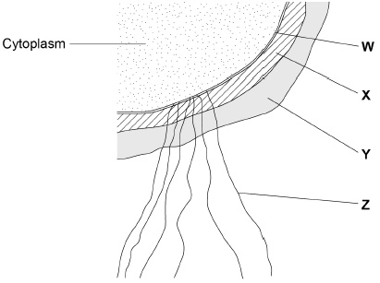
(a) Name the structures labelled W to Z in the diagram.
W ________________________________________________________________
X _________________________________________________________________
Y _________________________________________________________________
Z _________________________________________________________________
(2)
(b) Name the main biological molecule in:
W ________________________________________________________________
X _________________________________________________________________
(2)
(c) Name the process by which prokaryotic cells divide.
___________________________________________________________________
(1)

(d) Some prokaryotic cells can divide every 30 minutes. A liquid culture contained a starting population of 1.35 × 10⁴ cells.
Assuming each cell divides every 30 minutes, calculate how many cells there will be after 3 hours. Assume no cells die during this time.
Answer = ____________________
(2)
(Total 7 marks)

Q2.
(a) Describe how you could make a temporary mount of a piece of plant tissue to observe the position of starch grains in the cells when using an optical (light) microscope.
___________________________________________________________________
___________________________________________________________________
___________________________________________________________________
___________________________________________________________________
___________________________________________________________________
___________________________________________________________________
___________________________________________________________________
___________________________________________________________________
(4)
The figure below shows a microscopic image of a plant cell.
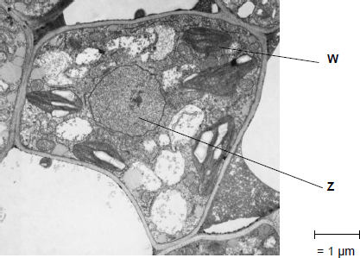
© Science Photo Library
(b) Give the name and function of the structures labelled W and Z.
Name of W__________________________________________________________
Function of W________________________________________________________
Name of Z __________________________________________________________
Function of Z ________________________________________________________
(2)

(c) A transmission electron microscope was used to produce the image in the figure above.
Explain why.
___________________________________________________________________
___________________________________________________________________
___________________________________________________________________
___________________________________________________________________
___________________________________________________________________
(2)
(d) Calculate the magnification of the image shown in the figure in part (a).

Answer = ____________________
(1)
(Total 9 marks)

Q3.
The diagram shows a bacterium.
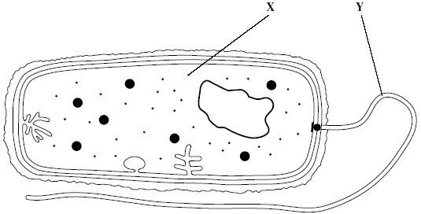
(a) Give the function of
(i) organelle X;
______________________________________________________________
(ii) organelle Y.
______________________________________________________________
(2)
(b) (i) Give two ways in which the structure of this bacterium is similar to the structure of a cell lining the human small intestine.
1. ____________________________________________________________
______________________________________________________________
2. ____________________________________________________________
______________________________________________________________
(2)
(ii) Give two ways in which the structure of this bacterium differs from the structure of a cell lining the human small intestine.
1. ____________________________________________________________
______________________________________________________________
2. ____________________________________________________________
______________________________________________________________
(2)

(Total 6 marks)

Total 22 marks

