NETFLIX  (Spanish) | 
How to find Spanish Language TV/ Films in Netflix:
1. Sign in to your Netflix account:

2. Type in “SPANISH” into the search bar:
3. You will then be able to explore titles related to different Spanish areas (with parental consent):
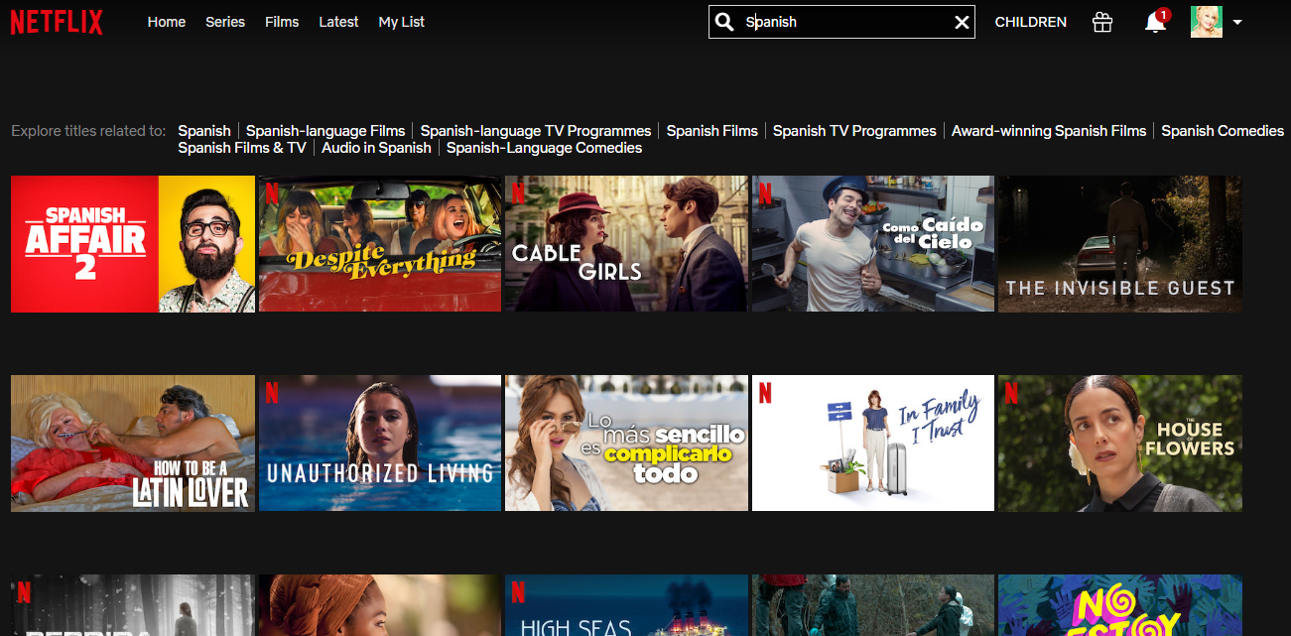

Particularly Good Spanish Series’ to Watch
- Velvet
- Las chicas del cable
- El ministerio del tiempo
- Elite
- La casa de papel
- La víctima numero ocho
- Mar de plástico

