A-level Biology – Year 11 transition work

Section 4 – Exchange

Quick questions

- Which has a bigger surface area to volume ratio, a small organism or a large organism?

.................................................................................................................................... (1)
- Give three materials that need to be exchanged across the membrane of organisms’ cells.

....................................................................................................................................
....................................................................................................................................
................................................................................................................................... (3)
- In which part of the lungs does gas exchange take place?

.................................................................................................................................... (1)
- Does the volume of the thorax increase or decrease when you breathe out?

.................................................................................................................................... (1)
- Which two sets of muscles contract when we breathe in?

................................................................................................................................... (2)
Total 8 marks

Examination questions

Q1.
(a) The diagram shows the structure of the human gas exchange system.
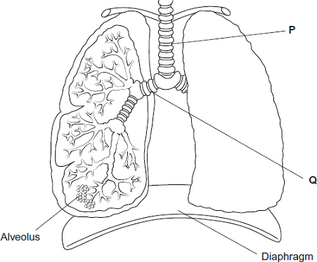
Name organs
P ____________________
Q ____________________
(1)
(b) Explain how downward movement of the diaphragm leads to air entering the lungs.
___________________________________________________________________
___________________________________________________________________
___________________________________________________________________
___________________________________________________________________
(2)
(Total 3 marks)

Q2.
(a) Describe the relationship between size and surface area to volume ratio of organisms.
___________________________________________________________________
___________________________________________________________________
___________________________________________________________________
___________________________________________________________________
___________________________________________________________________
(1)
(b) A scientist calculated the surface area of a large number of frog eggs. He found that the mean surface area was 9.73 mm². Frog eggs are spherical.
The surface area of a sphere is calculated using this equation
Surface area = 4πr²
where r is the radius of a sphere
π = 3.14
Use this equation to calculate the mean diameter of a frog egg.
Show your working.
Diameter = ____________________ mm
(2)

The scientist calculated the ratio of surface area to mass for eggs, tadpoles and frogs. He also determined the mean rate of oxygen uptake by tadpoles and frogs.
His results are shown in the table.

Stage of frog development | Ratio of surface area to mass | Mean rate of oxygen uptake / μmol g^{–1} h^{–1}
Egg | 2904 : 1 | no information
Tadpole | 336 : 1 | 5.7
Adult | 166 : 1 | 1.3
(c) The scientist used units of μmol g^{–1} h^{–1} for the rate of oxygen uptake.
Suggest why he used μmol in these units.
___________________________________________________________________
___________________________________________________________________
___________________________________________________________________
___________________________________________________________________
___________________________________________________________________
(1)
(d) The scientist decided to use the ratio of surface area to mass, rather than the ratio of surface area to volume. He made this decision for practical reasons.
Suggest one practical advantage of measuring the masses of frog eggs, tadpoles and adults, compared with measuring their volumes.
___________________________________________________________________
___________________________________________________________________
___________________________________________________________________
___________________________________________________________________
___________________________________________________________________
___________________________________________________________________
(1)
(e) Explain why oxygen uptake is a measure of metabolic rate in organisms.
___________________________________________________________________
___________________________________________________________________
___________________________________________________________________
___________________________________________________________________
___________________________________________________________________
(1)
(f) A student who looked at these results said that they could not make a conclusion about the relationship between stage of development and metabolic rate.
Use information in the table to explain reasons why they were unable to make a conclusion.
___________________________________________________________________
___________________________________________________________________
___________________________________________________________________
___________________________________________________________________
___________________________________________________________________
___________________________________________________________________
___________________________________________________________________
___________________________________________________________________
(3)
(Total 9 marks)

Q3.
Breathing out as hard as you can is called forced expiration.
(a) Describe and explain the mechanism that causes forced expiration.
___________________________________________________________________
___________________________________________________________________
___________________________________________________________________
___________________________________________________________________
___________________________________________________________________
___________________________________________________________________
___________________________________________________________________
___________________________________________________________________
(4)
Two groups of people volunteered to take part in an experiment.
• People in group A were healthy.
• People in group B were recovering from an asthma attack.
Each person breathed in as deeply as they could. They then breathed out by forced expiration.
A scientist measured the volume of air breathed out during forced expiration by each person.
The graph below shows the results.
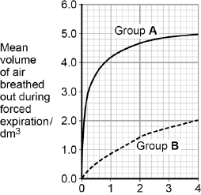
Time breathing out / s

(b) Forced expiration volume (FEV) is the volume of air a person can breathe out in1 second.
Using data from the first second of forced expiration, calculate the percentage decrease in the FEV for group B compared with group A.

Answer = ____________________ %
(1)
(c) The people in group B were recovering from an asthma attack.
Explain how an asthma attack caused the drop in the mean FEV shown in the figure above.
___________________________________________________________________
___________________________________________________________________
___________________________________________________________________
___________________________________________________________________
___________________________________________________________________
___________________________________________________________________
___________________________________________________________________
___________________________________________________________________
(4)
(Total 9 marks)

