**Nicklas Bendtner admits he has lost more than £5m playing poker**

The former Arsenal striker made the admission while staring on a Danish reality television show

Former [Arsenal](https://www.independent.co.uk/topic/Arsenal) striker [Nicklas Bendtner](https://www.independent.co.uk/topic/NicklasBendtner) has said that he has lost over £5m playing poker during his playing career.

Bendtner, who made over 100 appearances for Arsenal in the Premier League, is currently without a club after being released by Copenhagen last season.

The 32-year-old is instead starring in a reality television series with his girlfriend, fashion model Philine Roepstorff.

And on the show Bendter made the shocking admission that he had lost millions of pounds while playing Texas Hold’Em.

“I lost a lot of money, an unrealistic amount,” Bendtner said on Bendtner and Philine.

“It’s hard to say how much it was in reality, but I’d estimate that it was almost 50 million Korona (£5.4m).

“It was something that I was always in control of and I simply betted big sums of money.

“Sometimes in London, things would get out of control on a night and things could really have ended badly. Now I place smaller bets of 100 Korona (£12).”

* This text was produced by the Independent, a British news publication. As such, it’s aimed at British people; that’s why Bendtner is here referred to as a ‘former Arsenal striker,’ as opposed to a former Juventus striker (Italian) or Wolfsburg striker (German); because the fans of those teams are less likely to be reading it. With the current coronavirus pandemic limiting the amount of sport currently happening, it’s no surprise that sports publications are having to look further afield for their news stories, and a gambling ex-Arsenal star fits that bill.
* As I said, this article has been aimed at football fans, particularly British football fans. That’s not to say it wouldn’t interest Spanish or Italian fans, as two arbitrary examples, but conversions from Danish korona to British pounds is a good indication that this has been aimed at a British audience. It’s a small and easily digestible article, so it’s not really been aimed at anyone in particular in terms of occupations or income, rather it’s a short and interesting story highlighting the issues faced by a famous footballer.
* It is a written piece of text, but seeing as I found it online, it’s also electronic.
* This seems purely informative, with intentions of informing audiences of the activities of Niklas Bendtner. Whilst this could be interpreted as a PSA regarding the dangers of a gambling addiction, but as far as I’m concerned, the author of this article wasn’t intending advise audiences not to gamble.
* It is a web article.
* Whilst the subject of the article is almost trivial, the register always remains formal.
* The key representation here is Niklas Bendtner, because he is central to everything that happens in this article.

### **Covers stray greys, no problem!**

### **Introducing Plantur 39 Colour Brown**



How do you freshen up your hair colour during lockdown? We have a safe and easy solution for brunettes who are bothered by their roots: Plantur 39 Colour Brown. It washes colour into your hair without you having to do any complex colouring procedures. No experiments, no hair stress – with Plantur 39 Colour Brown. Say goodbye to the first grey hairs and light roots.

## The Plantur 39 colour effect

Plantur 39 Colour Brown helps to tide you over between visits to the hairdresser. The cosmetic pigments in the products are deposited on the outside of each hair to intensify its natural colour. The brown becomes more intense every time you wash your hair. The first grey hairs and light roots are concealed. The colour becomes more vibrant with every use.

[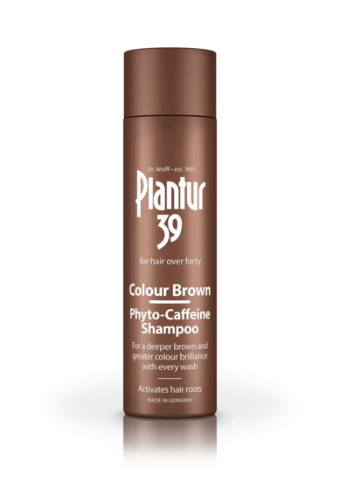](https://www.plantur39.com/fileadmin/_processed_/a/6/csm_plantur39-packshot-colour-brown-phyto-caffeine-shampoo-united-kingdom-co-uk_a0e83199fb.png)[](https://www.plantur39.com/fileadmin/_processed_/6/9/csm_plantur39-grafik-color-braun-color-effekt-braun-great-britain-uk_615e143a5e.jpg)

For the perfect result:

[](https://www.plantur39.com/fileadmin/_processed_/5/5/csm_plantur39-color-braun-uhr-reat-britain-uk_6b03a8aadd.jpg)[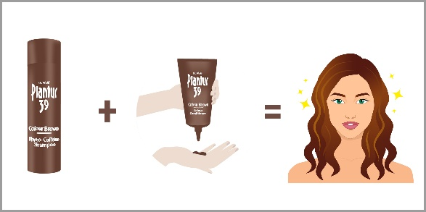](https://www.plantur39.com/fileadmin/_processed_/3/d/csm_plantur39-color-braun-grafik-gleichung-glueckliche-frau-germany-de_3af52ba5c6.jpg)

## Phyto-Caffeine Shampoo Colour Brown

### **For a breathtaking shade of brown**

* Conceals annoying roots and first grey hairs
* Colour becomes more intense with every wash
* The Phyto-Caffeine complex helps to prevent menopausal hair loss.

* The above advert is trying to sell a myriad of hair products from the brand Plantur. Unsurprisingly, this advert exists because there is a market of people who aren’t too pleased with the thought of getting grey hair. As such, Plantur offer what they would describe as a solution. If everyone was completely content with having grey hair, there would be no need for this product, however that’s not the case.
* I was not persuaded by this advert, nor did I particularly enjoy reading it, but that’s okay because it’s not aimed at sixteen-year-old boys; it’s aimed at women who are starting to develop grey hair. Presumably, the product could also be used by men, however the language and images used in the advert show that’s not who the target audience is. Stereotypically feminine language is used, notably the section in which it states ‘Plantur 39 Colour Brown helps to tide you over between visits to the hairdresser.’ Whilst obviously women are not the only people who go to hairdressers, most of the people in hairdressers are women, so this is a good indication that the product is aimed at them.
* Like the previous article, this is written, and I found it online, so it’s also electronic.
* This is an advert; its primary purpose is to persuade the target audience to buy their product. This advert uses information and rhetorical questions to do so.
* Genre wise, it’s a piece of advertising.
* The register here isn’t quite as formal as the Niklas Bendtner article, likely because a slightly more informal tone is more likely to attract customers. If people see something that is overly formal, it’s likely to put them off.
* The key representation here is the product. Ultimately, Plantur don’t care who buys their product and what they use it for, just as long as someone buys it. As such, nothing else really matters but their ability to sell their product.



* This is a leaflet by Chackatrade, a business offering several trade services. As we can see in the top right, this particular leaflet is specific to the Wilmslow and Cheadle area. As such, we can make a couple of assumptions: prices may be slightly higher than the national average, based on the affluency of the areas and the tradespeople in question likely all live in and around the local area.
* It’s intended for people in need of a specific tradesperson who live in the Wilmslow or Cheadle area.
* It’s written and printed.
* Like the Plantur advert, this aims to both inform and persuade the reader to purchase the services on offer.
* Again, likethe Plantur advert, saying that this leaflet is informal would be misleading, however it’s not the most formal thing I’ve ever read and that’s by design, in order to attract customers.
* The key representation is the company of Checkatrade. The author of the leaflet isn’t important.

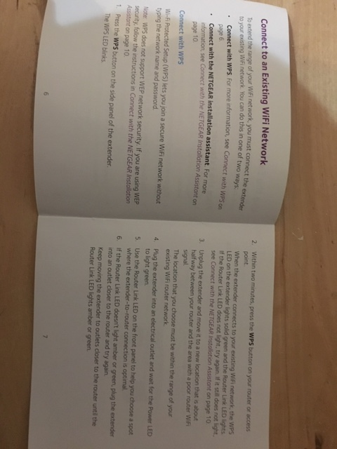

* Here are two pages from an instruction manual on how to correctly set up a router. Many instruction manuals have an annoying tendency to be printed in several languages, but this one doesn’t fall into that group: it’s all in English. As such, it’s aimed at people in British speaking countries who need a new router and are unsure as to how to set it up properly.
* This is also written.
* The sole purpose of this instruction manual, unsurprisingly, is to instruct. It doesn’t need to persuade the reader, because the reader has already bought the product with which the instruction manual comes.
* In terms of genre, it’s an instruction manual.
* As is often the case with instruction manuals, this one is extremely formal and doesn’t break such formality. You’re not supposed to feel conversational when reading instructions, and as such the instructions don’t try to be that.
* The key representation of the text is the router in question. The writer doesn’t need to be specified, and it’s not important who’s reading it either so long as they have a router which they need to set up.

LaLiga to hold games EVERY DAY with new timetable agreed 📆

Representatives of LaLiga and the Spanish Football Federation have agreed a new timetable for games once football can return.

LaLiga is hoping to continue the season in June, and with Uefa setting a deadline of July 29 for the campaign to be complete, board members from both interested parties have been discussing a new calendar.

Several outlets on Sunday, including Carrusel Deportivo and AS, claim that an agreement is now in place for LaLiga matches to be played every day of the week, with kick off times varying between 20:00 CET to 23:00 CET.

Another hurdle passed by the league is the agreement that teams can play two games with a rest of just 72 hours.

It means that LaLiga will have two matchdays every week between mid-June and the end of July.

Barcelona currently lead the table on 58 points, with Real Madrid in second on 56.

Espanyol prop up the league with only 20 points.

* This is an online article published by a company called Onefootball. Unsurprisingly, Onefootball specialise in articles about football and football-based activities. A big factor affecting football and life right now is the coronavirus, so any return to normality in a sporting sense or just in general is something that currently amasses a lot of interest. La Liga is Spain’s topflight, so news of a potential return is something that is exciting for a lot of people.
* Again, an English article is usually aimed at English people. In this instance, Onefootball is a British company, but this is news that is interesting for football fans everywhere. It’s short and easy to read, and as such there are no barriers to it, as long as you have access to technology.
* It’s written but also electronic.
* Its purpose is to inform people. Whilst the article about Niklas Bendtner could also be considered a form of entertainment, I wouldn’t say the same for this one. Whilst football itself is entertaining, reading an article about the specifics of a fixture-schedule is much more oriented around information.
* It’s a news article.
* This isn’t as formal as the instructions or the previous article, but I would describe it as more formal than the advert and the leaflet. It sits right in the middle of the five pieces.
* The main representation is La Liga. As the main focus, the whole article revolves around it.