GCSE Business Assessment Framework
What skills are tested?
Knowledge
Application
Analysis
How are the skills examined?
There are two examination papers:
Paper one
- Influences of operations and HRM on business activity
- 90 marks
- 50% of your GCSE result
- 1 hour 45 minutes
Paper two
- Influences of marketing and finance on business activity
- 90 marks
- 50% of your GCSE result
- 1 hour 45 minutes

Because the knowledge structure in business looks like this:
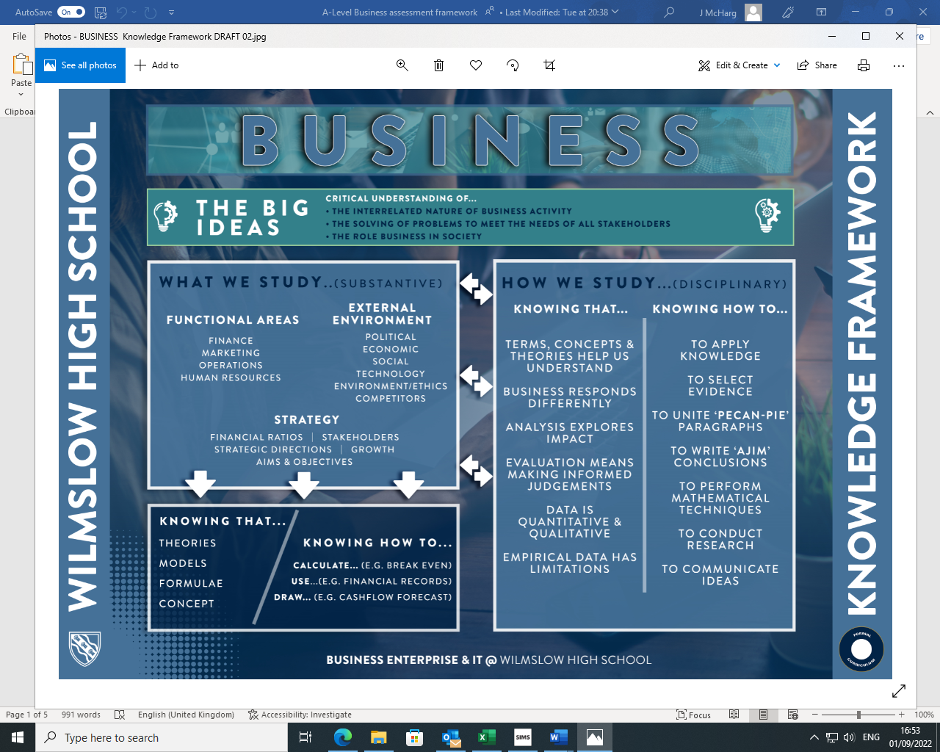
Short cycle
Each lesson begins with a low-stakes knowledge retrieval activity in the form of a “5-a-day quiz”. This task assesses the students’ recall of previously taught knowledge. Plenaries in the form of ‘exit tickets’ are used throughout lessons as a form of formative assessment to gauge the pupils’ understanding of the content and to provide us with immediate feedback on progress and potential misconceptions. We also utilize various questioning strategies such as “cold calling” and “hinge questions” in order to gain an insight into how well the pupils are learning the new content. We frequently use examination-style questions in order to challenge the pupils’ procedural knowledge and application of the content that they have been taught.
Medium cycle
So as to avoid “Construct Irrelevant Variance”, there will be frequent knowledge quizzes, key terms quizzes and exam-style questions completed during each term. The variety of assessment methods will aid us in determining where the misconceptions of the pupils lie. As well as consolidating declarative knowledge, exam-style questions will also be used to assess the procedural knowledge of the pupils. ‘Exercise book checks’ will be conducted to check students classwork is complete and that they are engaging with the lesson activities; books will be assigned a ‘Green, Amber, Red’ rating and students will be asked to fill any gaps.
Long cycle
The pupils will complete end of unit assessments and mock examinations throughout years 10 and 11. The data obtained from these tests will provide us with an overview of how the pupil is performing and how they fare in examination conditions. The assessments will comprise of past paper examination-style questions so they will test both the procedural knowledge and declarative knowledge of the pupils.
 | Half Term 1 | Half Term 2 | Half Term 3 | Half Term 4 | Half Term 5 | Half Term 6
Year 10  Procedural | Exam-style questions on  - Krispy Kreme, 6 marks on stakeholders | Exam-style questions on  - Going for gold, 9 marks on growth  Mock exam covering  - Unit 1 | Exam-style questions on  - Sky High – 9 mark question on sources of finance | Exam-style questions on  - Polly Potter – SAQ & 9 marks on break-even analysis  End of unit test covering  - Unit 6 Finance | Exam-style questions on  - M4B – 9 mark question on e-commerce  - M&S – 6 mark question on ethics | Exam-style questions on  - Employment legislation 12 marks  Mock exam covering  - Unit 1  - Part of Unit 2  - Unit 6
Year 10  Declarative | - Key terms tests on current unit  - Knowledge quizzes on current unit  - 5 a day questions on prior knowledge  - Exercise book check | - Key terms tests on current unit  - Knowledge quizzes on current unit  - 5 a day questions on prior knowledge  - Exercise book check | - Key terms tests on current unit  - Knowledge quizzes on current unit  - 5 a day questions on prior knowledge  - Exercise book check | - Key terms tests on current unit  - Knowledge quizzes on current unit  - 5 a day questions on prior knowledge  - Exercise book check | - Key terms tests on current unit  - Knowledge quizzes on current unit  - 5 a day questions on prior knowledge  - Exercise book check | - Key terms tests on current unit  - Knowledge quizzes on current unit  - 5 a day questions on prior knowledge  - Exercise book check
Year 11  Procedural | Exam-style questions on  - Wedding Belles – 9 mark question on suppliers  - Krispy Kreme – 6 marks on quality  End of unit test covering  - Unit 2 | Exam-style questions on  - Organic Snacks – 12 mark on centralization  Mock exam covering  - Unit 2  - Unit 6 | Exam-style questions on  - Jolly Jim’s Gym – 9 mark on segmentation  Mock exam covering  - Unit 1  - Unit 2  - Unit 3  - Unit 6 | Exam-style questions on  End of unit test covering  - Unit 5 | Exam-style questions on  Tests covering | Exam-style questions on  Tests covering
Year 11  Declarative | - Key terms tests on current unit  - Knowledge quizzes on current unit  - 5 a day questions on prior knowledge  - Exercise book check | - Key terms tests on current unit  - Knowledge quizzes on current unit  - 5 a day questions on prior knowledge  - Exercise book check | - Key terms tests on current unit  - Knowledge quizzes on current unit  - 5 a day questions on prior knowledge  - Exercise book check | - Key terms tests on current unit  - Knowledge quizzes on current unit  - 5 a day questions on prior knowledge  - Exercise book check | - Key terms tests on current unit  - Knowledge quizzes on current unit  - 5 a day questions on prior knowledge  - Exercise book check | - Key terms tests on current unit  - Knowledge quizzes on current unit  - 5 a day questions on prior knowledge  - Exercise book check

