**Year 11 – 12 transition work – A level PE**

**Section C**

**Task 1: Pick 3 things from the list below to watch/read**

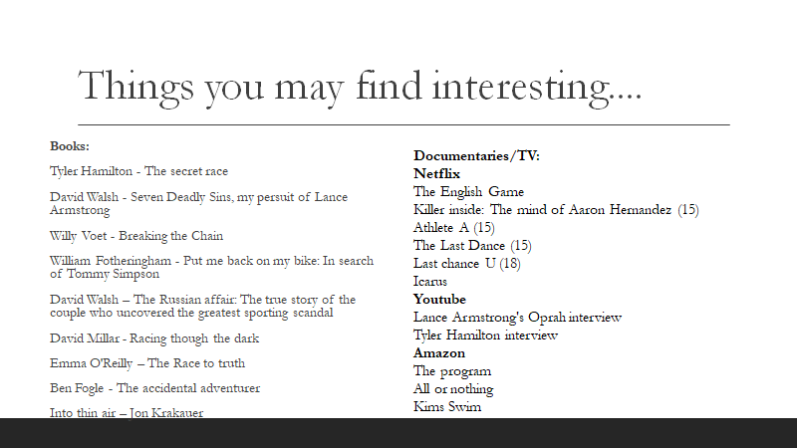

**Task 2: Download the Strava app and log your exercise over the summer holidays!**



**Task 3: Find news articles about the following topics:**

1. Drugs in sport
2. Cheating/deviance in sport
3. Sportsmanship

**Task 4: Research what advancements have there been in technology in sport over the last 100 years.**

e.g. The materials used for tennis racquets. Until the 1980s, tennis rackets were made of wood and rather basic in their construction. Today though, as players are faster, stronger, more accurate and hit at very high speeds, tennis racket technology has gone stratospheric. Manufacturers are using robotics, space-age materials and physics to give players the competitive edge and to maximise performance. Tennis rackets are made with a variety of materials, but the most common is graphite. This is a lightweight, carbon-based material either used on its own or as a composite blend with materials such as Kevlar, carbon fibre, titanium, tungsten and fibreglass.