A-level Biology – Year 11 transition work

Section 7 – Variation, evolution and classification

Quick questions

- Describe what is meant by the term evolution.

...................................................................................................................................
................................................................................................................................... (2)
- Name one mechanism by which evolution occurs.

................................................................................................................................... (1)
- What is an allele?

................................................................................................................................... (2)
- What is an adaptation?

................................................................................................................................... (1)
- In classification, what is meant by a hierarchy?

................................................................................................................................... (1)
- Describe what is meant by a species.

...................................................................................................................................
................................................................................................................................... (2)
- Give three types of evidence that scientists can use when classifying organisms.

...................................................................................................................................
...................................................................................................................................
................................................................................................................................... (3)
Total 12 marks

Examination questions
Q1.
(a) Explain what is meant by a
(i) phylogenetic group
______________________________________________________________
______________________________________________________________
(1)
(ii) species.
______________________________________________________________
______________________________________________________________
______________________________________________________________
______________________________________________________________
(2)
The classification of tigers and clouded leopards is shown in Table 1.

Table 1
Taxonomic group | Tiger | Clouded Leopard
Kingdom | Animalia | Animalia
 | Chordata | Chordata
 | Mammalia | Mammalia
Order | Carnivora | Carnivora
 | Felidae | Felidae
 | Panthera | Neofelis
Species | Tigris | Nebulosa
(b) Complete Table 1 by adding the four other taxonomic groups to which the tiger and clouded leopard belong.
(1)

The circles in the diagram represent the hierarchy of taxonomic groups for the classification shown in Table 1.
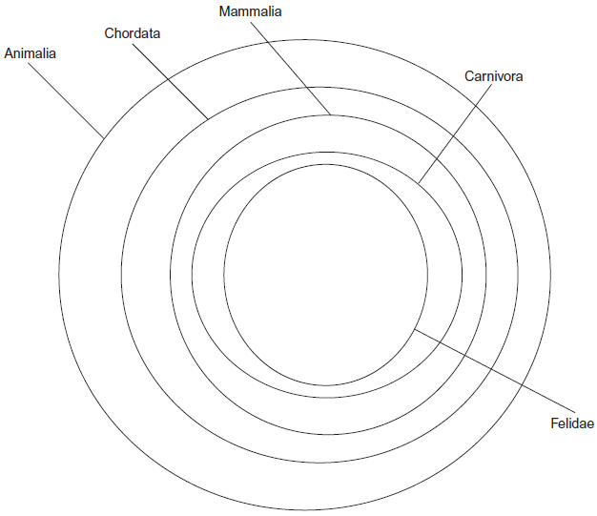

(c) Draw additional circles on the diagram and label them to include all the information about the tiger and clouded leopard shown in Table 1.
(2)

Table 2 shows part of the nucleotide sequence in a gene in populations of tigers living in different parts of the world.

Table 2
Siberian tiger | G C A C C G T
South China tiger | A C G C C G C
Sumatran tiger | A C G C C G C
(d) Explain what the information in Table 2 suggests about the phylogenetic relationships between these tigers.
___________________________________________________________________
___________________________________________________________________
___________________________________________________________________
___________________________________________________________________
___________________________________________________________________
(2)
(Total 8 marks)

Q2.
The following figure shows how some animals with hooves are classified.
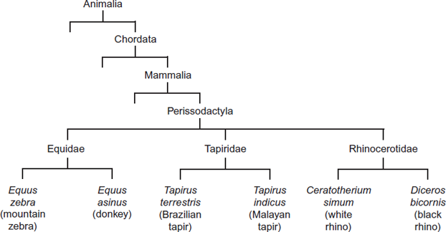
(a) This type of classification can be described as a phylogenetic hierarchy.
(i) What is meant by a hierarchy?
______________________________________________________________
______________________________________________________________
______________________________________________________________
______________________________________________________________
(2)
(ii) How many different families are shown in the figure?

(1)
(iii) To which phylum does the white rhino belong?
______________________________________________________________
(1)

(b) A zedonk is the offspring produced from breeding a mountain zebra with a donkey.
• The body cells of a mountain zebra contain 32 chromosomes.
• The body cells of a donkey contain 62 chromosomes.
Use this information to suggest why zedonks are usually infertile.
______________________________________________________________
______________________________________________________________
______________________________________________________________
______________________________________________________________
(2)
(Total 6 marks)

Q3.
In 2002, biologists identified a new group of insects. They called these insects gladiators.
(a) (i) Mantophasma zephyra is one species of gladiator. Complete the table to show how this species is classified.

Kingdom | Animalia
 | Arthropoda
 | Insecta
 | Notoptera
Family | Mantophasmatodae
Species
(2)
(ii) This system of classification consists of a hierarchy. Explain what is meant by a hierarchy.
______________________________________________________________
______________________________________________________________
______________________________________________________________
______________________________________________________________
(2)
(b) In 2002, very few gladiators were available for identification. Scientists around the world used photographs to establish the relationship of gladiators to other insects.
Explain how.
___________________________________________________________________
___________________________________________________________________
(1)
(Total 5 marks)

