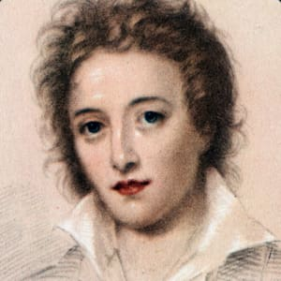
‘Ozymandias’ (first pub. 1818)
Percy Bysshe Shelley (1792-1822)

Biographical details
- Son of an MP and had a wealthy upbringing.
- Went to Oxford but didn’t go to class and wrote poetry instead. He was expelled as he had unconventional views for the time. At Oxford he wrote an essay “The Necessity of Atheism”.
- He wrote political pamphlets which attacked the oppressiveness of religion as well as of customs and institutions such as the monarchy.
- He objected to powerful rulers who mistreated the poor.
- Married Harriet and was expecting their second child when met Mary Godwin. They eloped to Europe.
- His wife committed suicide and he married Mary who went on to write ‘Frankenstein’, also published in 1818.

Social and historical context details
- The poem is thought to have been inspired by the gigantic statue of Rameses II (or Ozymandias) that was bought for the British Museum. Interest in Ancient Egyptian history was fashionable at the time. It was written in late 1817 as part of a competition between Shelley and his friend Horace Smith.
- Ozymandias was Egyptian King Rameses II - Ozymandias was his Greek name – from was famous as a warrior for reconquering land previously lost to the Egyptian empire in older battles. He was also regarded as a tyrant and the statue he had built of himself was constructed by slaves.
- Ozymandias to be ninety-six years old, ruled as Pharoah for 66 years, had over 200 wives. So long was his reign that all of his subjects, when he died, had been born knowing Ramesses as pharaoh and there was widespread panic that the world would end with the death of their king.

Extension ideas for top grades
- Shelley was a Romantic poet. Romanticism in art and literature explored the power of the natural world and humanity’s relationship with it.

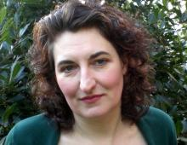
‘Poppies’ (first pub. 2009)
Jane Weir (1963 - )

Biographical details
- Jane Weir was born in Italy and grew up in Italy and Manchester with an English mother and an Italian father. She has continued to absorb different cultural experiences throughout her life, also living in Northern Ireland during the troubled 1980s.
- She now works as a poet and as a textile designer.

Social and historical context details
- The poem was commissioned by Carol Ann Duffy (who wrote ‘War Photographer’) as part of a collection of ten contemporary war poems which were published in the Guardian in 2009, as part of a response to the escalating conflict in Afghanistan and, in Duffy’s words, the “dead teenagers” who were being sent back to England.
- The Iraq inquiry was about to begin; many British soldiers also lost their lives in Iraq.
- Weir said that she deliberately left out any specific war which makes it relevant to all wars and that she was deliberately thinking about mothers, including Susan Owen, Wilfred Owen’s mother.
- The poem ‘Poppies’ is set in the present day but reaches right back to the beginning of the Poppy Day tradition. Remembrance Sunday (the Sunday closest to Armistice Day of 11th November) began as a way of marking the end of WW1 in 1918. It was set up so people could remember the thousands killed in that war. Today, the event is used to remember soldiers of all wars who have died since then.
- We now use poppies as memorials, linking to the idea of memory in the poem.

Extension ideas for top grades
- Weir said: “This poem attempts on one level to address female experience and is consciously a political act.”

‘Remains’ (first pub. 2008)
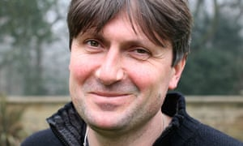
Simon Armitage (1963 - )

Biographical details
- Armitage was born in West Yorkshire and earned a degree from Portsmouth University in Geography
- After studying social work at the University of Manchester, where he studied the impact of televised violence on young offenders, he worked as a probation officer for six years before focusing on poetry.
- Simon Armitage's poetry is known for its colloquial style, strong rhythms and voice.

Social and historical context details
- In 2007, Simon Armitage made a Channel 4 documentary programme called The Not Dead which featured interviews with veterans who had fought in the Gulf War (1990-1991) in Iraq.
- ‘Remains’ was first published in a collection of war poems also called The Not Dead which were written as Armitage’s response to the testimonies of ex-soldiers from the Gulf War who had featured in the Channel 4 documentary.
- Who are the Not Dead? The ex-servicemen and the ghosts trapped in their memories; the people who live and die and live again every time one of the veterans experiences a bad memory.
- The poem is about modern warfare and how soldiers suffer from Post -Traumatic Stress Disorder (PTSD), a common mental condition for former soldiers.

Extension ideas for top grades
- Could the poem be viewed as an anti-war or protest poem?

‘London’ (first pub. 1794)
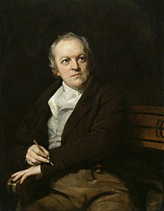
William Blake (1757- 1827)

Biographical details
- Blake lived in London for most of his life, completing an apprenticeship as an engraver and then working as an artist, art teacher and poet. However, he was definitely outside of mainstream art and poetry of his day.
- Blake was particularly concerned about poverty and poor children who didn’t receive an education as well as child labour, prostitution and dangerous industrial conditions. He believed in liberty and freedom for all, especially women.
- He became disillusioned with organised religion.

Social and historical context details
- This was the time of the Enlightenment which brought new ideas such as the movement away from monarchy towards democracy, more religious tolerance and concern with social justice.
- It was also the time of the French Revolution. In 1789, the French people revolted against the monarchy and aristocracy, using violence and murder to overthrow those in power, including the King. Blake alludes to the French Revolution in the poem.
- Blake acknowledged the deeply ingrained respect for tradition and institutions that stopped the people of London from following the example of revolutionary Paris and overthrowing their oppressors in Church and State.

Extension ideas for top grades
- “Man is born free, but everywhere he is in chains.” Jean Jacques Rousseau, an 18th century philosopher.
- The poem was published in a collection called ‘The Songs of Innocence and Experience’ which he intended to show “two contrary states of the human soul”. The poems are largely partnered, one being of Innocence and one of Experience. ‘London’ appears as a song of Experience but does not have a partner poem of Innocence.
- Blake is considered a Romantic poet and also a pre-Romantic poet.


‘The Emigree’ (first pub 1993)
Carol Rumens (1944 - )

Biographical details
- Rumens was born in London. She has never been in the position of having to leave a country.
- Therefore, she is imagining what it would be like to be a person who is forced to leave their home country and start again.
- She often writes about foreign customs, countries and languages.

Social and historical context details
- For social and political reasons, people have had to leave their home country for hundreds of years.
- The early 1990s saw an increase in the number of immigrants entering various countries across the world.
- The Gulf War in 1991 in Iraq and Kuwait led to migration from the Middle East. Today, the war in Syria is causing people to migrate, and people are coming to Britain from a variety of countries including Iraq, Iran, Somalia and Eastern Europe.
- This is a nostalgic poem – it is about homesickness and the power of memories, which we can all experience even if we have not been forced to leave our home country.

Extension ideas for top grades
- “The past is a foreign country; they do things differently there.”

‘Kamikaze’ (first pub 2013)
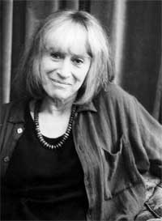
Beatrice Garland (1938 - )
Biographical details
- Beatrice Garland once said: “I spend a lot of the day listening to other people’s worlds”. ‘Kamikaze’ is an example of her imaginative writing where she recounts a story told by someone else about a place and time beyond her own direct experience.
- Garland has said that she has a particular interest in what persuades young people to give up their lives for a higher cause. She is also interested in the power of the natural world.
- The structure Garland uses - a story recounted in one voice, with an ending in someone else's direct words – is a structure she uses in other poems, too.
Social and historical context details
- The word “Kamikaze” originates from Japanese, from ‘kami’ (divinity) and ‘kazi’ (wind) [Divine wind], originally referring to the gale that, in Japanese tradition, destroyed the fleet of invading Mongols in 1281.
- Kamikaze pilots would fly manned missiles into targets (usually enemy warships) with high accuracy and a powerful payload, thereby committing suicide.
- This sacrifice brought great honour in tightly controlled Japan. However, the decision not to carry out the mission would bring great dishonour and shame to a family.
- The Japanese culture is referred to in the ‘samurai sword’. Many pilots kept a sword and picture of the Emperor in the cockpit. Japan is known as ‘The Land of the Rising Sun’, linked to the “sunrise”.
- Beatrice Garland's poem reflects the immense social pressure on the pilots to carry out kamikaze missions as part of Japan's war effort during World War Two. By the end of the campaign Japan had difficulty finding kamikaze pilots. Many were forcibly conscripted.
- Many volunteered due to “powerful incantations” because “the newspapers were saying that if the Americans land, they were all going to be slaves, the women were all going to be raped and the men would all be murdered.”
- Instead of simply thinking of the poem as being about a military strategy in the past, consider suicide missions as part of 21st century conflicts - they are very much in the news.

Extension ideas for top grades
- Are adults in powerful roles always positive role models for children?

- Garland says that the conflict is personal as well as national in this poem. She is exploring the conflict between the cultural expectation and the inner conscience.
‘Checking out Me History’ (first pub 2007) John Agard (1949 - )
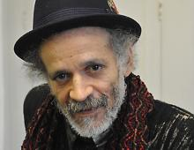
Biographical details
- Born in British Guiana now called Guyana, South America, Agard moved to Britain in 1977.
- The British took control in 1796 until Guyana became independent in 1966. This meant that as a boy at school, John Agard learned British history rather than the history of his home country.
- Agard is of mixed heritage that includes Portuguese and African. The poem expresses a sense that he feels ignorant about his own identity.

Social and historical context details
- The poet uses a mixture of English and the rhythmic musicality of Guyanese Creole to represent the voice of someone who is angered and frustrated by a Eurocentric history syllabus and is expressing his own identity.
- The original Guiana was inhabited by semi-nomadic Amerindian tribes who lived by hunting and fishing – notably Arawaks and Caribs. Agard wasn’t taught about them.
- He refers to people who were inspirational in terms of action against the European colonisers of South America. Toussaint L’Ouverture was a well-known leader of the Haitian Revolution that fought against and defeated racist colonial forces. It was a great source of concern for slavers and a great source of hope for slaves during its time.
- Nanny of the Maroons was one of the earliest leaders of slave resistance in the Americas, and one of very few women to hold the role.
- Shaka is a historic figure who revolutionized African communities and his achievements were in his revolutionary fighting tactics.
- Mary Seacole was Jamaican went to be a nurse in the Crimean War, despite being told she could not go. She nursed British soldiers using her own money to set up a hospital.
- Agard refers to a variety of famous figures from British culture and history, including childhood stories. He learned about all of these but not about figures from his own history of Guyana and Africa.
- The poem can be viewed as a poem about anyone who is living in a position where they are in a position of powerlessness and can’t establish their identity.
- The poem is about self-empowerment. He has learned about his own history for himself and is “carving out” his own identity by not accepting the restrictions on him.
- This is a poem very much in the oral tradition – it is meant to be read aloud.

Extension ideas for top grades
- Who has the power to decide what children learn in school?
- Could this poem be considered a protest poem?

‘War Photographer’
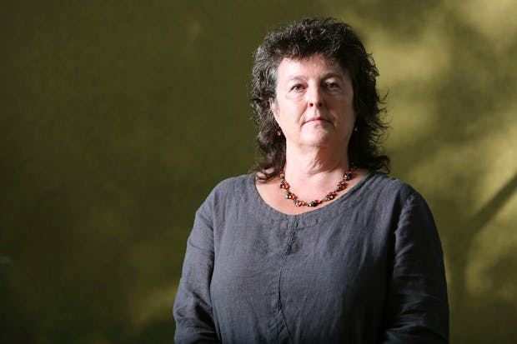
(first pub. 1985)
Carol Ann Duffy (1955 - )
Biographical details
- In the 1970s Carol Ann Duffy was friendly with Don McCullin and Phillip Jones Griffiths, famous photographers whose photographs of war were widely published.
- She was especially intrigued by the difficult decisions (dilemmas) faced by these people whose job requires them to record terrible, horrific events without being able to directly help their subjects.

Social and historical context details
- The poem is set in the late 1970s or early 1980s but is written in present tense to show the events could be happening at any time.
- The poem explores the war photographer’s conflict when he develops his photographs and how the memories of war haunt him. His personal experiences contrast with the general apathy of the British public, in their comparatively safe environment.
- The war photographer is able to return safely to his home in the English countryside.
- The photographer is using old-style film photography where a film was put into a camera to take a number of photos. They had to be developed in a darkroom where only red light could be used or it would ruin the photographs. Now journalists would upload them electronically.
- Duffy is exploring that war photographers do a difficult and dangerous job. Some are killed. There may also be psychological damage as a result of what they see and they are unable to select the pictures seen by the public and lose control of their art.
- People who see the picture aren’t really moved by what they see in the Sunday paper. It is therefore about the impossibility of presenting the true horrors of war, also shown by the photographer going out again at the end of the poem – nothing has changed.
- However, war photographers have played a vital role in trying to bring the realities of war to us, for example Nick Ut's photograph of Kim Phúc running naked amid other fleeing villagers in the Vietnam War.
Extension ideas for top grades
- Duffy says: “I like to use simple words, but in a complicated way”.
- Is it morally right for war photographers not to intervene if they see horrific events? Does Duffy question this in the poem?
‘My Last Duchess’
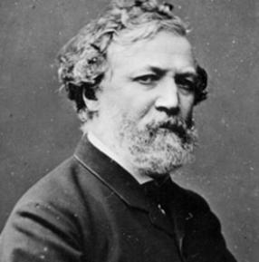
(first pub. 1842)
(Robert Browning 1812 - 1889 )

Biographical details
- Browning was home schooled from his father’s 6000 library books and was fluent in Italian.
- He visited Italy shortly before publishing the poem and was particularly interested in Ferrara, an area of Italy.

Social and historical context details
- It is not certain but Browning is likely to have based the poem on the life of Alfonso II d’Este, the Duke of Ferrara from 1533 to 1598.
- He married Lucrezia di Cosimo Medici when he was 25 and she was 14. She was from a wealthy banking family but didn’t have the same social status as the Duke’s family as long-standing members of the aristocracy.
- Lucrezia died at 17, supposedly of tuberculosis but it was widely speculated that she had been poisoned by Alfonso who was seeking to marry Barbara, the eighth daughter of the Holy Roman Emperor and of significantly more social importance than Lucrezia.
- Browning set the poem during the Italian Renaissance but there are links to Victorian England including the position of and attitudes to women (e.g. when they married, they became the legal property of their husband), with Browning possibly criticising Victorian men’s obsession with power over women and their control over women’s sexuality.

Extension ideas for top grades
- The poem is written in dramatic monologue form which allows Browning to explore the ideas of the individual and the psychology of the speaker. Are there signs of madness in the Duke’s language?

Extract from ‘The Prelude’
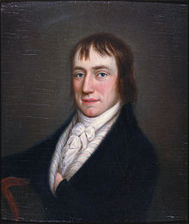
(first pub. 1850 but begun 1798)
William Wordsworth (1770-1850)
Biographical details
- Wordsworth’s deep love for the “beauteous forms” of the natural world was established early. The Wordsworth children seem to have lived in a sort of rural paradise along the Derwent River in the Lake District
- However, both Wordsworth's parents died before he was 15, and he and his four siblings were left in the care of different relatives.
- Wordsworth believed that, upon being born, human beings move from a perfect, idealized realm into the imperfect, un-ideal earth. As children, some memory of the former purity and glory in which they lived remains, best perceived in the solemn and joyous relationship of the child to the beauties of nature. But as children grow older, the memory fades, and the magic of nature dies.
- The Prelude is a long autobiography. The Prelude is one of the greatest works of literature ever written in English. It is a long poem in 14 sections. His wife Mary published it three months after his death in 1850.
- The poem shows the spiritual growth of the poet, how he comes to terms with who he is, and his place in nature and the world. Wordsworth was inspired by memories of events and visits to different places, explaining how they affected him. He described The Prelude as "a poem on the growth of my own mind" with "contrasting views of Man, Nature, and Society".
- It explores his childhood thoughts and the ways in which he has changed and grown over time. This portion begins with the speaker as a boy and explores his feelings of peace with nature. Then, an event occurs which changes the speaker’s feelings toward the world. This represents the boy coming to an age of understanding the dangers of the world. After this experience the speaker became aware that there are mysterious and dark things hidden in nature, and that nature was something to be feared as well as enjoyed. His realisation hung over him for the rest of his days and he was never able to see the world in the light of childhood again.
- It manages to capture much of the wildness and beauty of the Lake District terrain.
Social and historical context details
- Romanticism is not about romance, but nature.
- The Romantics believed that God was present in everything natural and so that, therefore, all nature should be worshipped - this was a very controversial view at the time.
- William Wordsworth and his friend Samuel Taylor Coleridge were the founders of the Romantic movement. The Prelude is dedicated to Coleridge.

‘Tissue’ (first pub. 2006)

Imtiaz Dharker 1954 - )

Biographical details
- Imtiaz Dharker was born in Pakistan and grew up in Scotland. She draws on her multi-cultural experience in her work.
- Her poems often deal with themes of identity, the role of women in contemporary society and the search for meaning.
- The poem comes from her collection called ‘The Terrorist at my Table’

Social and historical context details
- The poem is written from the point of view of someone today looking out at the conflict and troubles of the modern world such as destruction, war and politics, money and wealth as well as issues like terrorism and identity.
- The poem can be interpreted to be about the fragility of human life and the true power of nature. Nothing is meant to last and it would be better not to hold too tightly to things and instead we should be willing to let go and pass things on in their time to be remade
- The Koran, buildings, maps and grocery slips can be seen as symbols of wider issues in the world, notably religion, the major cities and landmarks of various nations, maps represent borders of countries and the divides in politics and culture while grocery slips could represent the influence of money and wealth on society, for better or worse. The poet wonders what the world would be like if these things were more like the tissue.

- The poem looks at conflict in terms of destruction and politics.

- There is reference to the power that nature (symbolised by sunlight) has to break through man-made symbols of power.

Extension ideas for top grades
- How many different interpretations of the poem can you think of? Remember that the poem is in the Power and Conflict cluster.
- ‘Treat the earth well: it was not given to you by your parents, it was loaned to you by your children. We do not inherit the Earth from our ancestors, we borrow it from our Children.’ (Ancient Indian Proverb) How far is this quote applicable to the poem?

‘Exposure’ (first pub. 1920)
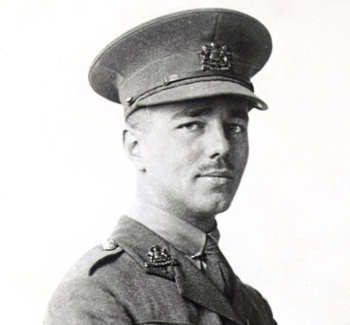
Wilfred Owen (1893-1918)

Biographical details
- Owen composed nearly all of his poems in slightly over a year, from August 1917 to September 1918.
- Owen had joined the army in 1915 but was hospitalised in May 1917 suffering from ‘shell shock’ (today known as PTSD – Post-Traumatic Stress Disorder).
- 'Exposure' gives a worm's-eye view of the front line, based on Owen's experiences in the winter of 1917. Owen and his fellow soldiers were forced to lie outside in the snow of Redan Ridge for two days and nights, unable to move in freezing conditions. He wrote: “We were marooned in a frozen desert. There was not a sign of life on the horizon and a thousand signs of death… The marvel is we did not all die of cold.”
- Owen's religious upbringing means that Christian imagery is found in much of his work. However, in ‘Exposure’ faith in the God of love is diminishing, if they hold on to the concept that he is the author of life and therefore of the soliders’ current situation.
- Owen eventually returned to the war but was tragically killed just days before the war ended; he was just 26.

Social and historical context details
- The poem conveys the boredom and inactivity of war. ‘Nothing happens', except tiny changes in the time of day, the weather and the progress of the war. The men appear trapped in a No Man's Land between life and death, and the poem's movement is circular. When it ends, they are exactly where they were in the first verse.
- World War 1 began in 1914 and at first it was predicted that it would end swiftly. However, as both sides dug trenches across France and Belgium, the opposing armies became locked in a stalemate that neither side could break. By the winter of 1917 both sides had sustained massive losses and extreme cold weather made the misery even worse. It was said to be the coldest winter in living memory. The soldiers suffered from hypothermia and frostbite and many developed trench foot, a crippling disease caused by feet being wet and cold and confined in boots for days on end.
- Owen and a number of other poets of the time used their writing to inform people back in Britain about the horrors of the war and in particular about life on the front line. The picture they painted contradicted the scenes of glory portrayed in the British press.
- It captures a different kind of war, a war that seems almost to be against a different enemy, against the world itself. This is a war within a war – a battle against Dawn, against the cold, against the snow, against the silence. The conflict is not the war, but the battle to keep sane, to stay alive, to fight off the weather and inertia.

Extension ideas for top grades
- Passive suffering is not a theme for poetry', wrote Yeats, attempting to justify his distaste for Owen. Do you think ‘Exposure’ is a valuable poem 100 years after the end of World War 1?

‘Bayonet Charge’ (first pub. 1957)
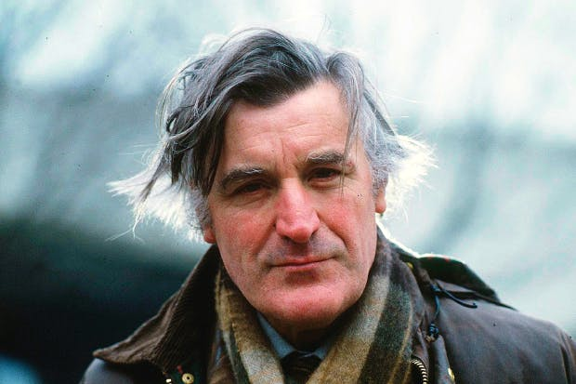
Ted Hughes (1930-1998)

Biographical details
- Hughes did not fight in any wars but his uncle and father both fought in World War 1.
- Hughes grew up in Yorkshire and enjoyed the moors and the countryside. Many of his poems are about animals, nature and their relationship to humans.
Social and historical context details
- In ‘Bayonet Charge’, The conflict isn’t specified, but the likelihood is that it is World War 1, as there is a reference to the ‘King’ — George V was on the throne at the time — and because of the descriptions of the fighting. However, as there is no precise date and location, we can assume it has universal application to any soldier and any conflict.
- The poem depicts a soldier at the chaotic moment of going into combat. The experience of ‘going over-the-top’ — that is, when soldiers hiding in trenches were ordered to ‘fix bayonets’ (attach the long knives to the end of their rifles) and climb out of the trenches to charge an enemy position twenty or thirty metres away — is described. The aim was to capture the enemy trench. The poem reveals how this process transforms a soldier from a living thinking person into a dangerous weapon of war.
- The soldier begins to question his role in the conflict. He doesn’t feel that he has made a choice to actively participate in war. He is merely a hand on a clock, a cog in the machine, exploited by much larger and more powerful forces such as governments and army generals.

Extension ideas for top grades
- Do you agree that we see soldiers who fought in war as cogs in the machine or do you think we are, in the 21st century, encouraged to recognise them as individuals? Do you think this poem helps us to do this?

‘The Charge of the Light Brigade’
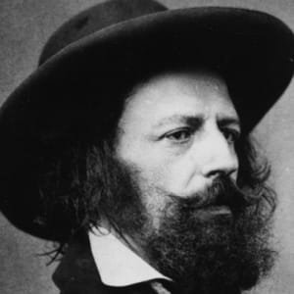
(first pub. 1854)
Alfred, Lord Tennyson (1809-1892)
Biographical details
- Tennyson wrote poetry from an early age and wrote his most famous poems from the 1840s onwards
- He was moved to write ‘The Charge of the Light Brigade’ after reading an article in the Times newspaper. He focuses on the bravery of the soldiers, also emphasising the futility, but the poem lacks a lot of specifics as he did not have first-hand experience of the battle.

Social and historical context details
- The poem, written in ballad form, tells of the Battle of Balaclava in the 1854 Crimean War - the country’s greatest ever military blunder.
- The Battle was part of the siege of Sevastopol, which lasted from 1854 to 1855. The objective of the British army was to capture the port of Sevastopol from the Russians.
- The Light Brigade had been ordered to chase a retreating Russian artillery company. After receiving the order to charge, the brigade rode into a valley between two cliffs – a near suicidal mission as the valley was flanked on three sides by Russians.
- Poor communication meant that they fought a larger and more prepared army than they were expecting.
- Lord Raglan, the 7th Earl of Cardigan, led the Charge of the Light Brigade. He is generally recognized for his bravery in leading the charge, despite there being little chance of succeeding.
- About 107 of the 674 soldiers involved in the charge were killed (figures aren’t exact). Other British troops later died in hospital, and many were taken prisoner by the Russians.
- Lord Raglan himself, the Earl of Lucan (who commanded the cavalry), the Earl of Cardigan (in charge of the Light Brigade), and Captain Louis Nolan (who brought the order from Raglan to the cavalry) have all been blamed for the high death and injury rates.
- Many of the soldiers were from the working classes and many of the cavalry (horse riders) were from the upper classes as they were experienced riders.

Extension ideas for top grades
- Letters written by the soldiers back to their family and friends show they were aware the orders were “perfect madness” but they followed them anyway. Should soldiers always follow orders in battle?

‘Storm on the Island’ .
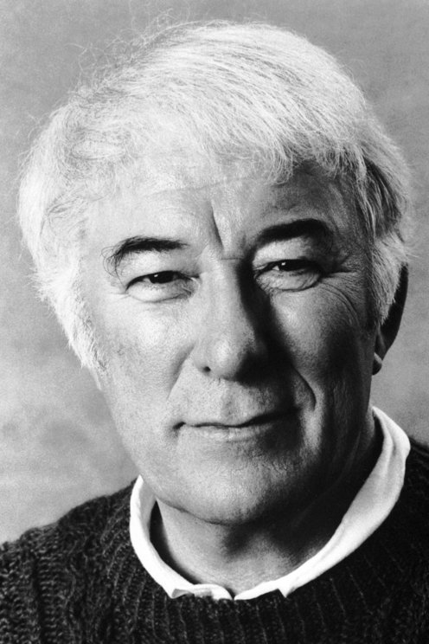
(first pub. 1966)
Seamus Heaney (1939-2013) Biographical details
- Heaney was brought up on a small farm in Derry, Northern Ireland.
- Heaney moved away from the farm, including moving to the Republic of Ireland in 1972, but rural County Derry is the “country of the mind” where much of Heaney’s poetry is still grounded.
- He was a Catholic: "Be advised, my passport's green / No glass of ours was ever raised / To toast the Queen," he once wrote. He was also a prominent voice for peace during the Troubles in Ireland. However, he chose through his poetry not to become a political voice outright, but to concentrate on farming, family and history.
- Heaney's poems are often triggered by small, intimate memories.

Social and historical context details

- Heaney’s life saw the escalation of conflict over Northern Ireland at the end of the 1960s. The conflict was between those (largely Catholic) who wanted Northern Ireland to join with the Republic of Ireland and break free from British rule.
- Storm On The Island is a poem that can be taken literally, as a dramatic monologue on the life and attitude of island people facing a storm.
- Or it can be understood as an extended metaphor of political struggle on the island of Ireland. This is suggested by the war imagery.
- Whether these forces are natural or political the phrase 'collective responsibility' comes to mind - the people have to get their act together or else they will not survive.
- From the first line of the poem it is clear that the speaker represents a people, a specific family, an island folk. In this sense the voice is that of a spokesperson addressing someone who does not quite understand their predicament.
- It is a poem that gives voice to a people who live in constant fear of the power of natural storms.
- The poem's theme is therefore the ongoing conflict between humans and nature.
Extension ideas for top grades
- “We're all alone in the vast, powerful, and often terrible natural world.”
- “Heaney manages to avoid the conflict, and not avoid it.”
How far does the poem show these views?

