A level Mathematics Year 11 to 12 transition

### 1

**Contents**

1. Introduction
2. Expanding brackets and simplifying expressions *
3. Factorising expressions *
4. Rules of indices *
5. Surds *
6. Rearranging equations *
7. Completing the square *
8. Solving quadratic equations by factorisation *
9. Solving quadratic equations by completing the square *
10. Solving quadratic equations by using the formula *
11. Solving linear simultaneous equations by elimination *
12. Solving linear simultaneous equations by substitution *
13. Solving linear and quadratic simultaneous equations *
14. Solving simultaneous equations graphically
15. Linear inequalities *
16. Quadratic inequalities
17. Sketching cubic and reciprocal graphs
18. Translating graphs
19. Stretching graphs
20. Straight line graphs
21. Parallel and perpendicular lines
22. Volume and surface area of 3D solids
23. Pythagoras’ theorem *
24. Trigonometry in right-angled triangles *
25. The cosine rule
26. The sine rule
27. Area of a triangle using ½absin C

2

**Introduction**

Why is transition important?

Preparation is crucial for studying A levels. A levels require you to be an independent learner. Although you have fewer subjects, A levels require different study skills and the volume of work is greater due to the increased demand of depth and detail. The exercises in this booklet will ensure that you are ready for the exciting challenges of becoming an A level Mathematics student in September. You should complete the questions from the booklet in your own note pad, exercise book or on paper. Those topics with a highlighted star are the priority topics and are things that will not be retaught but will be assumed knowledge for the A level course.

Is the transition work checked?

Yes. In September you will be expected to bring ALL your transition work with you to your first few lessons. This will be shown to the Maths team leader in charge of A level. You will be required to sit a baseline assessment in the first week to see if you are unable to demonstrate a sound understanding of the majority of content covered in this booklet. If you do not pass the baseline assessment, you will need to complete extra work and then sit a retest at a time arranged, this will be after school.

**YOU MUST SHOW YOUR WORKING OUT.**

**You must bring all the work with you to your first few lessons in Year 12 Mathematics lesson in September.**

**Please ensure that all your work is marked and you have made any corrections and figure out why you were wrong**

How is this booklet structured?

When you have completed each section use the answer booklet to mark your work. When you have gone wrong retry the question until you are able to get the correct answer.

|  |  |
| --- | --- |
| Key points | Precise bullet points which outline the key knowledge you need to know in each topic |
| Examples | A series of examples to walk you through the questions you can expect in each topic. A commentary is also provided to explain each step of each example. |
| Video tutorials | Hyperlinked QR codes that lead to video tutorials on each topic. Sometimes, it is easier to watch a mathematician talking through a concept rather than reading a series of examples. |
| Practice | A series of questions to give you the opportunity to practice and demonstrate you have understand the topic fully |
| Extend | Some more challenging and stretching questions to make you think a little bit more. Rise to the challenge and have a go at these questions! |

## Expanding brackets and simplifying expressions

|  |
| --- |
| Key points |
| * When you expand one set of brackets you must multiply everything inside the bracket by what is outside. |
| * When you expand two linear expressions, each with two terms of the form *ax* + *b*, where *a* ≠ 0 and *b* ≠ 0, you create four terms. Two of these can usually be simplified by   collecting like terms. |

### Examples

**Example 1** Expand 4(3*x* − 2)

|  |  |
| --- | --- |
| 4(3*x* − 2) = 12*x* − 8 | Multiply everything inside the bracket by the 4 outside the bracket |

**Example 2** Expand and simplify 3(*x* + 5) − 4(2*x* + 3)

|  |  |
| --- | --- |
| 3(*x* + 5) − 4(2*x* + 3)  = 3*x* + 15 − 8*x* – 12  = 3 − 5*x* | 1. Expand each set of brackets separately by multiplying (*x* + 5) by 3 and (2*x* + 3) by −4 2. Simplify by collecting like terms: 3*x* − 8*x* = −5*x* and 15 − 12 = 3 |

**Example 3** Expand and simplify (*x* + 3)(*x* + 2)

|  |  |
| --- | --- |
| (*x* + 3)(*x* + 2)  = *x*(*x* + 2) + 3(*x* + 2)  = *x*2 + 2*x* + 3*x* + 6  = *x*2 + 5*x* + 6 | 1. Expand the brackets by multiplying (*x* + 2) by *x* and (*x* + 2) by 3 2. Simplify by collecting like terms: 2*x* + 3*x* = 5*x* |

**Example 4** Expand and simplify (*x* − 5)(2*x* + 3)

|  |  |
| --- | --- |
| (*x* − 5)(2*x* + 3)  = *x*(2*x* + 3) − 5(2*x* + 3)  = 2*x*2 + 3*x* − 10*x* − 15  = 2*x*2 − 7*x* − 15 | 1. Expand the brackets by multiplying (2*x* + 3) by *x* and (2*x* + 3) by −5 2. Simplify by collecting like terms: 3*x* − 10*x* = −7*x* |

### Video tutorials

|  |  |
| --- | --- |
| Expanding a single bracket | Expanding double brackets |
|  |  |

*or click on the QR code to follow the hyperlink*

### Practice

1. Expand.

**Watch out!**

When multiplying (or dividing) positive and negative numbers, if the signs are the same the answer is ‘+’; if the signs are different the answer is ‘–’.

2

|  |  |  |  |  |
| --- | --- | --- | --- | --- |
| **a** | | 3(2*x* − 1) | **b** | −2(5*pq* + 4*q*2) |
| **c** | | −(3*xy* − 2*y*2) |  |  |
| **2** Expand and simplify. | | | | |
| **a** | | 7(3*x* + 5) + 6(2*x* – 8) | **b** | 8(5*p* – 2) – 3(4*p* + 9) |
| **c** | | 9(3*s* + 1) –5(6*s* – 10) | **d** | 2(4*x* – 3) – (3*x* + 5) |
| **3** | Expand. | |  |  |
|  | **a** 3*x*(4*x* + 8) | | **b** | 4*k*(5*k*2 – 12) |
|  | **c** –2*h*(6*h*2 + 11*h* – 5) | | **d** | –3*s*(4*s*2 – 7*s* + 2) |
| **4** | Expand and simplify. | |  |  |
|  | **a** 3(*y*2 – 8) – 4(*y*2 – 5) | | **b** | 2*x*(*x* + 5) + 3*x*(*x* – 7) |
|  | **c** 4*p*(2*p* – 1) – 3*p*(5*p* – 2) | | **d** | 3*b*(4*b* – 3) – *b*(6*b* – 9) |
| **5** | Expand 1 (2*y* – 8) | |  |  |
| **6** | Expand and simplify. | |  |  |
|  | **a** 13 – 2(*m* + 7) | | **b** | 5*p*(*p*2 + 6*p*) – 9*p*(2*p* – 3) |

**7** The diagram shows a rectangle.

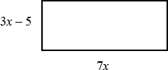Write down an expression, in terms of *x*, for the area of the rectangle.

Show that the area of the rectangle can be written as 21*x*2 – 35*x*

|  |  |  |  |
| --- | --- | --- | --- |
| **8** | Expand and simplify. |  | |
|  | **a** (*x* + 4)(*x* + 5) | **b** | (*x* + 7)(*x* + 3) |
|  | **c** (*x* + 7)(*x* – 2) | **d** | (*x* + 5)(*x* – 5) |
|  | **e** (2*x* + 3)(*x* – 1) | **f** | (3*x* – 2)(2*x* + 1) |
|  | **g** (5*x* – 3)(2*x* – 5)  **i** (3*x* + 4*y*)(5*y* + 6*x*)  **k** (2*x* − 7)2 | **h j**  **l** | (3*x* – 2)(7 + 4*x*) (*x* + 5)2  (4*x* − 3*y*)2 |

### Extend

1. Expand and simplify (*x* + 3)² + (*x* − 4)²

**10** Expand and simplify.

**a**  **b** 

## Factorising expressions

### Key points

* Factorising an expression is the opposite of expanding the brackets.
* A quadratic expression is in the form *ax*2 + *bx* + *c*, where *a* ≠ 0.
* To factorise a quadratic equation find two numbers whose sum is *b* and whose product is

*ac*.

* An expression in the form *x*2 – *y*2 is called the difference of two squares. It factorises to (*x* – *y*)(*x* + *y*).

### Examples

**Example 1** Factorise 15*x*2*y*3 + 9*x*4*y*

|  |  |
| --- | --- |
| 15*x*2*y*3 + 9*x*4*y* = 3*x*2*y*(5*y*2 + 3*x*2) | The highest common factor is 3*x*2*y*.  So take 3*x*2*y* outside the brackets and then divide each term by 3*x*2*y* to find the terms in the brackets |

**Example 2** Factorise 4*x*2 – 25*y*2

|  |  |
| --- | --- |
| 4*x*2 – 25*y*2 = (2*x* + 5*y*)(2*x* − 5*y*) | This is the difference of two squares as the two terms can be written as (2*x*)2 and (5*y*)2 |

**Example 3** Factorise *x*2 + 3*x* – 10

|  |  |
| --- | --- |
| *b* = 3, *ac* = −10  So *x*2 + 3*x* – 10 = *x*2 + 5*x* – 2*x* – 10  = *x*(*x* + 5) – 2(*x* + 5)  = (*x* + 5)(*x* – 2) | 1. Work out the two factors of   *ac* = −10 which add to give *b* = 3 (5 and −2)   1. Rewrite the *b* term (3*x*) using these two factors 2. Factorise the first two terms and the last two terms 3. (*x* + 5) is a factor of both terms |

**Example 4** Factorise 6*x*2 − 11*x* − 10

|  |  |
| --- | --- |
| *b* = −11, *ac* = −60  So  6*x*2 − 11*x* – 10 = 6*x*2 − 15*x* + 4*x* – 10  = 3*x*(2*x* − 5) + 2(2*x* − 5)  = (2*x* – 5)(3*x* + 2) | 1. Work out the two factors of   *ac* = −60 which add to give *b* = −11 (−15 and 4)   1. Rewrite the *b* term (−11*x*) using these two factors 2. Factorise the first two terms and the last two terms 3. (2*x* − 5) is a factor of both terms |

**Example 5** Simplify

*x*2  4*x*  21

2*x*2  9*x*  9

|  |  |
| --- | --- |
| *x*2  4*x*  21  2*x*2  9*x*  9  For the numerator:  *b* = −4, *ac* = −21  So  *x*2 − 4*x* – 21 = *x*2 − 7*x* + 3*x* – 21  = *x*(*x* − 7) + 3(*x* − 7)  = (*x* – 7)(*x* + 3)  For the denominator:  *b* = 9, *ac* = 18  So  2*x*2 + 9*x* + 9 = 2*x*2 + 6*x* + 3*x* + 9  = 2*x*(*x* + 3) + 3(*x* + 3)  = (*x* + 3)(2*x* + 3)  So  *x*2  4*x*  21  (*x*  7)(*x*  3) 2*x*2  9*x*  9 (*x*  3)(2*x*  3)  = *x*  7  2*x*  3 | 1. Factorise the numerator and the denominator 2. Work out the two factors of   *ac* = −21 which add to give *b* = −4 (−7 and 3)   1. Rewrite the *b* term (−4*x*) using these two factors 2. Factorise the first two terms and the last two terms 3. (*x* − 7) is a factor of both terms 4. Work out the two factors of   *ac* = 18 which add to give *b* = 9 (6 and 3)   1. Rewrite the *b* term (9*x*) using these two factors 2. Factorise the first two terms and the last two terms 3. (*x* + 3) is a factor of both terms 4. (*x* + 3) is a factor of both the numerator and denominator so cancels out as a value divided by itself is 1 |

### Video tutorials

|  |  |
| --- | --- |
| Factorising using a single bracket | Factorising simple quadratic expressions |
|  |  |

|  |  |
| --- | --- |
| Factorising difficult quadratics | Difference between two squares |
|  |  |

|  |
| --- |
| Simplifying algebraic fractions by factorising |
|  |

*or click on the QR code to follow the hyperlink*

### Practice

|  |  |  |  |  |  |
| --- | --- | --- | --- | --- | --- |
| **1** Factorise.  **a** 6*x*4*y*3 – 10*x*3*y*4  **c** 25*x*2*y*2 – 10*x*3*y*2 + 15*x*2*y*3 | | | **b** | 21*a*3*b*5 + 35*a*5*b*2 | **Hint**  Take the highest common factor |
| **2** | Factorise  **a** *x*2 + 7*x* + 12 | | **b** | *x*2 + 5*x* – 14 | outside the bracket. |
|  | **c** *x*2 – 11*x* + 30  **e** *x*2 – 7*x* – 18  **g** *x*2 – 3*x* – 40 | | **d f h** | *x*2 – 5*x* – 24 *x*2 + *x* –20 *x*2 + 3*x* – 28 |  |
| **3** | Factorise  **a** 36*x*2 – 49*y*2  **c** 18*a*2 – 200*b*2*c*2 | | **b** | 4*x*2 – 81*y*2 |  |
| **4** | Factorise  **a** 2*x*2 + *x* –3 | | **b** | 6*x*2 + 17*x* + 5 |  |
|  | **c** 2*x*2 + 7*x* + 3  **e** 10*x*2 + 21*x* + 9 | | **d f** | 9*x*2 – 15*x* + 4  12*x*2 – 38*x* + 20 |  |
| **5** | Simplify the algebraic fractions. | |  |  |  |
| **a** | | 2*x*2  4*x x*2  *x* | **b** | *x*2  3*x x*2  2*x*  3 | |
| **c** | | *x*2  2*x*  8  *x*2  4*x* | **d** | *x*2  5*x x*2  25 | |
| **e** | | *x*2  *x* 12  *x*2  4*x* | **f** | 2*x*2  14*x*  2*x*2  4*x*  70 | |

1. Simplify

9*x*2 16

**a**

3*x*2 17*x*  28

4  25*x*2

**c**

10*x*2 11*x*  6

2*x*2  7*x* 15

**b**

3*x*2 17*x* 10

6*x*2  *x* 1

**d**

2*x*2  7*x*  4

### Extend

1. Simplify

*x*2 10*x*  25

1. Simplify

(*x*  2)2  3(*x*  2)2

*x*2  4

## Rules of indices

Key points

* *am* × *an* = *am* + *n*
* 
* (*am*)*n* = *amn*
* *a*0 = 1
*  i.e. the *n*th root of *a*
* 
* 
* The square root of a number produces two solutions, e.g. .

Examples

**Example 1** Evaluate 100

|  |  |
| --- | --- |
| 100 = 1 | Any value raised to the power of zero is equal to 1 |

**Example 2** Evaluate 

|  |  |
| --- | --- |
| = 3 | Use the rule |

**Example 3** Evaluate 

|  |  |
| --- | --- |
| =  = 9 | **1** Use the rule  **2** Use |

**Example 4** Evaluate 

|  |  |
| --- | --- |
|  | **1** Use the rule  **2** Use |

**Example 5** Simplify 

|  |  |
| --- | --- |
| = 3*x*3 | 6 ÷ 2 = 3 and use the rule  to give |

**Example 6** Simplify 

|  |  |
| --- | --- |
| = *x*8 − 4 = *x*4 | **1** Use the rule  **2** Use the rule |

**Example 7** Write  as a single power of *x*

|  |  |
| --- | --- |
|  | Use the rule , note that the fraction  remains unchanged |

**Example 8** Write  as a single power of *x*

|  |  |
| --- | --- |
|  | **1** Use the rule  **2** Use the rule |

### Video tutorials

|  |  |
| --- | --- |
| Index laws | Negative indices |

[](https://videopress.com/v/Pl3mVnG0)[](https://videopress.com/v/A1kYglvB)

Fractional indices

[](https://videopress.com/v/HPqUuvcL)

*or click on the QR code to follow the hyperlink*

### Practice

1. Evaluate.

**a** 140 **b** 30 **c** 50 **d** *x*0

1. Evaluate.

1 1 1 1

**a** 492

**b** 643

**c** 1253

**d** 164

1. Evaluate.

3 5 3 3

**a** 252

**b** 83

**c** 492

**d** 164

1. Evaluate.

**a** 5–2 **b** 4–3 **c** 2–5 **d** 6–2

**5** Simplify.

**a**  **b** 

**c**  **d** 

**Watch out!**

Remember that any value raised to the power of zero is 1. This is the rule *a*0 = 1.

**e**  **f** 

**g**  **h** 

**6** Evaluate.

**a**  **b**  **c** 

**d**  **e**  **f** 

**7** Write the following as a single power of *x*.

**a**  **b**  **c** 

**d**  **e**  **f** 

**8** Write the following without negative or fractional powers.

**a**  **b** *x*0 **c** 

**d**  **e**  **f** 

**9** Write the following in the form *axn*.

**a**  **b**  **c** 

**d**  **e**  **f** 3

# **Extend**

**10** Write as sums of powers of *x*.

**a**  **b**  **c** 

## Surds

### Key points – Surds

* A surd is the square root of a number that is not a square number, for example 2, 3, 5, etc.
* Surds can be used to give the exact value for an answer.

 *a* 





*ab*



*b*

*a*

*b*



*a*

*b*

* To rationalise the denominator means to remove the surd from the denominator of a fraction.



*b*

* To rationalise *a*

*b*



*c*

you multiply the numerator and denominator by the surd

* To rationalise *a*



*b*  *c*

you multiply the numerator and denominator by *b* 



### Examples

**Example 1** Simplify



50

|  |  |
| --- | --- |
| 50  25 2   25  2   5  2   5 2 | 1. Choose two numbers that are factors of 50. One of the factors must be a square number 2. Use the rule *ab*  *a*  *b* 3. Use 25  5 |

**Example 2** Simplify  2

147



12

|  |  |
| --- | --- |
| 147  2 12   49  3  2 4  3   49  3  2 4  3   7  3  2 2 3   7 3  4 3   3 3 | 1. Simplify 147 and 2 12 . Choose two numbers that are factors of 147 and two numbers that are factors of   12. One of each pair of factors must  be a square number   1. Use the rule *ab*  *a*  *b* 2. Use 49  7 and 4  2 3. Collect like terms |

**Example 3** Simplify 



7



7

 2 

− 2 





|  |  |
| --- | --- |
|  7  2  7  2   = 49  7 2  2 7  4  = 7 – 2  = 5 | 1. Expand the brackets. A common mistake here is to write  7 2  49 2. Collect like terms:    7 2  2 7    7 2  7 2  0 |

**Example 4** Rationalise



1

3



|  |  |
| --- | --- |
| 1 = 1  3  3 3 3  = 1 3  9  = 3  3 | 1. Multiply the numerator and denominator by 3 2. Use 9  3 |

**Example 5** Rationalise and simplify



2

12



|  |  |
| --- | --- |
| 2 = 2  12  12 12 12  = 2  4  3  12  = 2 2 3  12  = 2 3  6 | 1. Multiply the numerator and denominator by 12 2. Simplify 12 in the numerator. Choose two numbers that are factors of 12. One of the factors must be a square number 3. Use the rule *ab*  *a*  *b* 4. Use 4  2 5. Simplify the fraction:   2 simplifies to 1  12 6 |





**Example 6** Rationalise and simplify



3

2  5



|  |  |
| --- | --- |
| 3 = 3  2  5  2  5 2  5 2  5  32  5   = 2  5 2  5   6  3 5  =  4  2 5  2 5  5  = 6  3 5  1  = 3 5  6 | 1. Multiply the numerator and denominator by 2  5 2. Expand the brackets 3. Simplify the fraction 4. Divide the numerator by −1 Remember to change the sign of all terms when dividing by −1 |

### Video tutorial

|  |  |
| --- | --- |
| Rules of surds and simplifying | Addition and subtraction of surds |
|  |  |

|  |  |
| --- | --- |
| Expanding brackets involving surds | Rationalising the denominator |
|  |  |

*or click on the QR code to follow the hyperlink*

### Practice

1. Simplify.

**Hint**

One of the two numbers you choose at the start

must be a square number.

|  |  |  |  |
| --- | --- | --- | --- |
| **a** | 45 | **b** | 125 |
| **c** | 48 | **d** | 175 |
| **e** | 300 | **f** | 28 |
| **g** | 72 | **h** | 162 |

1. Simplify.



27

**Watch out!**

Check you have chosen the highest square number at the

**a** 72 

162

**c** 50 



8

**e** 2 28 



28

**b** 45 2

**d** 75 



5



48

**f** 2 12 

12 

1. Expand and simplify.

**a** ( 2 

3)( 2 

3) **b**

(3 

3)(5 

12)

**c** (4 

5)( 45  2) **d**

(5 

2)(6  8)

1. Rationalise and simplify, if possible.

**a** 1 **b**



1

11

5

**c** 2 **d** 2

7 8

**e** 2 **f** 5

2 5



8

24



5

45

**g h**

1. Rationalise and simplify.



1

3 5

**a**

**b c**



2

4  3



6

5 2

### Extend



*x*

1. Expand and simplify 



*x*

 *y* 

− *y* 

1. Rationalise and simplify, if possible.

**a b** 1



1

9  8



*x*  *y*

## Rearranging equations

### Key points

* To change the subject of a formula, get the terms containing the subject on one side and everything else on the other side.
* You may need to factorise the terms containing the new subject.

### Examples

**Example 1** Make *t* the subject of the formula *v* = *u* + *at*.

|  |  |
| --- | --- |
| *v* = *u* + *at*  *v* − *u* = *at*  *t*  *v*  *u*  *a* | 1. Get the terms containing *t* on one side and everything else on the other side. 2. Divide throughout by *a*. |

**Example 2** Make *t* the subject of the formula *r* = 2*t* − *πt*.

|  |  |
| --- | --- |
| *r* = 2*t* − *πt*  *r* = *t*(2 − *π*)  *t*  *r*  2  ** | 1. All the terms containing *t* are already on one side and everything else is on the other side. 2. Factorise as *t* is a common factor. 3. Divide throughout by 2 − *π*. |

**Example 3** Make *t* the subject of the formula

*t*  *r*  3*t* .

5 2

|  |  |
| --- | --- |
| *t*  *r*  3*t*  5 2  2*t* + 2*r* = 15*t* 2*r* = 13*t*  *t*  2*r*  13 | 1. Remove the fractions first by multiplying throughout by 10. 2. Get the terms containing *t* on one side and everything else on the other side and simplify. 3. Divide throughout by 13. |

**Example 4** Make *t* the subject of the formula *r*  3*t*  5 .

*t* 1

|  |  |
| --- | --- |
| *r*  3*t*  5  *t* 1  *r*(*t* − 1) = 3*t* + 5  *rt* − *r* = 3*t* + 5 *rt* − 3*t* = 5 + *r t*(*r* − 3) = 5 + *r*  *t*  5  *r*  *r*  3 | 1. Remove the fraction first by multiplying throughout by *t* − 1. 2. Expand the brackets. 3. Get the terms containing *t* on one side and everything else on the other side. 4. Factorise the LHS as *t* is a common factor. 5. Divide throughout by *r* − 3. |

### Video tutorials

|  |  |
| --- | --- |
| Changing the subject | Advanced changing the subject |
|  |  |

*or click on the QR code to follow the hyperlink*

### Practice

Change the subject of each formula to the letter given in the brackets.

**1** *C* = *πd* [*d*] **2** *P* = 2*l* + 2*w* [*w*] **3** *D = S T*

[*T*]

**4** *p*  *q*  *r t*

[*t*] **5** *u* = *at* – 1 *t* [*t*] **6** *V* = *ax* + 4*x* [*x*]

2

**7** *y*  7*x*  7  2 *y*

2 3

1. **8**

*x*  2*a* 1

* 1.  *a*

[*a*] **9**

*x*  *b*  *c*

*d*

[*d*]

**10** *h*  7*g*  9

2  *g*

[*g*] **11** *e*(9 + *x*) = 2*e* + 1 [*e*] **12**

*y*  2*x*  3

* 1.  *x*

[*x*]

1. Make *r* the subject of the following formulae.

**a** *A* = *πr*2 **b**

*V*  4 ** *r*3

3

**c** *P* = *πr* + 2*r* **d**

*V*  2 ** *r* 2*h*

3

1. Make *x* the subject of the following formulae.

**a** *xy*  *ab* **b** 4** *cx*  3*z*

*z cd d py*2

1. Make sin *B* the subject of the formula

*a*

#### sin *A*

 *b*

#### sin *B*

1. Make cos *B* the subject of the formula *b*2 = *a*2 + *c*2 – 2*ac* cos *B*.

### Extend

1. Make *x* the subject of the following equations.
   1. *p* (*sx*  *t*)  *x* 1

*q*

* 1. *p* (*ax*  2 *y*)  3 *p* (*x*  *y*) *q q*2

## Completing the square

Key points

* Completing the square for a quadratic rearranges *ax*2 + *bx* + *c* into the form *p*(*x* + *q*)2 + *r*
* If *a* ≠ 1, then factorise using *a* as a common factor.

Examples

**Example 1** Complete the square for the quadratic expression *x*2 + 6*x* − 2

|  |  |
| --- | --- |
| *x*2 + 6*x* − 2  = (*x* + 3)2 − 9 − 2  = (*x* + 3)2 − 11 | **1** Write *x*2 + *bx* + *c* in the form  **2** Simplify |

**Example 2** Write 2*x*2 − 5*x* + 1 in the form *p*(*x* + *q*)2 + *r*

|  |  |
| --- | --- |
| 2*x*2 − 5*x* + 1  =  =  =  = | **1** Before completing the square write *ax*2 + *bx* + *c* in the form  **2** Now complete the square by writing  in the form  **3** Expand the square brackets – don’t forget to multiply by the factor of 2  **4** Simplify |

### Video tutorials

|  |
| --- |
| Completing the square |
|  |

*or click on the QR code to follow the hyperlink*

### Practice

1. Write the following quadratic expressions in the form (*x* + *p*)2 + *q*

|  |  |  |  |
| --- | --- | --- | --- |
| **a** | *x*2 + 4*x* + 3 | **b** | *x*2 – 10*x* – 3 |
| **c** | *x*2 – 8*x* | **d** | *x*2 + 6*x* |
| **e** | *x*2 – 2*x* + 7 | **f** | *x*2 + 3*x* – 2 |

1. Write the following quadratic expressions in the form *p*(*x* + *q*)2 + *r*

|  |  |  |  |
| --- | --- | --- | --- |
| **a** | 2*x*2 – 8*x* – 16 | **b** | 4*x*2 – 8*x* – 16 |
| **c** | 3*x*2 + 12*x* – 9 | **d** | 2*x*2 + 6*x* – 8 |

1. Complete the square.

**a** 2*x*2 + 3*x* + 6 **b** 3*x*2 – 2*x*

**c** 5*x*2 + 3*x* **d** 3*x*2 + 5*x* + 3

### Extend

1. Write (25*x*2 + 30*x* + 12) in the form (*ax* + *b*)2 + *c*.

## Solving quadratic equations by factorisation

### Key points

* A quadratic equation is an equation in the form *ax*2 + *bx* + *c* = 0 where *a* ≠ 0.
* To factorise a quadratic equation find two numbers whose sum is *b* and whose products is *ac*.
* When the product of two numbers is 0, then at least one of the numbers must be 0.
* If a quadratic can be solved it will have two solutions (these may be equal).

### Examples

**Example 1** Solve 5*x*2 = 15*x*

|  |  |
| --- | --- |
| 5*x*2 = 15*x*  5*x*2 − 15*x* = 0  5*x*(*x* − 3) = 0  So 5*x* = 0 or (*x* − 3) = 0  Therefore *x* = 0 or *x* = 3 | 1. Rearrange the equation so that all of the terms are on one side of the equation and it is equal to zero.   Do not divide both sides by *x* as this would lose the solution *x* = 0.   1. Factorise the quadratic equation. 5*x* is a common factor. 2. When two values multiply to make zero, at least one of the values must be zero. 3. Solve these two equations. |

**Example 2** Solve *x*2 + 7*x* + 12 = 0

|  |  |
| --- | --- |
| *x*2 + 7*x* + 12 = 0  *b* = 7, *ac* = 12  *x*2 + 4*x* + 3*x* + 12 = 0  *x*(*x* + 4) + 3(*x* + 4) = 0 (*x* + 4)(*x* + 3) = 0  So (*x* + 4) = 0 or (*x* + 3) = 0  Therefore *x* = −4 or *x* = −3 | 1. Factorise the quadratic equation. Work out the two factors of *ac* = 12 which add to give you *b* = 7.   (4 and 3)   1. Rewrite the *b* term (7*x*) using these two factors. 2. Factorise the first two terms and the last two terms. 3. (*x* + 4) is a factor of both terms. 4. When two values multiply to make zero, at least one of the values must be zero. 5. Solve these two equations. |

**Example 3** Solve 9*x*2 − 16 = 0

|  |  |
| --- | --- |
| 9*x*2 − 16 = 0  (3*x* + 4)(3*x* – 4) = 0  So (3*x* + 4) = 0 or (3*x* – 4) = 0  *x*  4 or *x*  4  3 3 | 1. Factorise the quadratic equation. This is the difference of two squares as the two terms are (3*x*)2 and (4)2. 2. When two values multiply to make zero, at least one of the values must be zero. 3. Solve these two equations. |

**Example 4** Solve 2*x*2 − 5*x* − 12 = 0

|  |  |
| --- | --- |
| *b* = −5, *ac* = −24  So 2*x*2 − 8*x* + 3*x* – 12 = 0 2*x*(*x* − 4) + 3(*x* − 4) = 0 (*x* – 4)(2*x* + 3) = 0  So (*x* – 4) = 0 or (2*x* +3) = 0  *x*  4 or *x*  3  2 | 1. Factorise the quadratic equation. Work out the two factors of *ac* = −24 which add to give you *b* = −5.   (−8 and 3)   1. Rewrite the *b* term (−5*x*) using these two factors. 2. Factorise the first two terms and the last two terms. 3. (*x* − 4) is a factor of both terms. 4. When two values multiply to make zero, at least one of the values must be zero. 5. Solve these two equations. |

### Video tutorials

|  |
| --- |
| Solving quadratic equations by factorisation |
|  |

*or click on the QR code to follow the hyperlink*

### Practice

|  |  |  |  |
| --- | --- | --- | --- |
| **1** | Solve  **a** 6*x*2 + 4*x* = 0 | **b** | 28*x*2 – 21*x* = 0 |
|  | **c** *x*2 + 7*x* + 10 = 0  **e** *x*2 – 3*x* – 4 = 0  **g** *x*2 – 10*x* + 24 = 0 **i** *x*2 + 3*x* – 28 = 0 **k** 2*x*2 – 7*x* – 4 = 0 | **d f h j l** | *x*2 – 5*x* + 6 = 0 *x*2 + 3*x* – 10 = 0 *x*2 – 36 = 0  *x*2 – 6*x* + 9 = 0 3*x*2 – 13*x* – 10 = 0 |
| **2** | Solve  **a** *x*2 – 3*x* = 10 | **b** | *x*2 – 3 = 2*x* |
|  | **c** *x*2 + 5*x* = 24  **e** *x*(*x* + 2) = 2*x* + 25  **g** *x*(3*x* + 1) = *x*2 + 15 | **d f**  **h** | *x*2 – 42 = *x*  *x*2 – 30 = 3*x* – 2 3*x*(*x* – 1) = 2(*x* + 1) |

**Hint**

Get all terms onto one side of the

## Solving quadratic equations by completing the square

### Key points

* Completing the square lets you write a quadratic equation in the form *p*(*x* + *q*)2 + *r* = 0*.*

Examples

**Example 5** Solve *x*2 + 6*x* + 4 = 0. Give your solutions in surd form.

|  |  |
| --- | --- |
| *x*2 + 6*x* + 4 = 0  (*x* + 3)2 − 9 + 4 = 0  (*x* + 3)2 − 5 = 0  (*x* + 3)2 = 5  *x* + 3 =  *x* =  So *x* =  or *x* = | **1** Write *x*2 + *bx* + *c* = 0 in the form  **2** Simplify.  **3** Rearrange the equation to work out *x*. First, add 5 to both sides.  **4** Square root both sides.  Remember that the square root of a value gives two answers.  **5** Subtract 3 from both sides to solve the equation.  **6** Write down both solutions. |

**Example 6** Solve 2*x*2 − 7*x* + 4 = 0. Give your solutions in surd form.

|  |  |
| --- | --- |
| 2*x*2 − 7*x* + 4 = 0  = 0  = 0  = 0  = 0          So  or | **1** Before completing the square write *ax*2 + *bx* + *c* in the form  **2** Now complete the square by writing  in the form  **3** Expand the square brackets.  **4** Simplify.  *(continued on next page)*  **5** Rearrange the equation to work out *x*. First, add  to both sides.  **6** Divide both sides by 2.  **7** Square root both sides. Remember that the square root of a value gives two answers.  **8** Add  to both sides.  **9** Write down both the solutions. |

### Video tutorials

|  |
| --- |
| Solving quadratic equations by completing the square |
|  |

*or click on the QR code to follow the hyperlink*

### Practice

|  |  |  |  |  |
| --- | --- | --- | --- | --- |
| **3** Solve by completing the square. | |  | | |
| **a** *x*2 – 4*x* – 3 = 0 | | **b** | *x*2 – 10*x* + 4 = 0 | |
| **c** *x*2 + 8*x* – 5 = 0 | | **d** | *x*2 – 2*x* – 6 = 0 | |
| **e** 2*x*2 + 8*x* – 5 = 0 | | **f** | 5*x*2 + 3*x* – 4 = 0 | |
| **4** Solv  **a** | e by completing the square.  (*x* – 4)(*x* + 2) = 5 | | | **Hint** |
| **b** | 2*x*2 + 6*x* – 7 = 0 | | | Get all terms |
| **c** | *x*2 – 5*x* + 3 = 0 | | | onto one side  of the |



## Solving quadratic equations by using the formula

### Key points

* Any quadratic equation of the form *ax*2 + *bx* + *c* = 0 can be solved using the formula

*x* 

*b*  *b*2  4*ac*

2*a*

* If *b*2 – 4*ac* is negative then the quadratic equation does not have any real solutions.
* It is useful to write down the formula before substituting the values for *a*, *b* and *c*.

### Examples

**Example 7** Solve *x*2 + 6*x* + 4 = 0. Give your solutions in surd form.

|  |  |
| --- | --- |
| *a* = 1, *b* = 6, *c* = 4  *b*  *b*2  4*ac*  *x*   2*a*  6  62  4(1)(4)  *x*   2(1)  *x*  6  20  2  *x*  6  2 5  2  *x*  3  5  So *x*  3  5 or *x*  5  3 | 1. Identify *a*, *b* and *c* and write down the formula.   Remember that *b*  *b*2  4*ac* is all over 2*a*, not just part of it.   1. Substitute *a* = 1, *b* = 6, *c* = 4 into the formula. 2. Simplify. The denominator is 2, but this is only because *a* = 1. The denominator will not always be 2. 3. Simplify 20 .   20  45  4  5  2 5   1. Simplify by dividing numerator and denominator by 2. 2. Write down both the solutions. |

**Example 8** Solve 3*x*2 − 7*x* − 2 = 0. Give your solutions in surd form.



|  |  |
| --- | --- |
| *a* = 3, *b* = −7, *c* = −2  *b*  *b*2  4*ac*  *x*   2*a*  (7)  (7)2  4(3)(2)  *x*   2(3)  *x*  7  73  6  So *x*  7  73 or *x*  7  73  6 6 | 1. Identify *a*, *b* and *c*, making sure you get the signs right and write down the formula.   Remember that *b*  *b*2  4*ac* is all over 2*a*, not just part of it.   1. Substitute *a* = 3, *b* = −7, *c* = −2 into the formula. 2. Simplify. The denominator is 6 when *a* = 3. A common mistake is to always write a denominator of 2. 3. Write down both the solutions. |

### Video tutorials

|  |
| --- |
| Solving quadratic equations by using the formula |
|  |

*or click on the QR code to follow the hyperlink*

Practice

1. Solve, giving your solutions in surd form.

**a** 3*x*2 + 6*x* + 2 = 0 **b** 2*x*2 – 4*x* – 7 = 0

1. Solve the equation *x*2 – 7*x* + 2 = 0

Give your solutions in the form *a* 



*c*

*b* , where *a*, *b* and *c* are integers.

1. Solve 10*x*2 + 3*x* + 3 = 5

**Hint**

Get all terms onto one side of the equation.

Give your solution in surd form.

### Extend

1. Choose an appropriate method to solve each quadratic equation, giving your answer in surd form when necessary.

**a** 4*x*(*x* – 1) = 3*x* – 2

**b** 10 = (*x* + 1)2

**c** *x*(3*x* – 1) = 10

## Sketching quadratic graphs

### Key points

* The graph of the quadratic function

*y* = *ax*2 + *bx* + *c*, where *a* ≠ 0, is a curve called a parabola.

* Parabolas have a line of symmetry and a shape as shown.

for *a* > 0 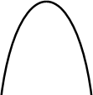 for *a* < 0

* To sketch the graph of a function, find the points where the graph intersects the axes.
* To find where the curve intersects the *y*-axis substitute *x* = 0 into the function.
* To find where the curve intersects the *x*-axis substitute *y* = 0 into the function.
* At the turning points of a graph the gradient of the curve is 0 and any tangents to the curve at these points are horizontal.
* To find the coordinates of the maximum or minimum point (turning points) of a quadratic curve (parabola) you can use the completed square form of the function.

### Examples

**Example 1** Sketch the graph of *y* = *x*2.

|  |  |
| --- | --- |
|  | The graph of *y* = *x*2 is a parabola. When *x* = 0, *y* = 0.  *a* = 1 which is greater than zero, so the graph has the shape: |

**Example 2** Sketch the graph of *y* = *x*2 − *x* − 6.

|  |  |
| --- | --- |
| When *x* = 0, *y* = 02 − 0 − 6 = −6  So the graph intersects the *y*-axis at  (0, −6)  When *y* = 0, *x*2 − *x* − 6 = 0  (*x* + 2)(*x* − 3) = 0  *x* = −2 or *x* = 3  So,  the graph intersects the *x*-axis at (−2, 0) and (3, 0)  *x*2 − *x* − 6 =  =  When ,  and , so the turning point is at the point  A picture containing line, diagram  Description automatically generated | **1** Find where the graph intersects the *y*-axis by substituting *x* = 0.  **2** Find where the graph intersects the *x*-axis by substituting *y* = 0.  **3** Solve the equation by factorising.  **4** Solve (*x* + 2) = 0 and (*x* − 3) = 0.  A black line on a white background  Description automatically generated with low confidence**5** *a* = 1 which is greater than zero, so the graph has the shape:  *(continued on next page)*  **6** To find the turning point, complete the square.  **7** The turning point is the minimum value for this expression and occurs when the term in the bracket is equal to zero. |

### Video tutorials

|  |
| --- |
| Sketching quadratic graphs |
|  |

*or click on the QR code to follow the hyperlink*

Practice

1. Sketch the graph of *y* = −*x*2.
2. Sketch each graph, labelling where the curve crosses the axes.

**a** *y* = (*x* + 2)(*x* − 1) **b** *y* = *x*(*x* − 3) **c** *y* = (*x* + 1)(*x* + 5)

1. Sketch each graph, labelling where the curve crosses the axes.

**a** *y* = *x*2 − *x* − 6 **b** *y* = *x*2 − 5*x* + 4 **c** *y* = *x*2 – 4

**d** *y* = *x*2 + 4*x* **e** *y* = 9 − *x*2 **f** *y* = *x*2 + 2*x* − 3

1. Sketch the graph of *y* = 2*x*2 + 5*x* − 3, labelling where the curve crosses the axes.

### Extend

1. Sketch each graph. Label where the curve crosses the axes and write down the coordinates of the turning point.

**a** *y* = *x*2 − 5*x* + 6 **b** *y* = −*x*2 + 7*x* − 12 **c** *y* = −*x*2 + 4*x*

1. Sketch the graph of *y* = *x*2 + 2*x* + 1. Label where the curve crosses the axes and write down the equation of the line of symmetry.

## Solving linear simultaneous equations by elimination

### Key points

* Two equations are simultaneous when they are both true at the same time.
* Solving simultaneous linear equations in two unknowns involves finding the value of each unknown which works for both equations.
* Make sure that the coefficient of one of the unknowns is the same in both equations.
* Eliminate this equal unknown by either subtracting or adding the two equations.

### Examples

**Example 1** Solve the simultaneous equations 3*x* + *y* = 5 and *x* + *y* = 1

|  |  |
| --- | --- |
| 3*x* + *y* = 5  *– x* + *y* = 1 2*x* = 4  So *x* = 2  Using *x* + *y* = 1  2 + *y* = 1  So *y* = −1  Check:  equation 1: 3 × 2 + (−1) = 5 YES  equation 2: 2 + (−1) = 1 YES | 1. Subtract the second equation from the first equation to eliminate the *y* term. 2. To find the value of *y*, substitute *x* = 2 into one of the original equations. 3. Substitute the values of *x* and *y* into both equations to check your answers. |

**Example 2** Solve *x* + 2*y* = 13 and 5*x* − 2*y* = 5 simultaneously.

|  |  |
| --- | --- |
| *x* + 2*y* = 13  + 5*x* − 2*y* = 5  6*x* = 18  So *x* = 3  Using *x* + 2*y* = 13  3 + 2*y* = 13  So *y* = 5  Check:  equation 1: 3 + 2 × 5 = 13 YES  equation 2: 5 × 3 − 2 × 5 = 5 YES | 1. Add the two equations together to eliminate the *y* term. 2. To find the value of *y*, substitute *x* = 3 into one of the original equations. 3. Substitute the values of *x* and *y* into both equations to check your answers. |

**Example 3** Solve 2*x* + 3*y* = 2 and 5*x* + 4*y* = 12 simultaneously.

|  |  |
| --- | --- |
| (2*x* + 3*y* = 2) × 4  8*x* + 12*y* = 8 (5*x* + 4*y* = 12) × 3  15*x* + 12*y* = 36  7*x* = 28  So *x* = 4  Using 2*x* + 3*y* = 2  2 × 4 + 3*y* = 2  So *y* = −2  Check:  equation 1: 2 × 4 + 3 × (−2) = 2 YES  equation 2: 5 × 4 + 4 × (−2) = 12 YES | 1. Multiply the first equation by 4 and the second equation by 3 to make the coefficient of *y* the same for both equations. Then subtract the first equation from the second equation to eliminate the *y* term. 2. To find the value of *y*, substitute *x* = 4 into one of the original equations. 3. Substitute the values of *x* and *y* into both equations to check your answers. |

### Video tutorials

|  |
| --- |
| Solving simultaneous equations by method of elimination |
|  |

*or click on the QR code to follow the hyperlink*

### Practice

Solve these simultaneous equations.

|  |  |  |  |
| --- | --- | --- | --- |
| **1** | 4*x* + *y* = 8  *x* + *y* = 5 | **2** | 3*x* + *y* = 7 3*x* + 2*y* = 5 |
| **3** | 4*x* + *y* = 3 3*x* – *y* = 11 | **4** | 3*x* + 4*y* = 7  *x* – 4*y* = 5 |
| **5** | 2*x* + *y* = 11  *x* – 3*y* = 9 | **6** | 2*x* + 3*y* = 11  3*x* + 2*y* = 4 |

## Solving linear simultaneous equations by substitution

### Key points

* + The subsitution method is the method most commonly used for A level. This is because it is the method used to solve linear and quadratic simultaneous equations.

### Examples

**Example 4** Solve the simultaneous equations *y* = 2*x* + 1 and 5*x* + 3*y* = 14

|  |  |
| --- | --- |
| 5*x* + 3(2*x* + 1) = 14  5*x* + 6*x* + 3 = 14  11*x* + 3 = 14  11*x* = 11  So *x* = 1  Using *y* = 2*x* + 1  *y* = 2 × 1 + 1  So *y* = 3  Check:  equation 1: 3 = 2 × 1 + 1 YES  equation 2: 5 × 1 + 3 × 3 = 14 YES | 1. Substitute 2*x* + 1 for *y* into the second equation. 2. Expand the brackets and simplify. 3. Work out the value of *x*. 4. To find the value of *y*, substitute *x* = 1 into one of the original equations. 5. Substitute the values of *x* and *y* into both equations to check your answers. |

**Example 5** Solve 2*x* − *y* = 16 and 4*x* + 3*y* = −3 simultaneously.

|  |  |
| --- | --- |
| *y* = 2*x* − 16  4*x* + 3(2*x* − 16) = −3  4*x* + 6*x* − 48 = −3  10*x* − 48 = −3  10*x* = 45  So *x* = 4 1  2  Using *y* = 2*x* − 16  *y* = 2 × 4 1 − 16  2  So *y* = −7  Check:  equation 1: 2 × 4 1 – (–7) = 16 YES  2  equation 2: 4 × 4 1 + 3 × (−7) = −3 YES  2 | 1. Rearrange the first equation. 2. Substitute 2*x* − 16 for *y* into the second equation. 3. Expand the brackets and simplify. 4. Work out the value of *x*. 5. To find the value of *y*, substitute   *x* = 4 1 into one of the original  2  equations.   1. Substitute the values of *x* and *y* into both equations to check your answers. |

### Video tutorials

|  |
| --- |
| Solving simultaneous equations by method of substitution |
|  |

*or click on the QR code to follow the hyperlink*

### Practice

Solve these simultaneous equations.

|  |  |  |  |
| --- | --- | --- | --- |
| **7** | *y* = *x* – 4  2*x* + 5*y* = 43 | **8** | *y* = 2*x* – 3 5*x* – 3*y* = 11 |
| **9** | 2*y* = 4*x* + 5  9*x* + 5*y* = 22 | **10** | 2*x* = *y* – 2  8*x* – 5*y* = –11 |
| **11** | 3*x* + 4*y* = 8  2*x* – *y* = –13 | **12** | 3*y* = 4*x* – 7  2*y* = 3*x* – 4 |
| **13** | 3*x* = *y* – 1 2*y* – 2*x* = 3 | **14** | 3*x* + 2*y* + 1 = 0  4*y* = 8 – *x* |

### Extend

**15** Solve the simultaneous equations 3*x* + 5*y* − 20 = 0 and 2(*x*  *y*)  3( *y*  *x*) .

4

## Solving linear and quadratic simultaneous equations

### Key points

* + Make one of the unknowns the subject of the linear equation (rearranging where necessary).
  + Use the linear equation to substitute into the quadratic equation.
  + There are usually two pairs of solutions.

### Examples

**Example 1** Solve the simultaneous equations *y* = *x* + 1 and *x*2 + *y*2 = 13

|  |  |
| --- | --- |
| *x*2 + (*x* + 1)2 = 13  *x*2 + *x*2 + *x* + *x* + 1 = 13 2*x*2 + 2*x* + 1 = 13  2*x*2 + 2*x* − 12 = 0 (2*x* − 4)(*x* + 3) = 0  So *x* = 2 or *x* = −3  Using *y* = *x* + 1  When *x* = 2, *y* = 2 + 1 = 3  When *x* = −3, *y* = −3 + 1 = −2  So the solutions are  *x* = 2, *y* = 3 and *x* = −3, *y* = −2  Check:  equation 1: 3 = 2 + 1 YES  and −2 = −3 + 1 YES  equation 2: 22 + 32 = 13 YES  and (−3)2 + (−2)2 = 13 YES | 1. Substitute *x* + 1 for *y* into the second equation. 2. Expand the brackets and simplify. 3. Factorise the quadratic equation. 4. Work out the values of *x*. 5. To find the value of *y*, substitute both values of *x* into one of the original equations. 6. Substitute both pairs of values of *x* and *y* into both equations to check your answers. |

**Example 2** Solve 2*x* + 3*y* = 5 and 2*y*2 + *xy* = 12 simultaneously.

|  |  |
| --- | --- |
| (*y* + 8)(*y* − 3) = 0  So *y* = −8 or *y* = 3  Using 2*x* + 3*y* = 5  When *y* = −8, 2*x* + 3 × (−8) = 5, *x* = 14.5  When *y* = 3, 2*x* + 3 × 3 = 5, *x* = −2  So the solutions are  *x* = 14.5, *y* = −8 and *x* = −2, *y* = 3  Check:  equation 1: 2 × 14.5 + 3 × (−8) = 5 YES  and 2 × (−2) + 3 × 3 = 5 YES  equation 2: 2×(−8)2 + 14.5×(−8) = 12 YES  and 2 × (3)2 + (−2) × 3 = 12 YES | **1** Rearrange the first equation.  **2** Substitute  for *x* into the second equation. Notice how it is easier to substitute for *x* than for *y*.  **3** Expand the brackets and simplify.  **4** Factorise the quadratic equation.  **5** Work out the values of *y*.  **6** To find the value of *x*, substitute both values of *y* into one of the original equations.  **7** Substitute both pairs of values of *x* and *y* into both equations to check your answers. |

### Video tutorials

|  |
| --- |
| Solving linear and quadratic simultaneous equations |
|  |

*or click on the QR code to follow the hyperlink*

### Practice

Solve these simultaneous equations.

|  |  |  |  |
| --- | --- | --- | --- |
| **1** | *y* = 2*x* + 1  *x*2 + *y*2 = 10 | **2** | *y* = 6 − *x*  *x*2 + *y*2 = 20 |
| **3** | *y* = *x* – 3  *x*2 + *y*2 = 5 | **4** | *y* = 9 − 2*x x*2 + *y*2 = 17 |
| **5** | *y* = 3*x* – 5  *y* = *x*2 − 2*x* + 1 | **6** | *y* = *x* − 5  *y* = *x*2 − 5*x* − 12 |
| **7** | *y* = *x* + 5  *x*2 + *y*2 = 25 | **8** | *y* = 2*x* – 1  *x*2 + *xy* = 24 |
| **9** | *y* = 2*x*  *y*2 – *xy* = 8 | **10** | 2*x* + *y* = 11  *xy* = 15 |

### Extend

**11** *x* – *y* = 1 **12** *y* – *x* = 2

*x*2 + *y*2 = 3 *x*2 + *xy* = 3

## Solving simultaneous equations graphically

### Key points

* You can solve any pair of simultaneous equations by drawing the graph of both equations and finding the point/points of intersection.

### Examples

**Example 1** Solve the simultaneous equations *y* = 5*x* + 2 and *x* + *y* = 5 graphically.

|  |  |
| --- | --- |
| *y* = 5 – *x*  *y* = 5 – *x* has gradient –1 and *y*-intercept 5.  *y* = 5*x* + 2 has gradient 5 and *y*-intercept 2.    Lines intersect at  *x* = 0.5, *y* = 4.5  Check:  First equation *y* = 5*x* + 2:  4.5 = 5 × 0.5 + 2 YES  Second equation *x* + *y* = 5:  0.5 + 4.5 = 5 YES | 1. Rearrange the equation *x* + *y* = 5 to make *y* the subject. 2. Plot both graphs on the same grid using the gradients and   *y*-intercepts.   1. The solutions of the simultaneous equations are the point of intersection. 2. Check your solutions by substituting the values into both equations. |

**Example 2** Solve the simultaneous equations *y* = *x* − 4 and *y* = *x*2 − 4*x* + 2 graphically.

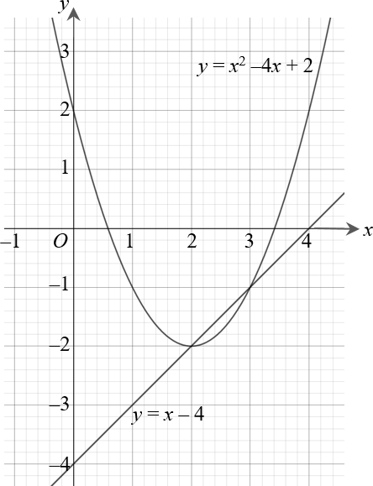

The line and curve intersect at

*x* = 3, *y* = −1 and *x* = 2, *y* = −2

Check:

First equation *y* = *x* − 4:

−1 = 3 − 4 YES

−2 = 2 − 4 YES

Second equation *y* = *x*2 − 4*x* + 2:

−1 = 32 − 4 × 3 + 2 YES

−2 = 22 − 4 × 2 + 2 YES

1. The solutions of the simultaneous equations are the points of intersection.
2. Check your solutions by substituting the values into both equations.
3. Plot the graph.
4. Plot the linear graph on the same grid using the gradient and

*y*-intercept.

*y* = *x* – 4 has gradient 1 and

*y*-intercept –4.

**1** Construct a table of values and calculate the points for the quadratic equation.

|  |  |  |  |  |  |
| --- | --- | --- | --- | --- | --- |
| ***x*** | 0 | 1 | 2 | 3 | 4 |
| ***y*** | 2 | –1 | –2 | –1 | 2 |

### Video tutorials

|  |
| --- |
| Solving simultaneous equations graphically |
|  |

*or click on the QR code to follow the hyperlink*

### Practice

1. Solve these pairs of simultaneous equations graphically.
   1. *y* = 3*x* − 1 and *y* = *x* + 3
   2. *y* = *x* − 5 and *y* = 7 − 5*x*
   3. *y* = 3*x* + 4 and *y* = 2 − *x*
2. Solve these pairs of simultaneous equations graphically.

**Hint**

Rearrange the equation to make *y* the

* 1. *x* + *y* = 0 and *y* = 2*x* + 6
  2. 4*x* + 2*y* = 3 and *y* = 3*x* − 1
  3. 2*x* + *y* + 4 = 0 and 2*y* = 3*x* − 1

1. Solve these pairs of simultaneous equations graphically.
   1. *y* = *x* − 1 and *y* = *x*2 − 4*x* + 3
   2. *y* = 1 − 3*x* and *y* = *x*2 − 3*x* − 3
   3. *y* = 3 − *x* and *y* = *x*2 + 2*x* + 5
2. Solve the simultaneous equations *x* + *y* = 1 and *x*2 + *y*2 = 25 graphically.

### Extend

1. **a** Solve the simultaneous equations 2*x* + *y* = 3 and *x*2 + *y* = 4
2. graphically
3. algebraically to 2 decimal places.
4. Which method gives the more accurate solutions? Explain your answer.

## Linear inequalities

### Key points

* Solving linear inequalities uses similar methods to those for solving linear equations.
* When you multiply or divide an inequality by a negative number you need to reverse the inequality sign, e.g. < becomes >.

### Examples

**Example 1** Solve −8 ≤ 4*x* < 16

|  |  |
| --- | --- |
| −8 ≤ 4*x* < 16  −2 ≤ *x* < 4 | Divide all three terms by 4. |

**Example 2** Solve 4 ≤ 5*x* < 10

|  |  |
| --- | --- |
| 4 ≤ 5*x* < 10  4 ≤ *x* < 2  5 | Divide all three terms by 5. |

**Example 3** Solve 2*x* − 5 < 7

|  |  |
| --- | --- |
| 2*x* − 5 < 7  2*x* < 12  *x* < 6 | 1. Add 5 to both sides. 2. Divide both sides by 2. |

**Example 4** Solve 2 − 5*x* ≥ −8

|  |  |
| --- | --- |
| 2 − 5*x* ≥ −8  −5*x* ≥ −10  *x* ≤ 2 | 1. Subtract 2 from both sides. 2. Divide both sides by −5. Remember to reverse the inequality when dividing by a negative number. |

**Example 5** Solve 4(*x* − 2) > 3(9 − *x*)

|  |  |
| --- | --- |
| 4(*x* − 2) > 3(9 − *x*)  4*x* − 8 > 27 − 3*x*  7*x* − 8 > 27  7*x* > 35  *x* > 5 | 1. Expand the brackets. 2. Add 3*x* to both sides. 3. Add 8 to both sides. 4. Divide both sides by 7. |

### Video tutorials

|  |  |
| --- | --- |
| Solving inequalities with one sign | Solving inequalities with two signs |
|  |  |

*or click on the QR code to follow the hyperlink*

### Practice

1. Solve these inequalities.

**a** 4*x* > 16 **b** 5*x* – 7 ≤ 3 **c** 1 ≥ 3*x* + 4

1. 5 – 2*x* < 12 **e**

*x*  5

2

**f** 8 < 3 – *x*

3

1. Solve these inequalities.
   1. *x*  4 5
   2. 10 ≥ 2*x* + 3 **c** 7 – 3*x* > –5
2. Solve

**a** 2 – 4*x* ≥ 18 **b** 3 ≤ 7*x* + 10 < 45 **c** 6 – 2*x* ≥ 4

**d** 4*x* + 17 < 2 – *x* **e** 4 – 5*x* < –3*x* **f** –4*x* ≥ 24

1. Solve these inequalities.

**a** 3*t* + 1 < *t* + 6 **b** 2(3*n* – 1) ≥ *n* + 5

1. Solve.

**a** 3(2 – *x*) > 2(4 – *x*) + 4 **b** 5(4 – *x*) > 3(5 – *x*) + 2

### Extend

1. Find the set of values of *x* for which 2*x* + 1 > 11 and 4*x* – 2 > 16 – 2*x*.

## Quadratic inequalities

### Key points

* + First replace the inequality sign by = and solve the quadratic equation.
  + Sketch the graph of the quadratic function.
  + Use the graph to find the values which satisfy the quadratic inequality.

### Examples

**Example 1** Find the set of values of *x* which satisfy *x*2 + 5*x* + 6 > 0

|  |  |
| --- | --- |
| *x*2 + 5*x* + 6 = 0  (*x* + 3)(*x* + 2) = 0  *x* = −3 or *x* = −2    *x* < −3 or *x* > −2 | 1. Solve the quadratic equation by factorising. 2. Sketch the graph of   *y* = (*x* + 3)(*x* + 2)   1. Identify on the graph where   *x*2 + 5*x* + 6 > 0, i.e. where *y* > 0   1. Write down the values which satisfy the inequality *x*2 + 5*x* + 6 > 0 |

**Example 2** Find the set of values of *x* which satisfy *x*2 − 5*x* ≤ 0

|  |  |
| --- | --- |
| *x*2 − 5*x* = 0  *x*(*x* − 5) = 0  *x* = 0 or *x* = 5    0 ≤ *x* ≤ 5 | 1. Solve the quadratic equation by factorising. 2. Sketch the graph of *y* = *x*(*x* − 5) 3. Identify on the graph where   *x*2 − 5*x* ≤ 0, i.e. where *y* ≤ 0   1. Write down the values which satisfy the inequality *x*2 − 5*x* ≤ 0 |

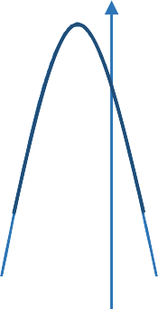**Example 3** Find the set of values of *x* which satisfy −*x*2 − 3*x* + 10 ≥ 0

|  |  |
| --- | --- |
| −*x*2 − 3*x* + 10 = 0  (−*x* + 2)(*x* + 5) = 0  *x* = 2 or *x* = −5  ***y***  **–5 *O* 2 *x***  −5 ≤ *x* ≤ 2 | 1. Solve the quadratic equation by factorising. 2. Sketch the graph of   *y* = (−*x* + 2)(*x* + 5) = 0   1. Identify on the graph where   −*x*2 − 3*x* + 10 ≥ 0, i.e. where *y* ≥ 0  **3** Write down the values which satisfy the inequality −*x*2 − 3*x* + 10 ≥ 0 |

### Video tutorials

|  |
| --- |
| Quadratic inequalities |
|  |

*or click on the QR code to follow the hyperlink*

### Practice

1. Find the set of values of *x* for which (*x* + 7)(*x* – 4) ≤ 0
2. Find the set of values of *x* for which *x*2 – 4*x* – 12 ≥ 0
3. Find the set of values of *x* for which 2*x*2 –7*x* + 3 < 0
4. Find the set of values of *x* for which 4*x*2 + 4*x* – 3 > 0
5. Find the set of values of *x* for which 12 + *x* – *x*2 ≥ 0

### Extend

Find the set of values which satisfy the following inequalities.

1. *x*2 + *x* ≤ 6
2. *x*(2*x* – 9) < –10
3. 6*x*2 ≥ 15 + *x*

## Sketching cubic and reciprocal graphs

### Key points

* + The graph of a cubic function, which can be written in the form *y* = *ax*3 + *bx*2 + *cx* + *d*, where *a* ≠ 0, has one of the shapes shown here.
  + 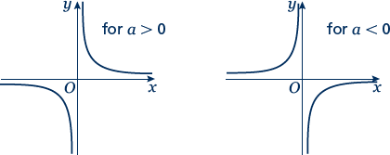The graph of a reciprocal

function of the form

*y*  *a*

*x*

has

one of the shapes shown here.

* + To sketch the graph of a function, find the points where the graph intersects the axes.
  + To find where the curve intersects the *y*-axis substitute *x* = 0 into the function.
  + To find where the curve intersects the *x*-axis substitute *y* = 0 into the function.
  + Where appropriate, mark and label the asymptotes on the graph.
  + Asymptotes are lines (usually horizontal or vertical) which the curve gets closer to but never touches or crosses. Asymptotes usually occur with reciprocal functions.

For example, the asymptotes for the graph of (the lines *y* = 0 and *x* = 0).

*y*  *a*

*x*

are the two axes

* + At the turning points of a graph the gradient of the curve is 0 and any tangents to the curve at these points are horizontal.
  + A double root is when two of the solutions are equal. For example (*x* – 3)2(*x* + 2) has a double root at *x* = 3.
  + When there is a double root, this is one of the turning points of a cubic function.

### Examples

**Example 1** Sketch the graph of *y* = (*x* − 3)(*x* − 1)(*x* + 2)

|  |  |
| --- | --- |
| To sketch a cubic curve find intersects with both axes and use the key points above for the correct shape. | |
| When *x* = 0, *y* = (0 − 3)(0 − 1)(0 + 2)  = (−3) × (−1) × 2 = 6  The graph intersects the *y*-axis at (0, 6)  When *y* = 0, (*x* − 3)(*x* − 1)(*x* + 2) = 0  So *x* = 3, *x* = 1 or *x* = −2  The graph intersects the *x*-axis at (−2, 0), (1, 0) and (3, 0) | 1. Find where the graph intersects the axes by substituting *x* = 0 and *y* = 0. Make sure you get the coordinates the right way around, (*x*, *y*). 2. Solve the equation by solving   *x* − 3 = 0, *x* − 1 = 0 and *x* + 2 = 0   1. Sketch the graph.   *a* = 1 > 0 so the graph has the shape: |

**Example 2** Sketch the graph of *y* = (*x* + 2)2(*x* − 1)

|  |  |
| --- | --- |
| To sketch a cubic curve find intersects with both axes and use the key points above for the correct shape. | |
| When *x* = 0, *y* = (0 + 2)2(0 − 1)  = 22 × (−1) = −4  The graph intersects the *y*-axis at (0, −4)  When *y* = 0, (*x* + 2)2(*x* − 1) = 0  So *x* = −2 or *x* =1  (−2, 0) is a turning point as *x* = −2 is a double root.  The graph crosses the *x*-axis at (1, 0) | 1. Find where the graph intersects the axes by substituting *x* = 0 and *y* = 0. 2. Solve the equation by solving   *x* + 2 = 0 and *x* − 1 = 0   1. *a* = 1 > 0 so the graph has the shape: |

### Video tutorials

|  |  |
| --- | --- |
| Cubic graphs | Reciprocal graphs |
|  |  |

*or click on the QR code to follow the hyperlink*

### Practice

**1** Here are six equations.

**Hint**

Find where each of the cubic equations cross the *y*-axis.

5

**A** *y*  **B** *y* = *x*2 + 3*x* – 10 **C** *y* = *x*3 + 3*x*2

*x*

**D** *y* = 1 – 3*x*2 – *x*3 **E** *y* = *x*3 – 3*x*2 – 1 **F** *x* + *y* = 5

Here are six graphs.

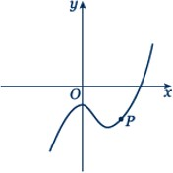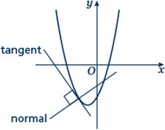**i ii iii**

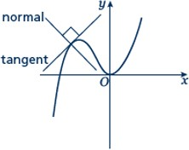

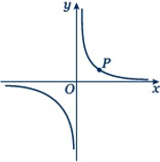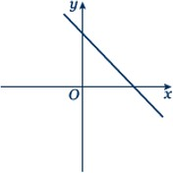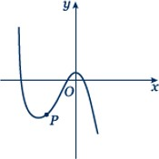**iv v vi**

1. Match each graph to its equation.
2. Copy the graphs ii, iv and vi and draw the tangent and normal each at point *P*.

Sketch the following graphs

|  |  |  |  |
| --- | --- | --- | --- |
| **2** | *y* = 2*x*3 | **3** | *y* = *x*(*x* – 2)(*x* + 2) |
| **4** | *y* = (*x* + 1)(*x* + 4)(*x* – 3) | **5** | *y* = (*x* + 1)(*x* – 2)(1 – *x*) |
| **6** | *y* = (*x* – 3)2(*x* + 1) | **7** | *y* = (*x* – 1)2(*x* – 2) |

**8** *y* = 3

*x*

**9** *y* =  2

*x*

### Extend

*a*

**Hint:** Look at the shape of *y* = *x*

in the second key point.

1

1

1. Sketch the graph of

*y*  *x*  2

1. Sketch the graph of

*y*  *x* 1

## Translating graphs

### Key points

* The transformation *y* = f(*x*) ± *a* is a translation of *y* = f(*x*) parallel to the *y*-axis; it is a vertical translation.

As shown on the graph,

* + *y* = f(*x*) + *a* translates *y* = f(*x*) up
  + *y* = f(*x*) – *a* translates *y* = f(*x*) down.
* 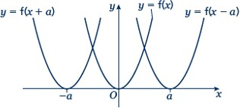The transformation *y =* f(*x ± a*) is a translation of *y* = f(*x*) parallel to the *x*-axis; it is a horizontal translation.

As shown on the graph,

* + *y* = f(*x* + *a*) translates *y* = f(*x*) to the left
  + *y* = f(*x* – *a*) translates *y* = f(*x*) to the right.

### Examples

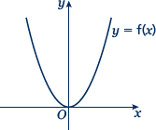**Example 1** The graph shows the function *y* = f(*x*).

Sketch the graph of *y* = f(*x*) + 2.

|  |  |
| --- | --- |
|  | For the function *y* = f(*x*) + 2 translate the function *y* = f(*x*) 2 units up. |

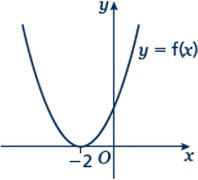**Example 2** The graph shows the function *y* = f(*x*).

Sketch the graph of *y* = f(*x* − 3).

|  |  |
| --- | --- |
|  | For the function *y* = f(*x* − 3) translate the function *y* = f(*x*) 3 units right. |

### Video tutorials

|  |
| --- |
| Transformations of graphs |
|  |

*or click on the QR code to follow the hyperlink*

### Practice

1. The graph shows the function *y* = f(*x*).

Copy the graph and on the same axes sketch and label the graphs of *y* = f(*x*) + 4 and *y* = f(*x* + 2).

1. 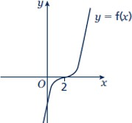The graph shows the function *y* = f(*x*).

Copy the graph and on the same axes sketch and label the graphs of *y* = f(*x* + 3) and *y* = f(*x*) – 3.

1. The graph shows the function *y* = f(*x*).

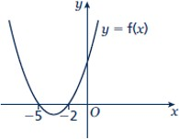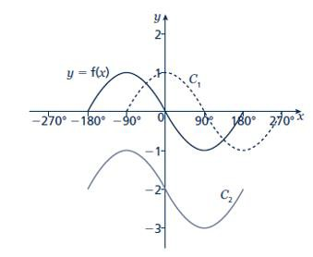

Copy the graph and on the same axes sketch the graph of *y* = f(*x* – 5).

1. The graph shows the function *y* = f(*x*) and two transformations of *y* = f(*x*), labelled *C*1 and *C*2. Write down the equations of the translated curves *C*1 and *C*2 in function form.
2. 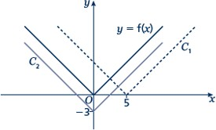The graph shows the function *y* = f(*x*) and two transformations of *y* = f(*x*), labelled *C*1 and *C*2. Write down the equations of the translated curves *C*1 and *C*2 in function form.
3. 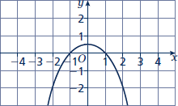The graph shows the function *y* = f(*x*).
   1. Sketch the graph of *y* = f(*x*) + 2
   2. Sketch the graph of *y* = f(*x* + 2)

## Stretching graphs

### Key points

* + The transformation *y* = f(*ax*) is a horizontal stretch of *y* = f(*x*) with scale

factor 1

*a*

parallel to the *x*-axis.

* + 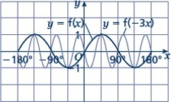The transformation *y* = f(–*ax*) is a horizontal stretch of *y* = f(*x*) with scale

factor 1

*a*

parallel to the *x*-axis and then a

reflection in the *y*-axis.

* + 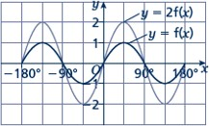The transformation *y* = *a*f(*x*) is a vertical stretch of *y* = f(*x*) with scale factor *a* parallel to the *y*-axis.
  + 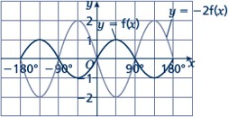The transformation *y* = –*a*f(*x*) is a vertical stretch of *y* = f(*x*) with scale factor *a* parallel to the *y*-axis and then a reflection in the *x*-axis.

### Examples

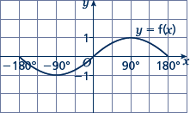**Example 3** The graph shows the function *y* = f(*x*).

Sketch and label the graphs of

*y* = 2f(*x*) and *y* = –f(*x*).

|  |  |
| --- | --- |
|  | The function *y* = 2f(*x*) is a vertical stretch of *y* = f(*x*) with scale factor 2 parallel to the *y*-axis.  The function *y* = −f(*x*) is a reflection of *y* = f(*x*) in the *x*-axis. |

**Example 4** The graph shows the function *y* = f(*x*).

Sketch and label the graphs of

*y* = f(2*x*) and *y* = f(–*x*).

|  |  |
| --- | --- |
|  | The function *y* = f(2*x*) is a horizontal stretch of *y* = f(*x*) with scale factor  1 parallel to the *x*-axis.  2  The function *y* = f(−*x*) is a reflection of *y* = f(*x*) in the *y*-axis. |

### Video tutorials

|  |
| --- |
| Transformations of graphs |
|  |

*or click on the QR code to follow the hyperlink*

### Practice

1. 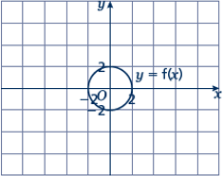The graph shows the function *y* = f(*x*).
2. Copy the graph and on the same axes sketch and label the graph of *y* = 3f(*x*).
3. Make another copy of the graph and on the same axes sketch and label the graph of *y* = f(2*x*).
4. 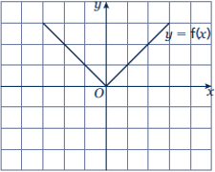The graph shows the function *y* = f(*x*). Copy the graph and on the same axes sketch and label the graphs of

*y* = –2f(*x*) and *y* = f(3*x*).

1. 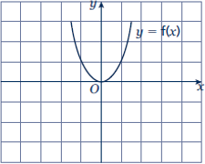The graph shows the function *y* = f(*x*). Copy the graph and, on the same axes, sketch and label the graphs of

*y* = –f(*x*) and *y* = f  1 *x* .

2

1. 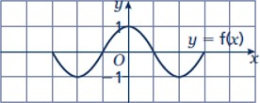The graph shows the function *y* = f(*x*). Copy the graph and, on the same axes, sketch the graph of *y* = –f(2*x*).
2. 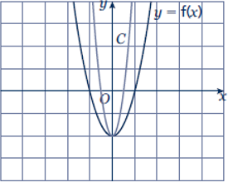The graph shows the function *y* = f(*x*) and a transformation, labelled *C*.

Write down the equation of the translated curve *C* in function form.

1. 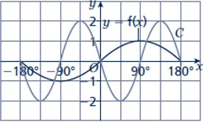The graph shows the function *y* = f(*x*) and a transformation labelled *C*.

Write down the equation of the translated curve *C* in function form.

1. 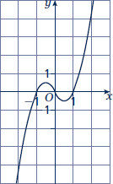The graph shows the function *y* = f(*x*).
2. Sketch the graph of *y* = −f(*x*).
3. Sketch the graph of *y* = 2f(*x*).

### Extend

1. **a** Sketch and label the graph of *y* = f(*x*), where f(*x*) = (*x* – 1)(*x* + 1).
2. On the same axes, sketch and label the graphs of *y* = f(*x*) – 2 and *y* = f(*x* + 2).
3. **a** Sketch and label the graph of *y* = f(*x*), where f(*x*) = –(*x* + 1)(*x* – 2).
4. On the same axes, sketch and label the graph of *y* = f  1 *x* .

2

## Straight line graphs

## Key points

* + A straight line has the equation *y* = *mx* + *c*, where *m* is the gradient and *c* is the *y*-intercept (where *x* = 0).
  + The equation of a straight line can be written in the form *ax* + *by* + *c* = 0, where *a*, *b* and *c* are integers.
  + When given the coordinates (*x*1, *y*1) and (*x*2, *y*2) of two points on a line the gradient is calculated using the

formula *m*  *y*2  *y*1

*x*2  *x*1

## Examples

**Example 1** A straight line has gradient  1

2

and *y*-intercept 3.

Write the equation of the line in the form *ax* + *by* + *c* = 0.

|  |  |
| --- | --- |
| *m* =  1 and *c* = 3  2  So *y* =  1 *x* + 3  2  1 *x* + *y* – 3 = 0  2  *x* + 2*y* − 6 = 0 | 1. A straight line has equation   *y* = *mx* + *c*. Substitute the gradient and *y*-intercept given in the question into this equation.   1. Rearrange the equation so all the terms are on one side and 0 is on the other side. 2. Multiply both sides by 2 to eliminate the denominator. |

**Example 2** Find the gradient and the *y*-intercept of the line with the equation 3*y* − 2*x* + 4 = 0.

|  |  |
| --- | --- |
| 3*y* − 2*x* + 4 = 0  3*y* = 2*x* − 4  *y*  2 *x*  4  3 3  Gradient = *m* = 2  3  *y*-intercept = *c* =  4  3 | 1. Make *y* the subject of the equation. 2. Divide all the terms by three to get the equation in the form *y* = … 3. In the form *y* = *mx* + *c*, the gradient is *m* and the *y*-intercept is *c*. |

**Example 3** Find the equation of the line which passes through the point (5, 13) and has gradient 3.

|  |  |
| --- | --- |
| *m* = 3  *y* = 3*x* + *c*  13 = 3 × 5 + *c*  13 = 15 + *c*  *c* = −2  *y* = 3*x* − 2 | 1. Substitute the gradient given in the question into the equation of a straight line *y* = *mx* + *c*. 2. Substitute the coordinates *x* = 5 and   *y* = 13 into the equation.   1. Simplify and solve the equation. 2. Substitute *c* = −2 into the equation   *y* = 3*x* + *c* |

**Example 4** Find the equation of the line passing through the points with coordinates (2, 4) and (8, 7).

|  |  |
| --- | --- |
| *x*1  2 , *x*2  8 , *y*1  4 and *y*2  7  *m*  *y*2  *y*1  7  4  3  1  *x*2  *x*1 8  2 6 2  *y*  1 *x*  *c*  2  4  1  2  *c*  2  *c* = 3  *y*  1 *x*  3  2 | 1. Substitute the coordinates into the equation *m*  *y*2  *y*1 to work out   *x*2  *x*1  the gradient of the line.   1. Substitute the gradient into the equation of a straight line   *y* = *mx* + *c*.   1. Substitute the coordinates of either point into the equation. 2. Simplify and solve the equation. 3. Substitute *c* = 3 into the equation   *y*  1 *x*  *c*  2 |

### Video tutorials

|  |  |
| --- | --- |
| *y* = *mx* + *c* | Finding the equation of a line |
|  |  |

*or click on the QR code to follow the hyperlink*

## Practice

1. Find the gradient and the *y*-intercept of the following equations.

|  |  |  |  |
| --- | --- | --- | --- |
| **a** | *y* = 3*x* + 5 | **b** | *y* =  1 *x* – 7  2 |
| **c**  **e** | 2*y* = 4*x* – 3  2*x* – 3*y* – 7 = 0 | **d**  **f** | *x* + *y* = 5  5*x* + *y* – 4 = 0 |

**Hint**

Rearrange the equations to the form *y* = *mx* + *c*

1. Copy and complete the table, giving the equation of the line in the form *y* = *mx* + *c*.

|  |  |  |
| --- | --- | --- |
| **Gradient** | ***y*-intercept** | **Equation of the line** |
| 5 | 0 |  |
| –3 | 2 |  |
| 4 | –7 |  |

1. Find, in the form *ax* + *by* + *c* = 0 where *a*, *b* and *c* are integers, an equation for each of the lines with the following gradients and *y*-intercepts.

**a** gradient  1 , *y*-intercept –7 **b** gradient 2, *y*-intercept 0

2

1. gradient 2 , *y*-intercept 4 **d** gradient –1.2, *y*-intercept –2

3

1. Write an equation for the line which passes though the point (2, 5) and has gradient 4.
2. Write an equation for the line which passes through the point (6, 3) and has gradient  2

3

1. Write an equation for the line passing through each of the following pairs of points.

|  |  |  |  |
| --- | --- | --- | --- |
| **a** | (4, 5), (10, 17) | **b** | (0, 6), (–4, 8) |
| **c** | (–1, –7), (5, 23) | **d** | (3, 10), (4, 7) |

## Extend

1. The equation of a line is 2*y* + 3*x* – 6 = 0.

Write as much information as possible about this line.

2 2

## Parallel and perpendicular lines

### Key points

* When lines are parallel they have the same gradient.
* A line perpendicular to the line with

equation *y* = *mx* + *c* has gradient  1 .

*m*

### Examples

**Example 1** Find the equation of the line parallel to *y* = 2*x* + 4 which passes through the point (4, 9).

|  |  |
| --- | --- |
| *y* = 2*x* + 4  *m* = 2  *y* = 2*x* + *c*  9 = 2 × 4 + *c*  9 = 8 + *c*  *c* = 1  *y* = 2*x* + 1 | 1. As the lines are parallel they have the same gradient. 2. Substitute *m* = 2 into the equation of a straight line *y* = *mx* + *c*. 3. Substitute the coordinates into the equation *y* = 2*x* + *c* 4. Simplify and solve the equation. 5. Substitute *c* = 1 into the equation   *y* = 2*x* + *c* |

**Example 2** Find the equation of the line perpendicular to *y* = 2*x* − 3 which passes through   
the point (−2, 5).

|  |  |
| --- | --- |
| *y* = 2*x* − 3  *m* = 2        5 = 1 + *c*  *c* = 4 | **1** As the lines are perpendicular, the gradient of the perpendicular line  is .  **2** Substitute *m* =  into *y* = *mx* + *c*.  **3** Substitute the coordinates (–2, 5) into the equation  **4** Simplify and solve the equation.  **5** Substitute *c* = 4 into . |

**Example 3** A line passes through the points (0, 5) and (9, −1).  
Find the equation of the line which is perpendicular to the line and passes through   
its midpoint.

|  |  |
| --- | --- |
| , ,  and        Midpoint = | **1** Substitute the coordinates into the equation  to work out the gradient of the line.  **2** As the lines are perpendicular, the gradient of the perpendicular line  is .  **3** Substitute the gradient into the equation *y* = *mx* + *c*.  **4** Work out the coordinates of the midpoint of the line.  **5** Substitute the coordinates of the midpoint into the equation.  **6** Simplify and solve the equation.  **7** Substitute  into the equation . |

### Video tutorials

|  |  |
| --- | --- |
| Parallel lines | Perpendicular lines |
|  |  |

*or click on the QR code to follow the hyperlink*

### Practice

1. Find the equation of the line parallel to each of the given lines and which passes through each of the given points.

|  |  |  |  |
| --- | --- | --- | --- |
| **a** | *y* = 3*x* + 1 (3, 2) | **b** | *y* = 3 – 2*x* (1, 3) |
| **c** | 2*x* + 4*y* + 3 = 0 (6, –3) | **d** | 2*y* –3*x* + 2 = 0 (8, 20) |

1. Find the equation of the line perpendicular to *y* = 1 *x* – 3 which

**Hint**

If *m* = *a* then the

*b*

negative reciprocal

− 1   *b*

*m a*

2

passes through the point (–5, 3).

1. Find the equation of the line perpendicular to each of the given lines and which passes through each of the given points.

**a** *y* = 2*x* – 6 (4, 0) **b** *y* =  1 *x* + 1

(2, 13)

3 2

1. *x* –4*y* – 4 = 0 (5, 15) **d** 5*y* + 2*x* – 5 = 0 (6, 7)
2. In each case find an equation for the line passing through the origin which is also perpendicular to the line joining the two points given.

**a** (4, 3), (–2, –9) **b** (0, 3), (–10, 8)

### Extend

1. Work out whether these pairs of lines are parallel, perpendicular or neither.

|  |  |  |  |  |  |
| --- | --- | --- | --- | --- | --- |
| **a** | *y* = 2*x* + 3  *y* = 2*x* – 7 | **b** | *y* = 3*x*  2*x + y* – 3 = 0 | **c** | *y* = 4*x* – 3 4*y* + *x* = 2 |
| **d** | 3*x* – *y* + 5 = 0  *x* + 3*y* = 1 | **e** | 2*x* + 5*y* – 1 = 0  *y* = 2*x* + 7 | **f** | 2*x* – *y* = 6  6*x* – 3*y* + 3 = 0 |

1. The straight line **L1** passes through the points *A* and *B* with coordinates (–4, 4) and (2, 1), respectively.
   1. Find the equation of **L1** in the form *ax* + *by* + *c* = 0

The line **L2** is parallel to the line **L1** and passes through the point *C* with coordinates (–8, 3).

* 1. Find the equation of **L2** in the form *ax* + *by* + *c* = 0

The line **L3** is perpendicular to the line **L1** and passes through the origin.

* 1. Find an equation of **L3**

## Volume and surface area of 3D solids

### Key points

* + Volume of a prism = cross-sectional area × length.
  + The surface area of a 3D shape is the total area of all its faces.
  + Volume of a pyramid = 1

3

× area of base × vertical height.

* + 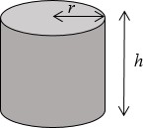Volume of a cylinder = *πr*2*h*
  + Total surface area of a cylinder = 2*πr*2 + 2*πrh*
  + Volume of a sphere =

4 ** *r*3

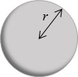3

* + 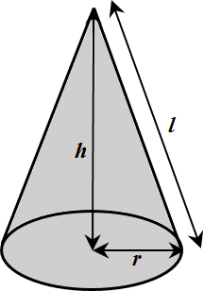Surface area of a sphere = 4*πr*2
  + Volume of a cone = 1 ** *r* 2*h*

3

* + Total surface area of a cone = *πrl* + *πr*2

### Examples

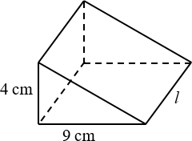**Example 1** The triangular prism has volume 504 cm3.

Work out its length.

|  |  |
| --- | --- |
| *V* = 1 *bhl*  2  504 = 1 × 9 × 4 × *l*  2  504 = 18 × *l*  *l* = 504 ÷ 18  = 28 cm | 1. Write out the formula for the volume of a triangular prism. 2. Substitute known values into the formula. 3. Simplify 4. Rearrange to work out *l*. 5. Remember the units. |

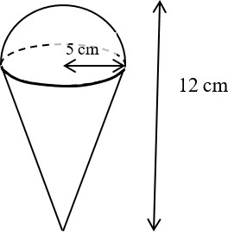**Example 2** Calculate the volume of the 3D solid.

Give your answer in terms of *π*.

|  |  |
| --- | --- |
| Total volume = volume of hemisphere  + Volume of cone  = 1 of 4 *πr*3 + 1 *πr*2*h*  2 3 3  Total volume = 1 × 4 × *π ×* 53  2 3  + 1 × *π ×* 52 × 7  3  425  = 3 *π* cm3 | 1. The solid is made up of a hemisphere radius 5 cm and   a cone with radius 5 cm and height 12 − 5 = 7 cm.   1. Substitute the measurements into the formula for the total volume. 2. Remember the units. |

### Video tutorials

|  |  |
| --- | --- |
| Volume of a cube/cuboid | Volume of a cylinder |
|  |  |
| Volume of a cone | Volume of a sphere |
|  |  |
| Surface area of cube/cuboid | Surface area of a cylinder |
|  |  |
| Surface area of a cone | Surface area of a sphere |
|  |  |

*or click on the QR code to follow the hyperlink*

### Practice

1. Work out the volume of each solid.

Leave your answers in terms of *π* where appropriate.

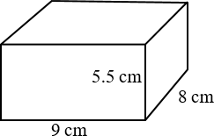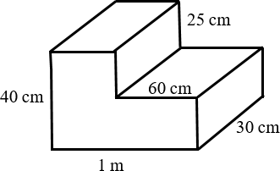**a b**

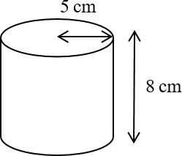**c d**

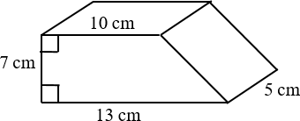

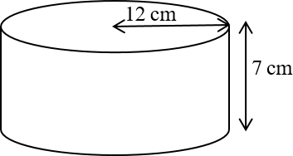**e f** a sphere with radius 7 cm

**g** a sphere with diameter 9 cm **h** a hemisphere with radius 3 cm

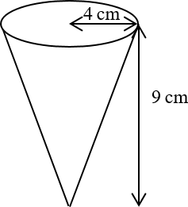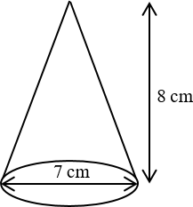**i j**

1. A cuboid has width 9.5 cm, height 8 cm and volume 1292 cm3. Work out its length.
2. 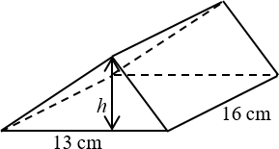The triangular prism has volume 1768 cm3. Work out its height.

### Extend

1. 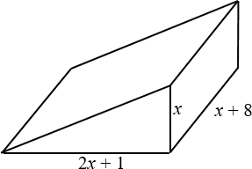The diagram shows a solid triangular prism. All the measurements are in centimetres. The volume of the prism is *V* cm3.

Find a formula for *V* in terms of *x*. Give your answer in simplified form.

1. 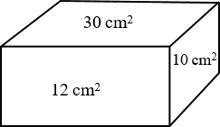The diagram shows the area of each of three faces of a cuboid.

The length of each edge of the cuboid is a whole number of centimetres.

Work out the volume of the cuboid.

1. 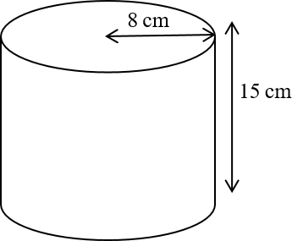The diagram shows a large catering size tin of beans in the shape of a cylinder.

The tin has a radius of 8 cm and a height of 15 cm. A company wants to make a new size of tin.

The new tin will have a radius of 6.7 cm.

It will have the same volume as the large tin. Calculate the height of the new tin.

Give your answer correct to one decimal place.

1. 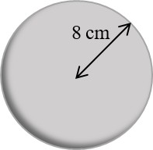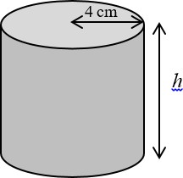The diagram shows a sphere and a solid cylinder. The sphere has radius 8 cm.

The solid cylinder has a base radius of 4 cm and a height of *h* cm.

The total surface area of the cylinder is half the total surface area of the sphere.

Work out the ratio of the volume of the sphere to the volume of the cylinder.

Give your answer in its simplest form.

1. 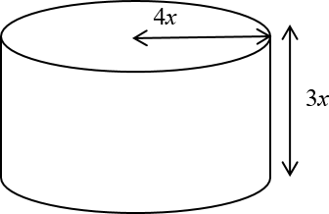The diagram shows a solid metal cylinder. The cylinder has base radius 4*x* and height 3*x*.

The cylinder is melted down and made into a sphere of radius *r*.

Find an expression for *r* in terms of *x*.



## Pythagoras’ theorem

### Key points

* + In a right-angled triangle the longest side is called the hypotenuse.
  + 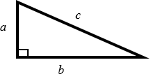Pythagoras’ theorem states that for a right-angled triangle the square of the hypotenuse is equal to the sum of the squares of the other two sides.

*c*2 = *a*2 + *b*2

### Examples

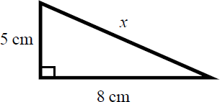**Example 1** Calculate the length of the hypotenuse.

Give your answer to 3 significant figures.

|  |  |
| --- | --- |
| *c*2 = *a*2 + *b*2    *x*2 = 52 + 82  *x*2 = 25 + 64  *x*2 = 89  *x*  89  *x* = 9.433 981 13...  *x* = 9.43 cm | 1. Always start by stating the formula for Pythagoras’ theorem and labelling the hypotenuse *c* and the other two sides *a* and *b*. 2. Substitute the values of *a*, *b* and *c* into the formula for Pythagoras' theorem. 3. Use a calculator to find the square root. 4. Round your answer to 3 significant figures and write the units with your answer. |

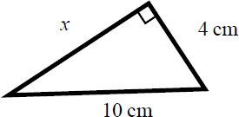**Example 2** Calculate the length *x*.

Give your answer in surd form.

|  |  |
| --- | --- |
| *c*2 = *a*2 + *b*2  102 = *x*2 + 42  100 = *x*2 + 16  *x*2 = 84  *x*  84  *x*  2 21 cm | 1. Always start by stating the formula for Pythagoras' theorem. 2. Substitute the values of *a*, *b* and *c* into the formula for Pythagoras' theorem. 3. Simplify the surd where possible and write the units in your answer. |

### Video tutorials

|  |
| --- |
| Pythagoras’ theorem |
|  |

*or click on the QR code to follow the hyperlink*

### Practice

1. Work out the length of the unknown side in each triangle. Give your answers correct to 3 significant figures.

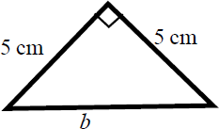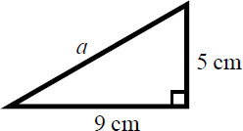**a b**

**c d**

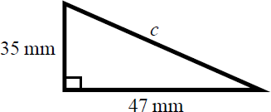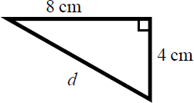

1. Work out the length of the unknown side in each triangle. Give your answers in surd form.

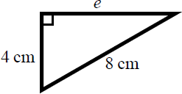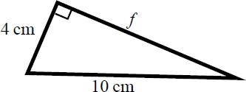**a b**

**c d**

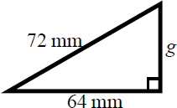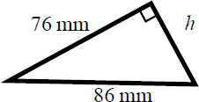

1. Work out the length of the unknown side in each triangle. Give your answers in surd form.

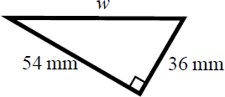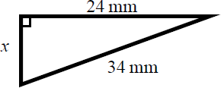**a b**

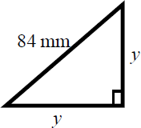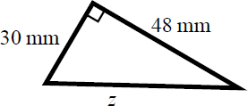**c d**

1. A rectangle has length 84 mm and width 45 mm. Calculate the length of the diagonal of the rectangle. Give your answer correct to 3 significant figures.

**Hint**

Draw a sketch of the rectangle.

### Extend

1. A yacht is 40 km due North of a lighthouse.

**Hint**

Draw a diagram using the information given in the question.

A rescue boat is 50 km due East of the same lighthouse. Work out the distance between the yacht and the rescue boat. Give your answer correct to 3 significant figures.

1. Points A and B are shown on the diagram. Work out the length of the line AB.

Give your answer in surd form.

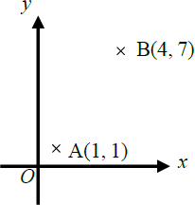

1. 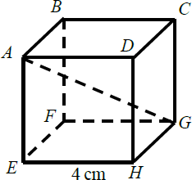A cube has length 4 cm.

Work out the length of the diagonal *AG*. Give your answer in surd form.

## Trigonometry in right-angled triangles

Key points

* + 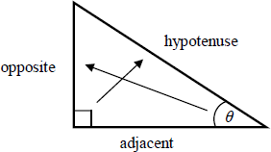In a right-angled triangle:
    - the side opposite the right angle is called the hypotenuse
    - the side opposite the angle *θ* is called the opposite
    - the side next to the angle *θ* is called the adjacent.
  + In a right-angled triangle:
    - the ratio of the opposite side to the hypotenuse is the sine of angle *θ*, sin**  opp

hyp

* + - the ratio of the adjacent side to the hypotenuse is the cosine of angle *θ*, cos**  adj

hyp

* + - the ratio of the opposite side to the adjacent side is the tangent of angle *θ*,

tan**  opp

adj

* + If the lengths of two sides of a right-angled triangle are given, you can find a missing angle using the inverse trigonometric functions: sin−1, cos−1, tan−1.
  + The sine, cosine and tangent of some angles may be written exactly.

|  |  |  |  |  |  |
| --- | --- | --- | --- | --- | --- |
|  | **0** | **30°** | **45°** | **60°** | **90°** |
| **sin** | 0 | 1  2 | 2  2 | 3  2 | 1 |
| **cos** | 1 | 3  2 | 2  2 | 1  2 | 0 |
| **tan** | 0 | 3  3 | 1 | 3 |  |

### Examples

**Example 1** Calculate the length of side *x*.

Give your answer correct to 3 significant figures.

|  |  |
| --- | --- |
| cos**  adj  hyp  cos 25 6  *x*  *x*  6 cos 25  *x* = 6.620 267 5...  *x* = 6.62 cm | 1. Always start by labelling the sides. 2. You are given the adjacent and the hypotenuse so use the cosine ratio. 3. Substitute the sides and angle into the cosine ratio. 4. Rearrange to make *x* the subject. 5. Use your calculator to work out   6 ÷ cos 25°.   1. Round your answer to 3 significant figures and write the units in your answer. |



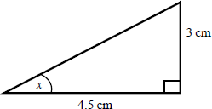**Example 2** Calculate the size of angle *x*.

Give your answer correct to 3 significant figures.

|  |  |
| --- | --- |
| tan**  opp  adj  tan *x*  3  4.5  *x* = tan–1  3    4.5      *x* = 33.690 067 5...  *x* = 33.7° | 1. Always start by labelling the sides. 2. You are given the opposite and the adjacent so use the tangent ratio. 3. Substitute the sides and angle into the tangent ratio. 4. Use tan−1 to find the angle. 5. Use your calculator to work out tan–1(3 ÷ 4.5). 6. Round your answer to 3 significant figures and write the units in your answer. |

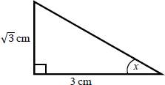**Example 3** Calculate the exact size of angle *x*.

|  |  |
| --- | --- |
| tan**  opp  adj  tan *x*  3 3  *x* = 30° | 1. Always start by labelling the sides. 2. You are given the opposite and the adjacent so use the tangent ratio. 3. Substitute the sides and angle into the tangent ratio. 4. Use the table from the key points to find the angle. |

### Video tutorials

|  |  |
| --- | --- |
| Finding a missing side | Finding a missing angle |
|  |  |

*or click on the QR code to follow the hyperlink*

### Practice

1. Calculate the length of the unknown side in each triangle. Give your answers correct to 3 significant figures.

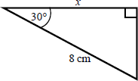**a b**

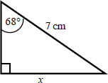

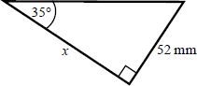**c d**

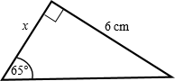

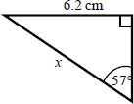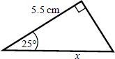**e f**

1. Calculate the size of angle *x* in each triangle. Give your answers correct to 1 decimal place.

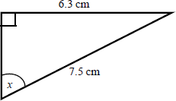**a b**

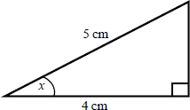

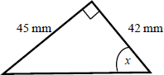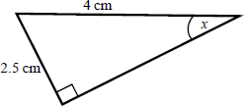**c d**

1. 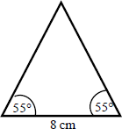Work out the height of the isosceles triangle. Give your answer correct to 3 significant figures.

**Hint:**

Split the triangle into two right-angled triangles.

1. 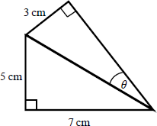Calculate the size of angle *θ*.

Give your answer correct to 1 decimal place.

**Hint:**

First work out the length of the common side to both triangles, leaving your answer in surd form.

1. 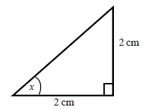Find the exact value of *x* in each triangle.

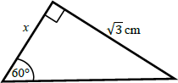**a b**

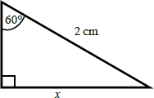**c d**

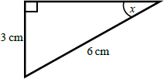

## The cosine rule

### Key points

* + 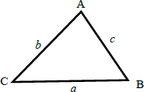*a* is the side opposite angle A.

*b* is the side opposite angle B.

*c* is the side opposite angle C.

* + You can use the cosine rule to find the length of a side when two sides and the included angle are given.
  + To calculate an unknown side use the formula *a*2  *b*2  *c*2  2*bc* cos *A*.
  + Alternatively, you can use the cosine rule to find an unknown angle if the lengths of all three sides are given.
  + To calculate an unknown angle use the formula cos *A*  *b*2  *c*2  *a*2 .

2*bc*

### Examples

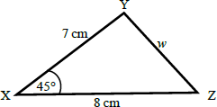**Example 4** Work out the length of side *w*.

Give your answer correct to 3 significant figures.

|  |  |
| --- | --- |
| *a*2  *b*2  *c*2  2*bc* cos *A*  *w*2  82  72  28 7cos 45  *w*2 = 33.804 040 51...  *w* = 33.80404051  *w* = 5.81 cm | 1. Always start by labelling the angles and sides. 2. Write the cosine rule to find the side. 3. Substitute the values *a*, *b* and *A* into the formula. 4. Use a calculator to find *w*2 and then *w*. 5. Round your final answer to 3 significant figures and write the units in your answer. |

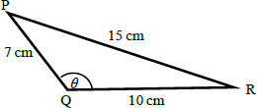**Example 5** Work out the size of angle *θ*.

Give your answer correct to 1 decimal place.

|  |  |
| --- | --- |
| *b*2  *c*2  *a*2  cos *A*   2*bc*  102  72 152  cos**   210 7  cos**  76  140  *θ* = 122.878 349...  *θ* = 122.9° | 1. Always start by labelling the angles and sides. 2. Write the cosine rule to find the angle. 3. Substitute the values *a*, *b* and *c* into the formula. 4. Use cos−1 to find the angle. 5. Use your calculator to work out cos–1(–76 ÷ 140). 6. Round your answer to 1 decimal place and write the units in your answer. |

### Video tutorials

|  |  |
| --- | --- |
| Finding a missing side | Finding a missing angle |
|  |  |

*or click on the QR code to follow the hyperlink*

### Practice

1. Work out the length of the unknown side in each triangle. Give your answers correct to 3 significant figures.

**a b**

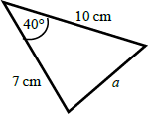

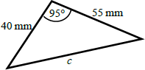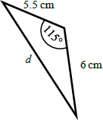**c d**

1. 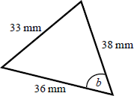Calculate the angles labelled *θ* in each triangle. Give your answer correct to 1 decimal place.
2. 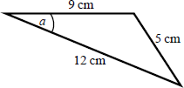**b**

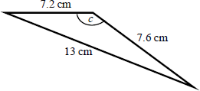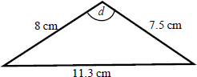**c d**

1. 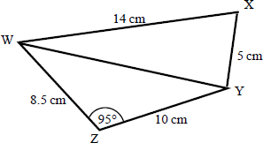**a** Work out the length of WY. Give your answer correct to 3 significant figures.
2. Work out the size of angle WXY. Give your answer correct to

1 decimal place.

## The sine rule

Key points

* + *a* is the side opposite angle A.

*b* is the side opposite angle B.

*c* is the side opposite angle C.

* + You can use the sine rule to find the length of a side when its opposite angle and another opposite side and angle are given.
  + To calculate an unknown side use the formula

*a* 

sin *A*

*b*

sin *B*

 *c* .

sin *C*

* + Alternatively, you can use the sine rule to find an unknown angle if the opposite side and another opposite side and angle are given.
  + To calculate an unknown angle use the formula sin *A*  sin *B*  sin *C* .

*a b c*

### Examples

**Example 6** Work out the length of side *x*.

Give your answer correct to 3 significant figures.

|  |  |
| --- | --- |
| *a*  *b*  sin *A* sin *B*  *x*  10 sin 36 sin 75  *x*  10 sin 36  sin 75  *x* = 6.09 cm | 1. Always start by labelling the angles and sides. 2. Write the sine rule to find the side. 3. Substitute the values *a*, *b*, *A* and *B*   into the formula.   1. Rearrange to make *x* the subject. 2. Round your answer to 3 significant figures and write the units in your answer. |

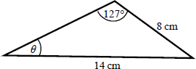**Example 7** Work out the size of angle *θ*.

Give your answer correct to 1 decimal place.

|  |  |
| --- | --- |
| sin *A*  sin *B a b*  sin**  sin127  8 14  sin**  8  sin127  14  *θ* = 27.2° | 1. Always start by labelling the angles and sides. 2. Write the sine rule to find the angle. 3. Substitute the values *a*, *b*, *A* and *B*   into the formula.   1. Rearrange to make sin *θ* the subject. 2. Use sin−1 to find the angle. Round your answer to 1 decimal place and write the units in your answer. |

### Video tutorials

|  |  |
| --- | --- |
| Finding a missing side | Finding a missing angle |
|  |  |

*or click on the QR code to follow the hyperlink*

### Practice

1. Find the length of the unknown side in each triangle. Give your answers correct to 3 significant figures.

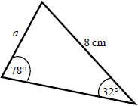**a b**

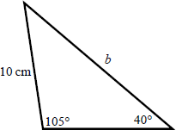

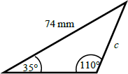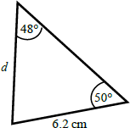**c d**

1. Calculate the angles labelled *θ* in each triangle. Give your answer correct to 1 decimal place.
2. 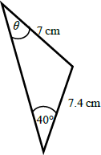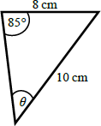**b**

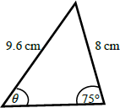**c d**

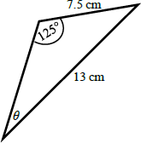

1. 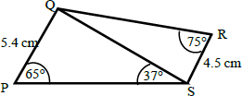**a** Work out the length of QS.

Give your answer correct to 3 significant figures.

1. Work out the size of angle RQS.

Give your answer correct to 1 decimal place.

Video tutorials

|  |  |
| --- | --- |
| Finding a missing side | Finding a missing angle |
|  |  |

*or click on the QR code to follow the hyperlink*

## Area of a triangle using ½absinC

### Key points

* *a* is the side opposite angle A.

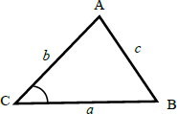*b* is the side opposite angle B.

*c* is the side opposite angle C.

* The area of the triangle is 1 *ab*sin *C* .

2

### Examples

**Example 8** Find the area of the triangle.

|  |  |
| --- | --- |
| Area = 1 *ab*sin *C*  2  Area = 1 85sin 82  2  Area = 19.805 361...  Area = 19.8 cm2 | 1. Always start by labelling the sides and angles of the triangle. 2. State the formula for the area of a triangle. 3. Substitute the values of *a*, *b* and *C* into the formula for the area of a triangle. 4. Use a calculator to find the area. 5. Round your answer to 3 significant figures and write the units in your answer. |

### Video tutorials

|  |
| --- |
| Area of a triangle |
|  |

*or click on the QR code to follow the hyperlink*

### Practice

1. Work out the area of each triangle.

Give your answers correct to 3 significant figures.

**a b**

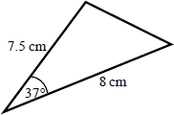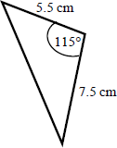

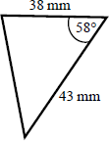**c**

1. 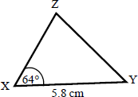The area of triangle XYZ is 13.3 cm2. Work out the length of XZ.

**Hint:**

Rearrange the formula to make a side the subject.

### Extend

1. Find the size of each lettered angle or side.

**Hint:**

For each one, decide whether to use the cosine or sine rule.

Give your answers correct to 3 significant figures.

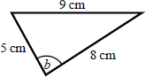**a b**

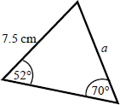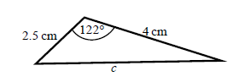

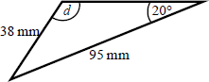**c d**

1. 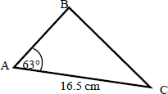The area of triangle ABC is 86.7 cm2. Work out the length of BC.

Give your answer correct to 3 significant figures.