Food and Nutrition KS3 Assessment Framework
We assess the students at different points during each unit of study. Teachers assess the fluency of declarative knowledge and procedural knowledge formally through assessments. Declarative knowledge is typically demonstrated through describe, identify, recall and explain key concepts. Procedural knowledge is demonstrated through the students’ ability to apply their understanding of food theory to areas of their practical making skills.
Short-cycle assessment:
- Mini whiteboards
- Cold calling on theory knowledge
- Questioning common misconceptions
- Exit slips are used to check understanding
- Verbal feedback takes place every lesson regarding progress with practical

Medium cycle assessment
- Pre/ post tests are used at the start and end of every project
- Retrieval starter questions
- Key assessed practical task
- Independent practice tasks (HW)
Long-cycle assessment
- Year 7 complete x2 summative assessments
- Year 8 and 9 x1 summative assessment at the end of the project.
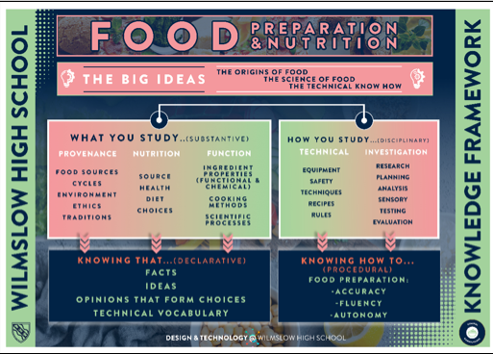
Because the knowledge structure in Food looks like this:
 | HT1 | HT2 | HT3 | HT4 | HT5 | HT6
Year 7 Declarative knowledge assessed | Food safety and hygiene; storage, safe food preparation  Food science | The cooker; heat transfer | Nutrition; Eatwell guide  Fat and sugar | Nutrition;  Salt, fibre and water  Active lifestyles | Protein, portion size | Food provenance; fair trade and food miles
Year 7 procedural knowledge assessed | Fruit salad practical- knife skills, enzymic browning | Weighing and measuring  Practical activities using the hob, grill and oven.  Fruit muffins  Croque monsieur  Crispy cakes  End of unit exam | Practical’s demonstrating low sugar, low fat.  Low sugar crumble  Eat-well pasta jar | Practical’s demonstrating high fibre; Potato wedges, cereal bar. | Practical’s demonstrating alternative protein sources; Frittata- knife skills and food science eggs | Practical’s demonstrating fair trade and food miles  Rubbing method; shortbread  Creaming; Pear marble cake  End of year exam
Year 8 Declarative knowledge assessed | Staple foods,  Food provenance  Functional properties of ingredients | Nutrition, food choice  Nutrition through life-stages  Food and religion | Nutrition- obesity  Food choice  Food science-shortening
Year 8 procedural knowledge assessed | Staples food practical  Spaghetti Bolognese/chili  Sweet and sour | Practical skills;  Pastabake  Pizza  Thai beef | Burgers; food safety  Timeplan  Food science; jam tarts  Evaluation  End of year exam
Year 9 Declarative knowledge assessed | Food science- pastry  Quality control | Functional properties of bread and eggs.  Food science of eggs | Dairy nutrition  Food science-gelatinisation
Year 9 procedural assessed knowledge assessed | Pastry skills- mini Bakewell tarts and galettes  Quality control | Swiss roll- foaming  Bread rolls  Focaccia  Evaluation | Decorated cheesecake  Decorated lemon curd tart- gelatinisation  End of year exam

