Term | Definition
Largo | Slowly and broadly.
Andante | Slowish, at walking pace.
Moderato | At moderate pace.
Allegro | Fast
Vivace | Lively
Presto | Very quick
Accelerando | Gradually speeding up.
Rallentando | Gradually slowing down.
Ritenuto | Immediately slower.
Allargando | Getting slower and broadening.
Dotted Rhythms | If a note has a dot after it, it extends the note by half of its original value. For example, a dotted crotchet = 1 beat, PLUS half of 1, so 1 and ½.
Compound time | In compound time, each beat is a dotted note. Common compound times are 6/8, 9/8 and 12/8.  So, although 6/8 has 6 quaver beats in a bar, the beat is given by two dotted crotchets.
Syncopation | When notes are played off the beat.
Cross-rhythms | The effect when two conflicting rhythms are played at once.
Polyrhythm | More than one rhythm playing at once, that have different pulses.
Triplets | Three notes played in the time of two.
Rhythm and Metre
Time Signatures
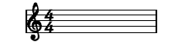 | This means there are four crotchet beats in each bar.
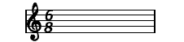 | This means there are six quaver beats in each bar.
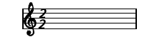 | This means there are two minim beats in each bar.

