Documentaries / YouTube clips to watch

TED Talks
- Bill Gates how we must respond to the coronavirus pandemic https://www.ted.com/talks/bill_gates_how_we_must_respond_to_the_coronavirus_pandemic
- Bill Gates the next outbreak? We’re not ready https://www.ted.com/talks/bill_gates_the_next_outbreak_we_re_not_ready
- Why COVID-19 is hitting us now and how to prepare for the next outbreak https://www.ted.com/talks/alanna_shaikh_why_covid_19_is_hitting_us_now_and_how_to_prepare_for_the_next_outbreak
- What vaccinating vampire bats can teach us about pandemics https://www.ted.com/talks/daniel_streicker_what_vaccinating_vampire_bats_can_teach_us_about_pandemics#t-435594
- How can we solve the antibiotic resistance crisis? https://www.ted.com/talks/gerry_wright_how_can_we_solve_the_antibiotic_resistance_crisis
- Why Bees are Disappearing https://www.ted.com/talks/marla_spivak_why_bees_are_disappearing
- Why Doctors Don’t Know About the Drugs They Prescribe https://www.ted.com/talks/ben_goldacre_what_doctors_don_t_know_about_the_drugs_they_prescribe?language=en
- Growing New Organs https://www.ted.com/talks/anthony_atala_growing_new_organs?language=en#t-891354

Documentary heaven
- https://documentaryheaven.com/the-elephant-life-after-death/
- https://documentaryheaven.com/charles-darwin-and-the-tree-of-life/
- https://documentaryheaven.com/the-future-of-food/
- The Brain with David Eagleman - What Is Reality - BBC Documentary 2016
- https://www.bbc.co.uk/iplayer/categories/documentaries-science-and-nature/a-z

Films
- The Island
- Jurassic Park (a little old school but... a classic)
- Gattaca
- My sister's keeper

Books to read
- Frankenstein’s cat – Emily Anthes
- A short history of nearly everything – Bill Bryson
- The body – Bill Bryson
- Hacking the code of life – Nessa Carey
- Junk DNA – Nessa Carey
- The epigenetics revolution – Nessa Carey
- Next – Michael Crichton
- Life unfolding – Jamie A Davies
- The selfish gene – Richard Dawkins
- Guns, germs and steel – Jared Diamond
- Gut - Giulia Enders
- The coming plague – Laurie Garrett
- Bad science – Ben Goldacre
- Unnatural selection – Mara Hvistendahl
- Power, sex, suicide: Mitochondria and the meaning of life – Nick Lane
- Mutants: on the form, varieties and errors of the human body – Armand Marie Leroi
- The story of the human body: Evolution, health and disease – Daniel Lieberman
- My sister's keeper – Jodi Picoult
- Gulp: adventures on the alimentary canal – Mary Roach
- The man who mistook his wife for a hat – Oliver Sacks
- The immortal life of Henrietta Lacks – Rebecca Skloot
- Bounce – Matthew Syed
- Genome – Matt Ridley
- After Dolly: The uses and misuses of human cloning – Ian Wilmut & Roger Highfield

Frankenstein's Cat (2013) by Emily Anthes  From the petri dish to the pet shop, meet the high-tech menagerie of the near future, as humans reinvent the animal kingdom  Fluorescent fish that glow near pollution. Dolphins with prosthetic fins. Robot-armoured beetles that military handlers can send on spy missions. Beloved pet pigs resurrected from DNA. Scientists have already begun to create these high-tech hybrids to serve human whims and needs. What if a cow could be engineered to no longer feel pain should we design a herd that would assuage our guilt over-eating meat?  Acclaimed science writer Emily Anthes travels round the globe to meet the fauna of the future, from the Scottish birthplace of Dolly the sheep and other clones to a pharm for cancer-fighting chickens. Frankenstein s Cat is an eye-opening exploration of weird science and how we are playing god in the animal world. | 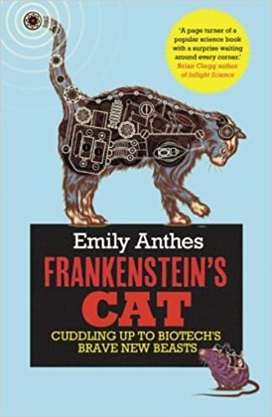
The Body: A Guide for Occupants (2019) by Bill Bryson  THE NUMBER ONE SUNDAY TIMES BESTSELLER - SUNDAY TIMES SCIENCE BOOK OF THE YEAR 2019  We spend our whole lives in one body and yet most of us have practically no idea how it works and what goes on inside it. The idea of the book is simply to try to understand the extraordinary contraption that is us.  Bill Bryson sets off to explore the human body, how it functions and its remarkable ability to heal itself. Full of extraordinary facts and astonishing stories The Body: A Guide for Occupants is a brilliant, often very funny attempt to understand the miracle of our physical and neurological make up.  A wonderful successor to A Short History of Nearly Everything, this new book is an instant classic. It will have you marvelling at the form you occupy, and celebrating the genius of your existence, time and time again. | 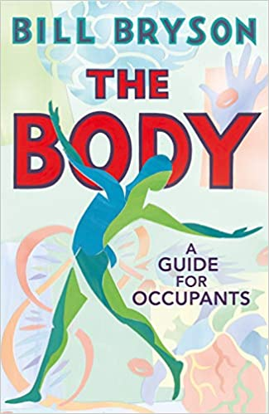
A Short History Of Nearly Everything (2003) by Bill Bryson  Bill Bryson describes himself as a reluctant traveller: but even when he stays safely in his own study at home, he can’t contain his curiosity about the world around him.  A Short History of Nearly Everything is his quest to understand everything that has happened from the Big Bang to the rise of civilization – how we got from there, being nothing at all, to here, being us. Bill Bryson’s challenge is to take subjects that normally bore the pants off most of us, like geology, chemistry and particle physics, and see if there isn’t some way to render them comprehensible to people who have never thought they could be interested in science.  It’s not so much about what we know, as about how we know what we know. How do we know what is in the centre of the Earth, or what a black hole is, or where the continents were 600 million years ago? How did anyone ever figure these things out? On his travels through time and space, he encounters a splendid collection of astonishingly eccentric, competitive, obsessive and foolish scientists, like the painfully shy Henry Cavendish who worked out many conundrums like how much the Earth weighed, but never bothered to tell anybody about many of his findings. In the company of such extraordinary people, Bill Bryson takes us with him on the ultimate eye-opening journey and reveals the world in a way most of us have never seen it before. | 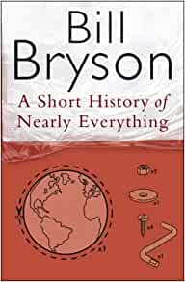
Hacking the Code of Life (2019) by Nessa Carey  In 2018 the world woke up to gene editing with a storm of controversy over twin girls born in China with genetic changes deliberately introduced by scientists – changes they will pass on to their own offspring.  Genetic modification (GM) has been with us for 45 years now, but the new system known as CRISPR or gene editing can manipulate the genes of almost any organism with a degree of precision, ease and speed that we could only dream of ten years ago.  But is it ethical to change the genetic material of organisms in a way that might be passed on to future generations? If a person is suffering from a lethal genetic disease, is it unethical to deny them this option? Who controls the application of this technology, when it makes ‘biohacking’ – perhaps of one’s own genome – a real possibility? Nessa Carey’s book is a thrilling and timely snapshot of a cutting-edge technology that will radically alter our futures and the way we prevent disease. | 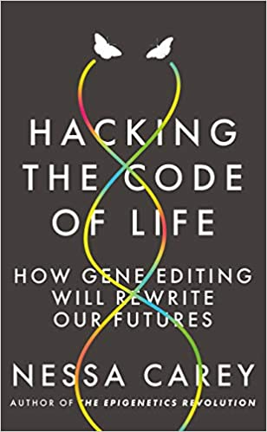
Junk DNA: A Journey Through the Dark Matter of the Genome (2015) by Nessa Carey  From the author of the acclaimed The Epigenetics Revolution (‘A book that would have had Darwin swooning’ – Guardian) comes another thrilling exploration of the cutting edge of human science.  For decades after the structure of DNA was identified, scientists focused purely on genes, the regions of the genome that contain codes for the production of proteins. Other regions – 98% of the human genome – were dismissed as ‘junk’. But in recent years researchers have discovered that variations in this ‘junk’ DNA underlie many previously intractable diseases, and they can now generate new approaches to tackling them.  Nessa Carey explores, for the first time for a general audience, the incredible story behind a controversy that has generated unusually vituperative public exchanges between scientists. She shows how junk DNA plays an important role in areas as diverse as genetic diseases, viral infections, sex determination in mammals, human biological complexity, disease treatments, even evolution itself – and reveals how we are only now truly unlocking its secrets, more than half a century after Crick and Watson won their Nobel prize for the discovery of the structure of DNA in 1962. | 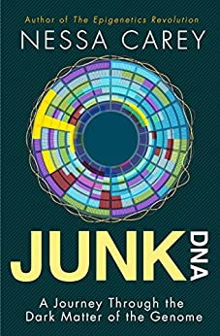
The Epigenetics Revolution (2011) by Nessa Carey  At the beginning of this century enormous progress had been made in genetics. The Human Genome Project finished sequencing human DNA. It seemed it was only a matter of time until we had all the answers to the secrets of life on this planet. The cutting-edge of biology, however, is telling us that we still don't even know all of the questions.  How is it that, despite each cell in your body carrying exactly the same DNA, you don't have teeth growing out of your eyeballs or toenails on your liver? How is it that identical twins share exactly the same DNA and yet can exhibit dramatic differences in the way that they live and grow?  It turns out that cells read the genetic code in DNA more like a script to be interpreted than a mould that replicates the same result each time. This is epigenetics and it's the fastest-moving field in biology today.  The Epigenetics Revolution traces the thrilling path this discipline has taken over the last twenty years. Biologist Nessa Carey deftly explains such diverse phenomena as how queen bees and ants control their colonies, why tortoiseshell cats are always female, why some plants need a period of cold before they can flower, why we age, develop disease and become addicted to drugs, and much more. Most excitingly, Carey reveals the amazing possibilities for humankind that epigenetics offers for us all - and in the surprisingly near future. | 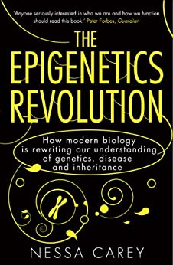
Next (2007) by Michael Crichton  The Number One international bestselling author of Jurassic Park, Congo and Sphere blends fact and fiction to create a near-future where genetic engineering opens up a whole new world of terrifying, page-turning possibilities…  Is a loved one missing body parts?  Are blondes becoming extinct?  Has a human already cross-bred with a monkey?  We live in a GENETIC WORLD. Fast, frightening – and potentially VERY lucrative. There are designer pets; a genetic cure for drug addiction; a booming market in eggs and sperm. But is there also a talking ape in Borneo? Has a 'master' gene for controlling others been found? Could an innocent man and his family be hunted cross-country because they happen to have certain valuable genes …  Are you ready for what comes NEXT in Michael Crichton's stunning thriller? | 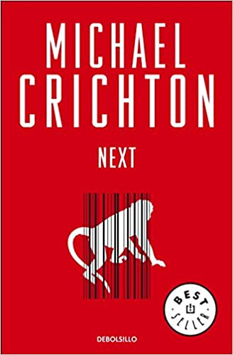
Life Unfolding: How the human body creates itself by Jamie A. Davies  Where did I come from? Why do I have two arms but just one head? How is my left leg the same size as my right one? Why are the fingerprints of identical twins not identical? How did my brain learn to learn? Why must I die?  Questions like these remain biology’s deepest and most ancient challenges. They force us to confront a fundamental biological problem: how can something as large and complex as a human body organize itself from the simplicity of a fertilized egg? A convergence of ideas from embryology, genetics, physics, networks, and control theory has begun to provide real answers. Based on the central principle of ‘adaptive self-organization’, it explains how the interactions of many cells, and of the tiny  molecular machines that run them, can organize tissue structures vastly larger than themselves, correcting errors as they go along and creating new layers of complexity where there were none before.  Life Unfolding tells the story of human development from egg to adult, from this perspective, showing how our whole understanding of how we come to be has been transformed in recent years. Highlighting how embryological knowledge is being used to understand why bodies age and fail, Jamie A. Davies explores the profound and fascinating impacts of our newfound knowledge. | 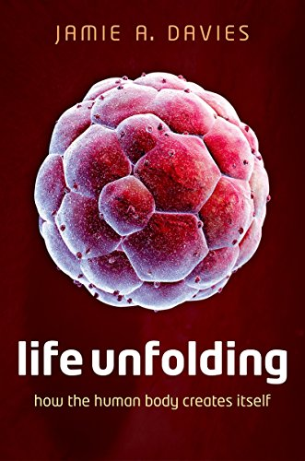
The Selfish Gene: 40th Anniversary edition by Richard Dawkins  The million copy international bestseller, critically acclaimed and translated into over 25 languages.  As influential today as when it was first published, The Selfish Gene has become a classic exposition of evolutionary thought. Professor Dawkins articulates a gene's eye view of evolution - a view giving centre stage to these persistent units of information, and in which organisms can be seen as vehicles for their replication. This imaginative, powerful, and stylistically brilliant work not only brought the insights of Neo-Darwinism to a wide audience, but galvanized the biology community, generating much debate and stimulating whole new areas of research. Forty years later, its insights remain as relevant today as on the day it was published.  This 40th anniversary edition includes a new epilogue from the author discussing the continuing relevance of these ideas in evolutionary biology today, as well as the original prefaces and foreword, and extracts from early reviews.  Oxford Landmark Science books are 'must-read' classics of modern science writing which have crystallized big ideas and shaped the way we think. | 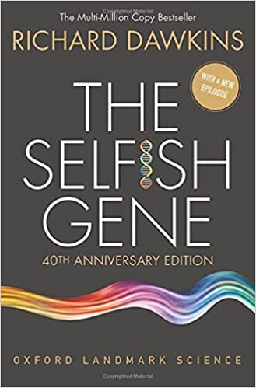
Guns, Germs and Steel: A short history of everybody for the last 13,000 years by Jared Diamond  'A book of big questions, and big answers' Yuval Noah Harari, bestselling author of Sapiens  Why has human history unfolded so differently across the globe?  Jared Diamond puts the case that geography and biogeography, not race, moulded the contrasting fates of Europeans, Asians, Native Americans, sub-Saharan Africans, and aboriginal Australians.  An ambitious synthesis of history, biology, ecology and linguistics, Guns, Germs and Steel is a ground-breaking and humane work of popular science.  *WINNER OF THE PULITZER PRIZE*  *Over One Million Copies Sold* | 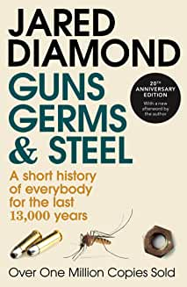
Gut by Giulia Enders  A Sunday Times bestseller  The key to living a happier, healthier life is inside us.  Our gut is almost as important to us as our brain or our heart, yet we know very little about how it works. In Gut, Giulia Enders shows that rather than the utilitarian and — let’s be honest — somewhat embarrassing body part we imagine it to be, it is one of the most complex, important, and even miraculous parts of our anatomy. And scientists are only just discovering quite how much it has to offer; new research shows that gut bacteria can play a role in everything from obesity and allergies to Alzheimer’s.  Beginning with the personal experience of illness that inspired her research and going on to explain everything from the basics of nutrient absorption to the latest science linking bowel bacteria with depression, Enders has written an entertaining, informative health handbook. Gut definitely shows that we can all benefit from getting to know the wondrous world of our inner workings.  In this charming book, young scientist Giulia Enders takes us on a fascinating tour of our insides. Her message is simple — if we treat our gut well, it will treat us well in return. But how do we do that? And why do we need to? Find out in this surprising, and surprisingly funny, exploration of the least understood of our organs. | 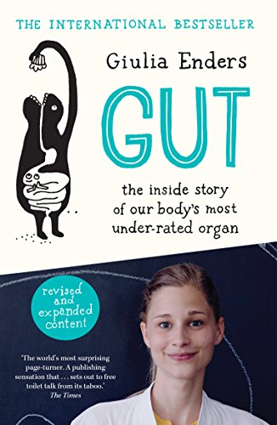
The Coming Plague: Newly Emerging Diseases in a World out of Balance by Laurie Garrett  As the global village becomes smaller, as destruction of the rainforests continues, and as bacteria increasingly develop resistance to overused antibiotics, the threat of new diseases, of which AIDS is potentially only the first, becomes ever greater. This book explores the world of new diseases - from AIDS to Toxic Shock Syndrome, Legionnaire's Disease, Ebola (the "Hot Zone" virus) and others - and the over-crowded world we have created that makes these diseases, and their spread, possible. | 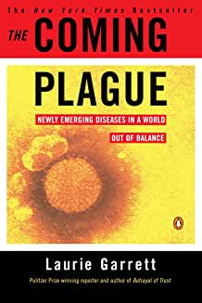
Bad Science by Ben Goldacre  We are constantly bombarded with inaccurate, contradictory and sometimes misleading information - until now.  Ben Goldacre masterfully dismantles the dubious science behind some of the great drug trials, court cases, and missed opportunities of our time. He also shows us the fascinating story of how we know what we know and gives us the tools to uncover bad science for ourselves. | 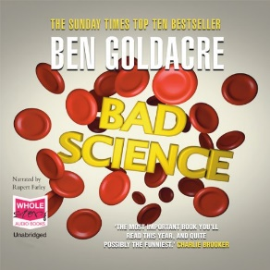
Unnatural Selection: Choosing Boys Over Girls and the Consequences of a World Full of Men by Mara Hvistendahl  Lianyungang, a booming port city, has China's most extreme gender ratio for children under four: 163 boys for every 100 girls. These numbers don't seem terribly grim, but in 10 years, the skewed sex ratio will pose a colossal challenge. By the time these children reach adulthood, their generation will have 24 million more men than women. The prognosis for China's neighbours is no less bleak: Asia now has 163 million females "missing" from its population. Gender imbalance reaches far beyond Asia, affecting Georgia, Eastern Europe, and cities in the U.S. where there are significant immigrant populations. The world, therefore, is becoming increasingly male, and this mismatch is likely to create profound social upheaval.  Historically, eras in which there have been an excess of men have produced periods of violent conflict and instability. Mara Hvistendahl has written a stunning, impeccably researched book that does not flinch from examining not only the consequences of the misbegotten policies of sex selection but Western complicity with them. | 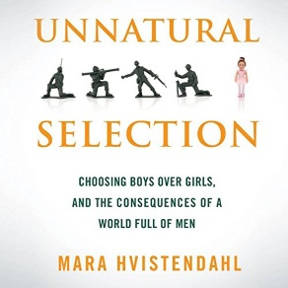
Power, Sex, Suicide: Mitochondria and the meaning of life by Nick Lane  Mitochondria are tiny structures located inside our cells that carry out the essential task of producing energy for the cell. They are found in all complex living things, and in that sense, they are fundamental for driving complex life on the planet. But there is much more to them than that.  Mitochondria have their own DNA, with their own small collection of genes, separate from those in the cell nucleus. It is thought that they were once bacteria living independent lives. Their enslavement within the larger cell was a turning point in the evolution of life, enabling the development of complex organisms and, closely related, the origin of two sexes. Unlike the DNA in the nucleus, mitochondrial DNA is passed down exclusively (or almost exclusively) via the female line. That's why it has been used by some researchers to trace human ancestry daughter-to-mother, to 'Mitochondrial Eve'. Mitochondria give us important information about our evolutionary history. And that's not all. Mitochondrial genes mutate much faster than those in the nucleus because of the free radicals produced in their energy-generating role. This high mutation rate lies behind our ageing and certain congenital diseases. The latest research suggests that mitochondria play a key role in degenerative diseases such as cancer, through their involvement in precipitating cell suicide.  Mitochondria, then, are pivotal in power, sex, and suicide. In this fascinating and thought-provoking book, Nick Lane brings together the latest research findings in this exciting field to show how our growing understanding of mitochondria is shedding light on how complex life evolved, why sex arose (why don't we just bud?), and why we age and die. This understanding is of fundamental importance, both in understanding how we and all other complex life came to be, but also in order to be able to control our own illnesses, and delay our degeneration and death. | 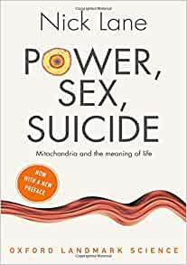
Mutants: On the Form, Varieties and Errors of the Human Body by Armand Marie Leroi  Full of fascinating and bizarre cases of genetic mutation and irregularity, ‘Mutants’ is an amazing exploration of the human form in all its beautiful and unique guises.  Why are most of us born with one nose, two legs, ten fingers and twenty-four ribs – and some of us not? Why do most of us stop growing in our teens – while others just keep going? Why do some us have heads of red hair – and others no hair at all? The human genome, we are told, makes us what we are. But how?  Armand Marie Leroi takes us to the extremes of human mutation – from the grotesque to the beautiful, and often both at the same time – to explain how we become what we are. Through the tales of long-lived Croatian dwarves, ostrich-footed Wadoma tribesmen, sex-changing French convent girls, and many more wonders of human development, Leroi has written a brilliant narrative account of our genetic grammar and people whose bodies have revealed it. | 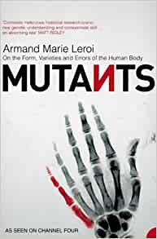
The Story of the Human Body: Evolution, Health, and Disease by  Daniel Lieberman  In this landmark book of popular science, Daniel E. Lieberman - chair of the department of human evolutionary biology at Harvard University and a leader in the field - gives us a lucid and engaging account of how the human body evolved over millions of years, even as it shows how the increasing disparity between the jumble of adaptations in our Stone Age bodies and advancements in the modern world is occasioning this paradox: greater longevity but increased chronic disease.  The Story of the Human Body brilliantly illuminates as never before the major transformations that contributed key adaptations to the body: the rise of bipedalism; the shift to a non-fruit-based diet; the advent of hunting and gathering, leading to our superlative endurance athleticism; the development of a very large brain; and the incipience of cultural proficiencies. Lieberman also elucidates how cultural evolution differs from biological evolution, and how our bodies were further transformed during the Agricultural and Industrial Revolutions.  While these ongoing changes have brought about many benefits, they have also created conditions to which our bodies are not entirely adapted, Lieberman argues, resulting in the growing incidence of obesity and new but avoidable diseases, such as type 2 diabetes. Lieberman proposes that many of these chronic illnesses persist and in some cases are intensifying because of "dysevolution," a pernicious dynamic whereby only the symptoms rather than the causes of these maladies are treated. And finally - provocatively - he advocates the use of evolutionary information to help nudge, push, and sometimes even compel us to create a more salubrious environment. | 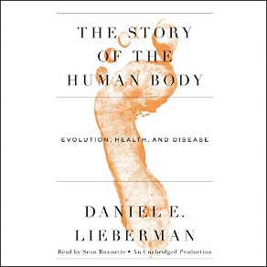
My Sister's Keeper by Jodi Picoult  THE MILLION-COPY BESTSELLER AND MAJOR MOTION PICTURE  'Emotionally riveting and will test your tear ducts to the limit' Daily Express  In all thirteen years of Anna's life, her parents have never given her a choice: she was born to be her sister Kate's bone marrow donor and she has always given Kate everything she needs.  But when Anna is told Kate needs a new kidney, she begins to question how much she should be prepared to do to save the older sibling she has always been defined by. So Anna makes a decision that will change their family forever - perhaps even fatally for the sister she loves.  From internationally bestselling author Jodi Picoult comes a masterpiece which asks us just how much we should do to care for the ones we love. | 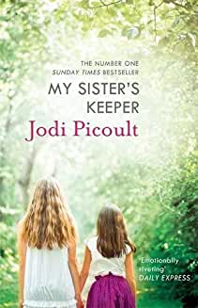
Gulp: Adventures on the Alimentary Canal by Mary Roach  The bestselling author of Stiff takes on the curious, comical intersection of delight and disgust that is eating (and what comes after).  Eating is the most pleasurable, gross, necessary, unspeakable biological process we humans undertake. But very few of us realise what strange wet miracles of science operate inside us after every meal - let alone have pondered the results (of the research). How have physicists made crisps crispier? What do laundry detergent and saliva have in common? Was self-styled ‘nutritional economist’ Horace Fletcher right to persuade millions of people that chewing a bite of shallot 700 times would yield double the vitamins? And did Elvis actually die from constipation?  In her trademark, laugh-out-loud style, Mary Roach breaks bread with spit connoisseurs and enema exorcists, stomach slugs, rectum-examining prison guards, and competitive hot dog eaters as she investigates the beginning - and the end - of our food. | 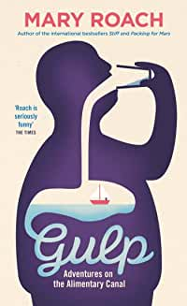
The Man Who Mistook His Wife for a Hat by Oliver Sacks  In this extraordinary book, Dr Oliver Sacks recounts the stories of patients struggling to adapt to often bizarre worlds of neurological disorder. Here are people who can no longer recognise everyday objects or those they love; who are stricken with violent tics or shout involuntary obscenities; who have been dismissed as autistic or retarded yet are gifted with uncanny artistic or mathematical talents. If inconceivably strange, these brilliant tales illuminate what it means to be human.  A provocative exploration of the mysteries of the human mind, The Man Who Mistook His Wife for a Hat is a million-copy best seller by the 20th century's greatest neurologist. | 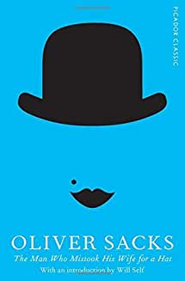
The Immortal Life of Henrietta Lacks by Rebecca Skloot  Her name was Henrietta Lacks, but scientists know her as HeLa. She was a poor Southern tobacco farmer whose cancer cells - taken without her knowledge - became one of the most important tools in medicine. The first 'immortal' human tissue grown in culture, HeLa cells were vital for developing the polio vaccine; uncovered secrets of cancer, viruses, and the effects of the atom bomb; helped lead to important advances like in vitro fertilization, cloning, and gene mapping; and have been bought and sold by the billions. Yet Henrietta herself remains virtually unknown, buried in an unmarked grave  Now Rebecca Skloot takes us on an extraordinary journey in search of Henrietta's story, from the 'coloured' ward of Johns Hopkins Hospital in the 1950s to East Baltimore today, where her children and grandchildren live, and struggle with the legacy of her cells. Full of warmth and questing intelligence, astonishing in scope and impossible to put down, The Immortal Life of Henrietta Lacks captures the beauty and drama of scientific discovery, as well as its human consequences. | 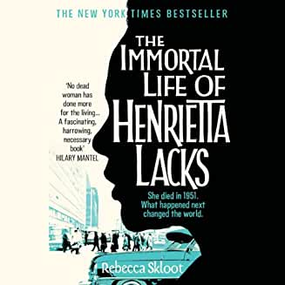
By Matthew Syed Bounce: How Champions are Made by Matthew Syed  Why have all the sprinters who have run the 100 meters in under 10 seconds been black?  What's one thing Mozart, Venus Williams, and Michelangelo have in common?  Is it good to praise a child's intelligence?  Why are baseball players so superstitious?  Few things in life are more satisfying than beating a rival. We love to win and hate to lose, whether it's on the playing field or at the ballot box, in the office or in the classroom. In this bold new look at human behaviour, award-winning journalist and Olympian Matthew Syed explores the truth about our competitive nature: why we win, why we don't, and how we really play the game of life.  Bounce reveals how competition - the most vivid, primal, and dramatic of human pursuits - provides vital insight into many of the most controversial issues of our time, from biology and economics, to psychology and culture, to genetics and race, to sports and politics.  Backed by cutting-edge scientific research and case studies, Syed shatters long-held myths about meritocracy, talent, performance, and the mind. He explains why some people thrive under pressure and others choke and weighs the value of innate ability against that of practice, hard work, and will. From sex to math, from the motivation of children to the culture of big business, Bounce shows how competition provides a master key with which to unlock the mysteries of the world. | 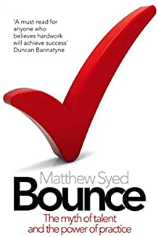
Genome by Matt Ridley  The most important investigation of genetic science since The Selfish Gene, from the author of the critically acclaimed and best-selling The Red Queen and The Origins of Virtue.  The genome is our 100,000 or so genes. The genome is the collective recipe for the building and running of the human body. These 100,000 genes are sited across 23 pairs of chromosomes. Genome, a book of about 100,000 words, is divided into 23 chapters, a chapter for each chromosome. The first chromosome, for example, contains our oldest genes, genes which we have in common with plants.  By looking at our genes we can see the story of our evolution, what makes us individual, how our sexuality is determined, how we acquire language, why we are vulnerable to certain diseases, how mind has arisen. Genome also argues for the genetic foundations of free will. While many believe that genetics proves biological determinism, Ridley will show that in fact free will is itself in the genes. Everything that makes us human can be read in our genes. Early in the next century we will have determined the function of every one of these 100,000 genes. | 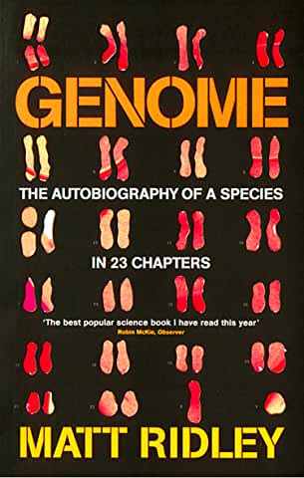
After Dolly: The Uses and Misuses of Human Cloning  by Professor Ian Wilmut  This book provides a timely and important discussion of the potential value of cloning and of the ethical choices that this radical new technology has raised, including the issues surrounding the current status of stem-cell research.  As leader of the team that produced Dolly, the first animal to be cloned from an adult cell, Ian Wilmut has played a unique role both in the science of cloning and the ensuing international debate about its implications. He has testified before parliamentary and congressional committees in the UK, France and the US and given many public lectures on the subject, in addition to participating in numerous panel discussions on the uses of cloning. AFTER DOLLY: THE USES AND MISUSES OF HUMAN CLONING distils the essence of the current scientific and social policy discussions around these critically important issues and presents them in an understandable manner so the educated reader can have an informed opinion. | 