A level Mathematics Year 11 to 12 transition

### 1

**Contents**

1. Introduction
2. Expanding brackets and simplifying expressions *
3. Factorising expressions *
4. Rules of indices *
5. Surds *
6. Rearranging equations *
7. Completing the square *
8. Solving quadratic equations by factorisation *
9. Solving quadratic equations by completing the square *
10. Solving quadratic equations by using the formula *
11. Solving linear simultaneous equations by elimination *
12. Solving linear simultaneous equations by substitution *
13. Solving linear and quadratic simultaneous equations *
14. Solving simultaneous equations graphically
15. Linear inequalities *
16. Quadratic inequalities
17. Sketching cubic and reciprocal graphs
18. Translating graphs
19. Stretching graphs
20. Straight line graphs
21. Parallel and perpendicular lines
22. Volume and surface area of 3D solids
23. Pythagoras’ theorem *
24. Trigonometry in right-angled triangles *
25. The cosine rule
26. The sine rule
27. Area of a triangle using ½absin C

2

## Expanding brackets and simplifying expressions

### Answers

|  |  |  |  |  |
| --- | --- | --- | --- | --- |
| **1** | **a**  **c** | 6*x* – 3  –3*xy* + 2*y*2 | **b** | –10*pq* – 8*q*2 |
| **2** | **a** | 21*x* + 35 + 12*x* – 48 = 33*x* – 13 | |  |
|  | **b** | 40*p* – 16 – 12*p* – 27 = 28*p* – 43 | |  |
|  | **c** | 27*s* + 9 – 30*s* + 50 = –3*s* + 59 = 59 – 3*s* | |  |
|  | **d** | 8*x* – 6 – 3*x* – 5 = 5*x* – 11 | |  |
| **3** | **a c** | 12*x*2 + 24*x* **b**  10*h* – 12*h*3 – 22*h*2 **d** | | 20*k*3 – 48*k*  21*s*2 – 21*s*3 – 6*s* |
| **4** | **a c** | –*y*2 – 4 **b**  2*p* – 7*p*2 **d** | | 5*x*2 – 11*x*  6*b*2 |
| **5** | *y* – 4 |  | |  |
| **6** | **a** | –1 – 2*m* **b** | | 5*p*3 + 12*p*2 + 27*p* |

**7** 7*x*(3*x* – 5) = 21*x*2 – 35*x*

|  |  |  |  |  |
| --- | --- | --- | --- | --- |
| **8** | **a** | *x*2 + 9*x* + 20 | **b** | *x*2 + 10*x* + 21 |
|  | **c** | *x*2 + 5*x* – 14 | **d** | *x*2 – 25 |
|  | **e** | 2*x*2 + *x* – 3 | **f** | 6*x*2 – *x* – 2 |
|  | **g** | 10*x*2 – 31*x* + 15 | **h** | 12*x*2 + 13*x* – 14 |
|  | **i** | 18*x*2 + 39*xy* + 20*y*2 | **j** | *x*2 + 10*x* + 25 |
|  | **k** | 4*x*2 − 28*x* + 49 | **l** | 16*x*2 − 24*xy* + 9*y*2 |

**9** 2*x*2 − 2*x* + 25

**10 a**

*x*2 1 2

*x*2

**b** *x*2  2  1

*x*2

## Factorising expressions

### Answers

|  |  |  |  |  |
| --- | --- | --- | --- | --- |
| **1** | **a c** | 2*x*3*y*3(3*x* – 5*y*) 5*x*2*y*2(5 – 2*x* + 3*y*) | **b** | 7*a*3*b*2(3*b*3 + 5*a*2) |
| **2** | **a c e g** | (*x* + 3)(*x* + 4) (*x* – 5)(*x* – 6)  (*x* – 9)(*x* + 2)  (*x* – 8)(*x* + 5) | **b d f h** | (*x* + 7)(*x* – 2)  (*x* – 8)(*x* + 3)  (*x* + 5)(*x* – 4)  (*x* + 7)(*x* – 4) |
| **3** | **a c** | (6*x* – 7*y*)(6*x* + 7*y*)  2(3*a* – 10*bc*)(3*a* + 10*bc*) | **b** | (2*x* – 9*y*)(2*x* + 9*y*) |
| **4** | **a**  **c e** | (*x* – 1)(2*x* + 3)  (2*x* + 1)(*x* + 3)  (5*x* + 3)(2*x* +3) | **b**  **d f** | (3*x* + 1)(2*x* + 5) (3*x* – 1)(3*x* – 4)  2(3*x* – 2)(2*x* –5) |

**5 a** 2(*x*  2)

*x* 1

*x*

**b** *x* 1

**c** *x*  2

*x*

**e** *x*  3

*x*

*x*

**d** *x*  5

*x*

**f** *x*  5

**6 a** 3*x*  4

*x*  7

**c** 2  5*x* 2*x*  3

**b** 2*x*  3

3*x*  2

1. 3*x*  1

*x*  4

**7** (*x* + 5)

**8** 4(*x*  2)

*x*  2

## Rules of indices

### Answers

|  |  |  |  |  |  |  |  |  |
| --- | --- | --- | --- | --- | --- | --- | --- | --- |
| **1** | **a** | 1 | **b** | 1 | **c** | 1 | **d** | 1 |
| **2** | **a** | 7 | **b** | 4 | **c** | 5 | **d** | 2 |
| **3** | **a** | 125 | **b** | 32 | **c** | 343 | **d** | 8 |

1. **a** 1 **b** 1

25 64

**c** 1 **d** 1

32 36

3*x*3

1. **a**

2

**b** 5*x*2

**c** 3*x* **d**

1

*y*

2*x*2

1. *y* 2
2. *c*–3
3. 2*x*6 **h** *x*
4. **a** 1 **b** 1

2 9

**d** 1 **e** 4

4 3

**c** 8

3

**f** 16

9

1

1. **a** *x*–1 **b** *x*–7 **c** *x*4

2

**d** *x*5

1. **a** 1

*x*3

**d**



5 *x*2

1

1. *x* 3

− 2

1. *x* 3



5 *x*

1



4 *x*3

|  |  |  |  |
| --- | --- | --- | --- |
| **b** | 1 |  | **c** |
| **e** |  | 1  *x* | **f** |

1

1. **a** 5*x* 2

− 1

**b** 2*x*–3 **c**

1

1 *x*4

3

1. 2*x* 2
2. 4*x* 3
3. 3*x*0
4. **a**

*x*3  *x*2

**b** *x*3  *x*

**c** *x*2  *x*7

## Surds

### Answers

|  |  |  |  |  |  |
| --- | --- | --- | --- | --- | --- |
| **1** | **a** | 3 5 | **b** | 5 | 5 |
|  | **c** | 4 3 | **d** | 5 | 7 |
|  | **e** | 10 3 | **f** | 2 | 7 |
|  | **g** | 6 2 | **h** | 9 | 2 |
| **2** | **a** | 15 2 | **b** | 5 | |
|  | **c** | 3 2 | **d** | 3 | |
|  | **e** | 6 7 | **f** | 5 3 | |

**3 a** −1 **b** 9 



3

**c** 10 5 7 **d** 26  4



2

1. **a** 5



5

**c** 2 7



7

**e**



2

**g** 3



3

**b** 11

11



**d** 2



2

**f**



5

**h** 1

3

1. **a** 3 5



4

**b** 2(4  3)

13



**c** 6(5 2)

23



1. *x* − *y*



*x*  *y*

1. **a** 3  2



2

**b** *x*  *y*

## Rearranging equations

### Answers

1. *d* = *C*

**

1. *w*  *P*  2*l*

2

1. *T*  *S D*
2. *t*  *q*  *r p*
3. *t* 

2*u* 2*a* 1

1. *x* 

*V*

*a*  4

**7** *y* = 2 + 3*x* **8**

*a*  3*x*  1

*x*  2

**9** *d*  *b*  *c x*

**10** *g*  2*h*  9

1.  *h*

*A*

**

**11** *e* 

1

*x*  7

**12** *x*  4 *y*  3

2  *y*

3*V*

3

4**

1. **a**

3*V*

2** *h*

*r*  **b** *r* 

* 1. *r* 

*P*

**  2

* 1. *r* 

1. **a**

*x*  *abz*

*cdy*

**b** *x* 

3*dz* 4** *cpy*2

1. sin *B*  *b* sin *A*

*a*

1. cos *B* 

*a*2  *c*2  *b*2

2*ac*

1. **a**

*x*  *q*  *pt*

**b** *x*  3 *py*  2 *pqy*  *y*(3  2*q*)

*q*  *ps*

3 *p*  *apq* 3  *aq*

## Completing the square

### Answers

|  |  |  |  |  |
| --- | --- | --- | --- | --- |
| **1** | **a** | (*x* + 2)2 – 1 | **b** | (*x* – 5)2 – 28 |
|  | **c** | (*x* – 4)2 – 16 | **d** | (*x* + 3)2 – 9 |

**e** (*x* – 1)2 + 6 **f**

 *x* 





3 2



2



− 17

4

**2 a** 2(*x* – 2)2 – 24 **b** 4(*x* – 1)2 – 20

**c** 3(*x* + 2)2 – 21 **d**

2 *x* 





3 2



2



− 25

2

 3 2 39  1 2 1

**3 a** 2 *x*   

4

  8

**b** 3 *x*   

  3

3

 3 2 9  5 2 11

**c** 5 *x*   

10

  20

**d** 3 *x*   

  12

6

**4** (5*x* + 3)2 + 3

## Solving quadratic equations by factorisation

Answers

1. **a** *x* = 0 or *x* =  2

3

**b** *x* = 0 or *x* = 3

4

|  |  |  |  |
| --- | --- | --- | --- |
| **c** | *x* = –5 or *x* = –2 | **d** | *x* = 2 or *x* = 3 |
| **e** | *x* = –1 or *x* = 4 | **f** | *x* = –5 or *x* = 2 |
| **g** | *x* = 4 or *x* = 6 | **h** | *x* = –6 or *x* = 6 |
| **i** | *x* = –7 or *x* = 4 | **j** | *x* = 3 |

**k** *x* =  1 2

or *x* = 4 **l** *x* =  2

3

or *x* = 5

|  |  |  |  |  |
| --- | --- | --- | --- | --- |
| **2** | **a** | *x* = –2 or *x* = 5 | **b** | *x* = –1 or *x* = 3 |
|  | **c** | *x* = –8 or *x* = 3 | **d** | *x* = –6 or *x* = 7 |
|  | **e** | *x* = –5 or *x* = 5 | **f** | *x* = –4 or *x* = 7 |

1. *x* = –3 or *x* = 2 1

2

1. *x* =  1 3

or *x* = 2

## Solving quadratic equations by completing the square

Answers

**3 a** *x* = 2 +



7

**c** *x* = –4 +

6.5

or *x* = 2 –

or *x* = –4 –



7



21

**b** *x* = 5 +

**d** *x* = 1 +

or *x* = 5 – or *x* = 1 –



21



21



21



7



7

**e** *x* = –2 +

**4 a** *x* = 1 +



14

**c** *x* =



5  13

2

or *x* = –2 –

or *x* = 1 – or *x* =

6.5



14



5  13

2

**f** *x* =

**b** *x* =

3  89

10



3  23



2

or *x* =

or *x* =

3  89

10



3  23



2



## Solving quadratic equations by using the formula

### Answers

**5 a** *x* = –1 + 3



3

or *x* = –1 – 3

3



**b** *x* = 1 + 3 2

2



or *x* = 1 – 3 2

2



1. *x* =
2. *x* =

3 

20

or *x* =

89 or *x* =



7  41

2



7  41

2



3  89

20



1. **a** *x* =



7  17

8

**b** *x* = –1 +

**c** *x* = –1 2

3

or *x* =

or *x* = –1 – or *x* = 2



7  17

8



10



10

## Sketching quadratic graphs

### Answers

**1**

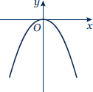

1. **a b c**

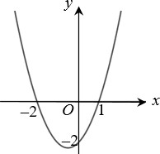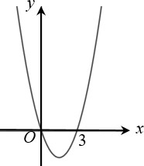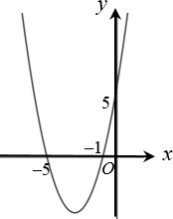

1. **a b c**

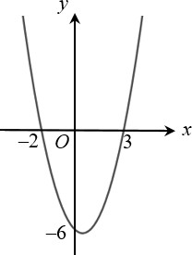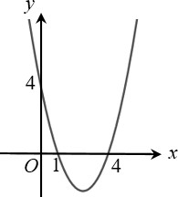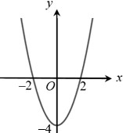

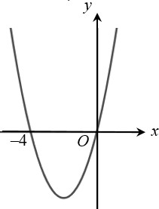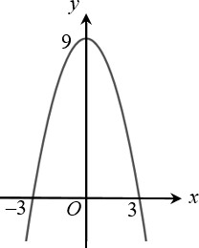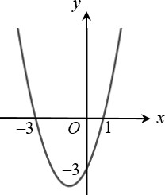**d e f**

**4**

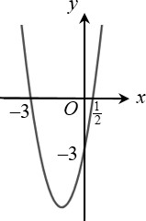

**5 a b c**

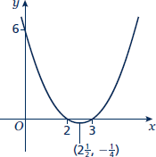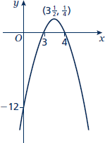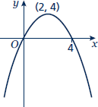

**6**

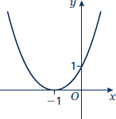

Line of symmetry at *x* = −1.

## Solving linear simultaneous equations by elimination

### Answers

**1** *x* = 1, *y* = 4

1. *x* = 3, *y* = –2
2. *x* = 2, *y* = –5
3. *x* = 3, *y* = – 1

2

1. *x* = 6, *y* = –1
2. *x* = –2, *y* = 5

## Solving linear simultaneous equations by substitution

### Answers

1. *x* = 9, *y* = 5
2. *x* = –2, *y* = –7
3. *x* = 1 , *y* = 3 1

2 2

1. *x* = 1 , *y* = 3

2

1. *x* = –4, *y* = 5
2. *x* = –2, *y* = –5
3. *x* = 1 , *y* = 1 3

4 4

1. *x* = –2, *y* = 2 1

2

1. *x* = –2 1 , *y* = 5 1

2 2

## Solving linear and quadratic simultaneous equations

Answers

**1** *x* = 1, *y* = 3



**2** *x* = 2, *y* = 4

*x* = 4, *y* = 2

**3** *x* = 1, *y* = −2

*x* = 2, *y* = –1

**4** *x* = 4, *y* = 1



**5** *x* = 3, *y* = 4

*x* = 2, *y* = 1

**6** *x* = 7, *y* = 2

*x* = −1, *y* = −6

**7** *x* = 0, *y* = 5

*x* = –5, *y* = 0

**8** *x* = , *y* = 

*x* = 3, *y* = 5

**9** *x* = –2, *y* = –4

*x* = 2, *y* = 4

**10** *x* = , *y* = 6

*x* = 3, *y* = 5

**11** *x* = , *y* = 

*x* = , *y* = 

**12** *x* = , *y* =  *x* = , *y* = 

## Solving simultaneous equations graphically

### Answers

**1 a** *x* = 2, *y* = 5

**b** *x* = 2, *y* = −3

1. *x* = −0.5, *y* = 2.5

**2 a** *x* = −2, *y* = 2

**b** *x* = 0.5, *y* = 0.5

**c** *x* = −1, *y* = −2

**3 a** *x* = 1, *y* = 0 and *x* = 4, *y* = 3

**b** *x* = −2, *y* = 7 and *x* = 2, *y* = −5

**c** *x* = −2, *y* = 5 and *x* = −1, *y* = 4

1. *x* = −3, *y* = 4 and *x* = 4, *y* = −3
2. **a i** *x* = 2.5, *y* = −2 and *x* = −0.5, *y* = 4

**ii** *x* = 2.41, *y* = −1.83 and *x* = −0.41, *y* = 3.83

**b** Solving algebraically gives the more accurate solutions as the solutions from the graph are only estimates, based on the accuracy of your graph.

## Linear inequalities

### Answers

|  |  |  |  |  |  |  |
| --- | --- | --- | --- | --- | --- | --- |
| **1** | **a**  **d** | *x* > 4  *x* > – 7 | **b**  **e** | *x* ≤ 2  *x* ≥ 10 | **c**  **f** | *x* ≤ –1  *x* < –15 |
| **2** | **a** | 2  *x* < –20 | **b** | *x* ≤ 3.5 | **c** | *x* < 4 |
| **3** | **a** | *x* ≤ –4 | **b** | –1 ≤ *x* < 5 | **c** | *x* ≤ 1 |
|  | **d** | *x* < –3 | **e** | *x* > 2 | **f** | *x* ≤ –6 |

1. **a** *t* < 5

2

**b** *n* ≥ 7 5

1. **a** *x* < –6 **b** *x* < 3

2

1. *x* > 5 (which also satisfies *x* > 3)

## Quadratic inequalities

### Answers

**1** –7 ≤ *x* ≤ 4

**2** *x* ≤ –2 or *x* ≥ 6

**3** 1  *x*  3

2

**4** *x* <  3

2

or *x* > 1

2

**5** –3 ≤ *x* ≤ 4

**6** –3 ≤ *x* ≤ 2

1. 2 < *x* < 2 1

2

1. *x*  3

2

or *x*  5

3

## Sketching cubic and reciprocal graphs

### Answers

1. **a** i – C
2. – E
3. – B
4. – A
5. – F
6. – D

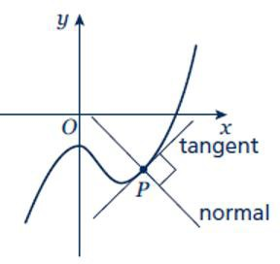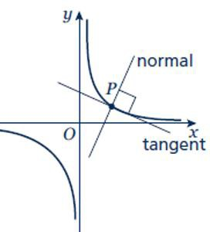**b ii iv**

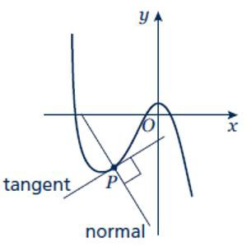**vi**

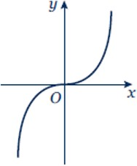**2 3**

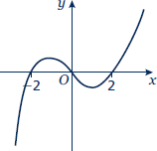

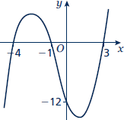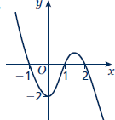**4 5**

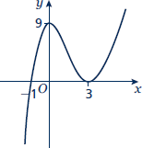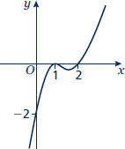**6 7**

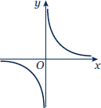**8 9**

***y***

***O***

***x***

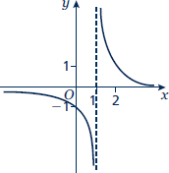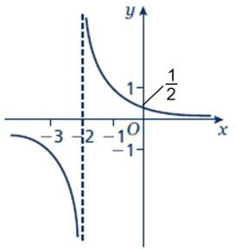**10 11**

## Translating graphs

### Answers

### **1 2**

**3**

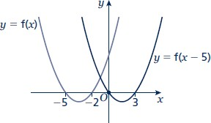

**4** *C*1: *y* = f(*x* – 90°)

*C*2: *y* = f(*x*) – 2

**5** *C*1: *y* = f(*x* – 5)

*C*2: *y* = f(*x*) – 3

1. **a b**

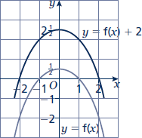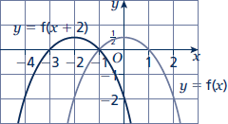

## Stretching graphs

### Answers

1. 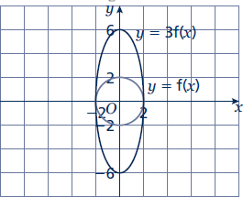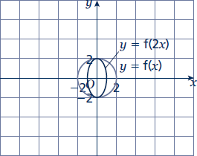**a b**

**8 9**

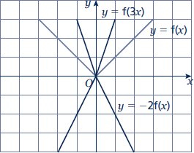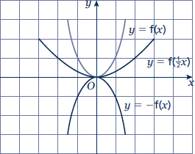

**10**

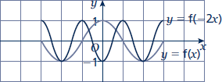

**11** *y* = f(2*x*)

**12** *y* = –2f(2*x*) or *y* = 2f(–2*x*)

1. **a b**

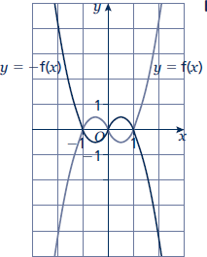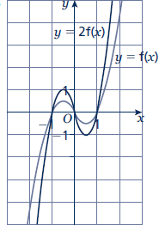

**14**

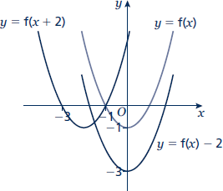

**15**

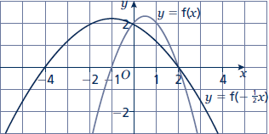

## Straight line graphs

## Answers

**1 a** *m* = 3, *c* = 5 **b** *m* =  1 , *c* = –7

2

**c** *m* = 2, *c* =  3

2

**e** *m* = 2 , *c* =  7 or –2 1

1. *m* = –1, *c* = 5

**f** *m* = –5, *c* = 4

3 3 3

**2**

|  |  |  |
| --- | --- | --- |
| **Gradient** | ***y*-intercept** | **Equation of the line** |
| 5 | 0 | *y* = 5*x* |
| –3 | 2 | *y* = –3*x* + 2 |
| 4 | –7 | *y* = 4*x* –7 |

|  |  |  |  |  |
| --- | --- | --- | --- | --- |
| **3** | **a** | *x* + 2*y* + 14 = 0 | **b** | 2*x* – *y* = 0 |
|  | **c** | 2*x* – 3*y* + 12 = 0 | **d** | 6*x* + 5*y* + 10 = 0 |

**4** *y* = 4*x* – 3

**5** *y* =  2 *x* + 7

3

|  |  |  |  |  |
| --- | --- | --- | --- | --- |
| **6** | **a** | *y* = 2*x* – 3 | **b** | *y* =  1 *x* + 6  2 |
|  | **c** | *y* = 5*x* –2 | **d** | *y* = –3*x* + 19 |

**7** *y*   3 *x*  3 , the gradient is  3

and the *y*-intercept is 3.

2 2

The line intercepts the axes at (0, 3) and (2, 0).

Students may sketch the line or give coordinates that lie on the line such as 1,



3  or 4, 3.

2



 

## Parallel and perpendicular lines

### Answers

|  |  |  |  |  |
| --- | --- | --- | --- | --- |
| **1** | **a** | *y* = 3*x* –7 | **b** | *y* = –2*x* + 5 |
|  | **c** | *y* = – 1 *x* | **d** | *y* = 3 *x* + 8 |

2 2

1. *y* = −2*x* – 7

|  |  |  |  |  |  |  |
| --- | --- | --- | --- | --- | --- | --- |
| **3** | **a** | *y* = – 1 *x* + 2 | **b** | *y* = 3*x* + 7 | | |
|  | **c** | *y* = –4*x* + 35 | **d** | *y* = 5 *x* – 8 | | |
|  |  |  |  | 2 | | |
| **4** | **a** | *y* = – 1 *x* | **b** | *y* = 2*x* | | |
| **5** | **a** | Parallel | **b** | Neither | **c** | Perpendicular |
|  | **d** | Perpendicular | **e** | Neither | **f** | Parallel |
| **6** | **a** | *x* + 2*y* – 4 = 0 | **b** | *x* + 2*y* + 2 = 0 | **c** | *y* = 2*x* |

2

2

## Volume and surface area of 3D solids

### Answers

**1 a** *V* = 396 cm3 **b** *V* = 75 000 cm3

**c** *V* = 402.5 cm3 **d** *V* = 200*π* cm3

**e** *V* = 1008*π* cm3 **f** *V=* 1372 *π* cm3

3

**g** *V* = 121.5*π* cm3 **h** *V* = 18*π* cm3

**i** *V* = 48*π* cm3 **j** *V* = 98 *π* cm3

3

1. 17 cm
2. 17 cm
3. *V* = *x*3 + 17 *x*2 + 4*x*

2

1. 60 cm3
2. 21.4 cm
3. 32 : 9
4. *r*  3 36*x*

## Pythagoras’ theorem

### Answers

|  |  |  |  |  |
| --- | --- | --- | --- | --- |
| **1** | **a**  **c** | 10.3 cm  58.6 mm | **b**  **d** | 7.07 cm  8.94 cm |
| **2** | **a** | 4 3 cm | **b** | 2 21 cm |
|  | **c** | 8 17 mm | **d** | 18 5 mm |
| **3** | **a** | 18 13 mm | **b** | 2 145 mm |
|  | **c** | 42 2 mm | **d** | 6 89 mm |
| **4** | 95.3 | mm |  |  |
| **5** | 64.0 | km |  |  |
| **6** | 3 5 | units |  |  |
| **7** | 4 3 | cm |  |  |

## Trigonometry in right-angled triangles

### Answers

|  |  |  |  |  |  |  |  |  |
| --- | --- | --- | --- | --- | --- | --- | --- | --- |
| **1** | **a** | 6.49 cm | **b** | 6.93 cm | **c** | 2.80 cm |  | |
|  | **d** | 74.3 mm | **e** | 7.39 cm | **f** | 6.07 cm |  |  |
| **2** | **a** | 36.9° | **b** | 57.1° | **c** | 47.0° | **d** | 38.7° |

1. 5.71 cm
2. 20.4°
3. **a** 45° **b** 1 cm **c** 30° **d** cm



3

## The cosine rule

### Answers

|  |  |  |  |  |  |  |  |  |
| --- | --- | --- | --- | --- | --- | --- | --- | --- |
| **6** | **a** | 6.46 cm | **b** | 9.26 cm | **c** | 70.8 mm | **d** | 9.70 cm |
| **7** | **a** | 22.2° | **b** | 52.9° | **c** | 122.9° | **d** | 93.6° |
| **8** | **a** | 13.7 cm | **b** | 76.0° |  |  |  |  |

## The sine rule

### Answers

|  |  |  |  |  |  |  |  |
| --- | --- | --- | --- | --- | --- | --- | --- |
| **9 a** | 4.33 cm | **b** | 15.0 cm | **c** | 45.2 mm | **d** | 6.39 cm |
| **10 a** | 42.8° | **b** | 52.8° | **c** | 53.6° | **d** | 28.2° |
| **11 a** | 8.13 cm | **b** | 32.3° |  |  |  |  |

## Area of a triangle using ½absinC

### Answers

**12 a** 18.1 cm2 **b** 18.7 cm2 **c** 693 mm2

**13** 5.10 cm

1. **a** 6.29 cm **b** 84.3° **c** 5.73 cm **d** 58.8°
2. 15.3 cm