Assessment Framework: Sociology

Because the knowledge structure in sociology looks like this:

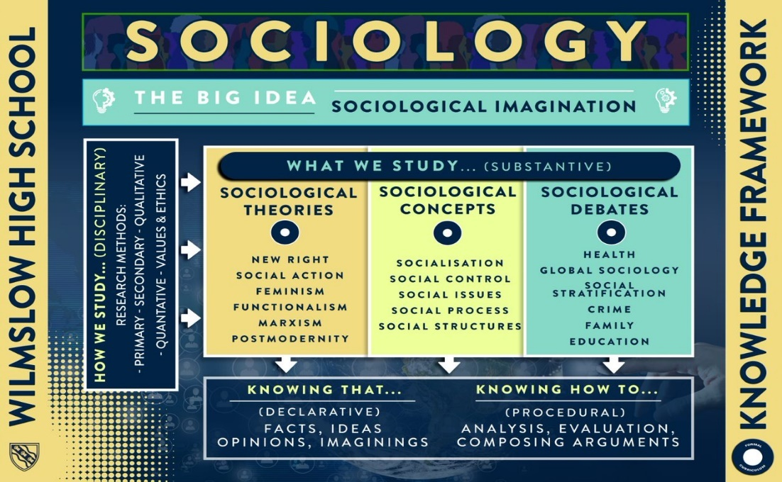

***Skills Tested***:

* Knowledge: Specific, explanatory and descriptive
* Application
* Analysis
* Evaluation
* Argumentation

We assess both declarative and procedural knowledge from a collection of units. Some units are synoptic and applied

|  |  |  |  |  |  |  |
| --- | --- | --- | --- | --- | --- | --- |
|  | HT1 | HT2 | HT3 | HT4 | HT5 | HT6 |
| Year 10 – Declarative | Knowledge Quizzes   * Theories * Concepts | Retrieval quizzes   * Sociological Theories & Concepts   Knowledge quizzes   * Methodologies * Families | Retrieval quizzes   * Sociological Theories & Concepts * Methodologies   Knowledge quizzes   * Theories of the family * Family diversity * Marriage, Divorce | Retrieval quizzes   * Sociological Theories & Concepts * Methodologies * Families   Knowledge quizzes   * Power in the Family * Family Roles * Contemporary Issues in the family | Retrieval quizzes   * Sociological Theories & Concepts * Methodologies * Families   Knowledge quizzes   * Education Theories * Debates surrounding schooling * Social Class * Internal/external | Retrieval quizzes   * Sociological Theories & Concepts * Methodologies * Families * Education   Knowledge quizzes   * Differential Achievement * Relationships and Processes * Social Policy and Education |
| Year 10 - Procedural | Applied exam questions on Theories and Concepts | Applied exam questions on Methodologies to Theories/concepts/ Families | **Mock**:   * Theories in Sociology * Concepts in Sociology * Methods in Sociology   **Mid Unit Exam**:   * Families   Applied exam questions on Methodologies to Families  Essay questions on Families  Key Study Exam Questions | Applied exam questions on Methodologies to Families  Essay questions on Families  Key Studies Exam Questions  **End of Unit Exam**:   * Families | Applied exam questions on Methodologies to Education  Essay questions on Education  Key Studies Exam Questions  **Mid Unit Exam**:   * Education | **Mock**:   * Methods * Family * Education   Applied exam questions on Methodologies to Education  Essay questions on Education  Key Studies Exam Questions |
| Year 11 – Declarative | Retrieval quizzes   * Sociological Theories * Methods * Families * Education   Knowledge Quizzes   * Theories of Crime * Social Control * Data & Crime * Social Constructs | Retrieval quizzes   * Sociological Theories * Methods * Families * Education * Crime   Knowledge quizzes   * Differential Crime * Prisons and Punishment * Young Offenders * Media and Crime | Retrieval quizzes   * Sociological Theories * Methods * Families * Education * Crime   Knowledge quizzes   * Theories of social stratification * Social Mobility * Welfare State * Life Chances | Retrieval quizzes   * Sociological Theories * Methods * Families * Education * Crime * Social Stratification   Knowledge quizzes   * Power in Society * Poverty * Patriarchy * Discrimination * Globalisation | Revision Retrieval quizzes   * Sociological Theories * Methods * Families * Education * Crime * Social Stratification   Knowledge quizzes   * Range of Revision Topics |  |
| Year 11 - Procedural | Applied exam questions on Methodologies to Crime  Essay questions on Crime  Key Study Exam Questions  **Mid Unit Exam**:   * Crime | **Mock**:   * Methodologies * Education * Family * Crime   Applied exam questions on Methodologies to Crime  Essay questions on Crime  Key Study Exam Questions | Applied exam questions on Methodologies to Social Stratification  Essay questions on Social Stratification  Key Study Exam Questions  **Mid Unit Exam**:   * Social Stratification | Applied exam questions on Methodologies to Social Stratification  Essay questions on Social Stratification  Key Study Exam Questions  **Mock**:   * Methodologies * Crime * Social Stratification | Key Study Exam Questions  Debate Essay Questions from all topics  Methods in Context Questions |  |
| Year 12 – Declarative | Knowledge Quizzes   * Health Theories * Concepts and Theories in Sociology | Retrieval quizzes   * Sociological Theories & Concepts * Theories of Health   Knowledge quizzes   * Educational Theories * Health Chances | Retrieval quizzes   * Health Chances * Theories of Health * Theories of education   Knowledge quizzes   * Social class and education * Access to health | Retrieval quizzes   * Health Access and Chances * Social class and education   Knowledge quizzes   * Mental health * Gender and education | Retrieval quizzes   * Mental health * Health chances * Social class and education * Theories of education * Gender and education   Knowledge quizzes   * Power in medicine * Ethnicity and education | Revision retrieval quizzes   * Theories of health * Theories of education * Differentials in education * Health Chances and Access * Mental health * Power in Medicine   Knowledge quizzes   * Methodologies * Social Policies in education |
| Year 12 - Procedural | Essay on Theories of Health  Introduction to Sociology Baseline   * Theories * Concepts | Essay on Health Chances  Essay on Theories in Education  Progress Test   * Theories of Health | **Mock**:   * Theories of Health * Health Chances * Access to Health * Theories of Education * Relationships and processes   Essay on Access to Health  Essay on Social Class and Education  Progress test   * Health Theories * Health Access * Health Chances | Essay on Mental Health  Essay on Gender and Education  Progress test   * Education Theories * Differential Achievement: Social Class and Gender | Essay on Power in the Medical Profession  Essay on Ethnicity and Education  Progress test   * Educational Theories * Differential Educational Achievement * Health Access & Chances * Mental Illness * Health Theories | **Mock**:   * Educational Theories * Differential Educational attainment * Relationships and Processes * Methodologies * Health Theories * Access to Health and Chances * Mental Illness   Essay on Methodologies  Essay on Social Policy and Education |
| Year 13 – Declarative | Retrieval quizzes   * Methods * Theories   Knowledge Quizzes   * Global development Theories * Crime Theory | Retrieval quizzes   * Methods * Educational Policy * Health Access * Power in the medical profession   Knowledge quizzes   * Crime Theories * Globalisation | Retrieval quizzes   * Ethnicity and Education * Theories of Education * Theories of GD * Theories of Health   Knowledge quizzes   * Gender, Ethnicity and White-Collar Crime * Social issues in GD | Retrieval quizzes   * Crime Theories * Health Access * Mental health * Relationships and processes   Knowledge quizzes   * Social issues in GD * TNCs, NGOs, Intl. Organisations * Contemporary Issues in Crime & Deviance | Retrieval Revision quizzes   * Methodologies * Theories in Sociology * Debates in Sociology * Health * GD * Education * Crime & Deviance   Knowledge quizzes   * Theories * Social Control, surveillance and victimology |  |
| Year 13 - Procedural | Essay on Crime and Theory  Essay on Global Development Theories  Progress Test   * Differential Educational Attainment * Crime and Theories * Global Development Theories * Differential health chances | Essay Crime and Theory  Essay on Globalisation  Essay on Social Issues in GD  Progress Test   * Theories of Crime * Global Development Theories * Globalisation   **Mock**:   * Health Chances * Mental Illness * Health Access * GD Theories * Globalisation * Gender and Education * Relationships and Processes in education * Ethnicity and education * Social class and education | Essay on Differentials in Crime and Deviance  Essay on Social Issues in Global Development  Progress test   * Theories in Crime * Globalisation * Theories of GD | Essay on Contemporary Issues in Crime and Deviance  Essay on Social Issues in Global Development  Essay on TNCs, NGOs & Intl. Organisations  Progress test   * Issues in Crime * Differentials in Crime * Social issues in GD * Globalisation * Theories of GD   **Mock**:   * Methods * Crime Theories * Differential Crime and Deviance * Contemporary Issues in Crime * Global Development and Social Issues * Globalisation * Theories of Global Development | Essay on Social Control, Surveillance and Victimology  Essay on Theories and Debates in Sociology |  |

**Assessment Cycle in Sociology**

|  |  |  |  |  |
| --- | --- | --- | --- | --- |
| ***Type*** | ***Length*** | ***Focus*** | ***Impact*** | ***Team Strategies*** |
| ***Short-cycle*** | Lesson to lesson | * Within lessons and between lessons (marking) - ongoing assessment to check students’ understanding through a unit of work. * It also helps teachers be more responsive to students’ needs and adjust delivery when appropriate | * Increased student engagement and understanding * Improve teacher responsiveness. | * Retrieval starters * Starter and plenary exercises * Exit tickets * 100% response through Q & A / white boards. * Strategic questioning * Traffic lights to indicate understanding |
| ***Medium-cycle*** | KS3 - End of each unit : Four to six weeks | * At the end of teaching units to find out what students know. * Declarative and procedural testing with multiple skills and knowledge being tested. * Shows students you value their previous learning. | * Improved student involvement in their assessment * improved teacher understanding about learning | * KS4- Assessed H/W e.g. extended writing, exam questions (weekly / fortnightly) * KS4 and KS5 End of unit tests   KS5- Exam questions and essays |
| ***Long-cycle*** | Bi-annual | * Teacher judgements on progress, informs data captures . | * Improved student monitoring * Informs curriculum development | * Summative 1 and 2 assessment points fixed in calendar. |