The TESCO supermarket chain estimated the impact of the COVID-19 pandemic would be between £650m and £925m.

**Fixed Cost Increase**

The company recruited 45,000 more workers to cope with the demand and make up for absence among staff who were sick or self-isolating. This means Tesco will have to pay for the new workers but also the staff who are off sick or self-isolating with sick pay. This means that there fixed costs will increase.

**Finance**

Tesco said "significant panic buying" had cleared its supply chain of certain items and caused sales to jump by around 30%.

**Employees**

45,000 more employees have been recruited to cope with the increased demands. This means that there is an improved service for the customers who are either ordering online or visiting the open stores.

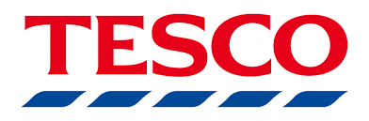

**Cost**

Tesco’s cost will also increase because they are buying more delivery vans so will have to pay for more petrol. Another increase of costs is the sanitising systems that will have been introduced into stores for employees and customers.



**Purchases**

Most people are only buying the basics and no extras. This will reduce overall sales as most customers are only buying bare necessities. Due to the restrictions on travel the fuel sales have reduced.

**Supply**

Industry data last week said UK grocery sales leapt by more than a fifth to a record £10.8bn in the four weeks to 22 March, which included the panic buying period.

Tesco creates 600,000 new delivery slots a week due to more customers self-isolating. This is good because it shows that Tesco are willing to go the extra mile for customers.

**Questions to Consider?**

Will TESCO require a different marketing campaign when shops reopen?

How many staff will TESCO keep on?

What do TESCO need to do to retain their new online customers?