Because the knowledge structure in MFL looks like this:
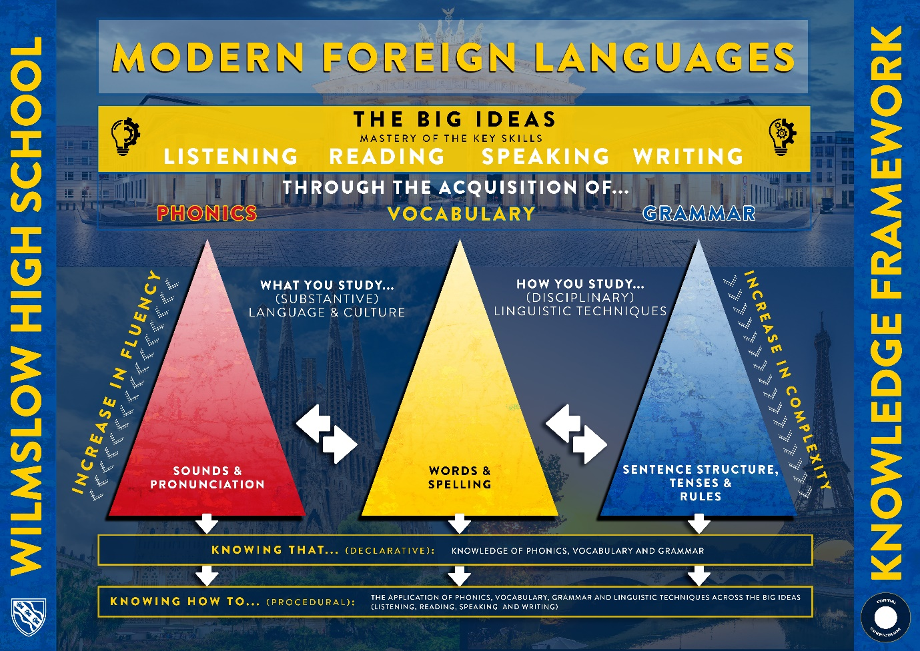

Year 7
Declarative knowledge is demonstrated through students’ knowledge of the ‘three pillars of progression’ (vocabulary, grammar and phonics) and is tested through both formatively and summatively throughout each topic in the form of vocabulary, grammar and phonics retrieval exercises.
Procedural knowledge is demonstrated through students’ ability to apply the vocabulary, grammar, phonics and linguistic techniques across the ‘Big Ideas’ (listening, reading, speaking and writing) and is tested summatively through end of topic ‘Key Task’ assessments which focus on these ‘Big Ideas’. We also assess students formatively on the ‘Big Ideas’ throughout each topic.
Short-cycle assessment:
- Mini whiteboards
- Cold calling for vocabulary knowledge
- Circulating during independent and paired work
- Questioning common misconceptions
Medium-cycle assessment:
- Short homework tasks
- Retrieval starter questions
- Formative reading, writing, listening and speaking tasks
- Formative and summative vocabulary, grammar and phonics tests.

Long-cycle assessment:
- At the end of each topic, students are tested on the material covered and on previous units shown in the below table.
French
 | Term 1  Unit 1 – all about me | Term 2  Unit 2 – festivals and traditions | Term 3  E.O.Y Assessment, including: Unit 3 – a trip to Paris
Declarative | Knowledge of vocabulary, grammar and phonics. | Knowledge of vocabulary, grammar and phonics. | Knowledge of vocabulary, grammar and phonics.
Procedural | Application of vocabulary, grammar and phonics across the ‘Big Ideas’. | Application of vocabulary, grammar and phonics across the ‘Big Ideas’. | Application of vocabulary, grammar and phonics across the ‘Big Ideas’.

German
 | Term 1  Unit 1 – festivals and traditions | Term 2  Unit 2 – a trip to Berlin | Term 3  E.O.Y Assessment, including Unit 3 – all about me
Declarative | Knowledge of vocabulary, grammar and phonics. | Knowledge of vocabulary, grammar and phonics. | Knowledge of vocabulary, grammar and phonics.
Procedural | Application of vocabulary, grammar and phonics across the ‘Big Ideas’. | Application of vocabulary, grammar and phonics across the ‘Big Ideas’. | Application of vocabulary, grammar and phonics across the ‘Big Ideas’.

Spanish
 | Term 1  Unit 1 – a trip to Barcelona | Term 2  Unit 2 – all about me | Term 3  E.O.Y Assessment, including Unit 3 – festivals and traditions
Declarative | Knowledge of vocabulary, grammar and phonics. | Knowledge of vocabulary, grammar and phonics. | Knowledge of vocabulary, grammar and phonics.
Procedural | Application of vocabulary, grammar and phonics across the ‘Big Ideas’. | Application of vocabulary, grammar and phonics across the ‘Big Ideas’. | Application of vocabulary, grammar and phonics across the ‘Big Ideas’.

Year 8
Declarative knowledge is demonstrated through students’ knowledge of the ‘three pillars of progression’ (vocabulary, grammar and phonics) and is tested through both formatively and summatively throughout each topic in the form of vocabulary, grammar and phonics retrieval exercises.
Procedural knowledge is demonstrated through students’ ability to apply the vocabulary, grammar, phonics and linguistic techniques across the ‘Big Ideas’ (listening, reading, speaking and writing) and is tested summatively through end of topic ‘Key Task’ assessments which focus on these ‘Big Ideas’. We also assess students formatively on the ‘Big Ideas’ throughout each topic.
Short-cycle assessment:
- Mini whiteboards
- Cold calling for vocabulary knowledge
- Circulating during independent and paired work
- Questioning common misconceptions
Medium-cycle assessment:
- Short homework tasks
- Retrieval starter questions
- Formative reading, writing, listening and speaking tasks
- Formative and summative vocabulary, grammar and phonics tests.
Long-cycle assessment:
- At the end of each topic, students are tested on the material covered and on previous units shown in the below table.

 | HT1 – My family and friends | HT2 – My hobbies | HT3 & 4– my school | EOY assessment- including where I live/ house and home.
Declarative | Knowledge of vocabulary, grammar and phonics. | Knowledge of vocabulary, grammar and phonics. | Knowledge of vocabulary, grammar and phonics. | Knowledge of vocabulary, grammar and phonics.
Procedural | Application of vocabulary, grammar and phonics across the ‘Big Ideas’. | Application of vocabulary, grammar and phonics across the ‘Big Ideas’. | Application of vocabulary, grammar and phonics across the ‘Big Ideas’. | Application of vocabulary, grammar and phonics across the ‘Big Ideas’.

Year 9
Declarative knowledge is demonstrated through students’ knowledge of the ‘three pillars of progression’ (vocabulary, grammar and phonics) and is tested through both formatively and summatively throughout each topic in the form of vocabulary, grammar and phonics retrieval exercises.
Procedural knowledge is demonstrated through students’ ability to apply the vocabulary, grammar, phonics and linguistic techniques across the ‘Big Ideas’ (listening, reading, speaking and writing) and is tested summatively through end of topic ‘Key Task’ assessments which focus on these ‘Big Ideas’. We also assess students formatively on the ‘Big Ideas’ throughout each topic.
Short-cycle assessment:
- Mini whiteboards
- Cold calling for vocabulary knowledge
- Circulating during independent and paired work
- Questioning common misconceptions
Medium-cycle assessment:
- Short homework tasks
- Retrieval starter questions
- Formative reading, writing, listening and speaking tasks
- Formative and summative vocabulary, grammar and phonics tests.
Long-cycle assessment:
- At the end of each topic, students are tested on the material covered and on previous units shown in the below table.
 | HT1 – Next weekend | HT2 – Holidays in the present and past | HT3 – Jobs and future plans | HT4 – Healthy living | EOY assessment including media
Declarative | Knowledge of vocabulary, grammar and phonics. | Knowledge of vocabulary, grammar and phonics. | Knowledge of vocabulary, grammar and phonics. | Knowledge of vocabulary, grammar and phonics. | Knowledge of vocabulary, grammar and phonics.
Procedural | Application of vocabulary, grammar and phonics across the ‘Big Ideas’. | Application of vocabulary, grammar and phonics across the ‘Big Ideas’. | Application of vocabulary, grammar and phonics across the ‘Big Ideas’. | Application of vocabulary, grammar and phonics across the ‘Big Ideas’. | Application of vocabulary, grammar and phonics across the ‘Big Ideas’.

