A-level Biology – Year 11 transition work

Section 1 - Biological molecules

Quick questions

- What is the primary structure of a protein?

.................................................................................................................................... (1)
- What type of bond holds together the secondary structure of a protein?

.................................................................................................................................... (1)
- Name two monosaccharides.

................................................................................................................................... (2)
- Which disaccharide is composed of two molecules of glucose?

.................................................................................................................................... (1)
- Name two polysaccharides.

................................................................................................................................... (2)
- Which elements are lipids composed of?

.................................................................................................................................... (1)
- What is the difference between saturated and unsaturated fatty acids?

..........................................................................................................................................
.................................................................................................................................... (1)
- What is the difference between triglycerides and phospholipids?

..........................................................................................................................................
................................................................................................................................... (2)
- What is the function of enzymes?

.................................................................................................................................... (1)
10. What is activation energy?

.................................................................................................................................... (1)
Total 13 marks
Examination questions

Q1.
The diagram shows four biological molecules.
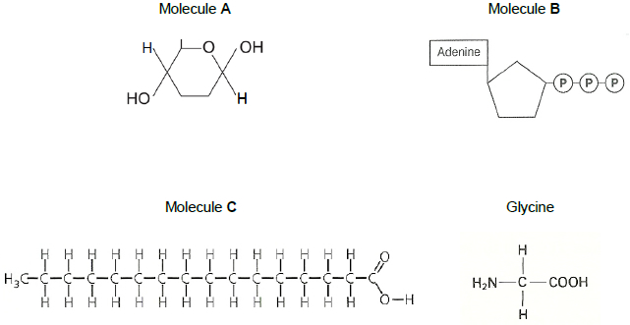
(a) Give the full name of:
Molecule A _____________________________________________________
Molecule B _____________________________________________________
(2)
(b) What type of molecule is molecule C?
___________________________________________________________________
(2)
(c) Glycine, shown in the diagram, is an amino acid.
In the space below, draw a diagram to show the dipeptide produced when two molecules of glycine are joined together.
(2)
(d) Name the other molecule formed when two molecules of glycine are joined together.
___________________________________________________________________
(1)
(Total 7 marks)

Q2.
The diagram represents a triglyceride.
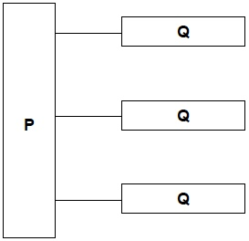
(a) Name the molecules represented in the diagram by:
Box P _____________________________________________________________
Box Q _____________________________________________________________
(2)
(b) Name the type of bond between P and Q in he diagram.
___________________________________________________________________
(1)
(c) Describe how you would test a liquid sample for the presence of lipid and how you would recognise a positive result.
___________________________________________________________________
___________________________________________________________________
___________________________________________________________________
___________________________________________________________________
___________________________________________________________________
___________________________________________________________________
___________________________________________________________________
___________________________________________________________________
___________________________________________________________________
___________________________________________________________________
(2)
(Total 5 marks)

Total 12 marks

