A-level Biology – Year 11 transition work

Section 6 – The circulatory system

Quick questions

- Name the three main types of blood vessel.

................................................................................................................................... (3)
- In which type of blood vessel are substances exchanged between the blood and the cells of the body?

.................................................................................................................................... (1)
- Does the right side of the heart pump blood to the body or to the lungs?

.................................................................................................................................... (1)
- What is the function of heart valves?

.................................................................................................................................... (1)
- Where does the blood go after leaving the atria?

.................................................................................................................................... (1)
- Name the blood vessels that supply the heart muscle with blood.

.................................................................................................................................... (1)
- What is the role of arteries in the circulatory system?

.................................................................................................................................... (1)
- How many molecules of oxygen are bound to a haemoglobin molecule when
it is fully saturated?

.................................................................................................................................... (1)
- Which gas affects the oxygen-binding properties of haemoglobin?

.................................................................................................................................... (1)
10. Under what circumstances does a tissue require the most oxygen?

.................................................................................................................................... (1)

Examination questions
Q1.
(a) What is the function of the coronary arteries?
___________________________________________________________________
___________________________________________________________________
___________________________________________________________________
___________________________________________________________________
___________________________________________________________________
(2)
(b) Figure 1 shows some of the large blood vessels in a mammal.
Figure 1
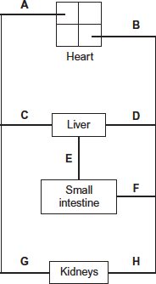
(i) Which of the blood vessels A to H is the vena cava?

(1)
(ii) Which of the blood vessels A to H is the renal artery?
(1)

(c) Figure 2 shows how the blood pressure changes as blood travels from the aorta to the capillaries.
Figure 2
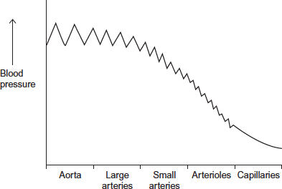
The rise and fall in blood pressure in the aorta is greater than in the small arteries.Suggest why.
___________________________________________________________________
___________________________________________________________________
___________________________________________________________________
___________________________________________________________________
___________________________________________________________________
___________________________________________________________________
(3)
(Total 7 marks)

Q2.
The diagram shows a section through the heart. The main blood vessels are labelled A, B, C and D.
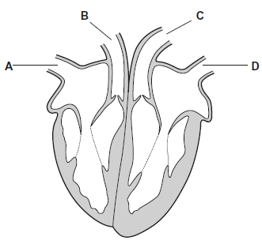
(a) Write a letter, A, B, C or D, in the box to represent the correct blood vessel.
(i) Which blood vessel carries oxygenated blood away from the heart?

(1)
(ii) Which blood vessel carries deoxygenated blood to the heart?
(1)
(b) Explain how the highest blood pressure is produced in the left ventricle.
___________________________________________________________________
___________________________________________________________________
___________________________________________________________________
(1)

(c) Some babies are born with a hole between the right and the left ventricles.
These babies are unable to get enough oxygen to their tissues.
Suggest why.
___________________________________________________________________
___________________________________________________________________
___________________________________________________________________
___________________________________________________________________
___________________________________________________________________
(2)
(Total 5 marks)

Q3.
The diagram shows a cross-section of a blood vessel.
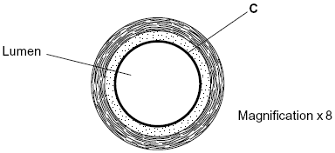
(a) Name layer C.
___________________________________________________________________
(1)
(b) Calculate the actual diameter of the lumen of this blood vessel in millimetres. Show your working.

Answer ____________________ mm
(2)
(c) The aorta has many elastic fibres in its wall. An arteriole has many muscle fibres in its wall.
(i) Explain the importance of elastic fibres in the wall of the aorta.
______________________________________________________________
______________________________________________________________
______________________________________________________________
______________________________________________________________
(2)
(ii) Explain the importance of muscle fibres in the wall of an arteriole.
______________________________________________________________
______________________________________________________________
______________________________________________________________
______________________________________________________________
(2)

(d) The graph shows the rate of blood flow in different blood vessels. It also shows the total cross-sectional area of these blood vessels.
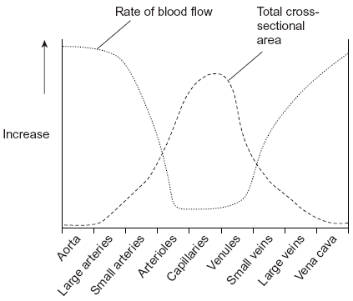
(i) The rate of blood flow decreases from the aorta to the capillaries. Use information from the graph to explain why.
______________________________________________________________
______________________________________________________________
______________________________________________________________
(1)
(ii) Efficient exchange of substances in the capillaries is linked to the rate of blood flow. Explain how.
______________________________________________________________
______________________________________________________________
______________________________________________________________
(1)
(Total 9 marks)

