So you want to study A Level Chemistry? – Wider reading
Introduction to A level chemistry
The A level course is divided in to 3 broad areas with equal weighting over the 2 year course: physical, inorganic and organic chemistry. In year 12 we teach content in all 3 areas, and the topics we will cover are
Physical chemistry atomic structure, bonding, mole calculations, energetics, rates, equilibria and redox
Inorganic chemistry periodicity, group 2 and group 7
Organic chemistry nomenclature, alkanes, alkenes, halogenoalkanes, alcohols, organic analysis
The textbook we use is AQA Chemistry (2nd Ed) by Ted Lister and Janet Renshaw, OUP
An online version of this textbook is available at www.kerboodle.com where you can log in with your own details.

Getting ready for A Level
Below are a selection of wider reading and ideas for you to advance your chemistry knowledge before embarking on A level.

Task 1
Read pages 4-9 in the AQA textbook on atomic structure. This is one of the first topics we will study, and these pages should reinforce what you already learned at GCSE.
Take it a bit further….now read pages 14-16 about electron arrangement. This will give you a good idea of how ideas you learned at GCSE are developed in further detail at A level.

Task 2
Read through the slides on the A level taster presentation. This will give you some background to how the course is taught and assessed, including the practical aspect, and what the expectations of you will be.

Task 3
Have a look at the transition guide on the AQA website:
https://filestore.aqa.org.uk/resources/chemistry/AQA-7404-7405-TG.PDF
Read through the information pages 1-10 and have a go at one of the tasks.

Task 4
Have a look at one or several of these you tube clips, which will help to set the scene and whet your appetite:
https://www.youtube.com/results?search_query=chemistry+a+level+crash+course
Crash course for A level chemistry. This VERY fast talking American presenter will talk you through an entire topic in about 15 minutes. Probably too fast to take it all in, but a good way to get the feel for each topic area. Try clips #1 on the nucleus and #4 on the periodic table for starters

https://www.youtube.com/watch?v=bOuEJf8Dr_4
25 chemistry experiments in 15 minutes
Inspirational chemistry teacher Andrew Szydlo flies through a whole range of chemistry explosive demonstrations

https://www.youtube.com/watch?v=TEl4jeETVmg
How big is a mole? Some interesting facts to get across the idea….its a big number!

https://www.youtube.com/user/periodicvideos
Martyn Poliakoff CBE is an acclaimed professor at the university of Nottingham. His you tube channel Periodic videos claims to have a video on every element of the periodic table- you can really spend all day here! His top 10 all time favourite chemistry videos are here:
https://www.youtube.com/watch?v=HcgpUkcYXfc

https://www.youtube.com/user/MrERintoul
If you really want to get ahead, Eliot Rintoul has created a series of free lessons on A level topics. I would’t suggest you watch too many as you may find them confusing, but if you want to get ahead on how we develop atomic structure, which is one of the first topics in year 12, then try watching that one

Task 5
Have a browse of some useful chemistry websites:
Compound Interest has a really fab selection of infographics: http://www.compoundchem.com/
including how the coronavirus tests work
Royal Society of Chemistry www.rsc.org.uk
Institution of Chemical Engineers www.icheme.org
www.chemguide.co.uk

Task 6
Try reading one or more of these interesting books which have a chemical theme:
Periodic Tales: The curious lives of the elements by Hugh Aldersey-Williams
Uncle Tungsten by Oliver Sacks. Read about Oliver Sacks’ chemical boyhood
‘The Periodic Table’ by Primo Levi. This book combines Levi’s two loves- chemistry and writing
Dorothy Hodgkin – A Life by Georgina Ferry. Read about a very famous woman chemist who was a
powerful inspiration to younger women scientists
Ten Beautiful Experiments by P. Ball ISBN 0854046747 published by the Royal Society of Chemistry This offers a window into the way that chemists think and work and illustrates how they affect the rest of science and the wider world.
The Pleasure of Finding Things Out - Richard Feynman
The Disappearing Spoon - Sam Kean
The Shocking History of Phosphorus: A Biography of the Devil’s Element - John Emsley
Caesar's Last Breath: Decoding the Secrets of the Air Around Us - Sam Kean

Periodic Tales: The curious lives of the elements by Hugh Aldersey-Williams  Everything is made of them, from the furthest reaches of the universe to this book that you hold in your hands, including you. Like you, the elements have lives: personalities and attitudes, talents and shortcomings, stories rich with meaning. You may think of them as the inscrutable letters of the periodic table but you know them much better than you realise. Welcome to a dazzling tour through history and literature, science and art. Here you'll meet iron that rains from the heavens and noble gases that light the way to vice. You'll learn how lead can tell your future while zinc may one day line your coffin. You'll discover what connects the bones in your body with the Whitehouse in Washington, the glow of a streetlamp with the salt on your dinner table. From ancient civilisations to contemporary culture, from the oxygen of publicity to the phosphorus in your pee, the elements are near and far and all around us. Unlocking their astonishing secrets and colourful pasts, Periodic Tales will take you on a voyage of wonder and discovery, excitement and novelty, beauty and truth. Along the way, you'll find that their stories are our stories, and their lives are inextricable from our own. | 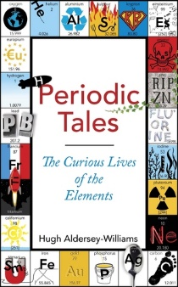
In Uncle Tungsten Oliver Sacks evokes, with warmth and wit, his upbringing in wartime England. He tells of the large science-steeped family who fostered his early fascination with chemistry. There follow his years at boarding school where, though unhappy, he developed the intellectual curiosity that would shape his later life. And we hear of his return to London, an emotionally bereft ten-year-old who found solace in his passion for learning. Uncle Tungsten radiates all the delight and wonder of a boy's adventures, and is an unforgettable portrait of an extraordinary young mind. | 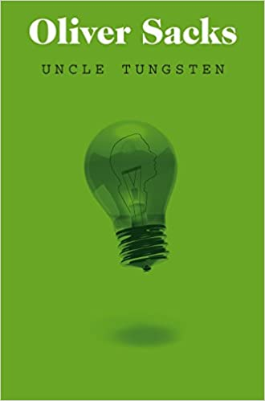
The Periodic Table by Primo Levi is an impassioned response to the Holocaust: Consisting of 21 short stories, each possessing the name of a chemical element, the collection tells of the author's experiences as a Jewish-Italian chemist before, during, and after Auschwitz in luminous, clear, and unfailingly beautiful prose. It has been named the best science book ever by the Royal Institution of Great Britain, and is considered to be Levi's crowning achievement. | 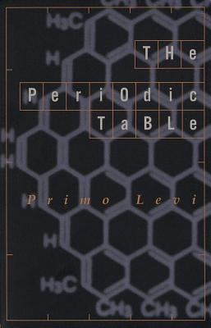
Dorothy Hodgkin – A Life by Georgina Ferry  Dorothy Hodgkin (1910-1994) was a remarkable woman, a researcher who reached the top of her field at a time when women were rarities in science: she remains the only British woman to have won a science Nobel prize. She revealed the hidden structure of important biological molecules such as penicillin and insulin, while having a full life as a mother and grandmother and campaigning passionately for peace and East-West understanding. This book, which was shortlisted for the Duff Cooper Prize and the Marsh Biography Award, tells her story with a narrative energy that brings her vividly to life. | 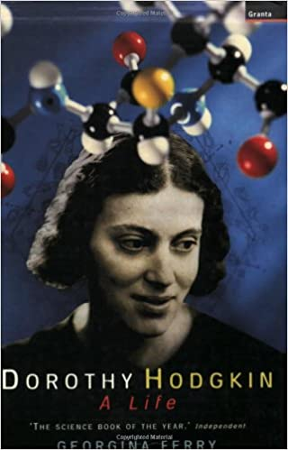
This book aims to stimulate the reader to think anew about some of the relationships and differences between science and art, and to challenge some of the common notions about particular 'famous experiments'. Elegant Solutions: Ten Beautiful Experiments in Chemistry is accessible to all readers, including those without a scientific background and can provide an unusual point of entry into some of the basic concepts of chemistry. Phillip Ball is a renowned, prolific, award winning science writer. | 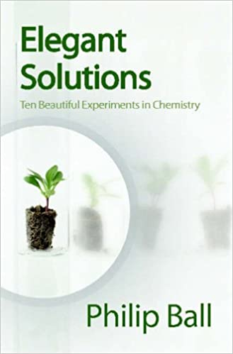
The Pleasure of Finding Things Out collects the best short works of rule-breaking genius Richard Feynman, showing his passion for knowledge and sense of fun at their most infectious.  The revealing and inspiring pieces here span a lifetime of enthusiasm for discovering what makes the world tick - including uproarious tales of early student experiments; safecracking and outwitting US censors during the Second World War; his first lecture as a graduate student (to an audience including Albert Einstein); and the memories of the father who delighted in showing him the world and sparked his insatiable curiosity. | 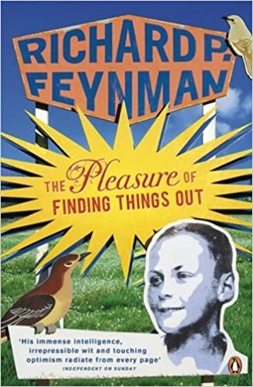
The Disappearing Spoon - Sam Kean  Why did Gandhi hate iodine (I, 53)? Why did the Japanese kill Godzilla with missiles made of cadmium (Cd, 48)? How did radium (Ra, 88) nearly ruin Marie Curie's reputation? And why did tellurium (Te, 52) lead to the most bizarre gold rush in history?  The periodic table is one of our crowning scientific achievements, but it's also a treasure trove of passion, adventure, betrayal and obsession. The fascinating tales in The Disappearing Spoon follow carbon, neon, silicon, gold and every single element on the table as they play out their parts in human history, finance, mythology, conflict, the arts, medicine and the lives of the (frequently) mad scientists who discovered them.  Why did a little lithium (Li, 3) help cure poet Robert Lowell of his madness? And how did gallium (Ga, 31) become the go-to element for laboratory pranksters? The Disappearing Spoon has the answers, fusing science with the classic lore of invention, investigation, discovery and alchemy, from the big bang through to the end of time. | 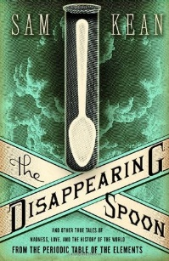
The Shocking History of Phosphorus: A Biography of the Devil’s Element - John Emsley  Born of the age of alchemy and harbouring the kind of mysterious influence that alchemists sought, phosphorus brought wealth to a few but misery to many. For over 300 years, phosphorus maimed, killed, polluted and burned - sometimes on a terrifying scale. Yet, such were its perceived benefits that doctors prescribed it, every home contained it and whole industries were dedicated to its manufacture | 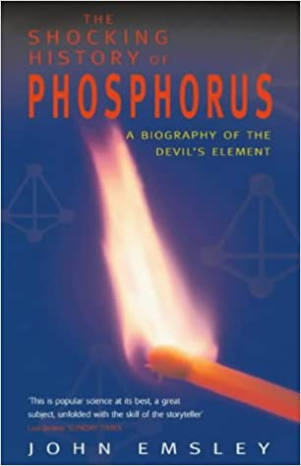
Caesar's Last Breath: Decoding the Secrets of the Air Around Us  -Sam Kean  With every breath, you literally inhale the history of the world. On the ides of March, 44 BC, Julius Caesar died of stab wounds on the Senate floor, but the story of his last breath is still unfolding; in fact, you're probably inhaling some of it now. Of the sextillions of molecules entering or leaving your lungs at this moment, some might well bear traces of Cleopatra's perfumes, German mustard gas, particles exhaled by dinosaurs or emitted by atomic bombs, even remnants of stardust from the universe's creation.  Tracing the origins and ingredients of our atmosphere, Kean reveals how the alchemy of air reshaped our continents, steered human progress, powered revolutions, and continues to influence everything we do. Along the way, we'll swim with radioactive pigs, witness the most important chemical reactions humans have discovered, and join the crowd at the Moulin Rouge for some of the crudest performance art of all time. Lively, witty, and filled with the astounding science of ordinary life, Caesar's Last Breath illuminates the science stories swirling around us every second. | 