Assessment Framework: Mathematics
Because the knowledge structure in maths looks like this:
Because the knowledge structure in Maths looks like this:
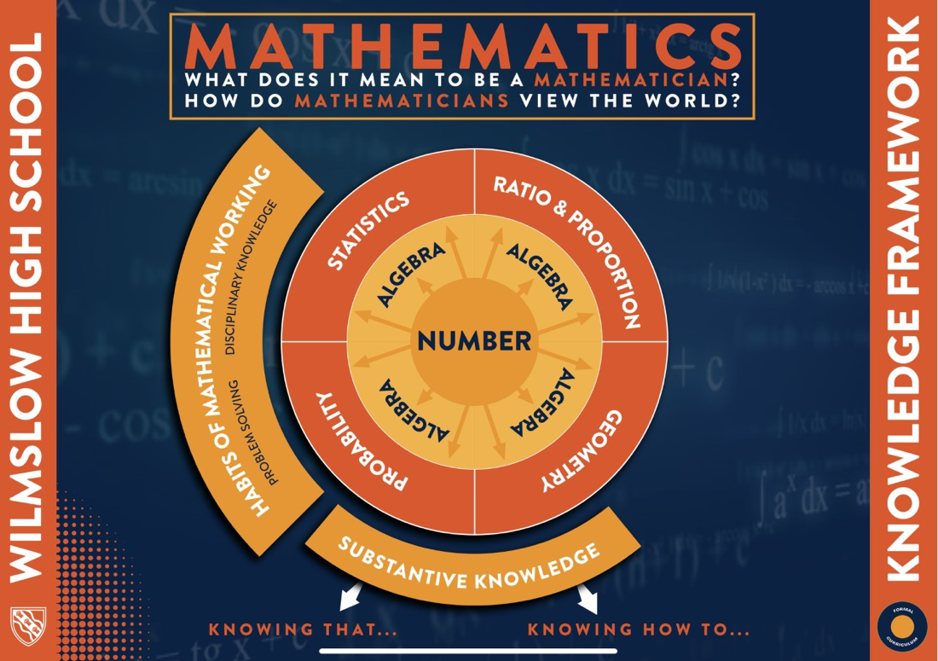
We assess the students fluency of number and algebra at the beginning of the year, then assess both declarative and procedural knowledge from a collection of units taught across a half term. Number and algebra are the language of mathematics, and are at the heart of all other topics taught.
This outlines the formal, teacher marked, assessments that will produce a gap analysis document for each student. In each half term between, we will also have student marked assessments that will be used to inform students’ revision and are conducted in a less formal setting.
Short-cycle assessment:
We are continually assessing students’ progress in and between lessons with
- Extended exit tickets which are either peer assessed or teacher assessed
- Multiple choice questions and hinge questions during lessons to observe the students immediate understanding.
- Teacher circulation and live marking
Medium-cycle assessment:
- Through Sparx maths homework
- Retrieval starter questions to check retained knowledge/knowledge from homework – these emphasise the importance of remembering key information
Long cycle assessment:
At the end of each half term, students are tested on the material covered in that half term and on expected prior knowledge of number and algebra. These assessments will be teacher marked.
Year 7 Gapped Assessments
 | HT1 | HT3 | HT6
Declarative | Baseline Assessment  Number: place value: integers and decimals, addition, subtraction, multiplication and division, rounding and estimation, prime numbers, ordering integers, decimals and fractions,  Geometry – calculating with time, converting units of length, perimeter of rectangles, marking coordinates on a graph  Algebra – terms and patterns in a sequence, using inequalities  Statistics – drawing bar charts | Number: calculations with negative numbers, choosing the correct order of operations.  Algebra: form an expression, simplifying, substitution.  Plus HT2 Retrieval | Number: Adding and Subtracting fractions and Mixed Numbers  Algebra: collecting like terms.  Geometry: types of angles, the sum of angles in polygons.  All topics from September are covered in the End Of Year Assessment
Procedural | Algebra: solving for missing numbers, Prime factorisation.  Geometry – nets a cube  Ratio and Proportion – solving proportion problems | Number: performing calculations in the correct order  Algebra: forming expressions  Geometry: Calculations with measurements  Plus HT2 Retrieval | Number: Addition and Multiplication in different contexts.  Algebra: Solving equations  Geometry: Construction of triangles, Area and Perimeter of 2D shapes, bearings  All topics from September are covered in the End Of Year Assessment

Year 7 Non gapped Assessments
 | HT2 | HT4 | HT5
Declarative | Number: Place value with integers and decimals, Multiplying and Dividing with integers and decimals, Rounding and Estimating, prime number recognition, factors and multiples, squares, cubes and roots,  Equivalent fractions, decimals and percentages, fractions and percentages of amounts  Geometry: Converting measures, Time and Timetables. | Number: function machines  Algebra: Correcting algebraic notation, First steps in solving equations, collecting like terms, sequences  Geometry: Understanding Polygons and symmetry  Plus HT3 retrieval | Number: HT4 retrieval  Geometry: Knowing angles within parallel lines, knowing the sum of angles in a triangle and quadrilateral. Stating lines of symmetry and order of rotational symmetry. Stating the three requirements for a bearing.
Procedural | Number: Prime factorisation, applying square, cube or roots to a number. Calculating fractions and percentages of amounts.  Geometry: Ordering measurements, converting area and volume problems. | Number: Finding missing inputs and outputs in number machines. Continuing sequences  Algebra: Describing sequences algebraically (nth term), solving equations.  Geometry: Finding missing angles in polygons | Algebra: Forming equations in context of angles, area and perimeter.  Geometry: Calculating missing angles, giving reasons for missing angles in diagrams, calculating area and perimeter, calculating with bearings

Year 8 Gapped Assessments
 | HT1 | HT3 | HT6
Declarative | Number: Decimal places, significant figures. Adding decimals, converting fractions decimals and percentages. Calculating with percentages  Geometry: Converting measures | Number: index laws.  Algebra: substitution. Recognising the gradient and y intercept of a straight line graph, drawing inequalities.  Geometry:  Statistics: definitions of averages | Geometry: Transformations  Statistics: Types of correlation
Procedural | Number: Round to a given degree of accuracy. Converting between fractions, decimals and percentages. Calculating percentages of amounts. | Number: Applying laws of indices  Algebra: Expand and Factorise, Solve Equations, drawing straight line graphs, describing inequalities  Statistics: calculating averages | Number: Share in a ratio, proportion,  Algebra: Substitution, straight line graphs, non- linear graphs,  Geometry: Missing angle problems. Area of 2D shapes and circles.  Statistics: Pie charts

Year 8 Non gapped Assessments
 | HT2 | HT4 | HT5
Declarative | Number: Converting between index form and expanded form.  Algebra: Expand brackets, factorise expressions. Solve equations with fractions. | Number: Writing a ratio, multiply and divide fractions.  Statistics: Labelling pie charts | Number: Addition and subtraction. Multiplication.  Algebra: form equations.  Geometry: Types of angles within parallel lines, sum of angles in polygons, Area of a circle, Area of 2d shapes.
Procedural | Number: Calculating with indices, simplifying with indices  Algebra: Substitution into expressions, solving equations, | Number: Using ratio to find missing values, use multiplicative relationships to find missing values in proportion questions.  Statistics: Calculating angles for a pie chart. finding the nth term of a sequences. | Geometry: Calculate missing angles in triangles, quadrilaterals and parallel lines. Calculate missing angles in polygons. Calculate the area of compound shapes.

Year 9 Gapped Assessments
 | HT1 | HT3 | HT6
Declarative | Number: Calculating with powers and roots, calculating with indices, stating HCF and LCM. Converting between standard form and ordinary form, converting between fractions, decimals and percentages, calculating percentages of amounts. | Number: Inputs and outputs for functions.  Algebra: substitution, rearranging formula, knowing gradients and intercepts of straight line graphs.  Geometry: Knowing units of compound measurements  Geometry: recognising similar shapes | Algebra: Substitution, simultaneous equations graphically.  Geometry: Recognising formula for 3D shapes  Probability: creating tree diagrams, reading venn diagrams.
Procedural | Number: Using percentages in context (interest), expressing a number as a product of primes.  Algebra: Solving equations with indices  Probability: Calculating basic probabilities. | Number:  Algebra: Substitution into formula, expanding and factorising, solving equations, drawing straight line graphs  Geometry: Calculating volume and surface area of shapes, calculating with speed, density, pressure. Using scale factors for proportion and enlargement.  . | Algebra: solving simultaneous equations. Solving inequalities.  Geometry: Calculating volume and surface area of 3D shapes,  Statistics: Creating a pie chart, interpreting pie charts, interpreting bar charts, comparing using averages. Drawing cumulative frequency charts, drawing box plots. Calculating quartiles.  Probability: Calculating probabilities from venn diagrams, using tree diagrams

Year 9 Non gapped Assessments
 | HT2 | HT4 | HT5
Declarative | Number: Multiplication, calculations with fractions and mixed numbers.  Algebra: functions, Substitution into formula, expanding brackets  Geometry: recognise and use formula for volume of 3d shapes. | Number: Multiplication  Algebra: Representing inequalities on a number line. | Number: Square numbers, square root of numbers, division.  Pythagoras’ theorem  Statistics: calculating averages, reading data
Procedural | Number: Calculating with fractions in context  Algebra: Solving equations, Rearranging formula, substitution into formula.  Geometry: calculating surface area of 3D shapes, volume of 3D shapes | Algebra: Representing inequalities on a number line and graphically, solving inequalities, solving simultaneous equations.  Geometry: constructions | Geometry: finding missing values with Pythagoras’ theorem,  Statistics: using averages, representing data with a pie chart or bar chart

