Spanish Films and Series on NETFLIX
Watching a Spanish film or programme on Netflix is a great way of learning a language as you can be immersed in the language while familiarising yourself with Hispanic and Latino culture and customs. Language learning should always be fun, as enjoyment plays a big role in keeping you motivated. So, why don’t you watch a few of the films on this list and make your learning entertaining!

Features on Netflix for Language Learning

Subtitles:

There are different options available on Netflix depending on your level. You can watch Spanish films or programmes with English subtitles first, and then watch them again with Spanish subtitles. When you’re more confident, you can watch films without subtitles altogether.

Audio description:
Another great feature on Netflix for learning Spanish is the audio description feature, which exists for some but not all shows. This feature allows you to hear what you see, in Spanish, which improves comprehension and also boosts your vocabulary. It is an intense but fruitful way to immerse yourself in a language.

 | Films on Netflix | Date I watched it | What I thought of it…
1 | Roma
2 | Holy Camp (La Llamada)
3 | Like water for chocolate (Como agaua para chocolate)
4 | Spanish Affair 2 (Ocho Apellidos Catalanes)
5 | The Invisible Guest (Contratiempo)
6 | The Fury of an Innocent man (Tarde para la Ira)
7 | Perdiendo el Norte
8 | Smoke and Mirrors (El hombre de las mil caras)
9 | 100 metres (100 metros)
10 | Palmtrees in the snow (Palmeras en la nieve)
11 | Holy Goalie
12 | Thi Mai

1) Roma (2hrs 14 mins )

Oscar winner Alfonso Cuarón delivers a vivid, emotional portrait of a domestic worker’s journey set against domestic and political turmoil in 1970’s Mexico. (2018)
Rated: Suitable for 15 years and over
Accent: Mexican Spanish

2) Holy Camp (La Llamada) (1hr 49 mins)

Popular Spanish film adaptation of a cult musical comedy. Two rebellious teen girls who love reggaeton music have a life –changing brush with the divine at a camp run by nuns. Very funny and relateable despite the unlikely plot. (2017)
Rated: Suitable for 12 years and over
Accent: European Spanish

3) Like water for chocolate (Como agua para chocolate) (1hr 45 min)
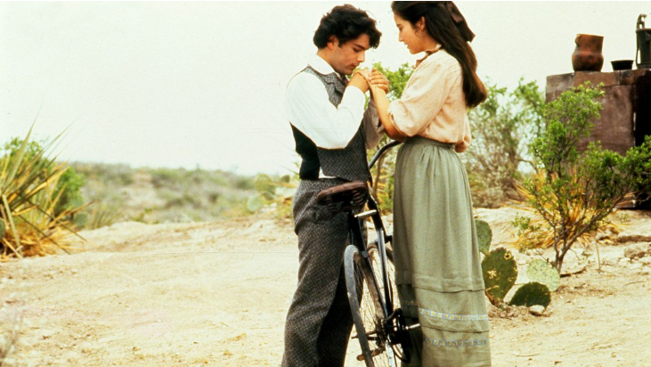
This Mexican Spanish-language movie is a romantic drama with some elements of magical realism. It is a delight for the senses, as it interweaves the wondrous worlds of food and human relationships. It tells a story laced with high emotion, familial tension and tradition. In this film, the viewer is launched into the complexities of family dynamics within Mexico. These difficulties are relatable, in that we recognize the classic roles and hierarchy that still exist to some extent within today’s society. Although these relationships might seem pretty antiquated to the modern viewer, we get a glimpse into the role of women within Mexican society at that time. We also witness the heartache of the character Tita, who is forbidden from marrying her love, Pedro. (This is also an A Level Spanish set text, for those of you who are thinking about continuing with A Level studies)
Rated: Suitable for 15 years and over
Accent: Mexican Spanish
4) Spanish Affair 2 (Ocho Apellidos catalanes) (1hr 46 mins)

Spanish provincialism is put into the spotlight as a man from the Basque Country embarks on a mission to keep his daughter from marrying a Catalan. (This film features a lot of the actors from the first film, Ocho Apellidos Vascos, which is an A Level Spanish set film) (2015)
Rated: Suitable for 15 years and over
Accent: European Spanish
5) The invisible guest (Contratiempo) (1hr 46mins)

This 2016 film is a great Spanish murder mystery. A successful businessman from Barcelona, who is being charged with the murder of his mistress, must produce an account of his actions. To add to the turmoil, he has just three hours to devise his testimony. A high-calibre trainer gives him witness coaching to ensure he is ready to go on trial. This is a tense and dramatic movie that demonstrates the dangerous and destructive consequences of lies and deception. Flashbacks bring this Netflix film to life and keep the viewer engaged as you try to piece this jigsaw puzzle together. (2016)
Rated: Suitable for 12 years and over
Accent: European Spanish
6) The Fury of an innocent man (Tarde para la ira) (1hr 32min)

This popular Spanish movie is a thriller that delves into the violent nature of humans. It is both tense and fascinating. This is a movie that has fantastically captivating and complex characters. Jose, a man who is ordinarily solitary and good-natured, gets caught up in the lives of a recently released convict, his girlfriend, and their son. This unexpected encounter takes them on a three day journey which involves violence, emotional confrontation, and revenge. This award-winning cocktail of bitterness makes for a great Spanish movie, but it may not be one for the faint-hearted. (2016)
Rated: Suitable for 15 years and over
Accent: European Spanish

7) Perdiendo el Norte

Cute and entertaining Spanish comedy about two overeducated and underemployed young Spaniards who move to Berlin to find professional jobs, but end up working in a Turkish cafe. Some hilarious moments of cultural misunderstanding.
Rated: 12
Accent: European Spanish
8) Smoke and Mirrors (El hombre de las mil caras) (2h 2mins)

“The Man of the Thousand faces” or “Smoke and Mirrors is a story of traitors and cheats inspired by real events. This is a hugely entertaining and gripping film which focuses on the corruption within the Spanish political system in the 1990s. As we watch, we are presented with a former spy’s revenge on the system that deceived and cheated him. Alongside an exciting script, is a beautifully colourful and striking movie. Viewers also benefit from the historical and political references, which may help you develop a slightly more specialized Spanish vocabulary. (2016)
Rated: PG
Accent: European Spanish

9) 100 Metres (100 metros) (1hr 48min)
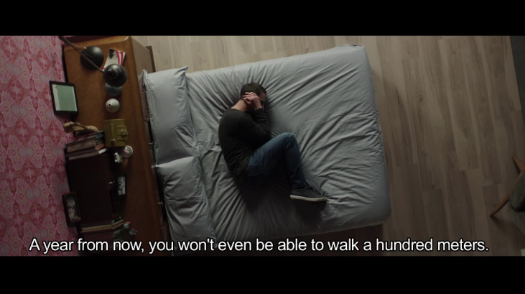
This is perhaps the most heartwarming of the Spanish movies on Netflix. This true story will introduce you to some interesting Spanish vocabulary. Ramon comes to terms with his diagnosis of multiple sclerosis and the realisation that he will not be able to walk 100 meters in just a few months’ time. However, he doesn’t allow this news to be a prophetic truth. He decides to complete an Ironman race and defy the odds. Ramon soon becomes an accomplished athlete with MS. This is a great Netflix film that shows one man’s grit and determination. This movie also has the Spanish audio description feature.(2016)
Rated: Suitable for 12 years and over
Accent: European Spanish
10) Palm trees in the snow (Palmeras en la nieve) (2hrs 43 min)

The accidental discovery of a long lost letter drives Clarence to travel from the snowy mountains of Spain to Africa, to visit the land where his father Jacobo and uncle Kilian spent most of their youth, the island of Fernando Poo. In the heart of a land as lush and seductive as dangerous, Clarence unearths the secret of a forbidden love story framed within turbulent historical circumstances whose consequences will have repercussions in her present-day life. (2015)
Rated: Suitable for 15 years and over
Accent: European Spanish
11) Holy Goalie (1hr 35min)

Holy Goalie is a comedy starring one of Spain’s top comic actors, Karra Elejalde. The plot revolves around a group of monks whose monastery is on the brink of financial ruin, and who spot a slim sliver of hope in the “Champion Clerum” — a European football tournament in which only those who have taken holy orders may compete. There is, however, one minor obstacle to overcome: not one of them has every played football before, and so the makeshift team is going to need a little divine intervention if they are to win the contest and keep the monastery afloat. (2017)
Rated: Suitable for 15 years and over
Accent: European Spanish
12) Thi Mai (1hr 29min)

This comedy film follows the quest of Carmen (Machi), who, after losing her daughter María in an accident, receives a letter informing her that she has been approved for the adoption of Thi Mai, the young Vietnamese girl of the film’s title. Accompanied by her two best friends, Elvira and Rosa, who have never set foot outside Spain, Marta travels to Asia to meet her new daughter. There, the three women encounter a series of increasingly complicated, exotic and outlandish situations that bring out the most eccentric aspects of each of their personalities. Andrés (played by Dani Rovira, a famous Spanish comedian), a Spanish actor who upped sticks to Hanoi to live with his partner, and a local tour guide also have their parts to play in the adventure. (2017)
Rated: Suitable for 15 years and over
Accent: European Spanish
13. A Cambio de Nada
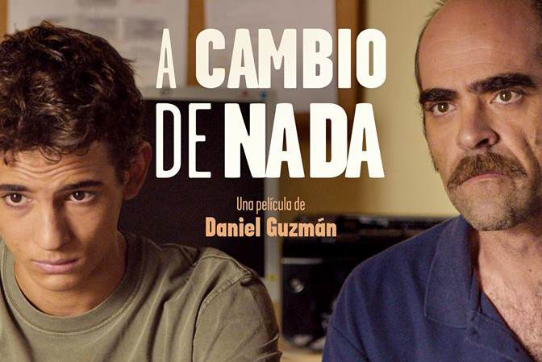
Dario, a teen living with his divorced mother in Madrid, takes to the streets when he is expelled from school. He finds a new family in his overweight friend, Luismi; Antonia, an old lady who collects and resells trashed furniture; and Caralimpia, a bike shop owner who fences stolen motorcycles and parts.
Rated : Suitable for 13 yrs and over
Accent: European Spanish

 |  | Spanish Series on Netflix | Date I watched an episode | What I thought of it…
1 |  | Velvet & Velvet Colleción
2 |  | Cable Girls (Las chicas del cable)
3 |  | Money Heist (La casa de papel)
4 |  | Morocco, Love in times of war
5 |  | Grand Hotel (Gran hotel)
6 |  | Unauthorised Living (Vivir sin permiso)
7 |  | High Seas
8 |  | Narcos
9 |  | The house of flowers (La casa de las flores)

1) Velvet (4 seasons) & Velvet Colección (2 seasons)

A feel-good, compelling Spanish television series about a fashion house in Madrid in the late 50's, which is scene to money, fashion, drama, entanglements, love, jealousies, plots, counter-plots involving its owners, customers and residential employees. Alberto (Miguel Ángel Silvestre) has been left to run a store called Velvet, one of the most prestigious fashion stores in Spain, by his late father. It takes place in the 50's / 60's and displays the beautiful clothing and cars from that era. The main storyline of the show is the business decisions surrounding the continuation of the fashion store and the steamy love story of Alberto, heir of Galerías Velvet, and Ana (Paula Echevarría), who works as a seamstress there. (2016)
Rated: PG
Accent: European Spanish

2) Cable Girls (Las Chicas del cable) (3 seasons)

It's the 1920s and Spain has just gotten its first national telephone company, located in Madrid. For four young women who get jobs there, it's more than just work. It represents progress that is being made at the time as women are gaining more equality with men. This drama series follows the ladies, known as "cable girls," who feel attached in different ways -- to their families, their partners and their memories.
Rated: PG
Accent: European Spanish

3) Money Heist (Casa de Papel) (2 seasons)

Casa de Papel is a recent Spanish series on Netflix. It has been very successful, and is still in production. It tells how El Profesor, a very mysterious man, imagined, organized and set up the biggest robbery ever attempted. Attempting to infiltrate the National Money Factory of Madrid, for 11 days, to manufacture nearly 2.4 billion euros. He surrounds himself with the best eight robbers in the country, and trains them for two months. (2017)
Rated: Suitable for 15 years and over
Accent: European Spanish

4) Morocco: Love in Times of War (1 season)

It's the 1920s and the North African territory of Rif is resisting being ruled by Morocco, leading to the War of Rif. During the conflict, Queen Victoria Eugenia sends a group of nurse trainees from Madrid's upper class to open a hospital in the city of Melilla to help Spanish soldiers who have been injured in battle. Along the way, the women find friendship and romance while saving the lives of the soldiers on the front lines. (2017)
Rated: Suitable for 15 years and over
Accent: European Spanish

5) Grand Hotel (Gran hotel) (3 seasons)

Set in Spain in the early 20th century, Julio arrives at a luxury hotel to meet his sister, head chambermaid Cristina only to discover she has disappeared. Julio makes it his mission to find her and infiltrates the hotel under the guise of a footman. (2013)
Rated: PG
Accent: European Spanish

6) Unauthorized living (Vivir sin permiso) (1 season)

An influential Galician drug cartel leader must seek out his successor while keeping his degenerative Alzheimer’s disease a secret. When he reveals his plans to reture, his second-in-command plots to steal the empire from the heir
Rated: Suitable for 15 years and over
Accent: European Spanish

7) High Seas (1 Season)

Mysterious deaths on a luxurious ship travelling from Spain to Rio de Janeiro in the 1940s uncover secrets surrounding two sisters who are travelling together. (2019)
Rated: Suitable for 15 years and over
Accent: European Spanish

8) Narcos (3 seasons)

Narcos is a series first launched to trace the story of one of the world’s largest drug traffickers, Pablo Escobar, and more generally the Medellin cartel, in the late 70s. The third season then focuses on the Cali cartel. The series is American but takes place in Colombia. It tells the story of these two huge cartels as they are tracked by the DEA, the US Drug Enforcement Administration, which fights against drug trafficking. Again, this series has had tremendous success on Netflix, which is why it is still in production today. The series is both English and Spanish. An agent of the American DEA tells the first two seasons in voiceover (so in English). However, it takes place in Colombia so the majority of the dialogues are in Spanish. The main actor, who plays Pablo Escobar, is surprisingly Brazilian. But his Spanish is perfect, and accessible (and he’s a great actor!). There is a lot of slang, and the conversations are sometimes very vulgar. But it’s a narcotrafic series, so we cannot expect nice dialogues!
Rated: Suitable for 15 years and over
Accent: Colombian Spanish & English

9) The house of flowers (La casa de las flores) (currently 1 season)

This new Netflix Original is generating rave reviews. In this satirical telenovela, the seemingly perfect De La Mora household deals with the dark secrets uncovered by the sudden death of the patriarch’s mistress, while learning that their flower shop shares its name with a cabaret secretly owned by the father of the family. (2018)
Rated: Suitable for 15 years and over
Accent: European Spanish

