Database structure document for use with Activity 2

Note: you are required to provide only one screenprint of each type of validation. However, you must have thoroughly validated your tables in order to meet the user requirements given.

Table Structures
Add screenprints of each of your tables in design view showing the table names, field names and data types ONLY
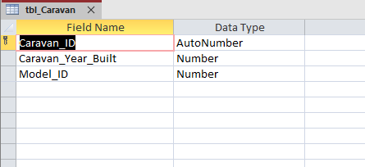
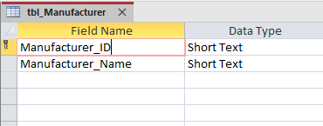
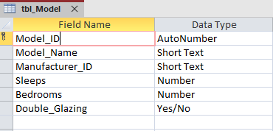
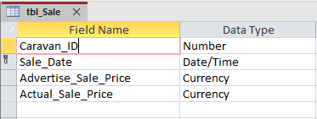

Table Validation
Ensure the validation and the field it is applied to can be seen clearly in your screenshots.

Presence Check
- Add a screenprint of one presence check
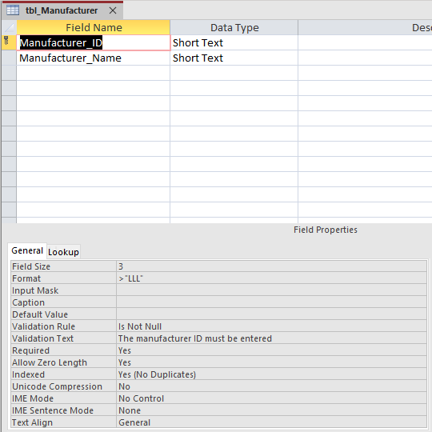

Length Check
- Add a screenprint of one length check

Value Lookup or Range Check
- Add a screenprint of one value lookup or one range check you have applied
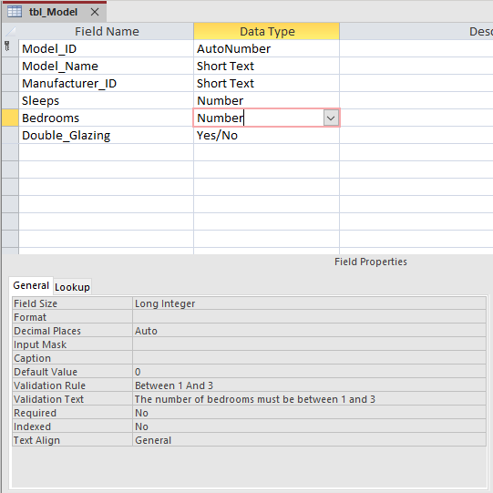

Table Lookup
- Add a screenprint of one table lookup you have applied (foreign key only)
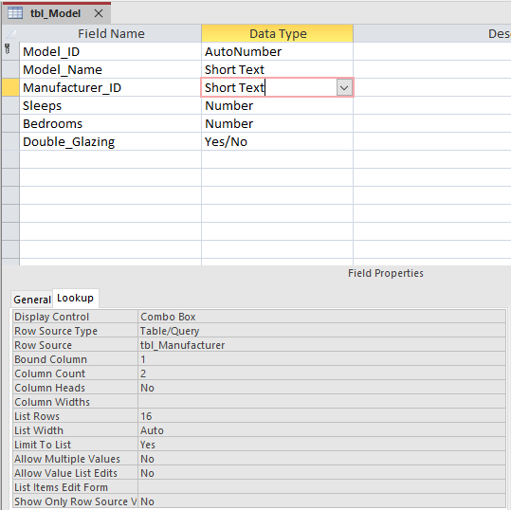

Format Check
- Add a screenprint of one format check you have applied

