**Answers**

1. What do computers use Binary?

|  |
| --- |
| So that computers can be based on logic circuits.  … ( each part of the circuit) can be in one of two states  ... 0 and 1/true or false |

1. What is the name of the electrical components that are contained in the CPU, consisting in one of two states (on/off)?

|  |
| --- |
| Transitor. |

1. Draw a diagram to represent the following expressions:
2. **P**=**A** AND **B**

|  |
| --- |
| A,B and P correct.  Correct AND gate drawn. |

1. **P**=**A** OR **B**

|  |
| --- |
| A,B and P correct.  Correct OR gate drawn. |

1. **P**=(**A** AND **B)** OR **C**

|  |
| --- |
| A AND B correct.  Joined to OR C. |

1. **P**=**(A** AND **B)** AND NOT **C**

|  |
| --- |
| A AND B correct, NOT C drawn correct.  Both (A AND B) and (NOT C) going into an AND gate. |

1. Complete the Truth Tables for the following expressions:
   1. **Q**=**(**NOT **A)** AND **B**

|  |  |  |  |
| --- | --- | --- | --- |
| **A** | **B** | **NOT A** | **Q** |
| 0 | 0 | 1 | 0 |
| 0 | 1 | 1 | 1 |
| 1 | 0 | 0 | 0 |
| 1 | 1 | 0 | 0 |

* 1. **Q**=(NOT **A**) OR **B**

|  |  |  |  |
| --- | --- | --- | --- |
| **A** | **B** | **NOT A** | **Q** |
| 0 | 0 | 1 | 1 |
| 0 | 1 | 1 | 1 |
| 1 | 0 | 0 | 0 |
| 1 | 1 | 0 | 1 |

* 1. **Q**=(**A** AND **B**) OR **C**

|  |  |  |  |  |
| --- | --- | --- | --- | --- |
| **A** | **B** | **C** | **A AND B** | **Q** |
| 0 | 0 | 0 | 0 | 0 |
| 0 | 0 | 1 | 0 | 1 |
| 0 | 1 | 0 | 0 | 0 |
| 0 | 1 | 1 | 0 | 1 |
| 1 | 0 | 0 | 0 | 0 |
| 1 | 0 | 1 | 0 | 1 |
| 1 | 1 | 0 | 1 | 1 |
| 1 | 1 | 1 | 1 | 1 |

* 1. **Q**=**AB** OR **CD**

|  |  |  |  |  |  |  |
| --- | --- | --- | --- | --- | --- | --- |
| **A** | **B** | **C** | **D** | **AB** | **CD** | **Q** |
| 0 | 0 | 0 | 0 | 0 | 0 | 0 |
| 0 | 0 | 0 | 1 | 0 | 0 | 0 |
| 0 | 0 | 1 | 0 | 0 | 0 | 0 |
| 0 | 0 | 1 | 1 | 0 | 1 | 1 |
| 0 | 1 | 0 | 0 | 0 | 0 | 0 |
| 0 | 1 | 0 | 1 | 0 | 0 | 0 |
| 0 | 1 | 1 | 0 | 0 | 0 | 0 |
| 0 | 1 | 1 | 1 | 0 | 1 | 1 |
| 1 | 0 | 0 | 0 | 0 | 0 | 0 |
| 1 | 0 | 0 | 1 | 0 | 0 | 0 |
| 1 | 0 | 1 | 0 | 0 | 0 | 0 |
| 1 | 0 | 1 | 1 | 0 | 1 | 1 |
| 1 | 1 | 0 | 0 | 1 | 0 | 1 |
| 1 | 1 | 0 | 1 | 1 | 1 | 1 |
| 1 | 1 | 1 | 0 | 1 | 0 | 1 |
| 1 | 1 | 1 | 1 | 1 | 1 | 1 |

1. Write out the Boolean expressions to represent each of the following circuits:

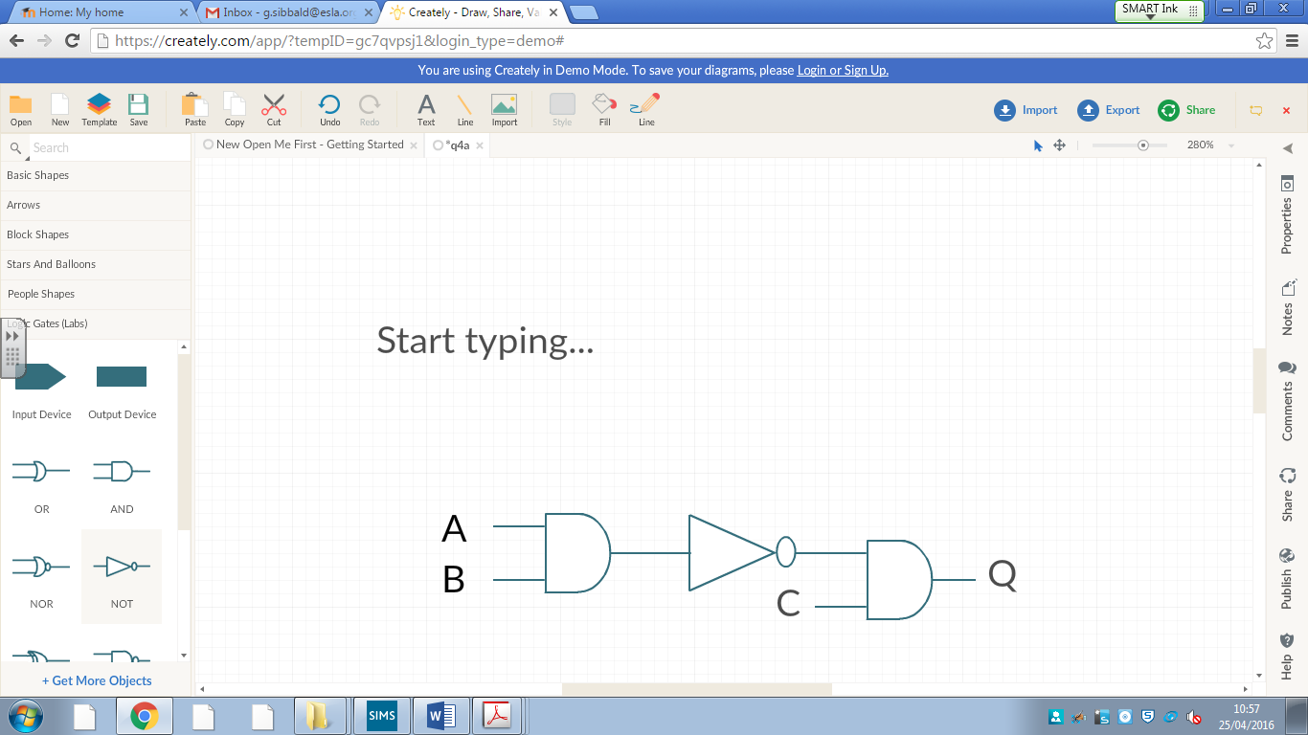

|  |
| --- |
| Q=NOT(A AND B)  AND C |

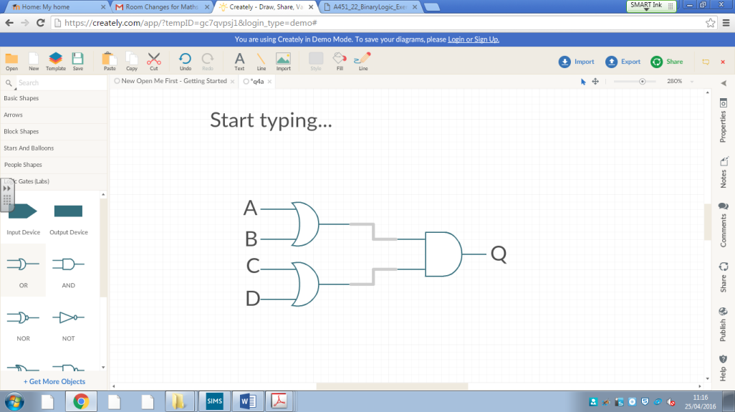

|  |
| --- |
| Q=(A OR B)  AND (C OR D) |

1. Evaluate the following arithmetic expressions where **a=3, b=4, c=5**. Show your working.
2. a^b

|  |
| --- |
| 3^4  **81** |

1. (c-a)^b

|  |
| --- |
| (5-3)^4=2^4  **16** |

1. 8*(a+c)/b

|  |
| --- |
| 8*(3+5)/4=8*8/4=64/4  **16** |

1. (a+b)*(b-c)/(c-a)

|  |
| --- |
| (3+4)*(4+5)/(5-3)=7*9/2=63/2  **31.5** |

1. (b+c)/a*b

|  |
| --- |
| (4+5)/3*4=9/3*4=3*4  **12** |

1. Write an algorithm that will input two numbers (X and Y). Using MOD and DIV output the whole number part and the remainder for dividing X by Y.

|  |
| --- |
| Input x,y  C=x MOD y  D=x DIV y  OUTPUT C,D |

1. What is the output of Z for the following algorithm, when the following numbers are input. **A=27, B=15, C=52**.
2. Z=A MOD 8

|  |
| --- |
| Z=27 MOD 8  3 r 3  MOD = 3 |

1. Z=C DIV B

|  |
| --- |
| Z=52 DIV 15  3 r 7  DIV = 3 |

1. Z=(A MOD 13)+C

|  |
| --- |
| Z=(27 MOD 13)+52  1+52  53 |

1. Z=(88 MOD B) DIV (A MOD 5)

|  |
| --- |
| Z=(88 MOD 15) DIV (27 MOD 5)  13 DIV 2  6 |