Assessment Framework: Mathematics
Because the knowledge structure in maths looks like this:
Because the knowledge structure in Maths looks like this:
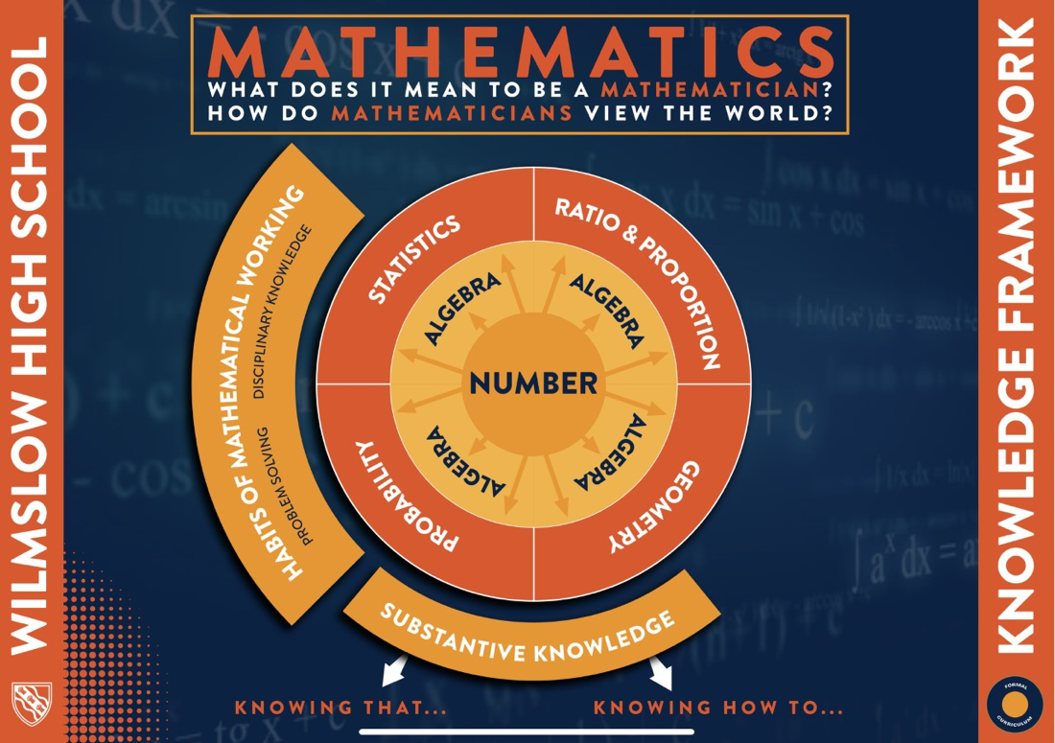
We assess the students fluency of number and algebra at the beginning of the year, then assess both declarative and procedural knowledge from a collection of units taught across a half term. Number and algebra are the language of mathematics, and are at the heart of all other topics taught.
All questions used in assessments at key stage 4 are of GCSE level to help students prepare for their GCSEs at the end of year 11. The more they get used to seeing these types of questions, the more fluent they will become with them.
Short-cycle assessment:
We are continually assessing students’ progress in and between lessons with
- Extended exit tickets which are either peer assessed or teacher assessed
- Multiple choice questions and hinge questions during lessons to observe the students immediate understanding.
- Teacher circulation and live marking
Medium-cycle assessment:
- Through homework, flipped learning tasks and Sparx maths
- Retrieval starter questions to check retained knowledge/knowledge from homework – these emphasise the importance of remembering key information
Long cycle assessment:
Students are regularly assessed throughout key stage 4 on the content they have covered in previous years, along with the new content they are learning at key stage 4.
Year 10
HT1 – Assessment on content learnt in year 9 and start of year 10. Retrieval of previous content with a focus on number and algebra for a strong start to Key Stage 4. Students will receive a GAP analysis of their performance in this assessment with links to sparx for them to complete independent practice to improve their fluency of these topics.
 | Foundation | Higher
Topics | Ordering integers  Ordering positive & negative numbers  Ordering decimals  4 operations with decimals  Round to decimal places/ significant figures  BIDMAS  Rules of indices  Factors  Primes  Prime decomposition  HCF/LCM  Collecting like terms  Simplifying expressions  Expand single brackets  Substitution  Stem & Leaf Diagrams  Averages | Laws of indices  Fractional indices  Negative numbers  Simplifying surds  Rationalise denominators  Percentage increase/decrease  Reverse percentages  Upper & lower bounds  Factorise quadratics (including with coefficient)  Solving quadratics  Difference of two squares  Solve linear equations

HT2 – Assessment focuses on content and procedural knowledge, seeing if students can apply skills in a standard question. Students will receive these papers back and their class teacher will go through the paper with them to identify areas for improvement. Students will receive a GAP analysis of their performance in this assessment with links to sparx for them to complete independent practice to improve their fluency of these topics.
 | Foundation | Higher
Topics | Integers & place value  Decimals  Indices, powers & roots  Factors, multiples & primes  Algebra introduction  Expressions & substitution  Tables, charts & graphs  Pie charts  Scatter graphs  FDP | Indices, roots & reciprocals  Surds  Percentages  Accuracy & bounds  Factorise & solve quadratics  Solve linear equations  Set up equations from worded problems  Change the subject  Functions

HT3/4 – Mid Year Assessment.
Students will receive a GAP analysis of their performance in this assessment with links to sparx for them to complete independent practice to improve their fluency of these topics.
 | Foundation | Higher
Topics | Integers & place values  Decimals  Indices, powers & roots  Factors, multiples & primes  Algebra basics  Expressions & substitution  Tables, charts & graphs  Pie charts  Scatter graphs  FDP  Percentages  Equations  Inequalities  Sequences  Properties of shapes  Interior & exterior angles | Indices, roots & reciprocals  Surds  Percentages  Accuracy & Bounds  Factorise & solve quadratics  Solve linear equations  Set up equations  Change the subject  Functions  Sequences  Simultaneous equations  Linear graphs  Quadratics, cubic & other graphs  Inequalities

HT5 – This assessment is to help students prepare for what topics they need to focus on in the build up to the end of year mock exam. Students will be assessed on topics they have learnt this year and then provided with feedback so they know which topics to focus on as part of their revision for half term 6. Students will receive these papers back and their class teacher will go through the paper with them to identify areas for improvement.
 | Foundation | Higher
Topics | Types of number  Converting fractions to percentages  Percentages of amounts  Fractions of amounts  Simplifying algebra  Solving equations  Product of primes  Rounding  Sequences  Area  Perimeter  Angles in parallel lines  Two way tables  Angles in polygons  Substitution  Calculations with fractions | Inequalities  Nth term of sequences  Solving quadratics  Equations of straight lines  Equation of perpendicular lines  Angles in parallel lines  Volume of a sphere/cone  Trigonometry  Area of compound shapes  Equation of circles

HT6 – End of Year Mock Assessment. Students will sit 2 full GCSE papers at the end of year 10. The majority of students will sit the foundation paper at the end of year 10; this will not limit whether they do higher or foundation in Year 11. Students will have more success on the foundation paper as they have covered more of the content in this paper. This mock will be used, alongside previous assessments and knowledge of the students to determine their tier of entry for year 11. No revision list is provided for the mock exam to help students prepare as they will for their GCSE. Students will receive a GAP analysis of their performance in this assessment with links to sparx for them to complete independent practice to improve their fluency of these topics.
Year 11
Throughout year 11 students will be completing retrieval starter tasks which are class specific based on their GAPs from previous assessments and extended exit tickets at the end of each topic. These are recorded on the mark book for staff use and in students' books in their curriculum journey to support their understanding of their own strengths and weaknesses.
HT2- students will sit a full series of mock assessments prior to the Christmas break. Students will sit either 2 or 3 full GCSE papers. This will be a full experience, the same as they will have for their GCSE exams in the summer with exams being in the hall/gym. This will assess all content for the GCSE and give students an accurate representation of what grade they are working at. Students will receive a GAP analysis of their performance in this assessment with links to sparx for them to complete independent practice to improve their fluency of these topics.
HT4- students will sit an assessment which depending on invigilators will also be in the hall/gym, alternatively will be an in-class assessment. If it is an in class assessment, this will be a split GCSE paper completed over more than one lesson. This will target the weakest paper for the cohort (non-calculator or calculator). Students will receive a GAP analysis of their performance in this assessment with links to sparx for them to complete independent practice to improve their fluency of these topics.

