Assessment Framework: Religion, Ethics & Philosophy

Because the knowledge structure in Religion, Ethics and Philosophy looks like this:

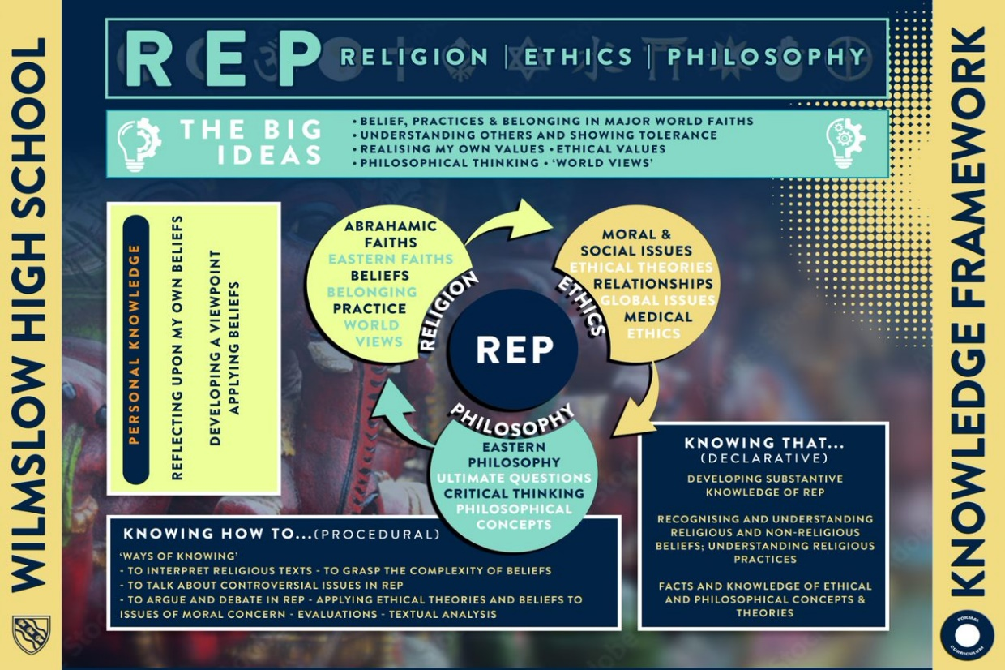

We assess both declarative and procedural knowledge from a collection of units – there are 3-4 units per year. The final unit is usually taught after the end of year exam.

This outlines the formal, teacher marked, assessments that will produce a gap analysis document for each student.

|  |  |  |  |  |  |  |
| --- | --- | --- | --- | --- | --- | --- |
|  | HT1 | HT2 | HT3 | HT4 | HT5 | HT6 |
| Year 7 – Declarative | Knowledge Quizzes:  The prophets- Abraham, Moses, Jesus, Muhammad | Knowledge Quizzes:  The prophets- Abraham, Moses, Jesus, Muhammad | Knowledge Quizzes:  Eastern Faiths- Hindu Dharma and Sikhi  Retrieval Quizzing:   * The Prophets | Knowledge Quizzes:  Eastern Faiths- Hindu Dharma and Sikhi  Retrieval Quizzing:   * The Prophets | Knowledge Quizzes:  Community and Devotion  Retrieval Quizzing:   * The Prophets * Eastern Faiths | Knowledge Quizzes:  Community and Devotion  Retrieval Quizzing:   * The Prophets * Eastern Faiths |
| Year 7 - Procedural | Weighted extended response on influence of Abraham and Moses | Essay response on the importance of the Prophets | Contrast extended response on Sikhi and Hindu  **Exam**   * The prophets * Eastern Faiths | Extended response on | Essay response on acts of devotion | **Exam**   * Eastern Faiths * Prophets * Community and Devotion |
| Year 8 – Declarative | Knowledge Quizzes:  Islam Beliefs  Retrieval Quizzing: Community  Devotion  Prophets | Knowledge Quizzes:  Islam Practices  Retrieval Quizzing: Community  Devotion  Prophets  Islamic Beliefs | Knowledge Quizzes:  Where do we come from?  Retrieval Quizzing: Prophets  Eastern Faiths | Knowledge Quizzes:  Buddhism  Retrieval Quizzing: Eastern Faiths | Knowledge Quizzes:  Why do we suffer?  Retrieval Quizzing: Community  Devotion  Prophets | Knowledge Quizzes:  World Views  Retrieval Quizzing:  Eastern Faiths  Abrahamic Faiths |
| Year 8 - Procedural | Extended essay on the pillars of Islam |  | **Exam**   * Islamic Beliefs and Practices   Essay on origins: Where do we come from? | Essay Question on Buddhism and suffering | Contrast essay on the afterlife | **Exam**   * Islamic beliefs and practices * Buddhism * Where do we come from * Why do we suffer   Exam Question contrasting World Views and organised religion |
| Year 9 – Declarative | Knowledge Quizzes:  Ethical Theories  Retrieval Quizzing: Abrahamic Faiths  Eastern Faiths | Knowledge Quizzes:  Abortion and Euthanasia  Retrieval Quizzing: Abrahamic Faiths  Eastern Faiths  Why do we suffer? | Knowledge Quizzes:  Medical Ethics  Religion and Social Justice  Retrieval Quizzing: Abrahamic Faiths  Eastern Faiths | Knowledge Quizzes:  Religion and Social Justice  Retrieval Quizzing: Abrahamic Faiths  Eastern Faiths  World Views  Community & devotion |  | Knowledge Quizzes:  War |
| Year 9 - Procedural | Essay question on Ethical Theories | Essay Question on Euthanasia and Abortion | Essay Question on Medical Ethics in application to ethical theories | Essay question on Social justice and religion |  | **Exam**   * Ethical Theories * Medical Ethics * Social Justice * War |
| Year 10 – Declarative | Knowledge Quizzes:  Christian Beliefs | Knowledge Quizzes:  Christian Beliefs  Christian practices  Retrieval Quizzing:  Christian Beliefs | Knowledge Quizzes:  Christian Practices  Retrieval Quizzing:  Christian Beliefs | Knowledge Quizzes:  Islamic Beliefs  Retrieval Quizzing:  Christian Beliefs  Christian Practices | Knowledge Quizzes:  Islamic Beliefs  Islamic practices  Retrieval Quizzing:  Christian Beliefs and Practices | Knowledge Quizzes:  Islamic practices  Relationships  Retrieval Quizzing:  Christian and Islamic Beliefs and practices |
| Year 10 - Procedural | Essay Questions on Christian Beliefs | Essay Questions on Christian Beliefs | **Mock**   * Christian Beliefs and Practices   Essay Questions on Christian Practices | Essay Questions on Islamic Beliefs | Essay Questions on Islamic Beliefs and Practices | **Mock**   * Islamic Beliefs and practices * Christian beliefs and practices   Essay Questions on Islamic Practices |
| Year 11 – Declarative | Knowledge Quizzes:  Relationships  Retrieval Quizzing:  Christian and Islamic Beliefs and practices | Knowledge Quizzes:  War and Peace  Retrieval Quizzing:  Christian and Islamic Beliefs and practices  Relationships | Knowledge Quizzes:  Crime and Punishment  Retrieval Quizzing:  Christian and Islamic Beliefs and practices  Relationships  War | Knowledge Quizzes:  Matters of Life  Retrieval Quizzing:  Christian and Islamic Beliefs and practices  Ethics |  |  |
| Year 11 - Procedural | Essay Questions on Relationships | Essay Questions on War and Peace  **Mock**   * Christian Beliefs and Practices * Islamic Beliefs and practices * Ethics: Relationships and War | Essay Questions on Crime and Punishment | Essay Questions on Matters of Life  **Mock**   * Ethics- War * Ethics- Relationships * Ethics- |  |  |

**Assessment Cycle in REP**

|  |  |  |  |  |
| --- | --- | --- | --- | --- |
| ***Type*** | ***Length*** | ***Focus*** | ***Impact*** | ***Team Strategies*** |
| ***Short-cycle*** | Lesson to lesson | * Within lessons and between lessons (marking) - ongoing assessment to check students’ understanding through a unit of work. * It also helps teachers be more responsive to students’ needs and adjust delivery when appropriate | * Increased student engagement and understanding * Improve teacher responsiveness. | * Retrieval starters * Starter and plenary exercises * Exit tickets * 100% response through Q & A / white boards. * Strategic questioning |
| ***Medium-cycle*** | KS3 - End of each unit : Four to six weeks | * At the end of teaching units to find out what students know. * Declarative and procedural testing with multiple skills and knowledge being tested. * Shows students you value their previous learning. | * Improved student involvement in their assessment * improved teacher understanding about learning | * KS3 end of unit assessments. * KS3 Individual pieces of assessed work. * KS4- Assessed H/W e.g. extended writing, annotated images. (weekly / fortnightly) * KS4 End of unit tests |
| ***Long-cycle*** | Bi-annual | * Teacher judgements on progress, informs data captures . | * Improved student monitoring * Informs curriculum development | * Summative 1 and 2 assessment points fixed in calendar. |