A-level Biology – Year 11 transition work

Section 3 – Genetics and cell division

Quick questions

1. What is the name given to the double stranded structure of DNA?

.................................................................................................................................... (1)
2. How many different bases are there in DNA?

.................................................................................................................................... (1)
3. Give the names of the bases in DNA.

.................................................................................................................................... (1)
4. How do the strands of DNA stay together?

.................................................................................................................................... (1)
5. What is complementary base pairing?

.................................................................................................................................... (1)
6. What is a gene?

..........................................................................................................................................
................................................................................................................................... (2)
7. What determines the order of amino acids in a protein?

.................................................................................................................................... (1)
8. What does the ‘m’ in mRNA stand for?

.................................................................................................................................... (1)
9. How many bases code for one amino acid?

.................................................................................................................................... (1)
10. What are mutations?

.................................................................................................................................... (1)

11. What do mutagenic agents do?

.................................................................................................................................... (1)
12. Where is the DNA found in a eukaryotic cell?

.................................................................................................................................... (1)
13. How many homologous pairs of chromosomes do human cells have?

.................................................................................................................................... (1)
14. Give two uses of mitosis.

................................................................................................................................... (2)
15. How many daughter cells are produced in meiosis?

.................................................................................................................................... (1)
Total 17 marks

Examination questions
Q1.
Figure 1 shows a short section of a DNA molecule.
Figure 1
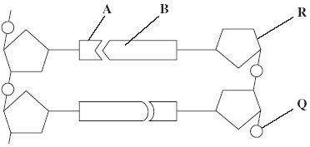
(a) Name parts R and Q.
(i) R ____________________
(ii) Q ____________________
(2)
(b) Name the bonds that join A and B.
___________________________________________________________________
(1)
(c) Ribonuclease is an enzyme. It is 127 amino acids long.
What is the minimum number of DNA bases needed to code for ribonuclease?

(1)

(d) Figure 2 shows the sequence of DNA bases coding for seven amino acids in the enzyme ribonuclease.
Figure 2
G T T T A C T A C T C T T C T T C T T T A
The number of each type of amino acid coded for by this sequence of DNA bases is shown in the table.

Amino acid | Number present
Arg | 3
Met | 2
Gln | 1
Asn | 1
Use the table and Figure 2 to work out the sequence of amino acids in this part of the enzyme. Write your answer in the boxes below.

Gln
(1)
(e) Explain how a change in a sequence of DNA bases could result in a non-functional enzyme.
___________________________________________________________________
___________________________________________________________________
___________________________________________________________________
___________________________________________________________________
___________________________________________________________________
___________________________________________________________________
(3)

(Total 8 marks)

Q2.
The diagram below represents one process that occurs during protein synthesis.
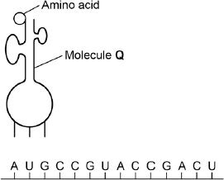
(a) Name the process shown.
___________________________________________________________________
(1)
(b) Identify the molecule labelled Q.
___________________________________________________________________
(1)
(c) In the diagram above, the first codon is AUG. Give the base sequence of:
the complementary DNA base sequence __________________________________
the missing anticodon _________________________________________________
(2)
The table below shows the base triplets that code for two amino acids.

Amino acid | Encoding base triplet
Aspartic acid | GAC, GAU
Proline | CCA, CCG, CCC, CCU

(d) Aspartic acid and proline are both amino acids. Describe how two amino acids differ from one another. You may use a diagram to help your description.

___________________________________________________________________
___________________________________________________________________
___________________________________________________________________
(1)
(e) Deletion of the sixth base (G) in the sequence shown in the diagram above would change the nature of the protein produced but substitution of the same base would not. Use the information in the table and your own knowledge to explain why.
___________________________________________________________________
___________________________________________________________________
___________________________________________________________________
___________________________________________________________________
___________________________________________________________________
___________________________________________________________________
(3)
(Total 8 marks)

Q3.
(a) The diagram shows a stage of mitosis in an animal cell.
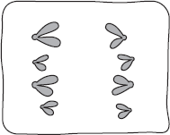
(i) Name this stage.
______________________________________________________________
(1)
(ii) Describe what happens during this stage that results in the production of two genetically identical cells.
______________________________________________________________
______________________________________________________________
______________________________________________________________
______________________________________________________________
______________________________________________________________
(2)
(b) A sample of epithelial tissue from the small intestine of an animal was analysed.
Some of the cells had 8.4 units of DNA, others had only 4.2 units.
(i) Use your knowledge of the cell cycle to explain why some cells had 8.4 units of DNA and others had only 4.2 units.
______________________________________________________________
______________________________________________________________
______________________________________________________________
______________________________________________________________
______________________________________________________________
(2)
(ii) How many units of DNA would you expect to be present in a gamete formed in this animal as a result of meiosis?

(1)
(Total 6 marks)

