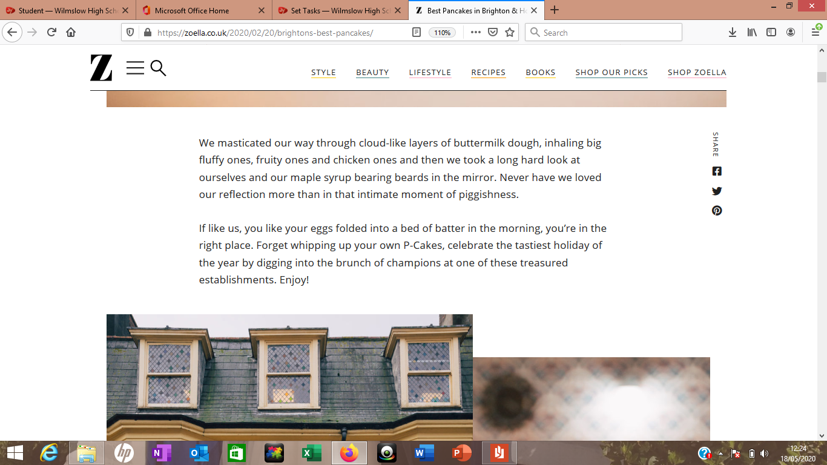

**C**- This piece of text was produced on the Zoella website perhaps because we all have a lot more time on our hands so, using a new recipe for pancakes is something you could give a go

**R** This blog has quite a mixed formality as it uses both high and low formality when communicating with the audience. The low formality can be seen by the similes and the way that the pancakes are described. However, it does use quite sophisticated vocabulary suggesting that it is high formality.

**P-** The purpose of this is to entertain and explain how to make the pancakes to the audience

**M-** The mode of this piece of text is spoken. It is written to be read like someone was speaking it. We can see this by the similes used.

**A**- The main audience of this is teenagers who have interests in baking and beauty as that is what Zoella promotes on her blog

**G-** This blog is a on the Zoella website so can be accessed by anyone.

**M-** The mode of this piece of text is written. The way it is been written shows it is important, with the quotes from people within the community and the writing

**A-** The target audience of this article could possibly be for those living in the Manchester community, all ages.

**C-** This article was produced by the BBC so, would be perceived by mostly people living in Great Britain. The context of it is it talks about the three-year commemoration for those who were at the Manchester arena when the bombing occurred in 2017.

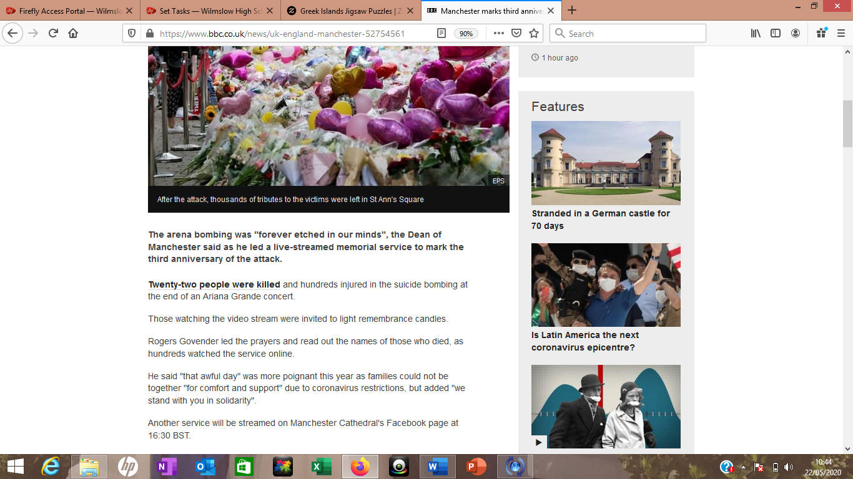

**R-** Personally, I would say that this is high formality due to the context behind it and the way it has been written. There is no slang and no contractions e.g. ‘can’t’.

**G-** This is an article from the BBC website.

**P-** The purpose if this article is to talk about remembering the 22 who lost their lives on this day. Especially during this hard time of a global pandemic, the BBC perhaps created this to show its importance

**A-** Perhaps aged at students in the same predicament so aged 15-18. It could be argued that they only interviewed girls so the audience will be more female based.

**C-** Here is another article produced by the BBC focusing on how the students are feeling after they found out their A-level exams were cancelled.

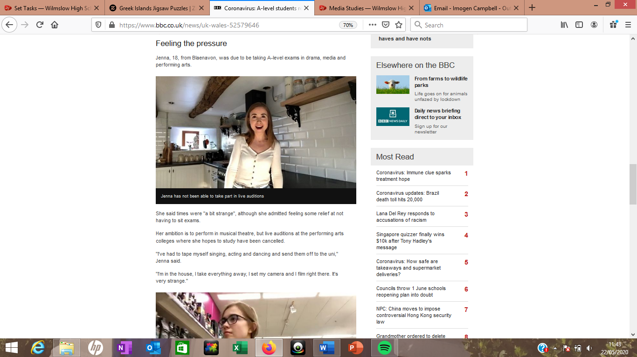

**R-** Personally, I would say that this is low formality. The whole article contains lots of contractions and shortened words. Also, the way these teens were talking could suggest low formality. E.g. slang.

**G-** This is an article from the BBC website.

**P-** This could be to inform those who are feeling uneasy because of this whole situation. Perhaps they wanted to get the point across that everyone will be feeling similar about this whole situation.

**M-** The mode is very much spoken. The article includes quotes said by the students, making it seem like they are talking to us.

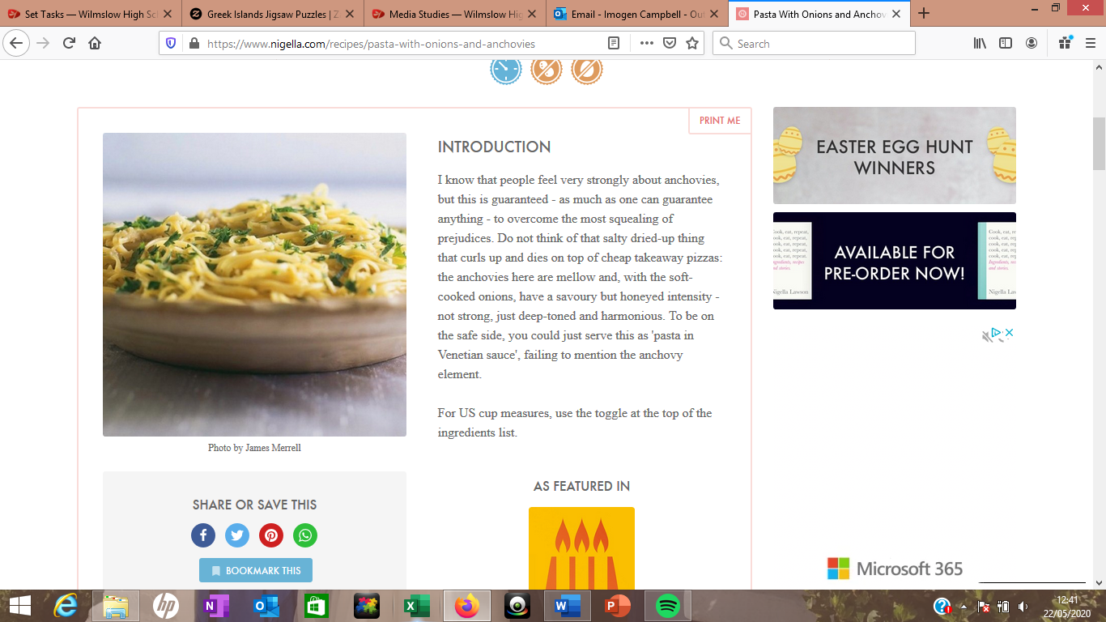 

**C-** Here is the introduction to a recipe by Nigella Lawson. It mentions that she has written this recipe involving anchovies because they are not appreciated enough

**G-** This is an article from the BBC website.

**P-** The purpose of this introduction is to explain and describe what is going to be made alongside with being slightly entertaining.

**M-** I would say the mode is also spoken. The recipe introduction is written almost like Nigella is directly talking to us

**A-** aimed at older people who make the family meals and want to try something new

**R-** Personally, I would say that this is mixed formality. The introduction to the recipe contains small jokes to make you laugh however has quite high level and sophisticated vocabulary.

**G-** This is a recipe from the Nigella Lawson website

**M-** I would say the mode is spoken. The recipe introduction is written almost like Nigella is directly talking to us about the cake

**A-** Aimed at all ages

**C-** Here is the introduction to a recipe by Nigella Lawson. She introduces us to her brilliant chocolate fudge cake with an almost story.

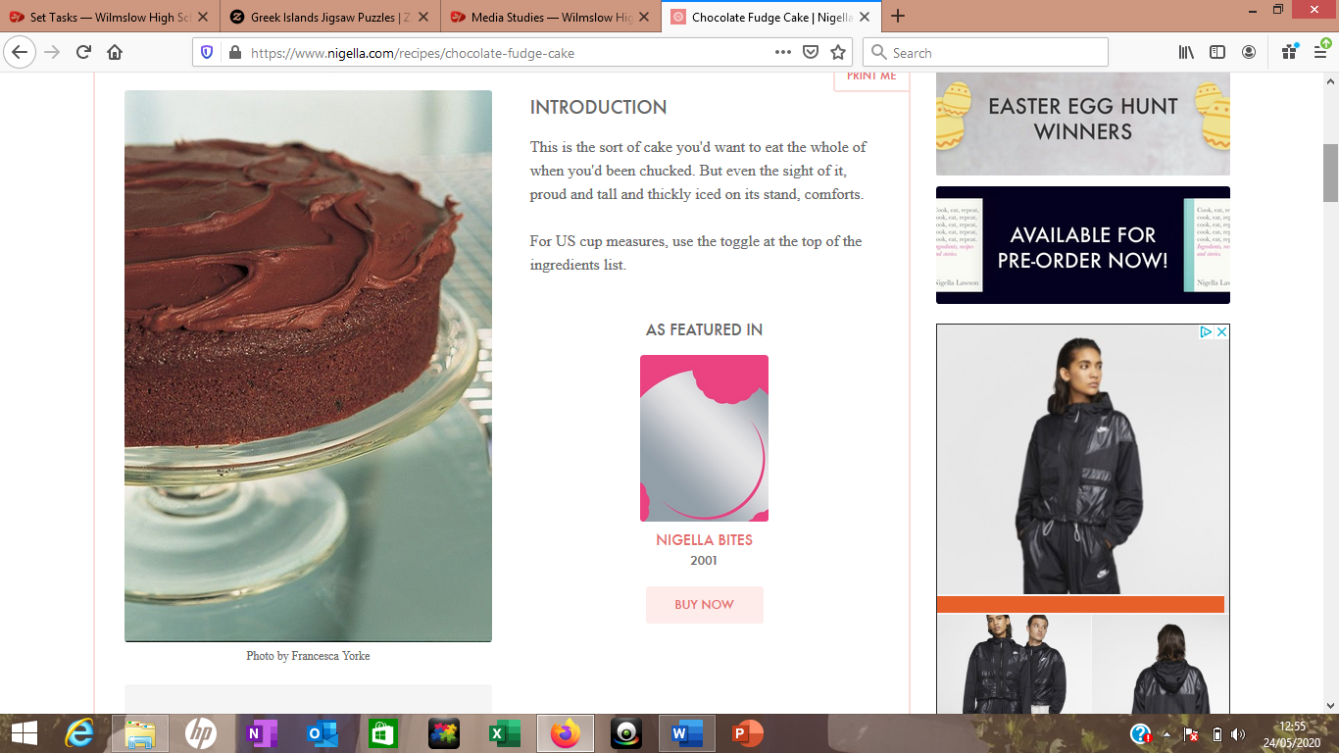

**G-** This is a recipe from the Nigella Lawson website

**P-** The purpose of this introduction is to explain and describe what is going to be made alongside with being slightly entertaining.

**R-** Personally, I would say that this is low formality. The introduction for the recipe is written almost like she is a friend to you and is quite humorous