|  |  |  |  |  |  |  |
| --- | --- | --- | --- | --- | --- | --- |
| RAT  RATING | Task 1 | Task 2 | Task 3 | Task 4 | Task 5 | Task 6 |
| RED |  |  |  |  |  |  |
| AMBER |  |  |  |  |  |  |
| GREEN |  |  |  |  |  |  |

YEAR 11

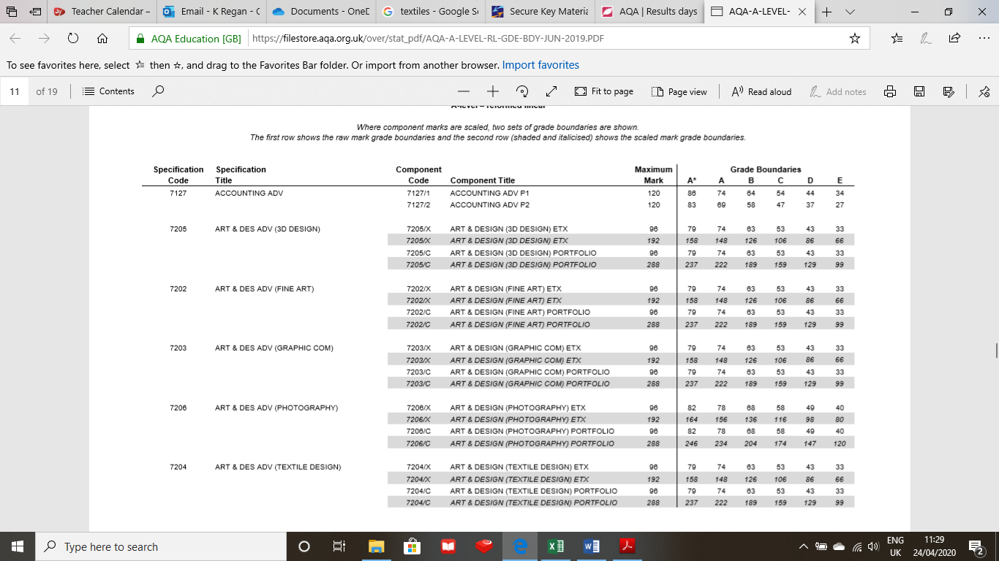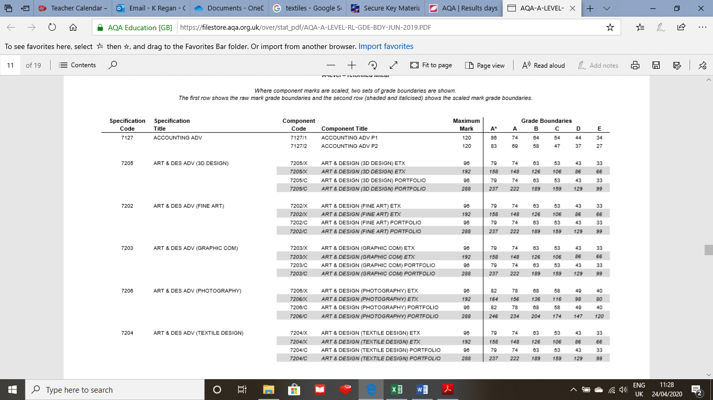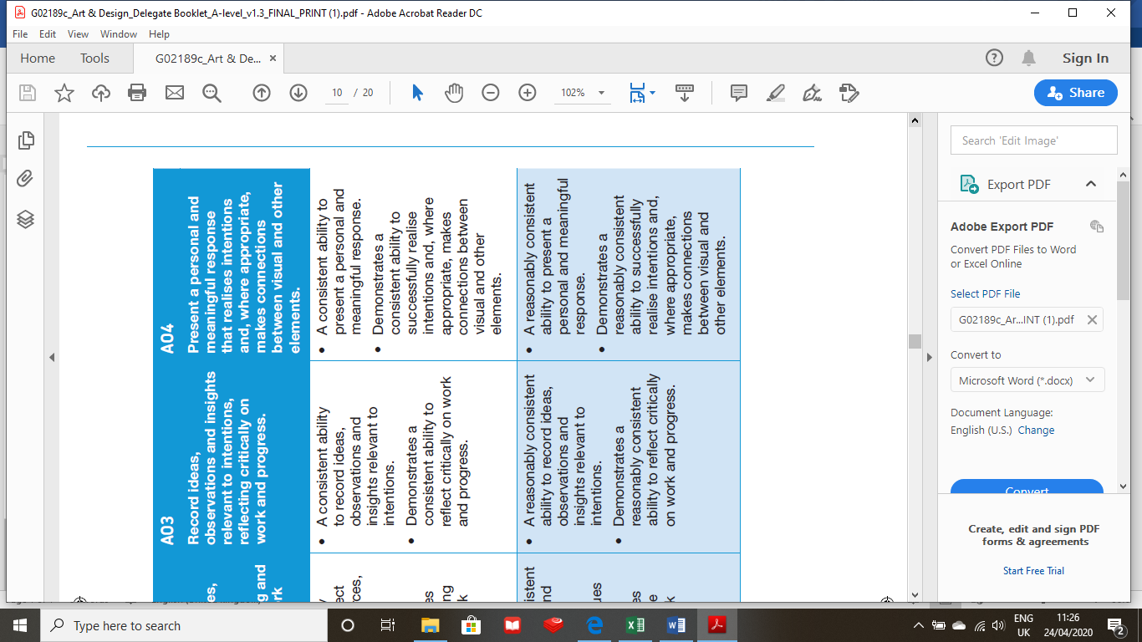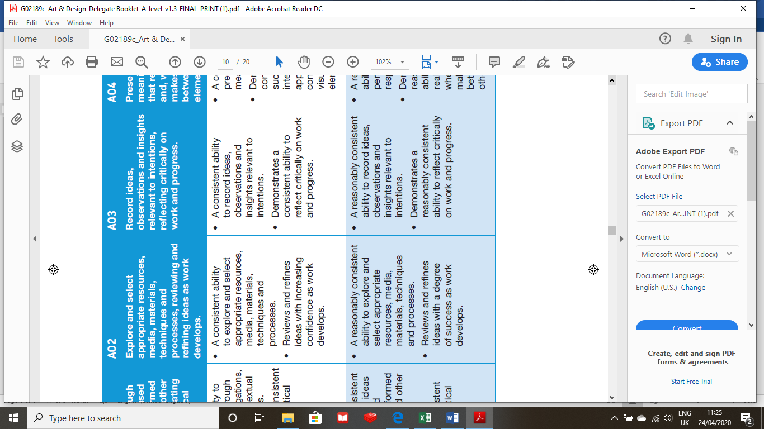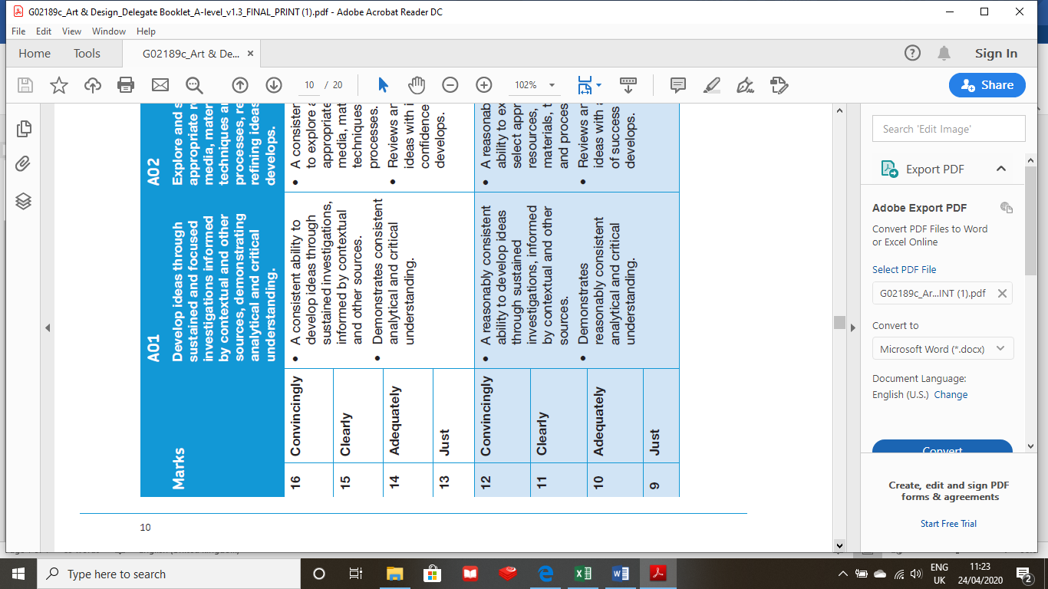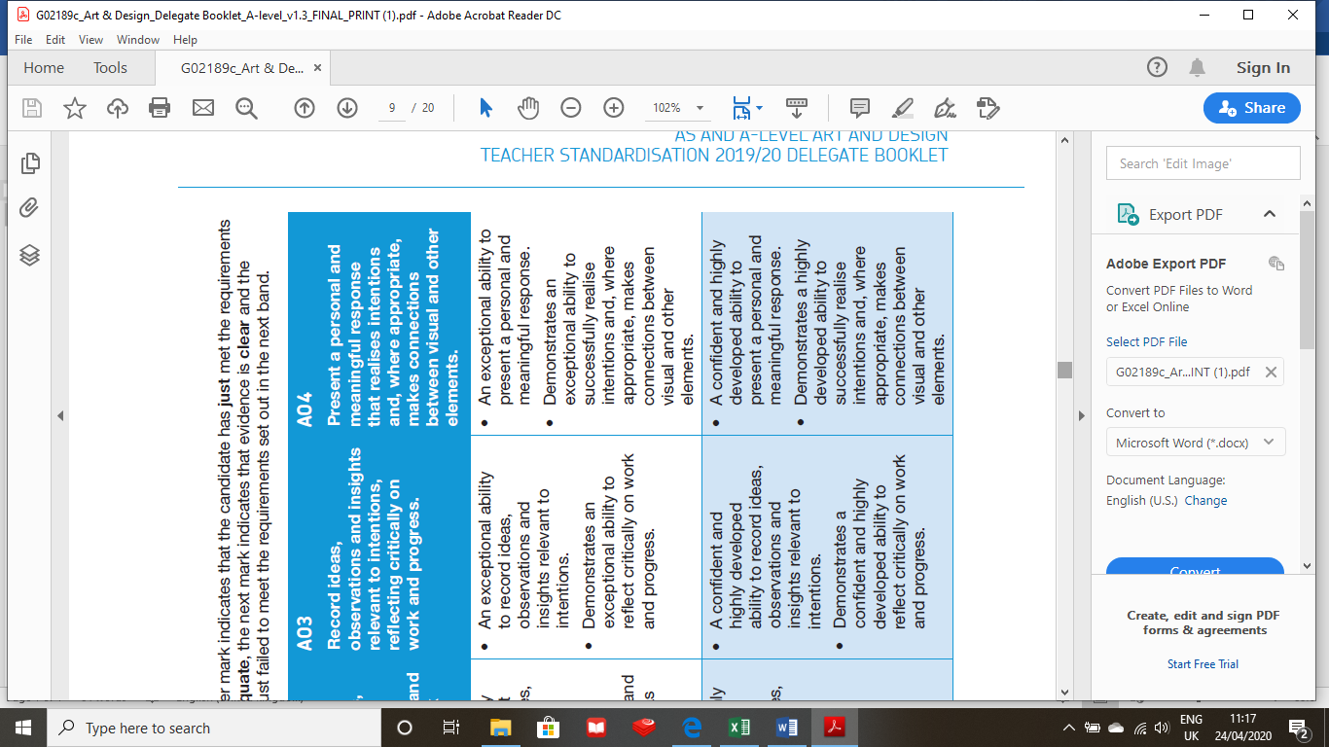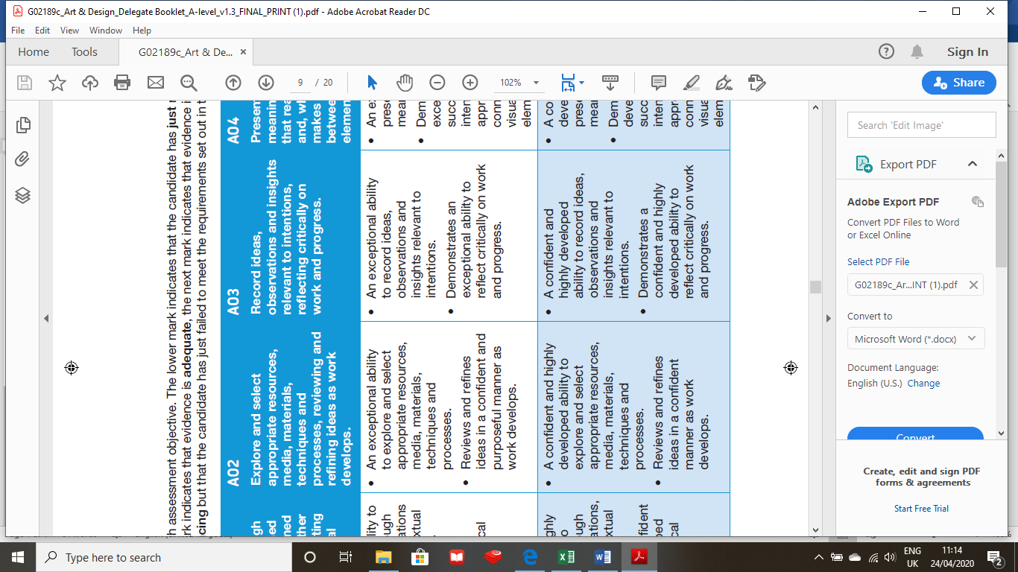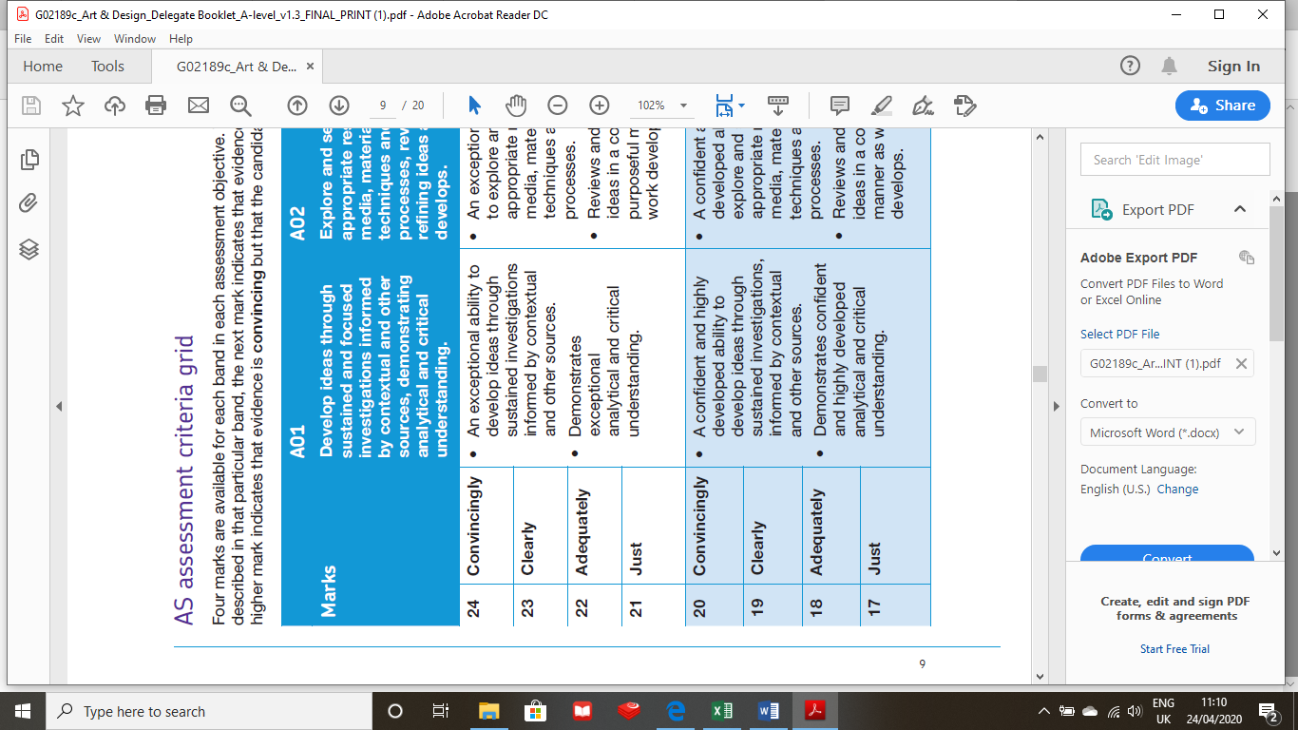Transition Work

During school closure you are required to complete some transition work to prepare you for Year 12 (Wilmslow High School Sixth Form). We are going to set you a series of tasks that require you to develop a range of skills in preparation for A Level Textiles. This work will be collected in and marked in relation to the A level mark scheme. **Below is the marking matrix to give you an idea of what is required.**

ALPS Target

Task One

Complete a virtual gallery tour of an Exhibition and write a 700 word review.

This can be any exhibition- Design/ Fashion/ Art/ Photography

In your review think about the following points:

* What you liked/ disliked in the exhibition?
* What inspired the designer/ designers? Who is the designer?
* How could you use these ideas to inspire a fashion/ textile collection?
* Pictures of the work to discuss.

[](https://www.google.com/url?sa=i&url=https://www.vertex42.com/WordTemplates/printable-lined-paper.html&psig=AOvVaw1n2UnpEFZZ6SwUFmyuGma2&ust=1587812292578000&source=images&cd=vfe&ved=0CAIQjRxqFwoTCNiIye_zgOkCFQAAAAAdAAAAABAE)

Here are some links to some virtual exhibitions to help you:

<https://blog.britishmuseum.org/category/exhibitions-and-events/>

<https://mnactec.cat/en/the-museum/project-detail/google-arts-culture?gclid=EAIaIQobChMI8Nr7z_CA6QIVxu7tCh39Hgy9EAAYBCAAEgJEnPD_BwE>

<https://www.elitetraveler.com/design-culture/10-best-virtual-museum-tours>

<http://www.samrohn.com/virtual-tour/fashion/>

[](https://www.google.com/url?sa=i&url=https://www.vertex42.com/WordTemplates/printable-lined-paper.html&psig=AOvVaw1n2UnpEFZZ6SwUFmyuGma2&ust=1587812292578000&source=images&cd=vfe&ved=0CAIQjRxqFwoTCNiIye_zgOkCFQAAAAAdAAAAABAE)

Task Two

Watch the episode of ‘The Great British Sewing Bee’, on firefly or down load from the link below:

<https://www.bbc.co.uk/iplayer/episode/m000hk4v/the-great-british-sewing-bee-series-6-episode-1>

[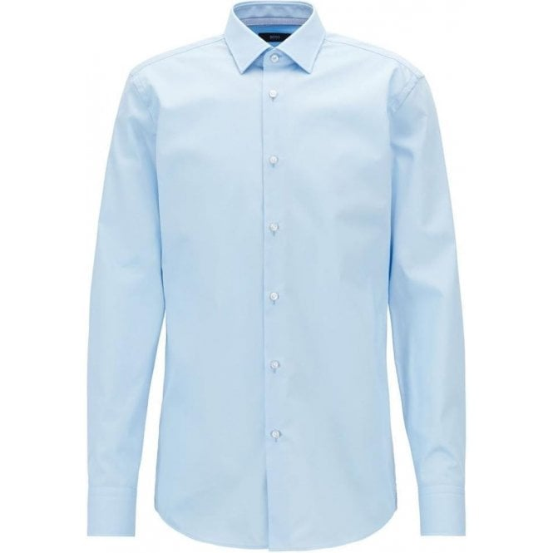](https://www.google.com/url?sa=i&url=https://www.chameleonmenswear.co.uk/menswear-c133/boss-business-jesse-formal-shirt-in-light-blue-p22463&psig=AOvVaw3RCFSUqWYWocrCSRZwtO6E&ust=1587812988289000&source=images&cd=vfe&ved=0CAIQjRxqFwoTCLjGrrv2gOkCFQAAAAAdAAAAABAE)

Challenge – Find a shirt and turn it into something new. Use what you have a home and please do not stress if you do not have access to a sewing machine, be creative in your response. We are going to assess you on creativity more than accuracy of finish.

In the space below plan and sketch out some ideas.

Task Three

Research a variety of Fashion/ Textile designers. Choose your favourite and create a fact file about them. Add images of a collection that you particularly find interesting created by your chosen Designer. Do not do the obvious!

Things to consider:

* Who are they? What has been their journey?
* What is it you like about their work?
* Why does this work inspire you?
* How could it be developed further?

[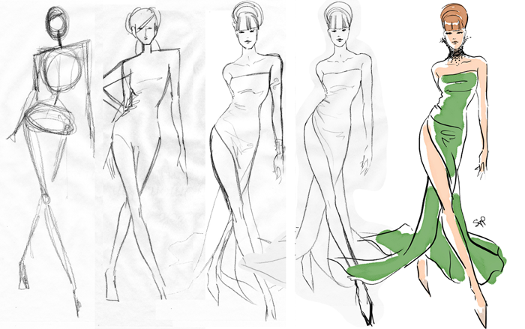](https://www.google.com/url?sa=i&url=https://susantaitporcaro.com/from-stick-figure-to-fashion-illustration/&psig=AOvVaw2WQ7pHVCHNJG863jtmlOZT&ust=1587813835027000&source=images&cd=vfe&ved=0CAIQjRxqFwoTCNirlM_5gOkCFQAAAAAdAAAAABAa)[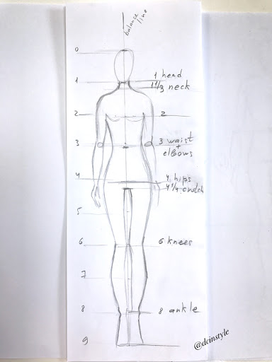](https://www.google.com/url?sa=i&url=http://elenafay.com/2017/04/13/how-to-draw-fashion-illustration-fashion-figure-101/&psig=AOvVaw2WQ7pHVCHNJG863jtmlOZT&ust=1587813835027000&source=images&cd=vfe&ved=0CAIQjRxqFwoTCNirlM_5gOkCFQAAAAAdAAAAABAP)Task Four

FIND YOUR STYLE

DO NOT THROW ANY ATTEMPTS AWAY WE WANT TO SEE HOW YOU HAVE DEVELOPED/ IMPROVED.

Now you are A level students have a go at drawing your own fashion silhouette figure: watch the video on firefly or follow the link below:

<https://www.google.com/search?source=hp&ei=2suiXorJDqK3gwfa_rfwDg&q=how+to+draw+a+fashion+figure&oq=how+to+draw+a+fashion+&gs_lcp=CgZwc3ktYWIQAxgAMgIIADICCAAyAggAMgIIADICCAAyAggAMgIIADICCAAyAggAMgIIADoFCAAQgwE6BAgAEApQgwVYgSRgjixoAHAAeACAAWqIAZcMkgEEMjEuMZgBAKABAaoBB2d3cy13aXo&sclient=psy-ab>

Design Task – Looking at the work of your chosen Textile/ Fashion Designer – sketch out 4 alternative designs that could form part of their collection. Please note this could be a textile item such as a cushion, wall hanging or Textile installation, it does not have to be a garment.

Things to consider:

* Fabric choice
* What inspires the collection?
* Who is the target market?
* Methods/ techniques involved? i.e pleats, smocking, darts, drapery, gathers etc.

Task Five

Creative Mood Board: Choose one of the following words and create a mood board/ collage to represent your chosen word- this can be imagery, fabrics, textures, sketches, samples etc.

**POURING GLASS MECHANICAL**

Task Six

Observational Drawing Task – Draw 4 objects using a range of media. These sketches/ drawings ca be any objects around your house/ garden. Use any of the following media to demonstrate your skills: These sketches need to be no bigger than A5 in size so 2 will fit on a A4 sheet.

* Biro / fine liner
* Watercolours
* Paint
* Pencil / tonal work
* Pencil crayon
* Wax / pastels