Assessment Framework: Music

Because the knowledge structure in music looks like this:

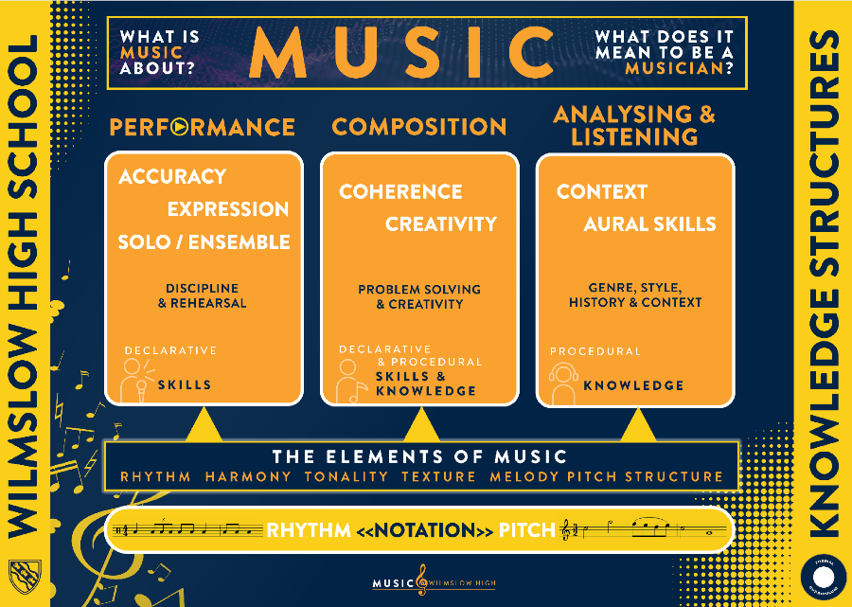

We assess the students at six points during each year. Across these six assessments students reflect on their understanding of the elements of music and aural analysis of music, as well as their development of practical skills, whether that be through performance or composing, which relates back to the three ‘big ideas’.

Teachers assess the fluency of declarative knowledge and procedural knowledge formally through these six assessments. Declarative knowledge is typically demonstrated by students’ ability to aurally describe music, identifying instruments and musical techniques, whilst using the elements of music correctly.

Procedural knowledge is demonstrated though students’ ability to apply their understanding of music theory to performances that are accurate in pitch with a sense of musicality and rhythm, as well as compositions that are structurally sound, following the fundamental rules of music theory and typical features of the genre they are writing for.

**Short-cycle assessment:**

* Mini whiteboards
* Cold calling for vocabulary knowledge
* Circulating during rehearsal/composition time
* Regular listening questions.

**Medium -Cycle assessment:**

* Retrieval starter questions
* Mid-cycle performances

**Long - Cycle assessment:**

* At the end of each unit, students are assessed on the material covered, as well as previous units covered in the year.

|  |  |  |  |  |  |  |
| --- | --- | --- | --- | --- | --- | --- |
|  | **HT1** | **HT2** | **HT3** | **HT4** | **HT5** | **HT6** |
| **Year 7**  **Declarative Knowledge Assessed.** | **Listening:** Elements of Music listening paper. | **Listening:**  Rhythmic dictation, instrument recognition and element analysis. | **Listening:**  Element analysis, notation reading. | **Listening:**  Element analysis, notation and instruments of the orchestra recognition. | **Listening:**  Element analysis, notation and instruments of the orchestra recognition. | **End of Year exam:** Listening skills and basic theory from across the entire year. |
| **Year 7**  **Procedural Knowledge Assessed.** | **Performance:** Exploration of the keyboard focusing on specific elements. | **Performance:** Ensemble performance on percussion focusing on polyrhythms. | **Performance:** Precise keyboard skills with focus on hand positions and fingers. | **Performance:** Ukulele skills, with the understanding of how to read tab. | **Composition:** Create music that represents an animal, using the elements of music to do this. | **End of Year Composition:** Musical cliché composition for a Tom and Jerry clip. |
| **Year 8**  **Declarative Knowledge Assessed.** | **Listening:**  Elements of music and analysis of typical features of The Blues. | **Listening:**  Elements of music and analysis of FX and remix tools. | **Listening:**  Elements of music and aural structural analysis. | **Listening:**  Elements of music and analysis of typical features of minimalism. | **Listening:**  Elements of music and analysis of typical features of Samba. | **End of Year exam:** Listening skills and basic theory from across the entire year. |
| **Year 8**  **Procedural Knowledge Assessed.** | **Performance:**  Paired performance of the 12 bar blues, walking bassline and improvisation. | **Composition:**  Basic music tech skills, using loops, metronome and FX. | **Composition:**  Composition of a ternary and binary piece of music, creating clear sections. | **Composition:**  Understanding of how to record and use the MIDI keyboards, creating loops that are ostinatos. | **Composition:**  Ability to create and perform Samba music as an ensemble, with typical features of Sambe, e.g. polyrhythm, call and response, solo breaks. | **End of Year Performance:**  Production of Gangsta’s paradise, recording in a bassline, melody, counter melody and drum beat, with no loops. |
| **Year 9**  **Declarative Knowledge Assessed.** | **Listening:**  Elements of music and analysis of typical features of Reggae. | **Listening:**  Elements of music and analysis of typical features of Film Music. | **Listening:**  Elements of music and analysis of typical features of Popular Music. | **Listening:**  Elements of music and general aural analysis of different genres of music. | **Listening:**  Elements of music and analysis of typical features of Dance music. | **End of Year exam:** Listening skills and basic theory from across the entire year. |
| **Year 9**  **Procedural Knowledge Assessed.** | **Performance:**  Paired performance of Three little birds, with a focus on syncopation. | **Composition:**  Composition of music appropriate for film, including techniques such as ostinato, drone and chords. | **Performance:**  Performance of popular music that must be both expressive and accurate. | **Composition:**  Responding to a brief and understanding how to write music suitable for different occasions. | **Composition:**  Understand how to write music for different genres of dance music through time. | **End of Year Performance:**  Performance of a ‘Made in Manchester’ song, displaying musicianship, rhythmical accuracy and a clear sense of style. |