A-level Biology – Year 11 transition work

Variation, evolution and classification

Quick questions
- The gradual change in the characteristics; of a population from one generation to the next / over time;
- Natural selection;
- Different forms/versions; of a particular gene;
- A characteristic / feature that gives the possessor a greater chance of survival;
- Where large groups are divided into smaller and smaller (non-overlapping) groups;
- A group of similar organisms; that can reproduce to give fertile offspring;
- DNA (similarities/difference in base sequence); proteins (comparing amino acid sequence); early development – embryo development;
Total 12 marks

Examination questions
Q1.
(a) (i) (Grouped according to) evolutionary
links/history/relationships / common ancestry;
Ignore: closely related, factors, characteristics
Ignore: genetically similar
1
(ii) 1. Able to reproduce;
Accept: smallest taxonomic group/groups of organisms with same genes/ chromosomes/same number of chromosomes
Accept: breed for ‘reproduce’
Ignore: mate
Reject: genetically identical
Ignore: similar genes/chromosomes
2. To produce fertile offspring;
Ignore: that are ‘viable’
2
(b) Phylum
Class
Family
Genus;
Accept: pleural answers phyla / genera / families
Accept phonetic answers phyllem/phylem/fylum/fyla/phylae/phyli/jenus/ jenera/familys
All 4 in correct order for 1 mark
1

(c) 1. Two circles/with two inner circles with no overlap;
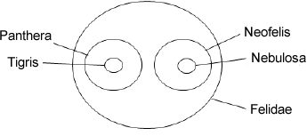
= 2 marks

OR
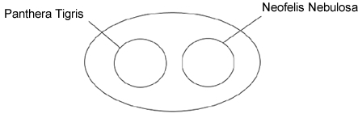
= 2 marks

OR
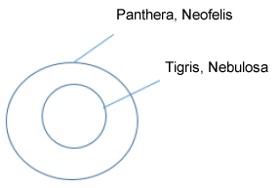
= 1 mark

OR
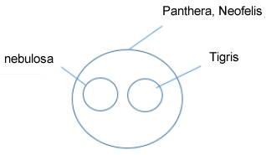
= 1 mark
2. Labels correct;
Ignore underlining / capitals
Accept: P tigris/ N nebulosa
Accept phonetic spelling
2
(d) 1. South China and Sumatran tigers share a more recent common ancestor;
Accept: more closely related (statement must be comparative)
Accept: a labelled hierarchy
2. (because) identical/same/matching (nucleotide) sequences;
Accept: converse for Siberian tiger eg Siberian is less closely related to South China AND Sumatran tigers
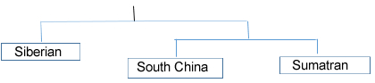
2
[8]
Q2.
(a) (i) 1. Groups within groups;
Accept: idea of larger groups at the top or smaller groups at the bottom
2. No overlap (between groups);
2
(ii) 3;
1
(iii) Chordata;
Accept: if phonetically correct eg ‘Cordata’
1
(b) 1. (Zedonk has) 47 / odd / uneven number of chromosomes;
Accept: diploid number would be odd
Reject: if wrong number of chromosomes is given
2. Chromosomes cannot pair / are not homologous / chromosome number cannot be halved / meiosis cannot occur / sex cells / haploid cells are not produced;
Accept: cannot have half a chromosome
Q Reject: meiosis cannot occur in sex cells
2
[6]
Q3.
(a) (i) Phylum, Class, Order, Genus;
Mantophasma (M) / (Mantophasma) zephyra;
2
(ii) Groups within (larger) groups;
No overlap;
2
(b) Comparison of / look for similar features / structures / appearance;
1
[5]

