Non-Verbal Intervention – Visible Signals
- The teacher can make these visible signals more effective by combining them with their Perch Position (increased Radar) and Be Seen Looking techniques.
- This allows the teacher to catch any off-task behaviour early without breaking the thread of instruction.
- Make eye contact with the student(s).
- Therefore, a small problem only requires a small solution.
Additional Benefits
- The visible signals save your voice.
- They depersonalise the intervention helping to avoid confrontation and a potential ‘death spiral’.
- They starve a poorly behaving student from public attention (which might be what they want).
Non-Verbal Intervention | Visible Signal | Explanation
- Stop talking |  | - Best to use when only one or two are talking.
- Listen to me | 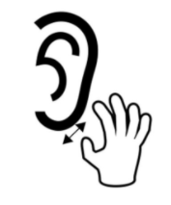 | - Wiggle the earlobe.
- Don’t do what you’re about to do | 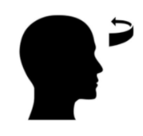 | - A gentle side to side headshake which says, ‘don’t even think about doing what you are about to do’.
- Stop doing that immediately | 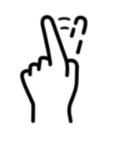 | - Similar to number 3 but a bit more forceful.
- Sit down |  | - A single finger waved up and down to lace a student in their seat.
- Settle down | 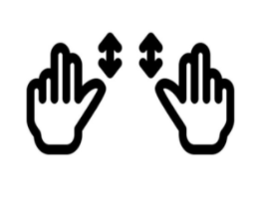 | - Best used as students enter the class in a hyper mood  - Two hands waving downwards says, ‘get ready to learn’  - Can combine with a precise ‘what to do’ instruction (eg: “30 seconds for reading book, classwork book and equipment out then we’re reading in silence”). Narrate the positive throughout then give a 10 second and 5 second warning.
- You’ve done what I’ve asked |  | - A universal sign of praise (even better with a smile). I  - deal for students who prefer quiet positive reinforcement .
- You should be reading |  | - Identical sign for a book in a game of charades.
- Start writing | 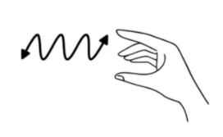 | - Hold an imaginary pen between your thumb and index finger and scribble quickly.
- Focus on your work |  | - As you circulate, direct students back on task with a few taps on their exercise book
- Turn around | 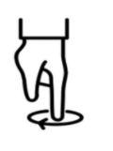 | - Get them performing a u-turn so they are facing the way you want them to be facing..
- You need to work faster | 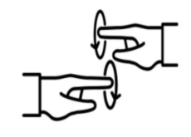 | - Think about a football referee signalling to a time-wasting player.
- I’m waiting for silence |  | - Accompanied with a theatrical backward step, this signals to a noisy class that you are waiting.  - However, may need a verbal whole-class instruction if you are waiting too long.
- I’m really quite annoyed with you | 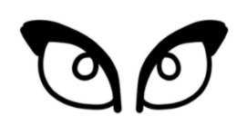 | - The thousand yard stare. Only use when absolutely needed.
- Come here – I want a word with you | 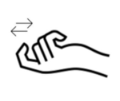 | - Allows you to speak to the student in close proximity so the conversation is not public.  - Preferred to a verbal correction across the room which may lead to more students being distracted and off-task (‘death spiral’)

