* 1. 01101010
  2. 6A
  3. The picture is split into a grid of pixels. Each pixel is given a binary code (which says what colour it is). The bitmap file contains the list of pixels along with meta data about the image e.g. height, width, colour depth, resolution etc.)
  4. 1. Use image manipulation software to resize the image so that it uses less pixels. 2. Reduce the colour depth to reduce the number of bits required to store each pixel. (3. Compress the file)  
     1. A single binary digit, 0 or 1.
     2. A group of 8 bits.
  5. 5120 / 1024 = 5kB
  6. Point B: Size=120, Binary=01111000, Hex=78  
     Point C: Size=60, Binary=00111100, Hex=3C
  7. Points to be made may include :  
     **Sampling Rate**  
     how close together the samples are taken  
     the closer together, the more numbers need to be stored (and therefore larger file)  
     but the sound that is created is closer to the original analogue  
     mention of variable bit rates  
     **Compression**  
     use algorithms to make the file smaller (e.g for transmitting over Internet)  
     and then recreated to be played  
     can be lossy (eg mp3) and the recreated file is of poorer quality or lossless (eg flac) and the recreated file is exactly the same as it was before compression
  8. 151
  9. 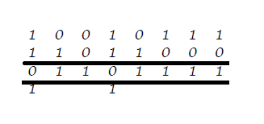  
       
     An overflow has occurred because the result is more than 255 (cannot be represented in 8 bits).

* 1. Each character is given a numeric code including symbols, digits, upper and lower case. This code is then stored in binary. Each character takes 1 byte. Text is stored as a series of bytes (1 per character). Some codes are reserved for control characters (eg TAB, Carriage Return)
  2. All the characters which are recognised/can be represented by the computer system.
  3. Unicode has a much larger character set, representing symbols from many different alphabets. This is possible because each character uses 16 bits whereas ASCII only uses 8 bits.

1. In lossy compression, when the data is uncompressed it is not exactly the same as the original but the difference is so small that it cannot normally be noticed eg music files(mp3) or large resolution images for displaying on small screens. In lossless compression, when the data is uncompressed it is restored completely to the original file eg compressed text files.  
   1. 106
   2. 01101010
   3. 3D
   4. Hex numbers are shorter/more memorable than equivalent binary numbers and can easily be converted to and from binary as each hex digit corresponds to 4 binary digits (a nybble).  
      1. Kilobyte(s)
      2. Megabyte(s)
      3. Byte(s)
   5. 2048GB
   6. 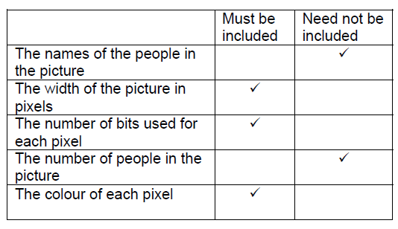
   7. The concentration of pixels.
   8. The higher the resolution the more pixels that are required for the picture which will increase the size of the bitmap file.