Assessment Framework: Science

Because the knowledge structure in science looks like this:

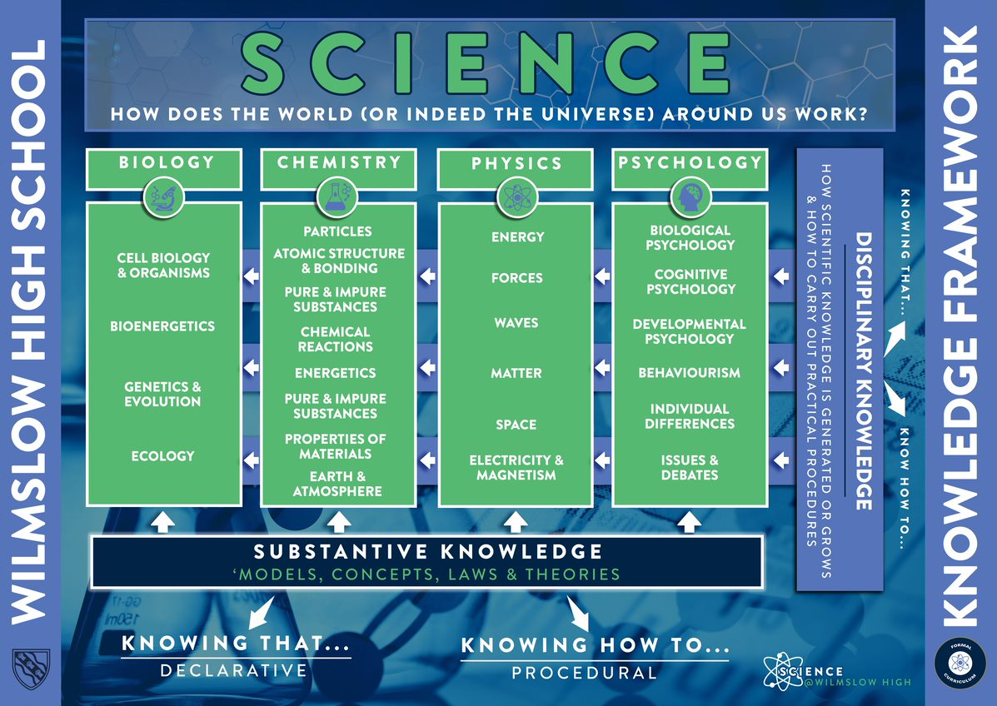

Learner fluency will be assessed every half-term via cumulative assessments. These will be primarily based on the most recent 2-3 topics taught over that half-term, but will also feature questions from previous topics. The final assessment in half-term 6 will be a summative end-of-year assessment.

We will assess both **substantive** and **disciplinary knowledge**, as outlined in the plan below.

Each assessment will have two sections:

1. a section consisting of short answer and/or multiple choice-questions, so that we can assess **declarative knowledge**
2. a section made up of questions requiring longer answers (written or calculation based) where learners will need to analyse, evaluate, explain or calculate, allowing us to assess **procedural knowledge**.

**Short-cycle assessment**:

We are continually assessing learners’ progress in and between lessons through formative assessment. Some examples of how we formatively asses are:

* Quick quizzes, multiple-choice questions and retrieval tasks
* Questioning and the use of mini whiteboards
* Hinge questions during lessons to assess students’ immediate understanding
* Independent practice, including the use of digital platforms such as Carousel Learning, SENECA, Cognito and Isaac Physics
* Practical work; students will be required to collect and analyse data.

**Medium-cycle assessment**

Due to the subject being divided into a number of short topics, medium-cycle assessments will be in the form of:

* Half-termly cumulative assessments
* Written or verbal feedback provided for longer pieces of work

**Long-term assessment**

* A summative end-of-year assessment in half-term 6

**Year 7 Assessment Plan**

|  |  |  |  |  |  |  |
| --- | --- | --- | --- | --- | --- | --- |
|  | **HT1** | **HT2** | **HT3** | **HT4** | **HT5** | **HT6** |
|  | ***Cumulative Assessments*** *– primarily based on the topics taught over that half-term, but will also feature questions from previous topics* | | | | | ***End-of-Year Summative Assessment*** |
| **Substantive Knowledge** | · Forces  · Particle nature of matter | · Energy  · Atoms, elements, and compounds | · Pure & impure  · Chemical changes  · Cells, | · Food & digestion  · Sound | · Reproduction  · Variation  · Electricity | All the substantive knowledge from HT1 to HT5, as well as:  · Ecology  · Human impacts |
| **Disciplinary Knowledge** | · Forces: friction investigation  · Particle nature of matter: scientific theories and models | · Energy: investigating energy in food  · Atoms, elements, and compounds: scientific models and conventions | · Pure & Impure: separating salt from a mixture  · Cells: using a microscope to view cells and record observations · Chemical changes: safety and observations | · Food tests: following a method, using equipment correctly and presenting observations. · Sound: applying an equation | · Electricity: drawing diagrams / scientific models  · Variation: investigating variation: sampling, collecting and presenting data. | All of the disciplinary knowledge from HT1 to HT5, as well as:  · Human impacts: classification - interpreting information e.g. classification keys. |

**Year 8 Assessment Plan**

|  |  |  |  |  |  |  |
| --- | --- | --- | --- | --- | --- | --- |
|  | **HT1** | **HT2** | **HT3** | **HT4** | **HT5** | **HT6** |
|  | ***Cumulative Assessments*** *– primarily based on the topics taught over that half-term, but will also feature questions from previous topics* | | | | | ***End-of-Year Summative Assessment*** |
| **Substantive Knowledge** | · Motion  · Energy  · Acids and Alkalis | · Chemical Reactions  · Photosynthesis | · Electricity | · Respiration  · Light | · Inheritance and evolution  · Earth structure and rocks | All of the substantive knowledge from HT1 to HT5, as well as:  · Earth and atmosphere  · Space |
| **Disciplinary Knowledge** | · Motion: applying an equation, analysing graphs · Energy: scientific models, investigate radiation · Acids and Alkalis: following a method and recording observations | · Chemical Reactions: following a method and recording observations  · Photosynthesis: identifying variables, collecting and interpreting data. | · Electricity: investigating circuits | · Respiration: collecting and interpreting data. Using scientific knowledge to explain results. · Light: investigating reflection and refraction | · Inheritance and evolution: investigating variation in beak shape  · Earth structure and rocks: making observations | All of the disciplinary knowledge from HT1 to HT5, as well as:  · Earth & atmosphere: investigating burning candles  · Space: scientific models |

**Year 9 Assessment Plan**

|  |  |  |  |  |  |  |
| --- | --- | --- | --- | --- | --- | --- |
|  | **HT1** | **HT2** | **HT3** | **HT4** | **HT5** | **HT6** |
|  | ***Cumulative Assessments*** *– primarily based on the topics taught over that half-term, but will also feature questions from previous topics* | | | | | ***End-of-Year Summative Assessment*** |
| **Substantive Knowledge** | Biology:  · Cell structure  Chemistry:  · Earth materials  · Mixtures  Physics:  · Energy transfers  · Work done | Biology:  · The digestive system  Chemistry:  · Atomic structure  Physics:  · Energy sources  · Particle model and behaviour | Biology:  · The respiratory system  · The circulatory system  Chemistry:  · The periodic table  Physics:  · Current, p.d & resistance | Biology:  · The skeletal and muscular systems  Chemistry:  · Rates of reaction  Physics:  · Forces and their effects  · Moments | Biology:  · Health  Chemistry:  · Materials and their properties  Physics:  · Transverse and longitudinal waves | All the substantive knowledge from HT1 to HT5, as well as:  Biology:  · Green biology  Chemistry:  · Green chemistry  Physics:  · Magnetic fields & Electromagnetism |
| **Disciplinary Knowledge** | Biology:  · Magnification calculations  Chemistry:  · Recording observations  Physics:  · Plotting and interpreting graphs · Application of mathematical concepts | Biology:  · Enzyme investigation  Chemistry:  · Scientific models | Biology:  · Burning candle investigation  · Dissections e.g., of a heart  · Recording observations  Chemistry:  · Development of scientific models  Physics:  · Planning investigations  · Evaluating sources/data  · Scientific models | Chemistry:  · Investigating rates of reaction  Physics:  · Planning investigations | Biology:  · interpreting data  · Identifying patterns and drawing conclusions  · Presenting observations and data.  Chemistry:  · Making and explaining observations  Physics:  · Presenting information  · Application of mathematical concepts | All of the disciplinary knowledge from HT1 to HT5, as well as:  Chemistry:  · Scientific models  Physics:  · Scientific models |