|  |  |  |  |  |  |  |
| --- | --- | --- | --- | --- | --- | --- |
| RAG  RATING | Task 1  (AO1) | Task 2  (AO1) | Task 3  (A02) | Task 4  (A02) | Task 5  (AO2) | Task 6  (AO3) |
| RED |  |  |  |  |  |  |
| AMBER |  |  |  |  |  |  |
| GREEN |  |  |  |  |  |  |

****A-Level Design & Technology

Product Design

Transition work

During summer you are required to complete some transition work to prepare you for Year 12 at Wilmslow High School. We are going to set you a series of tasks that require you to develop and demonstrate a range of skills in preparation for A Level Product Design. This work will take the form of a mini project. It will be collected in and marked in relation to the AQA A level NEA assessment criteria below.

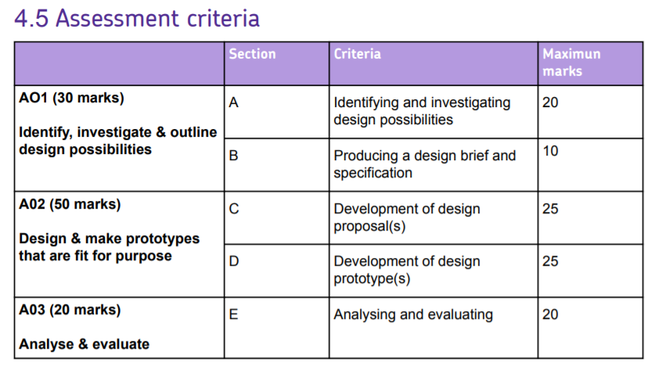

 Section A: Identify and investigate design possibilities

□ ***20-16 marks*** You demonstrate a detailed and perceptive understanding of the information gathered.

□ ***15-11 marks*** Good reasons for choosing the designer, with clear reference in the project as to how your design work is relevant to the designer. You demonstrate a good understanding of the information gathered.

□ ***10-6 marks*** Reasons for choosing the designer lack focus, with some reference in the project as to how your design work is relevant to the designer. You demonstrate an adequate understanding of the information gathered.

□ ***5-1 marks*** Basic reasons for choosing the designer, with limited reference in the project as to how your design work is relevant to the designer. You demonstrate a basic understanding of the information gathered.

***Comment where the evidence can be found:***

Section C: Development of design proposals

□ ***25-19 marks*** You demonstrate clear evidence of originality, creativity and a willingness to take design risks with your designs. Excellent use of drawing techniques to support development of ideas.

□ ***18-13 marks*** You demonstrate evidence of originality, creativity and a willingness to take design risks with your designs. Good use of drawing techniques to support development of ideas.

□ ***12-7 marks*** You demonstrate elements of originality, creativity and a willingness to take design risks with your designs. Adequate use of drawing techniques to support development of ideas.

□ ***6-1 marks*** You demonstrate little evidence of originality, creativity and a willingness to take design risks with your designs. Adequate use of drawing techniques to support development of ideas.

***Comment where the evidence can be found:***

Section D: Development of design prototypes

□ ***25-19 marks*** You have used CAM and worked to a high level of skill, precision and accuracy to produce your prototypes.

□ ***18-13 marks*** You have used CAM and worked with a good level of skill, precision and accuracy to produce your prototype(s).

□ ***12-7 marks*** You have used CAM and worked with an adequate level of skill, precision and accuracy to produce your prototype(s).

□ ***6-1 marks*** You have used CAM where required, but worked with only a basic level of skill, precision and accuracy to produce your prototype(s).

***Comment where the evidence can be found:***

Section E: Analysing and evaluating

□ ***20-16 marks*** You have provided a well-reasoned critical analysis of your final outcome and provided full justification for the extent to which the prototype is both fit for purpose and meets the needs of the client/user.

□ ***15-11 marks*** Good evidence of analysis of the final outcome which provides some justification for the extent to which the prototype is fit for purpose and meets most of the client/user needs.

□ ***10-6 marks*** Adequate evidence of analysis and with some reference to how the prototype is fit for purpose and meets some client/user needs.

□ ***5-1 marks*** Basic evidence of analysis and evaluation does not address the extent to which the prototype is either fit for purpose or meets client/user needs.

***Comment where the evidence can be found:***

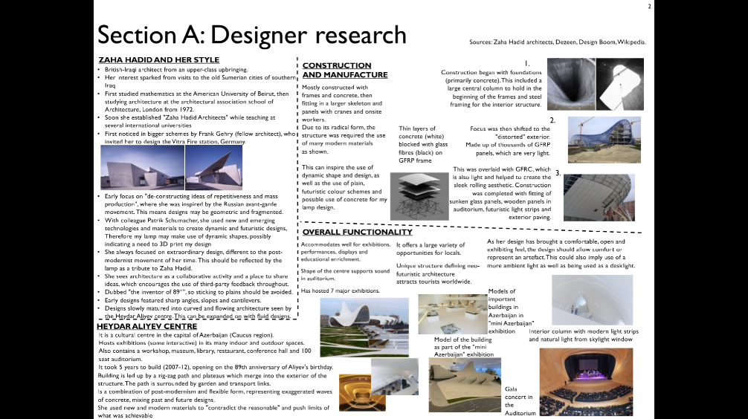Task One

Here are some web links to some links to help you:

* Phillipe Starck <https://www.youtube.com/watch?v=is5rdmWl1yg>
* James Dyson <https://www.youtube.com/channel/UCiEDKBFjGOT-zdxU9RApxDA>
* Margaret Calvert <https://www.youtube.com/watch?v=pyBrrmDw6-k>
* Dieter Rams <https://www.theschooloflife.com/thebookoflife/dieter-rams/>
* Charles and Ray Eames <https://www.theguardian.com/culture/gallery/2012/jul/22/10-best-eames-designs-pictures> <https://www.vitra.com/en-gb/product/lounge-chair> <https://www.youtube.com/watch?v=SFaLpbmP0Yw>
* Marianne Brant <https://www.core77.com/posts/36776/Marianne-Brandt-Bauhaus-Powerhouse>

**Research task:**

Choose one of the following industrial designers:

* Phillipe Starck
* James Dyson
* Margaret Calvert
* Dieter Rams
* Charles and Ray Eames
* Marianne Brant

Investigate the work of your chosen designer. **Write a short piece (approximately 600 words)** that demonstrates your understanding of the designer and their work. You may insert additional pages and should Include images.

|  |  |
| --- | --- |
| What to include | Guidance |
| Brief biography of the designer | Short history, focusing mainly on the designer’s higher education and career highlights and products that they are famous for. |
| Design ethos | What does the chosen designer see as good design? What are the designers core values and principles? |
| The key features of their design style | What makes their work unique and recognisable. |
| What design period they worked in, or were inspired by | Research design timelines and link your designer to the appropriate period. |
| The story of a product they have designed | What led to the design of the product? What inspired the design? How was it developed? Was it designed to meet a need?  Was the design ground-breaking? How? Has the product influenced other designs? How? |
| Product manufacture | What specific materials was the product made from? Why are these materials used for this product? (note: ‘wood’, ‘metal’ and ‘plastic’ are not specific materials). |
| How the product was made | What manufacturing methods were used in the manufacture of the product? (e.g. injection moulding, casting, etc)  Is the product a one-off, batch or mass-produced product? |
| Product Function | How does the product work?  What is the main function of the product?  Were any new materials or technologies involved in making the product? |
| Summary | Summarize your findings and include your thoughts on the designer and their work. |

1. Now produce an A3 sheet of **images** associated with your chosen designer and **explain the key features of their design style**.

Task 1: Designer Research

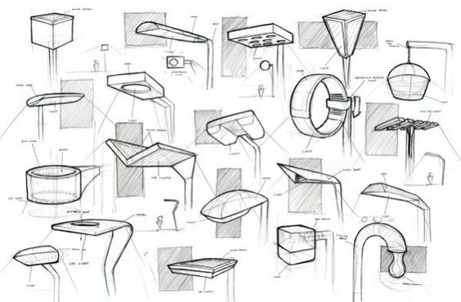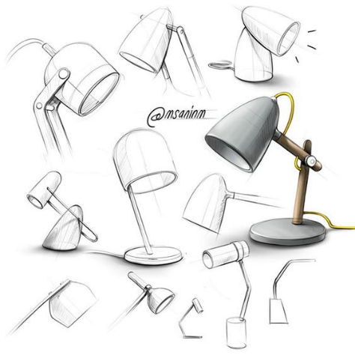Task Two

Here are some web links to help you:

Scamper <https://www.youtube.com/watch?v=vqnIEtlp9d8&feature=emb_logo>

Product Design sketching (annotation, what, how and why) <https://www.youtube.com/watch?v=JCyW4NI9znE>

Generating ideas when creativity fails <https://www.youtube.com/watch?v=Nb9uv51tlIQ>

Developing ideas quickly <https://www.youtube.com/watch?v=7FNbWCjihy0>

Building ideas in real time <https://www.youtube.com/watch?v=hdTTz6ZaCXs>

Abandon darkness from Angle poise <https://www.youtube.com/watch?v=fsnvD7Ly3pI>

**Design Ideas**

**Produce 2 pages of initial design ideas.**

There are many ways to generate ideas including SCAMPER, mind maps and discussions with friends and family.

You should create a minimum of 12 thumbnail sketches that mirror the style of your chosen designer and should show **imagination** and **flair**. They should be quick, confident and you should include **some annotation**.

**Designer Luminaire project**.

Over Summer you will be **designing and making a prototype for a desk lamp that reflects the work of your chosen designer.** The lamp/luminaire must be portable, ergonomic, and the materials you choose should reflect the designer and consider its impact on the environment.

episode of ‘The Great British Sewing Bee’, on firefly or download from the link below:

<https://www.bbc.co.uk/iplayer/episode/m000hk4v/the-great-british-sewing-bee-series-6-episode-1>

Task 2: Design Ideas

Task 2: Design Ideas

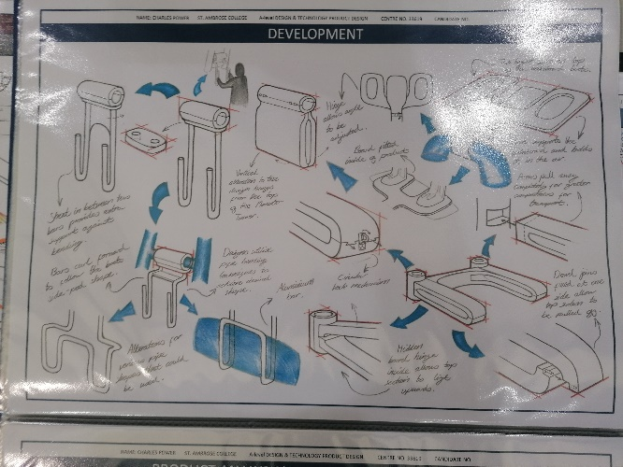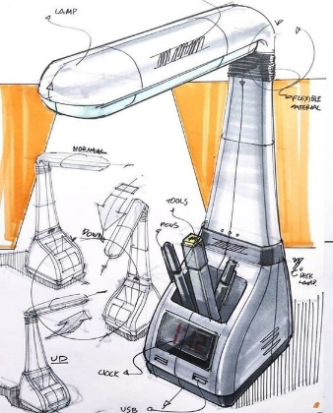Task Three

Here are some web links to help you:

Product Design Sketching (making your design pages’ shout) part 1

<https://www.youtube.com/watch?v=ZjfqWXuM-Ns>

Product Design Sketching (making your design pages’ shout) part 2

<https://www.youtube.com/watch?v=zUFqEez74lg>

**Design Development**

Choose one of your design ideas and create two iterations/developments of this design idea.

Annotate your design developments, rationalising your decisions, and making sugestions for materials and construction methods. How does each iteration meet the design brief? (creating a luminaire/desk lamp that takes inspiration from your chosen designer.

Task 3: Design development

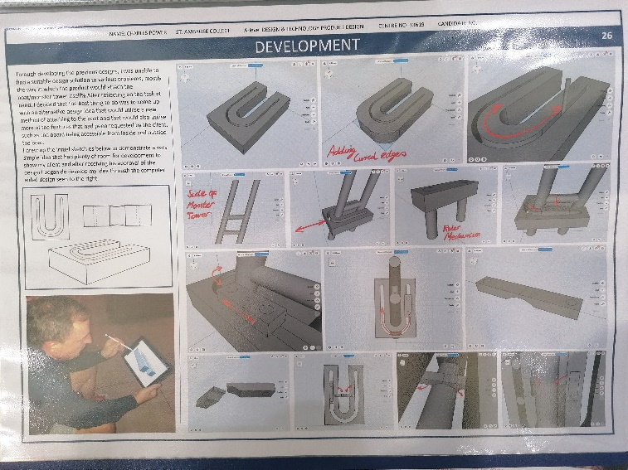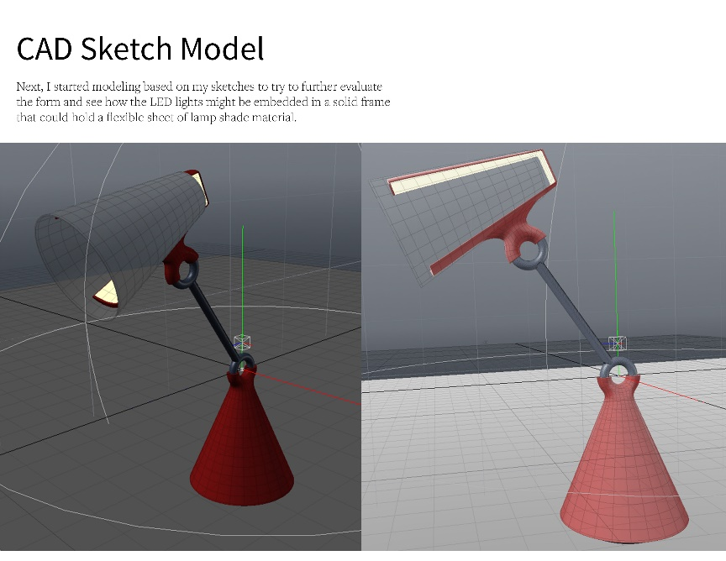Task Four

**Design Development - CAD**

Use CAD modelling to create a 3D development drawing of your luminnaire.

You can use any CAD modelling programe of your choice.

You may wish to look at;

Tinker CAD <https://www.tinkercad.com/>,

Google Sketchup <https://www.sketchup.com/plans-and-pricing/sketchup-free>

Auto CAD

n.b. If you cannot design the whole luminaire, design a section or a component of your design.

Take screen shots of your CAD developments and add them to a A4 page. Highlight key features in annotations that are written around the images.

Here are some web links to help you:

Tinker CAD tutorials: <https://www.tinkercad.com/learn/designs/learning>

How to use Tinker Cad 101 <https://www.youtube.com/watch?v=sh4o9k599pQ>

Sketchup school <https://www.youtube.com/channel/UCdv_VnYKlu_gaZa7rpXifEg>

Task 4: CAD Developments

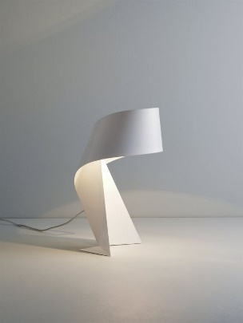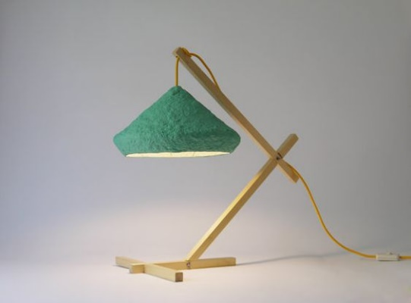Task Five

**Modelling**

Modelling is an essential tool used in developing design ideas and a final prototype. Modelling is usually done using compliant materials such as paper, card, Styrofoam, clay, wire, polymorph, modelling clay, foam board, Corriflute and balsa.

Create at least one model of one of your design developments using any material you have to hand. This may be any of the previously mentioned materials. One of the models should be to scale but does not need to be full scale. Please do not get rid of models you feel are not up to a high standard! Every iteration/development counts. Please photograph these to analyse later.

Here are some web links to help you:

Prototyping and Model making <https://www.youtube.com/watch?v=gWk6br5Ngkc&vl=en>

How to make a cardboard prototype <https://www.youtube.com/watch?v=k_9Q-KDSb9o>

Task Six

**Analysis**

Analysis and evaluation are crucial in the iterative design process. It can highlight any modifications that need to be made for further design developments. Analysing your work is extremely important as it also ensures the users/clients’ needs are met.

Create a page with photographs of your model(s) and analyse them, suggesting improvements and possible modifications.

Web links that might help you;

The iterative design process <https://www.bbc.co.uk/bitesize/guides/z6jkw6f/revision/1>

Product Analysis what am I <https://www.youtube.com/watch?v=hOP0UMVuvJU>

You could analyse your iterations/ model (s) in terms of function, ergonomics, aesthetics, materials, environmental impact, style, product life span, size and weight and performance compared to similar products.

You could test your design and also gain third party feedback on your iterations. Third party feedback should be SMART (specific, measurable, attainable – you should be able to do it, relevant and timely -you should be able to make the improvements over a matter of months and not years).

Task Six: Analysis

Extension

Completed all the work? Why not have a go at designing a sustainable solution for this?

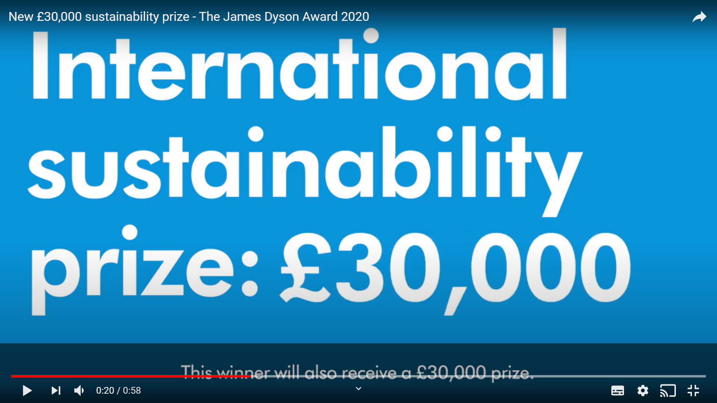

<https://www.youtube.com/watch?v=yUTu7pr9S2c>