***So, you think you might want to study A level Physics?***

***Good plan.*** It is a lot less boring than GCSE for you to learn and for us to teach.

To study physics at A level, you will need at least a grade 5 in Mathematics and:

* Separate scientists will need a 6 in Physics, plus a grade 6 in either Biology or Chemistry.
* Dual scientists (Trilogy) will need at least a 6-6.

These are ***minimum grades***, we prefer you to have at least grade 7s, as we will assume a good knowledge of the GCSE material, we will not be re-teaching it.

There is a lot of ***mathematics*** involved in the study of physics ⇨ more so at A Level than you will have seen at GCSE, so if you are good at mathematics, you will enjoy Physics more at A Level than you did at GCSE.

***A Level textbooks and revision guides*** can be found on Firefly at <https://wilmslowhigh.fireflycloud.net/physics-1/textbooks-and-revision-guides>

We have developed a ***Year 11 to year 12 transition guide*** which is also linked on a Firefly page. Note that some of the tasks are duplicated in the summer work you will be asked to do. <https://wilmslowhigh.fireflycloud.net/physics-1/y11-to-y12-transition-generic-skills>

***Crash Course*** are very well produced videos (American, but don’t let that put you off). Each video is up to 15 minutes long and gives you a good feel for the topic

***Physics Astronomy Engineering***

[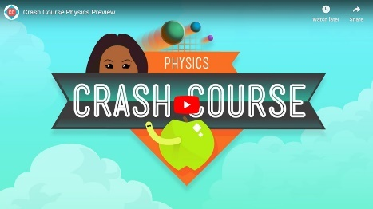](https://www.youtube.com/watch?v=OoO5d5P0Jn4) [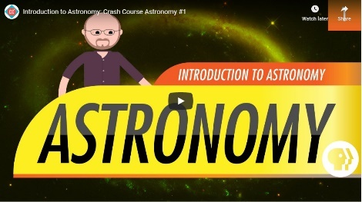](https://www.youtube.com/watch?v=0rHUDWjR5gg&t=2s) [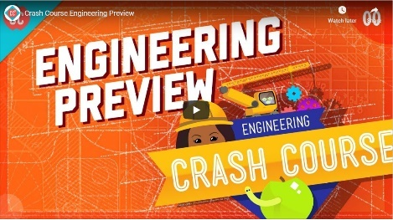](https://www.youtube.com/watch?v=ToC8rFFp88Y)

Images are hyperlinked (or should be)

There is a page on Firefly dedicated to the question ***What is Engineering?*** <https://wilmslowhigh.fireflycloud.net/physics-1/what-is-engineering>

We will be emailing out some summer work (which may come a little earlier in 2020) to be completed before re-joining us in September. The Isaac Physics boards that are suggested within these pages will also be include in the summer work - you will only need to complete the questions once, of course.

[Isaac Physics skills Chapters](https://isaacphysics.org/books/physics_skills_14#isaacModal)

On this page are some videos that you may find interesting. The images are hyperlinked (or should be). If you would like to suggest any of your favourites for me to add to this page, please email me the link.

***Electricity***

[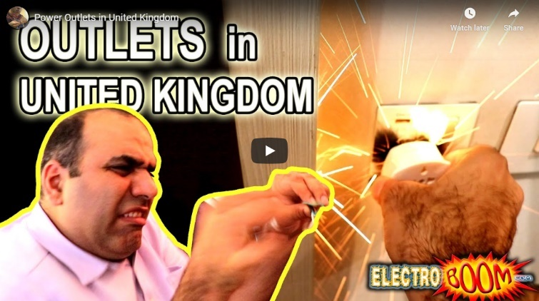](https://www.youtube.com/watch?v=abqMLqHwqpo&t=371s) [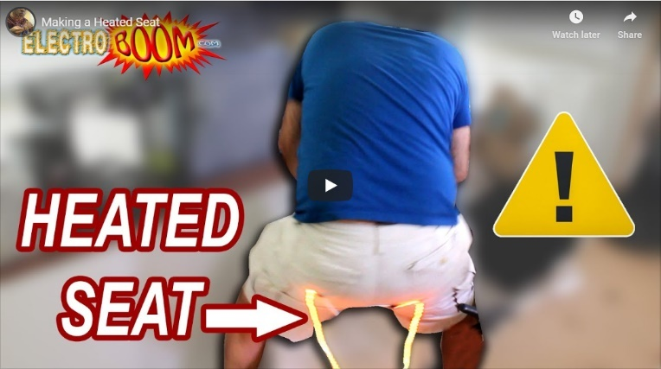](https://www.youtube.com/watch?v=NJRDclzi5Vg)

***Particle and Quantum Physics***

***[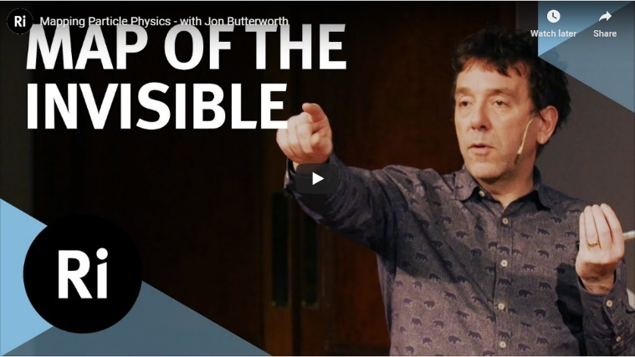](https://www.youtube.com/watch?v=wf1W_ZfqYEs) [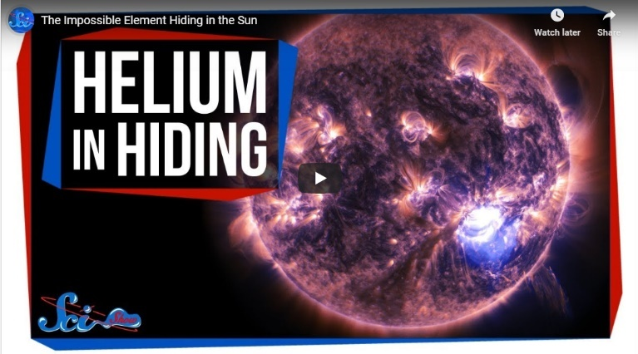](https://www.youtube.com/watch?v=GcfF40CPdl0)***

***Waves and Optics***

***[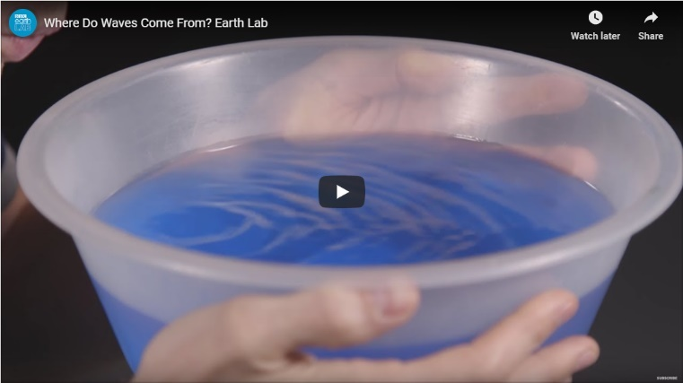](https://www.youtube.com/watch?v=Fkwkn7vXpWI) [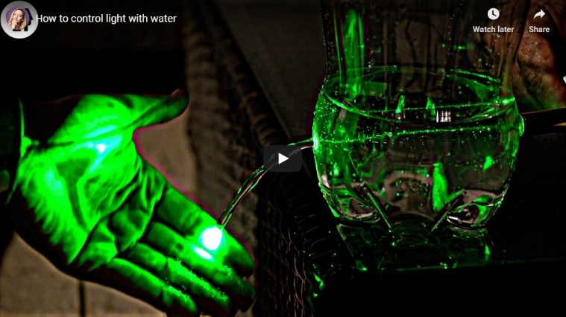](https://www.youtube.com/watch?v=gUPbysSt7XU)***

***Fields***

***[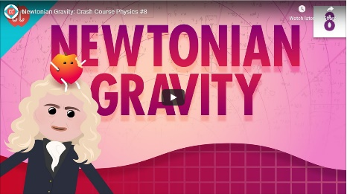](https://youtu.be/7gf6YpdvtE0) [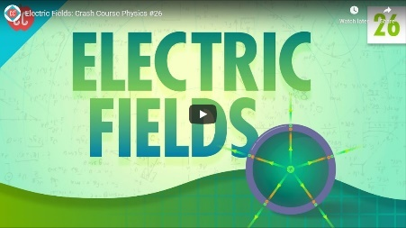](https://www.youtube.com/watch?v=mdulzEfQXDE) [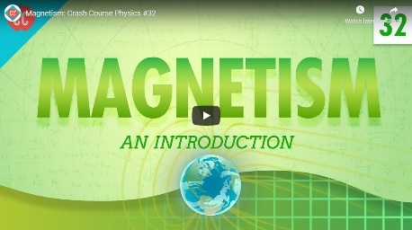](https://www.youtube.com/watch?v=s94suB5uLWw)***

***Nuclear Physics***

***[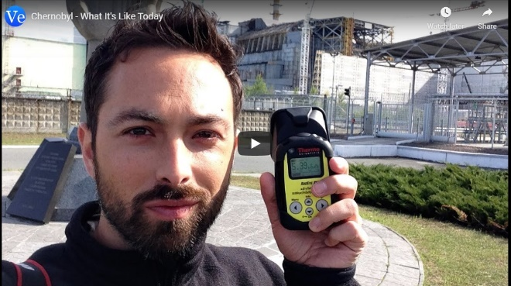](https://www.youtube.com/watch?v=TRL7o2kPqw0) [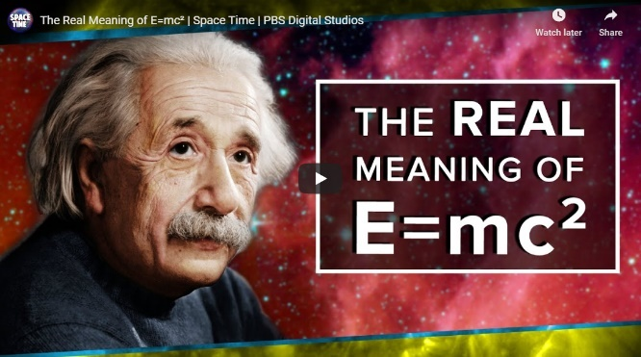](https://www.youtube.com/watch?v=Xo232kyTsO0)***

***Astro-Physics***

***[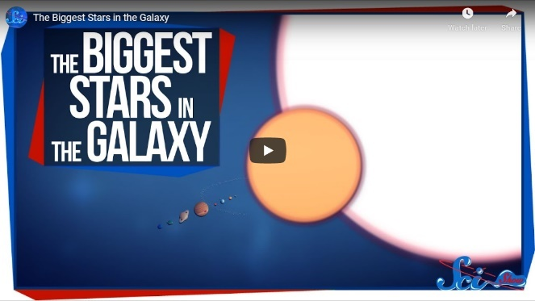](https://www.youtube.com/watch?v=L8_RnYjFvt0) [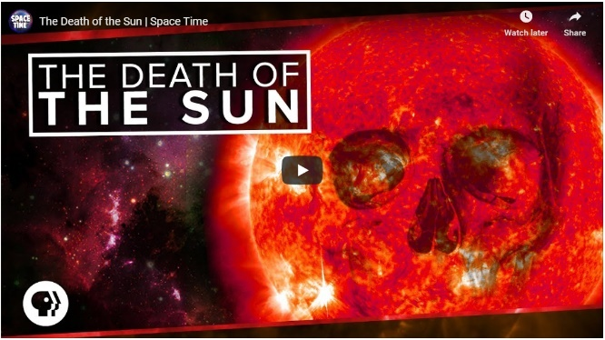](https://www.youtube.com/watch?v=iJY3y5_k0do)***

***[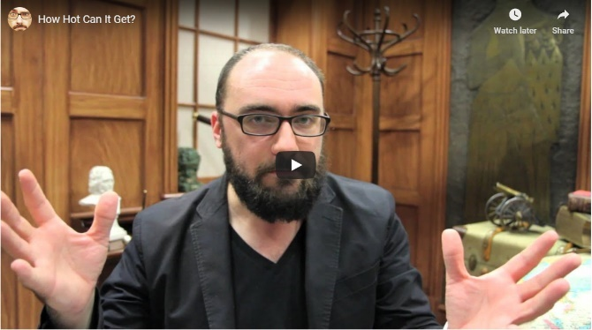](https://www.youtube.com/watch?v=4fuHzC9aTik) [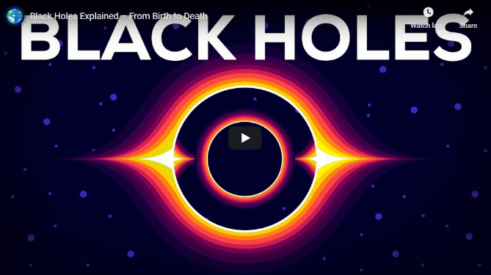](https://www.youtube.com/watch?v=e-P5IFTqB98)***

***[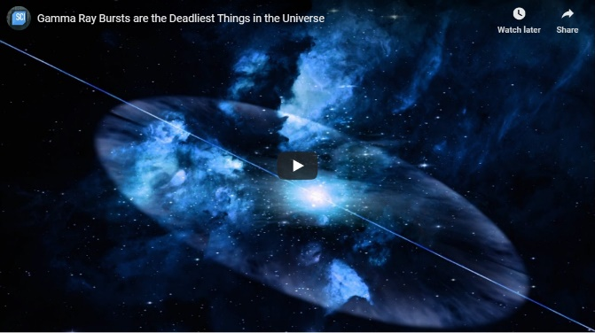](https://www.youtube.com/watch?v=IpuVnqYIgbo) [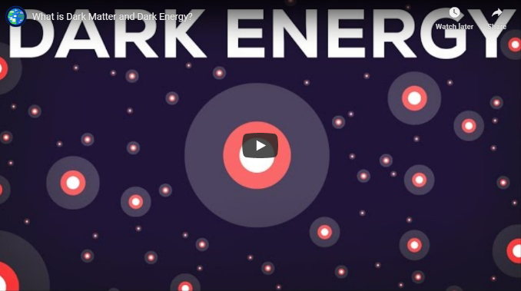](https://www.youtube.com/watch?v=QAa2O_8wBUQ)***

***[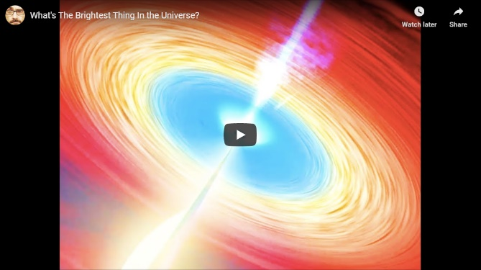](https://www.youtube.com/watch?v=FJB7gbjiJKw) [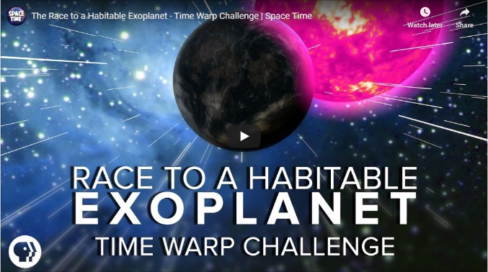](https://www.youtube.com/watch?v=_tmMKQ4kp_I)***

***All of these videos are also on the Firefly page:*** <https://wilmslowhigh.fireflycloud.net/physics-1/great-a-level-physics-videos>