**YEAR 12 A LEVEL SUMMER WORK**

**THE TUDORS 1485-1603**

***Context***

One half of your A level course will focus on 16th Century British History. The course begins in 1485. The purpose of this task is to encourage you to research what life was like for people in the Sixteenth Century and the political context in which the Tudors came to power. The A level history course involves the study of an unfamiliar period of history and this is an opportunity for you to broaden your individual wider reading and to do some independent research into what it was like to live in a society dominated by religion and with different systems of government.

***Task 1***

Research the following topics:

* How was England governed in 1500? Research the role of the monarch, Parliament, the nobility and the Church.
* Living conditions for people in England in 1500. How large was the population? What were houses like? What jobs did people do? How was life different for rich and poor?
* Religion in 1500. How was the Church organised? How popular was the Catholic Church c. 1500AD? What did people believe and do?
* The Wars of the Roses. When did it happen? Who was involved? What happened? Why did it happen? What were the consequences?

***Submission Details***

Paragraph / bullet point answers to each of the above (ready for a seminar / class discussion in September)

***Task 2***

***Aim to Read one of the following books***

* *The White Princess*  by Philippa Gregory
* *VIII* by Harriet Castor
* *Wolf Hall* by Hilary Mantel (its sequels are ‘*Bring up the Bodies’ and ‘The Mirror and the Light’)*

*Wolf Hall is also available in iplayer as a 6 part series*

* *Dissolution* by C.J. Sansom (*recently televised on Disney Channel*)
* *The King’s Curse* by Philippa Gregory

***Research Opportunities***

* The LRC and Wilmslow public library.
* An internet search on any of the topics will generate a range of sources.

***However ………..***

I would **strongly recommend** purchasing the following textbook (we have copies to use in class but it’s always better to have your own copy that can be used for homework – it will also help you with task 1 😊)

AQA A-level History: The Tudors: England 1485-1603

[**Ferriby, David; Anderson, Angela; Imperato, P A**](https://www.abebooks.co.uk/book-search/author/ferriby-david-anderson-angela-imperato/)

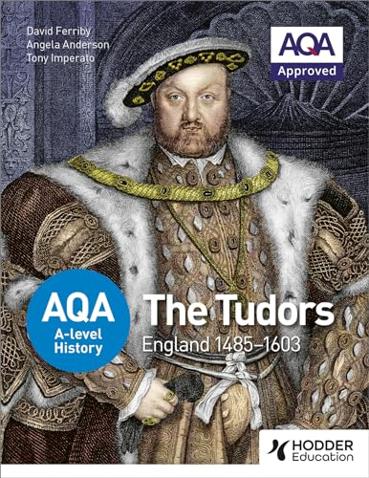

Looking forward to seeing you all in September

Mr Gaskarth 😊