A-level Biology – Year 11 transition work

Section 5 – Disease and immunity

Quick questions

Disease

1. What is the term for an organism that can cause disease?

.................................................................................................................................... (1)
2. Which white blood cell engulfs disease causing organisms?

.................................................................................................................................... (1)
3. What are antigens?

...................................................................................................................................
................................................................................................................................... (2)
4. What type of white blood cells produce antibodies?

.................................................................................................................................... (1)
5. What is the role of T-cells?

.................................................................................................................................... (1)
6. What do vaccines contain?

.................................................................................................................................... (1)
7. What does the body start to produce following a vaccination?

.................................................................................................................................... (1)
Total 8 marks

Examination questions
Q1.
(a) Describe how bacteria are destroyed by phagocytes.
___________________________________________________________________
___________________________________________________________________
___________________________________________________________________
___________________________________________________________________
___________________________________________________________________
___________________________________________________________________
(3)
(b) Give two structures a bacterial cell may have that a white blood cell does not have.
1. _________________________________________________________________
___________________________________________________________________
2. _________________________________________________________________
___________________________________________________________________
(2)
(Total 5 marks)

Q2.
(a) What is an antigen?
___________________________________________________________________
___________________________________________________________________
(2)
(b) What is an antibody?
___________________________________________________________________
___________________________________________________________________
(2)
Poliomyelitis is an infection caused by a virus.
A doctor vaccinated a group of patients against poliomyelitis. He gave each patient two doses of vaccine, 3 months apart.
An immunologist tested three samples of blood from each of the patients:
• (sample 1) taken 2 weeks before the first dose of vaccine
• (sample 2) taken 2 weeks after the first dose of vaccine
• (sample 3) taken 2 weeks after the second dose of vaccine.
He measured the concentration of antibodies against the poliomyelitis virus in the patients’ blood each time. The results are shown in the graph.
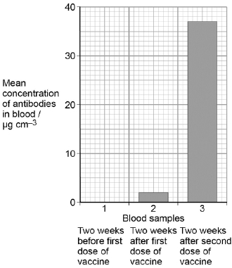

(c) Calculate the percentage increase in the mean concentration of antibodies in blood between samples 2 and 3.
Answer = ________________________ %
(1)
(d) Explain the differences between the mean concentrations of antibodies in blood samples 1, 2 and 3.
___________________________________________________________________
___________________________________________________________________
___________________________________________________________________
___________________________________________________________________
___________________________________________________________________
___________________________________________________________________
___________________________________________________________________
___________________________________________________________________
___________________________________________________________________
___________________________________________________________________
(4)
(Total 9 marks)

Q3.
(a) When a vaccine is given to a person, it leads to the production of antibodies against a disease-causing organism. Describe how.
___________________________________________________________________
___________________________________________________________________
___________________________________________________________________
___________________________________________________________________
___________________________________________________________________
___________________________________________________________________
___________________________________________________________________
___________________________________________________________________
___________________________________________________________________
___________________________________________________________________
(5)
(b) Describe the difference between active and passive immunity.
___________________________________________________________________
___________________________________________________________________
___________________________________________________________________
___________________________________________________________________
___________________________________________________________________
___________________________________________________________________
___________________________________________________________________
___________________________________________________________________
___________________________________________________________________
___________________________________________________________________
(5)
(Total 10 marks)

