**Sorting – Bubble and Insertion**

**Bubble Sort**

**Bubble – swap pairs**

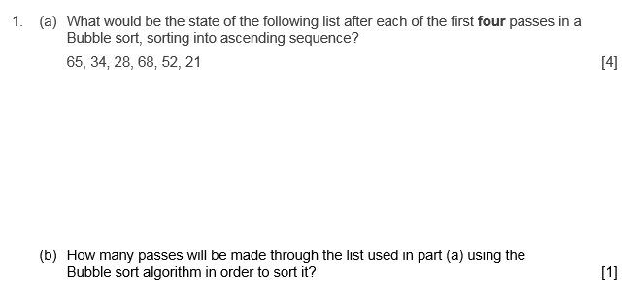

**Insertion Sort**

**Insertion – an ordered and an unordered list**

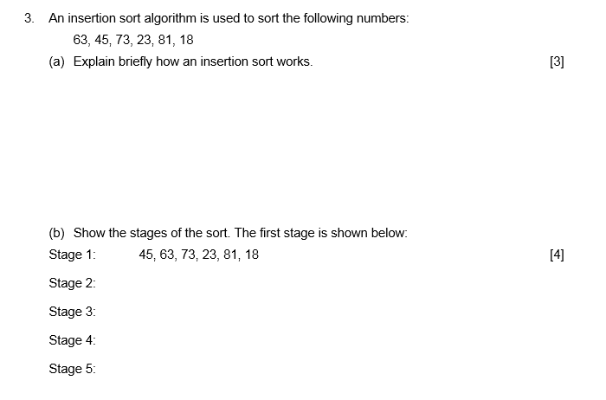

Answers further down – no cheating!

Q1

|  |  |  |  |  |  |  |
| --- | --- | --- | --- | --- | --- | --- |
| Pass | 65 | 34 | 28 | 68 | 52 | 21 |
| 1 | 34 | 28 | 65 | 52 | 21 | 68 |
| 2 | 28 | 34 | 52 | 21 | 65 | 68 |
| 3 | 28 | 34 | 21 | 52 | 65 | 68 |
| 4 | **28** | **21** | **34** | **52** | **65** | **68** |

A 5 – One more pass needed to swap 28 and 21

Q2 The insertion sort splits the list into an ordered list on the left and an unordered list on the right. In each pass it takes the first item from the unordered list and inserts it into the correct position in the ordered list. E.g.

b

|  |  |  |  |  |  |  |
| --- | --- | --- | --- | --- | --- | --- |
| Pass | **45** | 63 | 73 | 23 | 81 | 18 |
| 1 (shown in question) | **45** | **63** | 73 | 23 | 81 | 18 |
| 2 | **45** | **63** | **73** | 23 | 81 | 18 |
| 3 | **23** | **45** | **63** | **73** | 81 | 18 |
| 4 | **23** | **45** | **63** | **73** | **81** | 18 |
| 5 | **18** | **23** | **45** | **63** | **73** | **81** |