**Trilogy Physics 2H question 4 required practical activity – Force and extension**

**AO1 and AO3**

**Standard and high Demand AT 1.2**

# WS 2.5

The questions require the students to interpret data given in graphical form. Maths skills are required to interpret the graph in order to read values and to identify the pattern in the data. Students are directed to use the graph in support of their answer.

Note that the range is the smallest and largest values, and **not** the difference between the two values.

|  |  |
| --- | --- |
| **0** | **4** |
|  |  |
| **0** | **4** |

A student changed the force applied to a spring by adding weights.

**Figure 3** shows a graph of her results.

## Figure 3

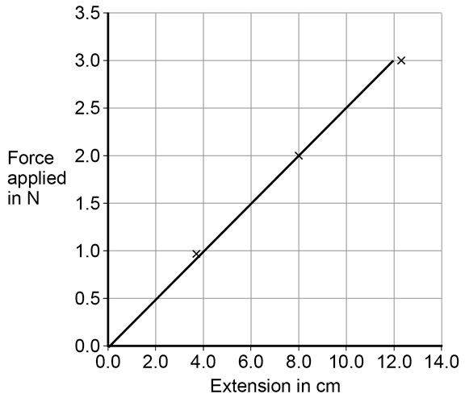

**. 1** Write down the equation that links the force applied and extension for a spring.

1. **mark]**

AO1

|  |  |
| --- | --- |
| **0** | **4** |

**. 2** Identify the pattern shown in **Figure 3**.

Explain your answer.

1. **marks]**

AO1 AO3

|  |  |
| --- | --- |
| **0** | **4** |

**. 3** Give **one** way the student could improve her investigation.

1. **mark]**

AO3

|  |  |
| --- | --- |
| **0** | **4** |

**. 4** Describe the relationship between work done and elastic potential energy in stretching aspring.

1. **marks]**

AO1

|  |  |
| --- | --- |
| **0** | **4** |

**. 5** Draw a line on **Figure 3** to show the results for a stiffer spring.

Explain the reason for the line you have drawn.

1. **marks]**

AO3

|  |  |
| --- | --- |
| **0** | **4** |

**. 6** Explain what would happen to the spring if the student kept adding weights?

**[2 marks]**

AO1

|  |  |  |  |  |
| --- | --- | --- | --- | --- |
| **Question** | **Answers** | **Extra information** | **Mark** | **AO/Spec.**  **Ref.** |
| **04.1** | force = spring constant x extension | accept f = ke | 1 | AO1/1  6.5.3 |
| **04.2** | extension is directly proportional to the force applied because it is straight line through the origin |  | 1  1 | AO3/2a      AO1/2  6.5.3 |
| **04.3** | test a greater range of load **or**  test more springs |  | 1 | AO3/3b  6.5.3  WS2.5 |
| **04.4** | work done is equal to elastic potential energy    as long as the spring does not go past the limit of proportionality |  | 1      1 | AO1/2  6.5.3 |

|  |  |  |  |  |
| --- | --- | --- | --- | --- |
| **04.5** | line extending with a greater gradient than existing line    a stiffer spring has a greater spring constant (*k*)    *k* = F/e |  | 1      1      1 | AO3/2a      AO3/2b    AO3/2b  6.5.3 |

|  |  |  |  |  |
| --- | --- | --- | --- | --- |
| **04.6** | the spring will be deformed    because it has passed the elastic limit | accept not gone back to original shape | 1    1 | AO1/2  6.5.3 |

**Physics1F question 5 required practical activity - resistance in a wire AO1 and AO2**

**Low demand**

**AT 1,6 and 7**

**WS 2.2, 2.3, 2.4, 3.2, 3.4**

|  |  |
| --- | --- |
| **0** | **5** |

A student wants to investigate how the current through a filament lamp affects its  resistance.

|  |  |
| --- | --- |
| **0** | **5** |

**. 1** Use the circuit symbols in the boxes to draw a circuit diagram that she could use.

**[2 marks]**

|  |  |  |  |  |
| --- | --- | --- | --- | --- |
| **12 V battery** | **variable**  **resistor** | **filament**  **lamp** | **voltmeter** | **ammeter** |
|  |  |  |  |  |

AO1

|  |  |
| --- | --- |
| **0** | **5** |

**. 2** Describe how the student could use her circuit to investigate how the current through a filament lamp affects its resistance.

**[4 marks]**

AO1

The student’s results are shown in **Figure 6**.

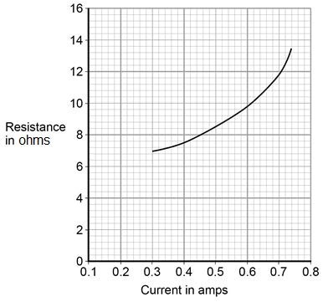

|  |  |
| --- | --- |
| **0** | **5** |

**. 3** Describe how the resistance of the filament lamp changes as the current through it increases.

**[1 mark]**

AO2

|  |  |
| --- | --- |
| **0** | **5** |

**. 4** Use **Figure 6** to estimate the resistance of the filament lamp when a current of

0.10 A passes through the lamp.

**[1 mark]**

Resistance = Ω

AO2

The current–potential difference graphs of three components are shown in **Figure 7**.

|  |  |
| --- | --- |
| **0** | **5** |

**. 5** Use answers from the box to identify each component.

AO1

**[3 marks]**

**diode filament lamp light dependent resistor**

**resistor at constant temperature thermistor**

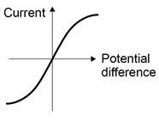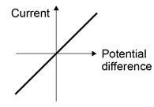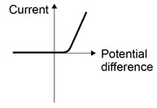

**Graph A**

**Graph B**

**Graph C**

|  |  |  |  |  |
| --- | --- | --- | --- | --- |
| **Question** | **Answers** | **Extra information** | **Mark** | **AO/Spec. Ref.** |
| **05.1** | battery, lamp and ammeter connected in series with variable resistor  voltmeter in parallel with  (filament) lamp |  | 1    1 | AO1/2  4.2.1.3 |

|  |  |  |  |  |
| --- | --- | --- | --- | --- |
| **05.2** | **Level 2:** A detailed and coherent description of a plan covering all the major steps is provided. The steps are set out in a logical manner that could be followed by another person to obtain valid results. | 3–4 | 4 | AO1/2  4.2.5.1 |
| **Level 1:** Simple statements relating to relevant apparatus or steps are made but they may not be in a logical order. The plan would not allow another person to obtain valid results. | 1–2 |
| No relevant content | 0 |
| **Indicative content**   * ammeter used to measure current * voltmeter used to measure potential difference * resistance of variable resistor altered to change current in circuit **or** change potential difference (across filament lamp) * resistance (of filament lamp) calculated **or** R=V/I statement * resistance calculated for a large enough range of different currents that would allow a valid conclusion about the relationship to be made | |  |

|  |  |  |  |  |
| --- | --- | --- | --- | --- |
| **05.3** | (as current increases) resistance increases (at an increasing rate) |  | 1 | AO2/2  4.2.1.4  WS3 |
|  | |  |  |  |
| **05.4** | any value between 6.3 and 6.9 (Ω) |  | 1 | AO2/2  4.2.1.4  WS3 |

|  |  |  |  |  |
| --- | --- | --- | --- | --- |
| **05.5** | **A**: Filament lamp **B**: Resistor at constant  temperature **C**: Diode |  | 1  1    1 | AO1/1  4.2.1.4 |

**Physics required practical activity - Waves**

**Synergy ‒ paper 1H, questions 09.1, 09.4**

**AO2**

**High demand**

**AT1, 4**

**WS 2.2, 3.1**

|  |  |
| --- | --- |
| **0** | **9** |

Some students did an investigation to study the behaviour of waves.

**Figure 8** shows a ripple tank that they used to model the behaviour of waves.

## Figure 8

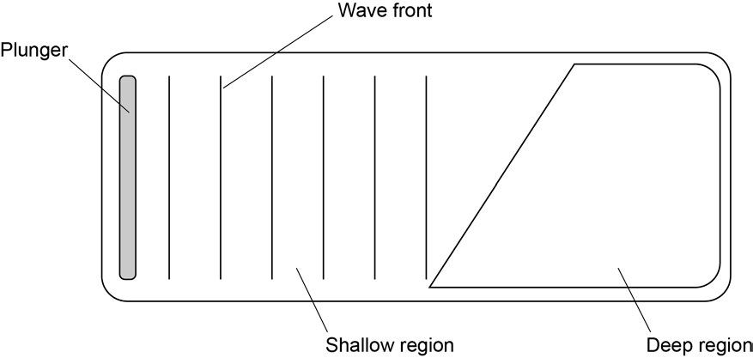

|  |  |
| --- | --- |
| **0** | **9** |

**. 1** Complete the wave fronts on **Figure 8** to show how the wave is refracted as it passes from the shallow region into the deep region.

1. **mark]**

|  |  |
| --- | --- |
| **0** | **9** |

**. 4** Some students investigate the properties of the waves generated in **Figure 8**.

Student **A** says ‘the waves move water from one end of the tank to the other’.

Student **B** says ‘that’s wrong. Only the waves move, not the water’.

Suggest what the students could do to decide which of them is correct.

1. **marks]**

|  |  |  |  |  |
| --- | --- | --- | --- | --- |
| **Question** | **Answers** | **Extra information** | **Mark** | **AO/Spec. Ref.** |
| **09.1** |  | lines should be further apart with the bottom of the wave fronts further to the right than the top | 1 | AO2  4.1.4.5 |
| **09.4** | place a floating object/plastic duck on the surface of the water |  | 1 | AO2  4.1.4.1 |
|  | it will stay in the same place **or** only bob up and down if the water doesn’t move |  | 1 |  |

**Physics paper 1H question 5**

**AO2 AO3**

**Standard demand**

**AT N/A**

**WS 2.2, 3.2, 3.4**

The question is not based on a required practical activity. Students should be able to access the question without having performed the experiment as all the relevant information is provided in the question.

|  |  |
| --- | --- |
| **0** | **5** |

A student investigated the efficiency of a motor using the equipment in **Figure 4**.

## Figure 4

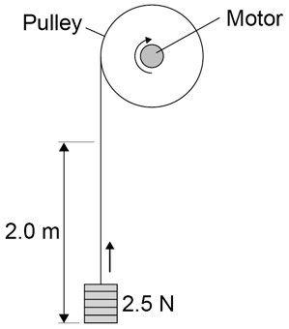

He used the motor to lift a weight of 2.5 N a height of 2.0 m.

He measured the speed at which the weight was lifted and calculated the efficiency of the energy transfer.

He repeated the experiment to gain two sets of data.

|  |  |
| --- | --- |
| **0** | **5** |

**. 1** Give **one** variable that the student controlled in his investigation.

1. **mark]**

AO3

|  |  |
| --- | --- |
| **0** | **5** |

**. 2** Give **two** reasons for taking repeat readings in an investigation.

1. **marks]**

1

2

**Figure**

**5**

shows a graph of the student’s results.

**Figure 5**

**0**

**5**

**.**

**3**

Give

**two**

conclusions that could be made from the data in

**Figure**

**5**

?

**[**

**2**

**mark**

**s**

**]**

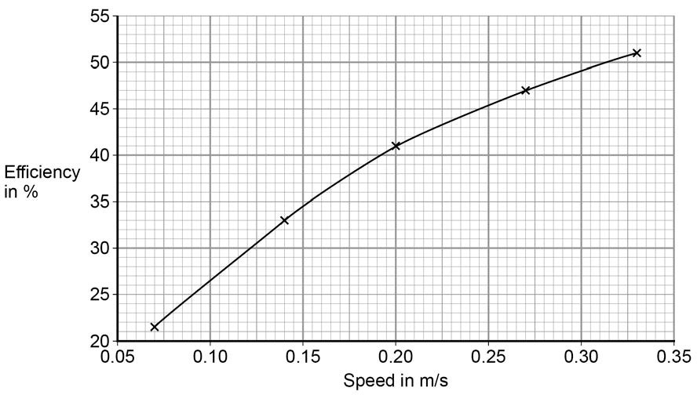

AO2

|  |  |
| --- | --- |
| **0** | **5** |

**. 4** Give the main way that the motor is likely to waste energy.

**[1 mark]**

AO2

|  |  |
| --- | --- |
| **0** | **5** |

**. 5** When the total power input to the motor was 5 W the motor could not lift the

2.5 N weight.

State the efficiency of the motor.

**[1 mark]**

Efficiency = %

AO2

|  |  |  |  |  |
| --- | --- | --- | --- | --- |
| **Question** | **Answers** | **Extra information** | **Mark** | **AO/Spec. Ref.** |

|  |  |  |  |  |
| --- | --- | --- | --- | --- |
| **05.1** | water boils at the same temperature each time control starting temp by allowing enough time for water and kettle to reach room temperature |  | 1    1 | AO3/3a  6.1.1.5  WS2.2 |

|  |  |  |  |  |
| --- | --- | --- | --- | --- |
| **05.2** | uncertainty = (302 –  298)/2  uncertainty = ± 2 (s) | ignore missing ± | 1  1 | AO2/2  6.1.1.5  WS3.4 |

|  |  |  |  |  |
| --- | --- | --- | --- | --- |
| **05.3** | (Energy transferred =  Power × time)  E = 2.20 × 300  E = 660 (kJ) | allow 660 (kJ) without working shown for **2** marks  allow answer calculated using incorrect value for t (298 or 302) for **1** mark | 1  1 | AO2/1  AO2/1  6.1.1.5 |

|  |  |  |  |  |
| --- | --- | --- | --- | --- |
| **05.4** | (mass × change in temperature)/mass    80 (°C) | allow **1** mark for any correct pair of values from the table  eg 20/0.25    allow 80 (°C) without working shown for **2** marks | 1      1 | AO2/2  6.1.1.4 |

|  |  |  |  |  |
| --- | --- | --- | --- | --- |
| **05.5** | four points plotted correctly          accurate line drawn | allow **1** mark for three correctly plotted points ecf their 5.3 allow ± 1mm line should be straight and drawn with a ruler line must not go through the origin | 2        1 | AO2/2  6.1.1.4  WS3.2 |

**Physics required practical – Specific heat capacity**

**Physics paper 1F question 12**

**AO1 AO2 AO3**

**Standard demand**

**AT 1 and 5**

**WS 2.3, 3.6, 3.7**

This question is set in the context of the required practical on specific heat capacity and assess related content from the specification along with working scientifically skills.

|  |  |
| --- | --- |
| **1** | **2** |

A student investigated how much energy from the Sun was incident on the Earth’s surface at her location.

She put an insulated pan of water in direct sunlight and measured the time it took for the temperature of the water to increase by 0.6 °C.

The apparatus she used is shown in **Figure 14**.

## Figure 14

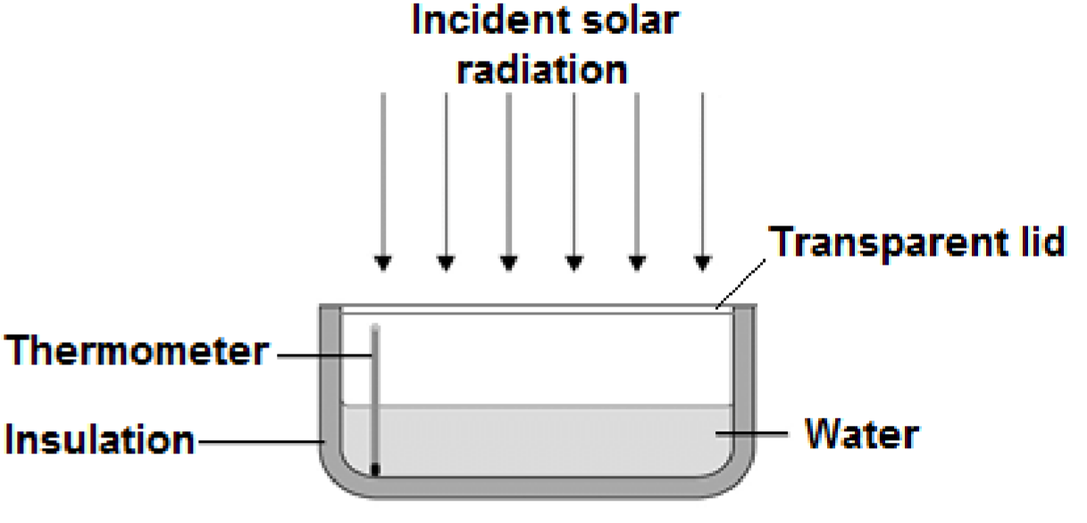

|  |  |  |  |
| --- | --- | --- | --- |
| **1** | **2** | **.** | **1** |

Choose the most appropriate resolution for the thermometer used by the student.

1. **mark]**

Tick **one** box.

|  |
| --- |
|  |

0.1 ⁰C

|  |
| --- |
|  |

0.5 ⁰C

|  |
| --- |
|  |

1.0 ⁰C

The energy transferred to the water was 1050 J.

The time taken for the water temperature to increase by 0.6 °C was 5 minutes.

AO3 The specific heat capacity of water is 4200 J/kg °C.

|  |  |
| --- | --- |
| **1** | **2** |

**. 2** Write down the equation which links energy transferred, power and time.

1. **mark]**

AO1

|  |  |
| --- | --- |
| **1** | **2** |

**. 3** Calculate the mean power supplied by the Sun to the water in the pan.

1. **marks]**

AO2

|  |  |
| --- | --- |
| **1** | **2** |

**. 4** Calculate the mass of water the student used in her investigation.

Use the correct equation from the Physics Equation Sheet.

1. **marks]**

AO2 Mass = Kg

|  |  |
| --- | --- |
| **1** | **2** |

**. 5** The student’s results can only be used as an estimate of the mean power at herlocation.

Give **one** reason why.

**[1 mark]**

AO3

|  |  |  |  |  |
| --- | --- | --- | --- | --- |
| **Question** | **Answers** | **Extra information** | **Mark** | **AO/Spec. Ref.** |
|  |  |  |  |  |
| **12.1** | 0.1 (⁰C) |  | 1 | AO3/3a  4.1.1.3  WS2.3 |
|  |  |  |  |  |
| **12.2** | power = energy transferred/time | allow P = E/t allow E = P x t | 1 | AO1/1  4.1.1.4 |
|  |  |  |  |  |
| **12.3** | 1050/300  3.5 (W) | accept 3.5 (W) with no working shown for **2** marks | 1  1 | AO2/1  4.1.1.4 |

|  |  |  |  |  |
| --- | --- | --- | --- | --- |
| **12.4** | 1050 = m x 4200 x 0.6 m = 1050/(4200 x 0.6) m = 0.417 (kg) | accept 0.417 (kg) with no working shown for **3** marks | 1 1  1 | AO2/2  4.1.1.3 |

|  |  |  |  |  |
| --- | --- | --- | --- | --- |
| **12.5** | any **one** from:   * energy used to heat metal pan (as well as the water) * energy transfer to the surroundings (through the insulation) * angle of solar radiation will have changed during investigation * intensity of solar radiation may have varied during investigation |  | 1 | AO3/3a  4.1.1.3  WS3 |

**Physics ‒ paper 1F, question 06.1**

**AO1**

**Low/Standard demand**

**AT N/A**

**WS N/A**

This is not a required practical activity, and the question is assessing the understanding of static charges. It is an extremely common activity that most students will experience but it is not essential that they have seen it first-hand.

|  |  |
| --- | --- |
| **0** | **6** |

A student rubs an acetate rod with a cloth.

**Figure 8** shows the charges on the acetate rod and cloth before and after rubbing.

## Figure 8

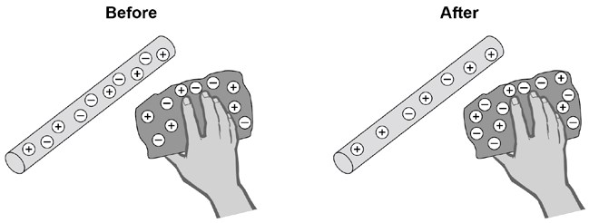

|  |  |
| --- | --- |
| **0** | **6** |

**. 1** Explain how rubbing an acetate rod with a cloth causes the rod and cloth to become charged.

**[4 marks]**

|  |  |  |  |  |
| --- | --- | --- | --- | --- |
| **Question** | **Answers** | | **Mark** | **AO/Spec. Ref.** |
| **06.1** | **Level 2:** Clear description of negative charge transfer and net charge, with logical links | 3–4 | 4 | AO1  4.2.5.1 |
| **Level 1:** Description of negative charge transfer **or** net charge | 1–2 |
| No relevant content | 0 |
| **Indicative content**   * friction (between cloth and rod causes) * electrons (to) move * from the acetate rod **or** to the cloth * (net) charge on cloth is negative and (net) charge on rod is positive | |

**Trilogy Physics 2H, questions 06.1, 06.2**

**AO1 AO2**

**High demand**

**AT N/A**

**WS N/A**

This is not a required practical activity. The context provides the background to the science concepts being assessed which are covered in the specification. It is not common for students to carry out this activity, but it would be likely that students would have seen the phenomenon demonstrated when this was taught.

|  |  |
| --- | --- |
| **0** | **6** |

A teacher used the equipment shown in **Figure 6**. to demonstrate the  motor effect.

## Figure 6

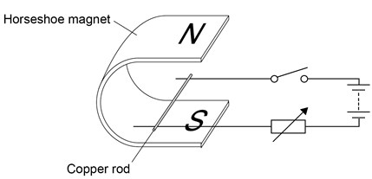

|  |  |
| --- | --- |
| **0** | **6** |

**. 1** Describe how Fleming’s left-hand rule can be used to determine the direction in which the rod will move when the switch is closed, and state the direction.

**[4 marks]**

AO1

|  |  |
| --- | --- |
| **0** | **6** |

**. 2** Increasing the current can increase the force acting on the copper rod.

Give **one** other way in which the size of the force acting on the copper rod could be increased.

**[1 mark]**

AO2

|  |  |
| --- | --- |
| **0** | **6** |

**. 3** The copper rod in **Figure 6** has a length of 7 cm and a mass of 4

×10–4 kg.

When there is a current of 1.12 A the resultant force on the copper rod is 0 N.

Calculate the magnetic flux density.

Gravitational field strength = 9.8 N/kg

**[5 marks]**

AO2

|  |  |  |  |  |
| --- | --- | --- | --- | --- |
| **Question** | **Answers** | **Extra information** | **Mark** | **AO/Spec. Ref.** |
| **06.1** | thumb, index finger and third finger are held mutually at right angles index finger shows the direction of the magnetic field from North to South, third finger shows the direction of the current from positive to negative terminal  the thumb then shows the direction of the force acting on the copper rod so the copper rod will move from left to right |  | 1  1          1    1 | AO1/2  6.7.2.2 |

|  |  |  |  |  |
| --- | --- | --- | --- | --- |
| **06.2** | any **one** from:  use a stronger magnet increase the magnetic flux density  increase the length of the copper rod in the magnetic field coil the copper rod |  | 1 | AO2/2  6.7.2.2 |

|  |  |  |  |  |
| --- | --- | --- | --- | --- |
| **06.3** | W = 9.8 × 4×10–4 = 3.92  × 10–3  conversion of the length 7cm to 0.07m  3.92 × 10–3 = B × 1.12 ×  0.07  B = 3.92 × 10–3/0.0784  B = 0.05 (T) | allow 0.05 (T) without working shown for the **5** calculation marks | 1  1    1  1  1 | AO2/2  6.5.1.3  6.7.2.2  WS4.5 |

**Physics - paper 1F, question 04**

**AO3**

**Low demand AT N/A**

**WS 3.7**

This is not a required practical and students do not need to have carried out the practical but when covering this part of the specification (4.3.1.2 and 4.3.2.3) it may have been referred to as a way of explaining the concepts. The question focuses on working scientifically skills and AO3

|  |  |
| --- | --- |
| **0** | **4** |

Two students investigated the change of state of stearic acid from liquid  to solid.

They measured how the temperature of stearic acid changed over 5 minutes as it changed from liquid to solid.

**Figure 4** shows the different apparatus the two students used.

## Figure 4

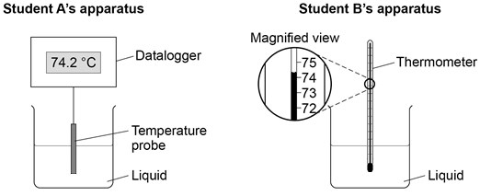

|  |  |
| --- | --- |
| **0** | **4** |

**. 1** Choose **two** advantages of using student **A**’s apparatus.

**[2 marks]**

Tick **two** boxes.

|  |
| --- |
|  |

Student **A**’s apparatus made sure the test was fair.

|  |
| --- |
|  |

Student **B**’s apparatus only measured categoric variables.

|  |
| --- |
|  |

Student **A**’s measurements had a higher resolution.

|  |
| --- |
|  |

Student **B** was more likely to misread the temperature.

AO1

|  |  |
| --- | --- |
| **0** | **4** |

**. 2** Student **B** removed the thermometer from the liquid each time he took a temperature reading.

What type of error would this cause?

**[1 mark]**

Tick **one** box.

|  |
| --- |
|  |

A systematic error

|  |
| --- |
|  |

A random error

|  |
| --- |
|  |

A zero error

AO3

Student **A**’s results are shown in **Figure 5**.

## Figure 5

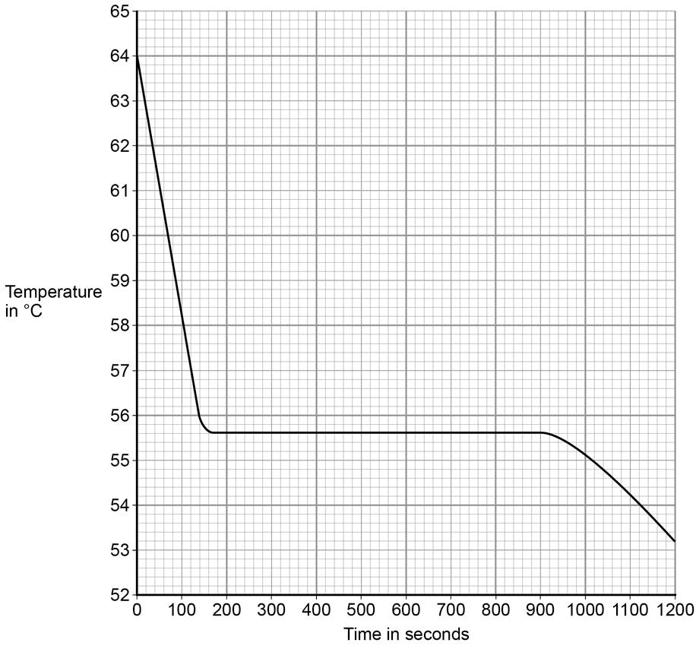

|  |  |
| --- | --- |
| **0** | **4** |

**. 3** What was the decrease in temperature between 0 and 160 seconds?

**[1 mark]**

Tick **one** box.

|  |
| --- |
|  |

8.2 °C

|  |
| --- |
|  |

8.4 °C

|  |
| --- |
|  |

53.2 °C

|  |
| --- |
|  |

AO3  55.6 °C

|  |  |
| --- | --- |
| **0** | **4** |

**. 4** Use **Figure 5** to determine the time taken for the stearic acid  to change from a liquid to a solid.

1. **mark]**

Time = seconds

AO3

|  |  |
| --- | --- |
| **0** | **4** |

**. 5** Calculate the energy transferred to the surroundings as 0.40 kg of stearic acid changed state from liquid to solid.

The specific latent heat of fusion of stearic acid is 199 000 J/kg.

Use the correct equation from the Physics Equations Sheet.

1. **marks]**

Energy =

J

AO2

|  |  |
| --- | --- |
| **0** | **4** |

**. 6** After 1200 seconds the temperature of the stearic acid continued to decrease. Explain why.

**[2 marks]**

AO3

|  |  |  |  |  |
| --- | --- | --- | --- | --- |
| **Question** | **Answers** | **Extra information** | **Mark** | **AO/Spec. Ref.** |

|  |  |  |  |  |
| --- | --- | --- | --- | --- |
| **04.1** | Student A’s measurements had a higher resolution Student B was more likely to misread the temperature |  | 1    1 | AO3/1b  4.3.1.3  WS3 |

|  |  |  |  |  |
| --- | --- | --- | --- | --- |
| **04.2** | a random error |  | 1 | AO3/3a  4.3.1.3  WS3 |

|  |  |  |  |  |
| --- | --- | --- | --- | --- |
| **04.3** | 8.4 ˚C |  | 1 | AO3/2a  4.3.2.3 |
|  | |  |  |  |
| **04.4** | 740 (seconds) | allow answers in the range 730 – 780 | 1 | AO3/2a  4.3.2.3 |

|  |  |  |  |  |
| --- | --- | --- | --- | --- |
| **04.5** | 0.40 x 199 000    79 600 (J) | accept 79 600 (J) with no working shown for **2** marks | 1    1 | AO2/1  4.3.2.3 |

|  |  |  |  |  |
| --- | --- | --- | --- | --- |
| **04.6** | stearic acid has a higher temperature than the surroundings  temperature will decrease  until stearic acid is the same as the room temperature/surroundings | accept stearic acid is hotter than the surroundings | 1      1 | AO3/2b  4.3.2.3 |

**Synergy ‒ paper 2H, (Physics) question 06.6**

**AO3**

**High demand**

**AT N/A**

**WS 2.7**

Note that although this is not a required practical activity, it would be helpful to students if they were able to observe radioactive sources.

|  |  |
| --- | --- |
| **0** | **6** |

**. 6** A teacher demonstrated an experiment to measure the count rate of a radioactive source.

**Figure 8** shows how the teacher set up the apparatus.

**Figure 8**

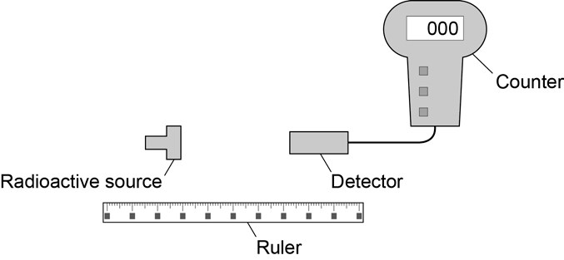

**Table 4** shows the results.

## Table 4

|  |  |
| --- | --- |
| **Distance in metres** | **Count rate in counts per minute** |
| 0.5 | 108 |
| 1.0 | 38 |
| 1.5 | 23 |
| 2.0 | 18 |

Suggest how the student could modify the experiment to determine the radiation type present in the source.

**[4 mark]**

|  |  |  |  |
| --- | --- | --- | --- |
| **Question** | **Answers** | **Mark** | **AO/Spec. Ref.** |
| **06.6** | **Level 2:** A detailed and coherent plan covering all the major steps is provided. The steps are set out in a logical manner that could be followed by another person to determine the type of radioactivity. | 3–4 | AO3          4.3.2.4 |
| **Level 1:** Simple statements relating to relevant apparatus or steps are made but they may not be in a logical order. The plan would not allow another person to determine the type of radioactivity. | 1–2 |
| No relevant content. | 0 |
| **Indicative content**   * move detector to within a few mm of source * insert thick paper and see whether the reading decreases * if so, could be alpha as paper absorbs this * repeat with thin aluminium * if reading falls then some beta radiation because absorbed by aluminium * if reading doesn’t fall then must be gamma radiation |  |