***Physics Stretch and Challenge***

On this page are some videos and books that you may find interesting. The images are hyperlinked and each book has a link to the book on amazon.

***Electricity***

[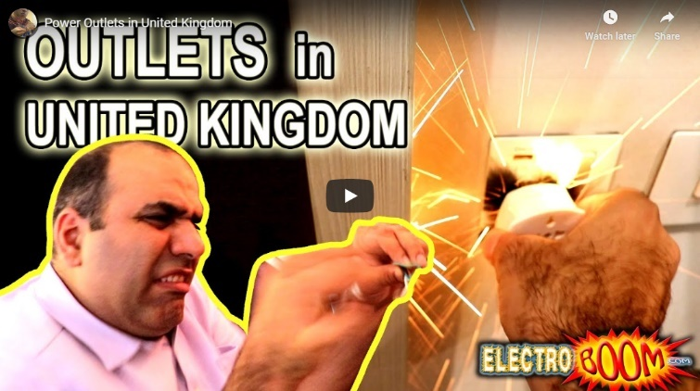](https://www.youtube.com/watch?v=abqMLqHwqpo&t=371s) [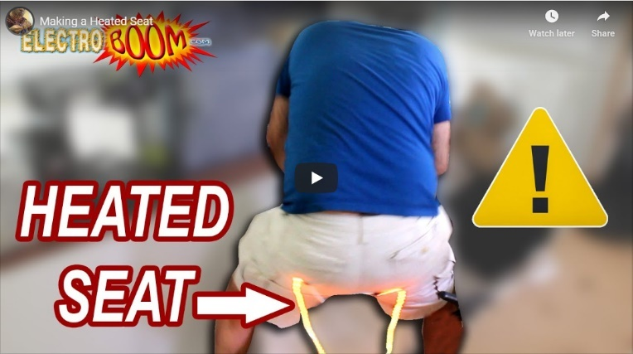](https://www.youtube.com/watch?v=NJRDclzi5Vg)

***Particle and Quantum Physics***

***[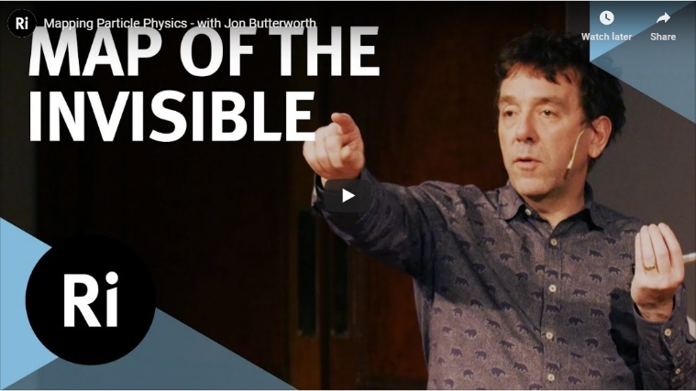](https://www.youtube.com/watch?v=wf1W_ZfqYEs) [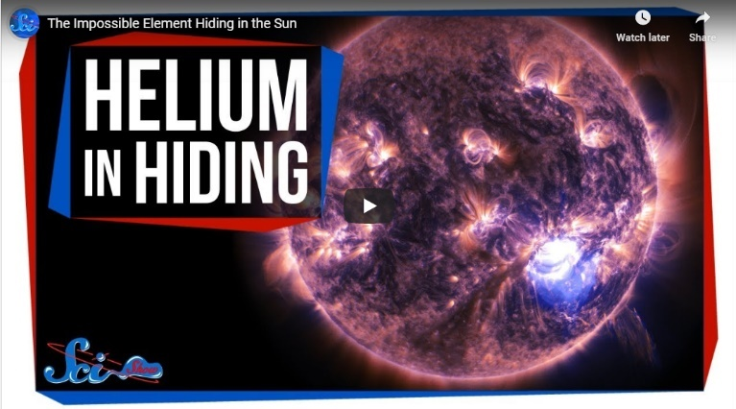](https://www.youtube.com/watch?v=GcfF40CPdl0)***

***Waves and Optics***

***[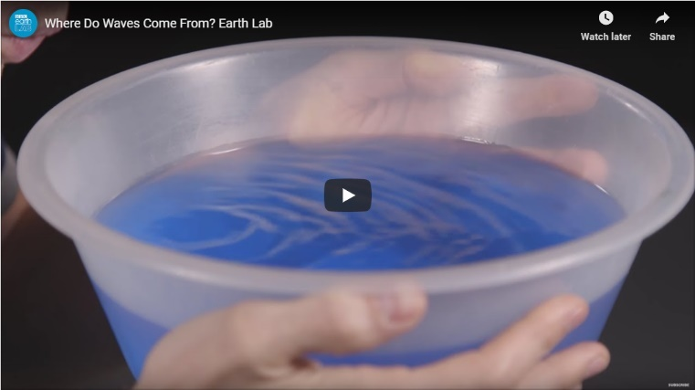](https://www.youtube.com/watch?v=Fkwkn7vXpWI) [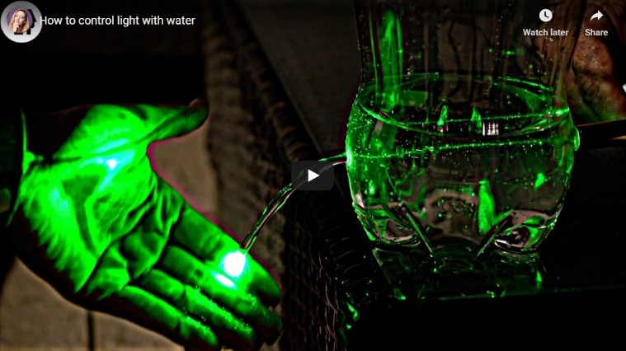](https://www.youtube.com/watch?v=gUPbysSt7XU)***

***Fields***

***[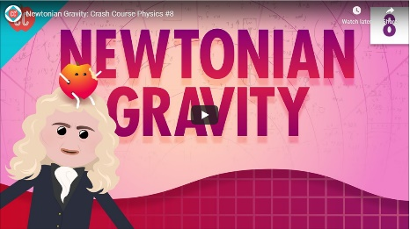](https://youtu.be/7gf6YpdvtE0) [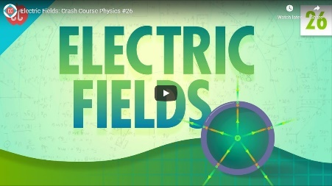](https://www.youtube.com/watch?v=mdulzEfQXDE) [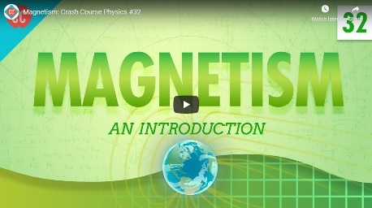](https://www.youtube.com/watch?v=s94suB5uLWw)***

***Nuclear Physics***

***[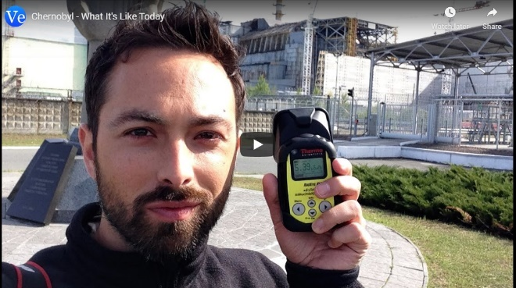](https://www.youtube.com/watch?v=TRL7o2kPqw0) [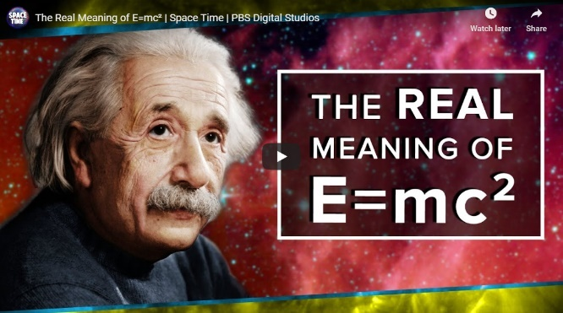](https://www.youtube.com/watch?v=Xo232kyTsO0)***

***Astro-Physics***

***[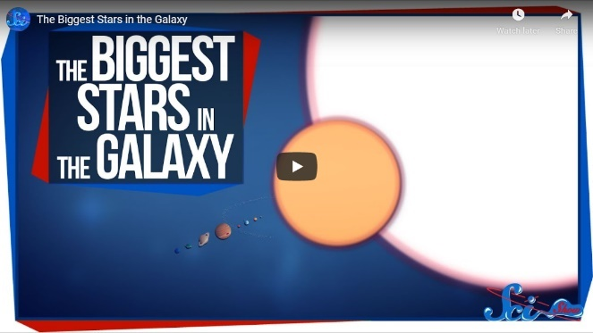](https://www.youtube.com/watch?v=L8_RnYjFvt0) [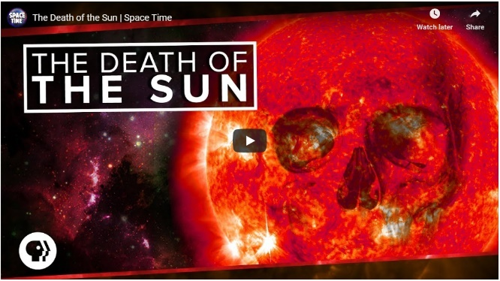](https://www.youtube.com/watch?v=iJY3y5_k0do)***

***[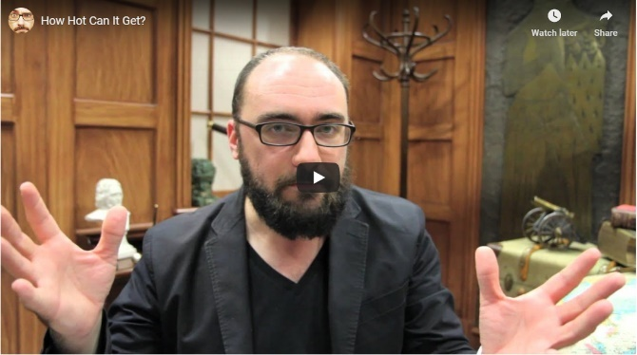](https://www.youtube.com/watch?v=4fuHzC9aTik) [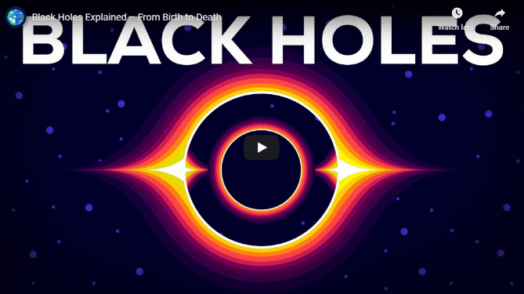](https://www.youtube.com/watch?v=e-P5IFTqB98)***

***[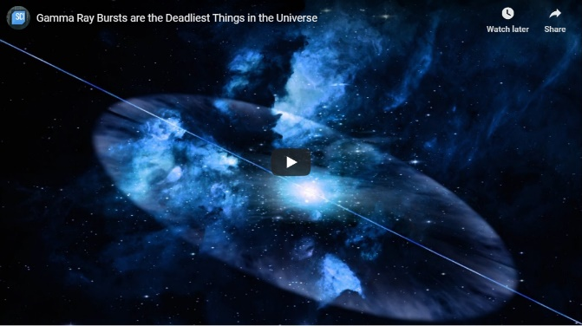](https://www.youtube.com/watch?v=IpuVnqYIgbo) [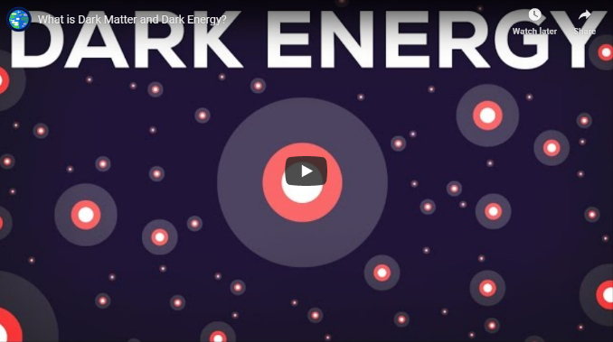](https://www.youtube.com/watch?v=QAa2O_8wBUQ)***

***[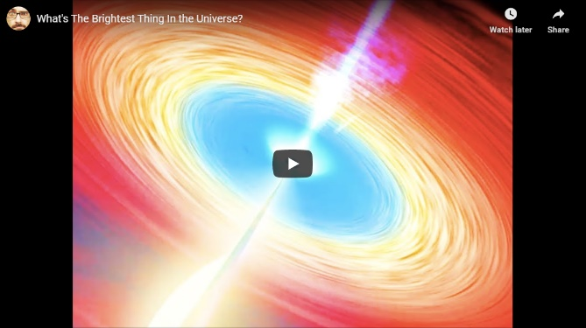](https://www.youtube.com/watch?v=FJB7gbjiJKw) [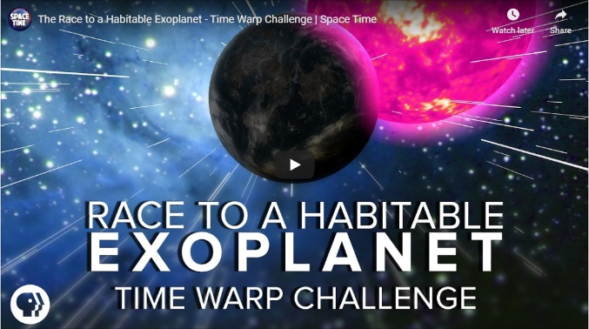](https://www.youtube.com/watch?v=_tmMKQ4kp_I)***

***All of these videos are also on the Firefly page:*** <https://wilmslowhigh.fireflycloud.net/physics-1/great-a-level-physics-videos>

***Y11/13 Suggested summer reading.*** I suggest you click on the Amazon links to find out what these books are about ***before*** buying. Next to each book is the year groups aimed at.

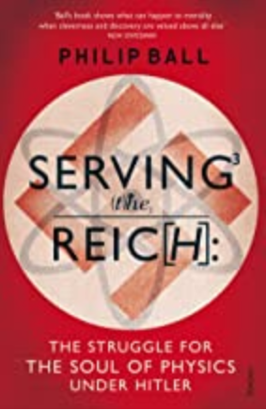Y10-13 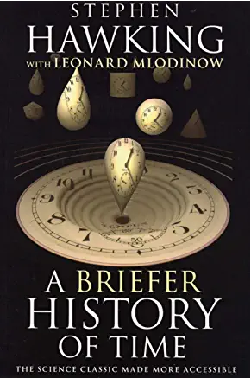Y11-13 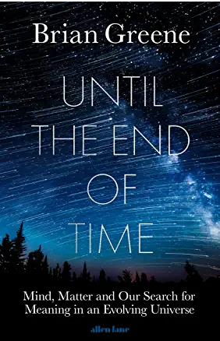Y13

<https://www.amazon.co.uk/s?k=Serving+the+Reich&i=stripbooks&ref=nb_sb_noss_2>

<https://www.amazon.co.uk/s?k=A+Briefer+History+of+Time&i=stripbooks&ref=nb_sb_noss_2>

<https://www.amazon.co.uk/s?k=Until-End-Time-Brian-Greene&i=stripbooks&ref=nb_sb_noss_2>

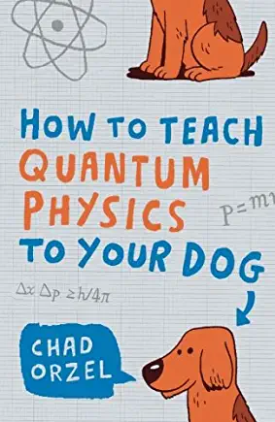Y11-13 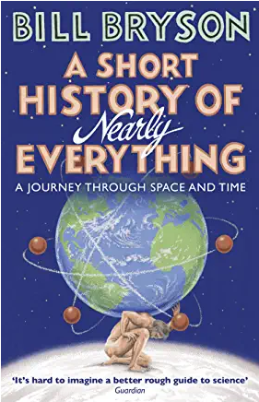Y10-13 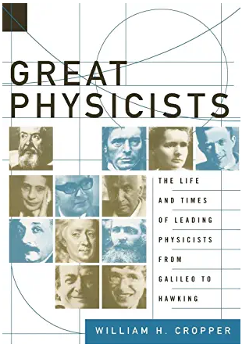 Y11-13

<https://www.amazon.co.uk/s?k=How+to+teach+Quantum+Physics+to+your+dog&i=stripbooks&ref=nb_sb_noss_2>

<https://www.amazon.co.uk/s?k=A+Short+History+of+Nearly+Everything&ref=nb_sb_noss_2>

<https://www.amazon.co.uk/s?k=Great+Physicists&ref=nb_sb_noss_2>

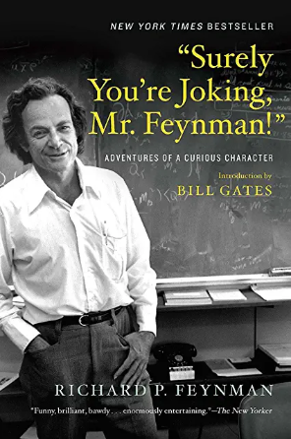Y13 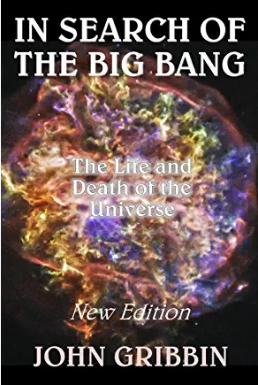Y13 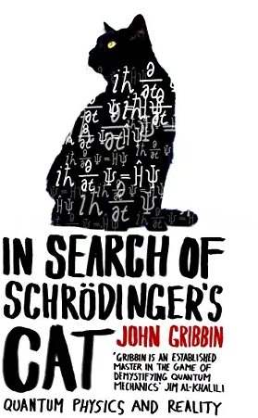Y13

<https://www.amazon.co.uk/s?k=Surely+You%27re+Joking+Mr+Feynman%3F&ref=nb_sb_noss_2>

<https://www.amazon.co.uk/s?k=In+Search+of+the+Big+Bang+-+John+Gribbin&ref=nb_sb_noss>

<https://www.amazon.co.uk/s?k=In+Search+Of+Schrodinger%27s+Cat+-+John+Gribbin&ref=nb_sb_noss>

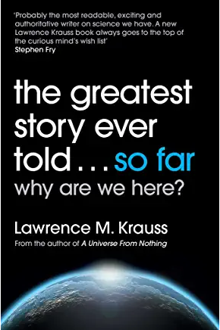Y13 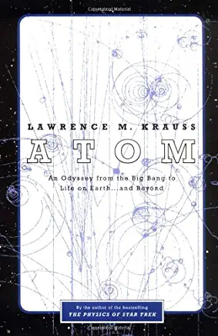 Y13 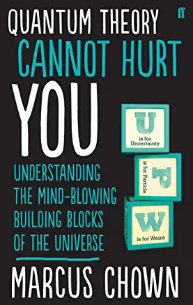Y11-13

<https://www.amazon.co.uk/s?k=The+Greatest+Story+Ever+Told...So+Far+-+Lawrence+Krauss&ref=nb_sb_noss>

<https://www.amazon.co.uk/s?k=Atom%3A+An+Odyssey+from+the+Big+Bang+to+Life+on+Earth...+and+Beyond&i=stripbooks&ref=nb_sb_noss>

<https://www.amazon.co.uk/s?k=Quantum+Theory+Cannot+Hurt+You+-+Marcus+Chown&i=stripbooks&ref=nb_sb_noss>

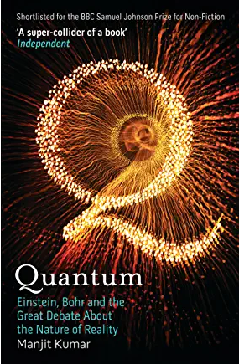 Y13 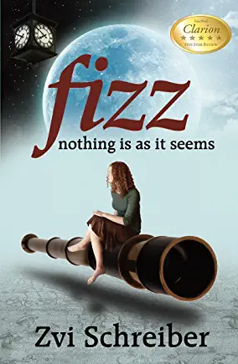 Y11-13 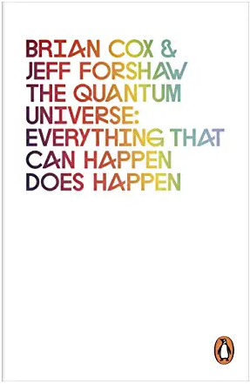 Y13

<https://www.amazon.co.uk/s?k=Quantum+-+Manjit+Kumar&i=stripbooks&ref=nb_sb_noss_2>

<https://www.amazon.co.uk/s?k=Fizz%3A+Nothing+is+as+it+seems+-+Zvi+Schreiber&i=stripbooks&ref=nb_sb_noss>

<https://www.amazon.co.uk/s?k=the+quantum+universe+everything+that+can+happen+does+happen&i=stripbooks&ref=nb_sb_noss_1>