**Y11 to 12 transition**

Task 1: Purchase AQA A level PE textbooks (book 1 and book 2)

Task 2: Purchase and label 2 folders. Buy dividers for the 3 sections (A/B/C)

Exercise Physiology

Task 1: Using the textbook and own knowledge, produce a mindmap, poster or notes on the exercise-related function of food classes; carbohydrate, fibre, fat (saturated fat, trans fat and cholesterol) and protein.

Example for carbohydrates:

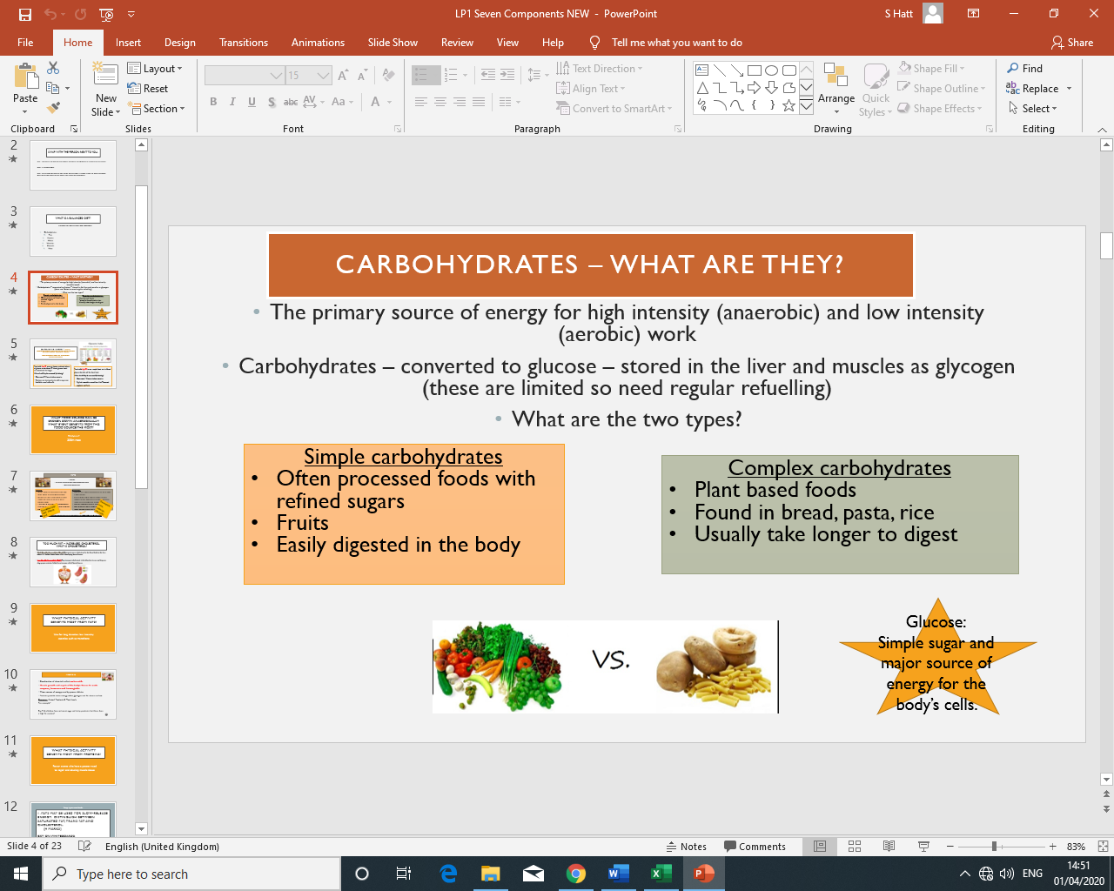

Anatomy and Physiology

Task 2: Using the textbook and own research, produce notes on the following:

1. What is HR, SV and Q and explain the relationship between them.
2. What is heart disease, high blood pressure, effects of cholesterol, stroke.