* 1. A **real world object** about which data is stored in a database. Corresponds to **tables** in the database.
     1. PupilNumber. It is a **unique identifier**. Two pupils cannot have the same PupilNumber but they can have the same surname, firstname or ClassCode.
     2. ClassCode is used here as a **foreign key** to link CLASS and PUPIL using the ClassCode, all the class details can be retrieved from the Class table otherwise the class details will have to be rewritten everytime/to avoid **data redundancy**.
     3. **Existence check**. Male/Female allowed, and no other entry possible.
     4. **Range check**. Must be a real number. Must be positive.
  2. It is used as a foreign key (in this table)... the primary key of the DOG table to link the two tables and allows us to find the details of the Dog to which each job relates.
  3. 36, 37, 39.
  4. There is a date. There is a title. Jobs are grouped/sorted appropriately (eg by dog, time or job type). Each job includes the Dog Name. Each job includes the Dog ID. Each Job includes the Job type. Each job includes details.
  5. A Database Management System. Used to manage the database. Provides facilities for creating tables, inserting data, editing/deleting data, producing reports and running queries (questions).
  6. **FORM**  
     An input screen, allowing chosen data items to be displayed and edited. Uses text boxes/drop down lists/checkboxes etc. When edited the changes are updated in the database. The grocery shop could use a form to enter new products into the database.  
     **REPORT**  
     An output of the data in a database. A snapshot of the data at a given time/when printed of specified fields (based on a query) and laid out in a specified format. Aggregates may be calculated and displayed. The grocery shop could use a report to display weekly sales.
     1. 0003, 0006
     2. 0001, 0002, 0004, 0008.
     3. (Discontinued = False) AND (QuantityLeft < ReorderLevel)

* 1. 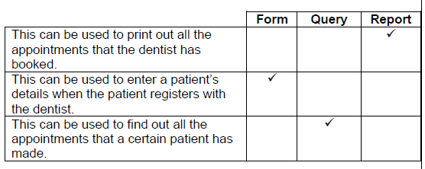
  2. Two from: The time is in the correct format hh:mm. The time is within the dentist’s working day. The hours are in the range 1-12 / 0-24. The minutes are in the range 0-59.
  3. The patient’s data does not have to be repeated for each appointment as the patient ID can be stored with the appointment to link the two entities. Allows the patient (and appointment) data to be manipulated independently e.g. if the name of the patient changes. Avoids the possibility of the patient data becoming inconsistent due to being stored multiple times.

1. A television set top box contains a database of television channels and programmes.
   1. A set of data organised as a set of records in one or more files.
   2. Primary key: ChannelID. It is a unique identifier. Two channels can have the same Channel Name but not the same Channel ID.
      1. ChannelID (the primary key of the Channel table) is stored in the PROGRAMME table where it is a foreign key.
      2. Less data entry required because programme and channel details are stored once. Avoids redundancy/don’t have to repeat channel details for every programme on that channel. Avoids inconsistency (when channel data changes)