Power & Conflict Poetry

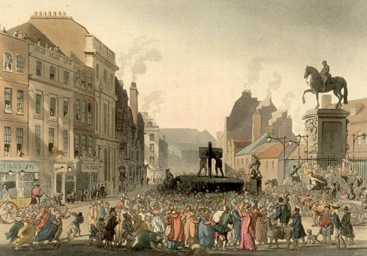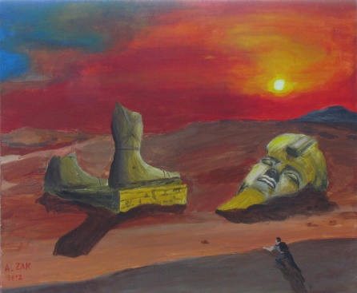

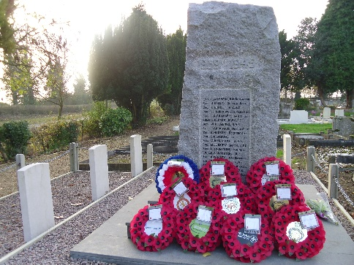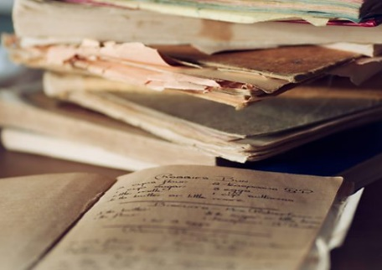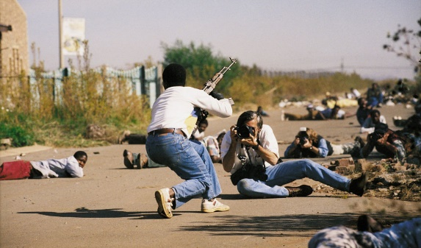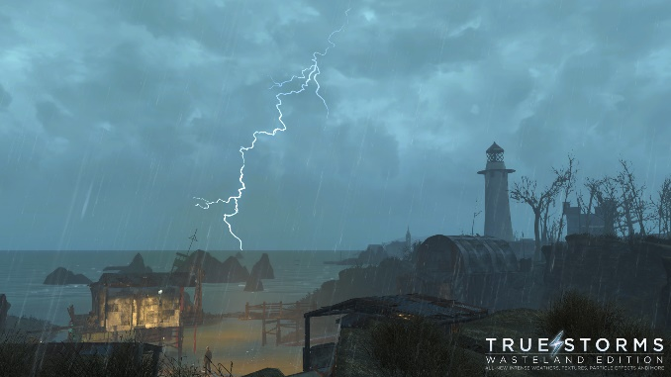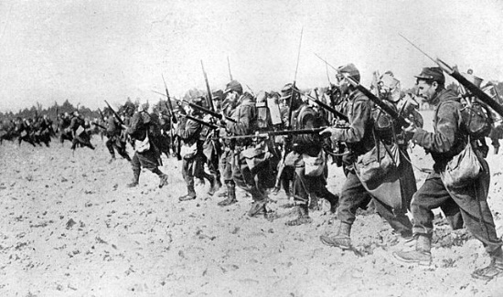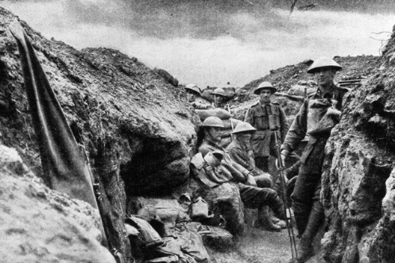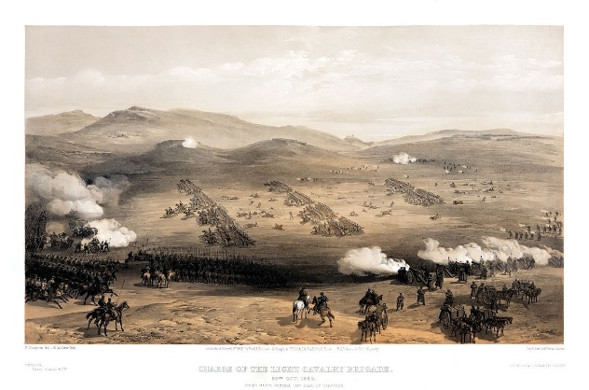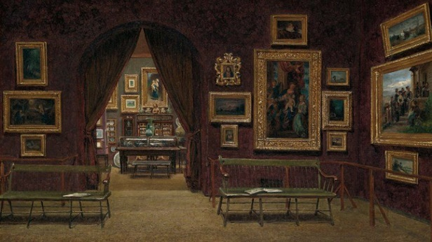

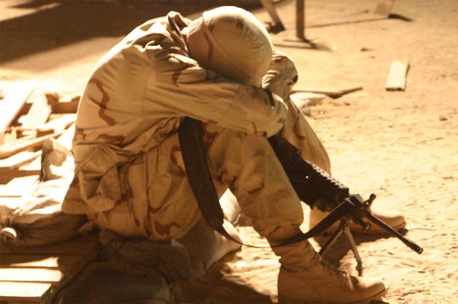

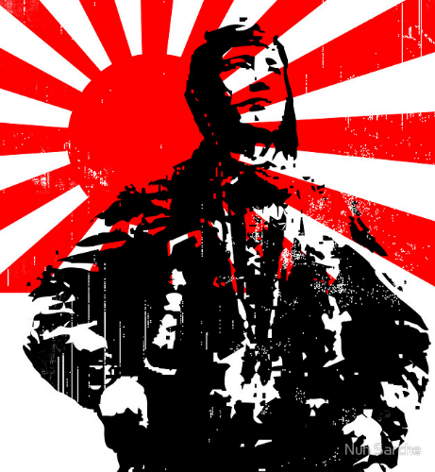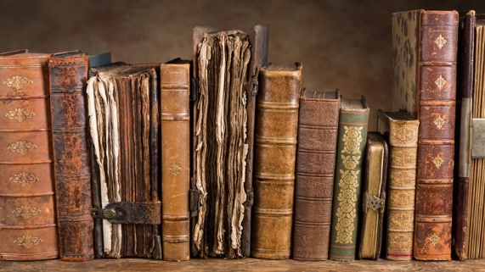

At Home Learning

Year 10

Name: _____________________________

1. ***Ozymandias***

**Once you have read the poem, complete the Seneca Learning quiz on ‘Ozymandias’, or use the study guide provided on Firefly to help you answer the following questions:**

1. **Who wrote the poem?**
2. **Write a one paragraph summarising what happens in the poem/ what the poem is about.**
3. **Write down three key facts about the writer of the poem.**
4. **Write down three key ideas the poem explores.**
5. **Pick out three interesting pieces of language and explain their significance.**
6. ***London***

**Once you have read the poem, complete the Seneca Learning quiz on ‘London’, or use the study guide provided on Firefly to help you answer the following questions:**

1. **Who wrote the poem?**
2. **Write a one paragraph summarising what happens in the poem/ what the poem is about.**
3. **Write down three key facts about the writer of the poem.**
4. **Write down three key ideas the poem explores.**
5. **Pick out three interesting pieces of language and explain their significance.**
6. ***Extract from ‘The Prelude’***

**Once you have read the poem, complete the Seneca Learning quiz on ‘Extract from The Prelude’, or use the study guide provided on Firefly to help you answer the following questions:**

1. **Who wrote the poem?**
2. **Write a one paragraph summarising what happens in the poem/ what the poem is about.**
3. **Write down three key facts about the writer of the poem.**
4. **Write down three key ideas the poem explores.**
5. **Pick out three interesting pieces of language and explain their significance.**
6. ***My Last Duchess***

**Once you have read the poem, complete the Seneca Learning quiz on ‘My Last Duchess’, or use the study guide provided on Firefly to help you answer the following questions:**

1. **Who wrote the poem?**
2. **Write a one paragraph summarising what happens in the poem/ what the poem is about.**
3. **Write down three key facts about the writer of the poem.**
4. **Write down three key ideas the poem explores.**
5. **Pick out three interesting pieces of language and explain their significance.**

***5.The Charge of the Light Brigade***

**Once you have read the poem, complete the Seneca Learning quiz on ‘The Charge of the Light Brigade’, or use the study guide provided on Firefly to help you answer the following questions:**

1. **Who wrote the poem?**
2. **Write a one paragraph summarising what happens in the poem/ what the poem is about.**
3. **Write down three key facts about the writer of the poem.**
4. **Write down three key ideas the poem explores.**
5. **Pick out three interesting pieces of language and explain their significance.**

***6.Exposure***

**Once you have read the poem, complete the Seneca Learning quiz on ‘Exposure’, or use the study guide provided on Firefly to help you answer the following questions:**

1. **Who wrote the poem?**
2. **Write a one paragraph summarising what happens in the poem/ what the poem is about.**
3. **Write down three key facts about the writer of the poem.**
4. **Write down three key ideas the poem explores.**
5. **Pick out three interesting pieces of language and explain their significance.**

***7.Storm on the Island***

**Once you have read the poem, complete the Seneca Learning quiz on ‘Storm on the Island’, or use the study guide provided on Firefly to help you answer the following questions:**

1. **Who wrote the poem?**
2. **Write a one paragraph summarising what happens in the poem/ what the poem is about.**
3. **Write down three key facts about the writer of the poem.**
4. **Write down three key ideas the poem explores.**
5. **Pick out three interesting pieces of language and explain their significance.**

***8.Bayonet Charge***

**Once you have read the poem, complete the Seneca Learning quiz on ‘Bayonet Charge’, or use the study guide provided on Firefly to help you answer the following questions:**

1. **Who wrote the poem?**
2. **Write a one paragraph summarising what happens in the poem/ what the poem is about.**
3. **Write down three key facts about the writer of the poem.**
4. **Write down three key ideas the poem explores.**
5. **Pick out three interesting pieces of language and explain their significance.**

***9.Remains***

**Once you have read the poem, complete the Seneca Learning quiz on ‘Remains’, or use the study guide provided on Firefly to help you answer the following questions:**

1. **Who wrote the poem?**
2. **Write a one paragraph summarising what happens in the poem/ what the poem is about.**
3. **Write down three key facts about the writer of the poem.**
4. **Write down three key ideas the poem explores.**
5. **Pick out three interesting pieces of language and explain their significance.**

***10.Poppies***

**Once you have read the poem, complete the Seneca Learning quiz on ‘Poppies’, or use the study guide provided on Firefly to help you answer the following questions:**

1. **Who wrote the poem?**
2. **Write a one paragraph summarising what happens in the poem/ what the poem is about.**
3. **Write down three key facts about the writer of the poem.**
4. **Write down three key ideas the poem explores.**
5. **Pick out three interesting pieces of language and explain their significance.**

***11.War Photographer***

**Once you have read the poem, complete the Seneca Learning quiz on ‘War Photographer’, or use the study guide provided on Firefly to help you answer the following questions:**

1. **Who wrote the poem?**
2. **Write a one paragraph summarising what happens in the poem/ what the poem is about.**
3. **Write down three key facts about the writer of the poem.**
4. **Write down three key ideas the poem explores.**
5. **Pick out three interesting pieces of language and explain their significance.**

***12.Tissue***

**Once you have read the poem, complete the Seneca Learning quiz on ‘Tissue’, or use the study guide provided on Firefly to help you answer the following questions:**

1. **Who wrote the poem?**
2. **Write a one paragraph summarising what happens in the poem/ what the poem is about.**
3. **Write down three key facts about the writer of the poem.**
4. **Write down three key ideas the poem explores.**
5. **Pick out three interesting pieces of language and explain their significance.**

***13.The Emigree***

**Once you have read the poem, complete the Seneca Learning quiz on ‘The Emigree’, or use the study guide provided on Firefly to help you answer the following questions:**

1. **Who wrote the poem?**
2. **Write a one paragraph summarising what happens in the poem/ what the poem is about.**
3. **Write down three key facts about the writer of the poem.**
4. **Write down three key ideas the poem explores.**
5. **Pick out three interesting pieces of language and explain their significance.**

***14.Checking Out Me History***

**Once you have read the poem, complete the Seneca Learning quiz on ‘Checking Out Me History’, or use the study guide provided on Firefly to help you answer the following questions:**

1. **Who wrote the poem?**
2. **Write a one paragraph summarising what happens in the poem/ what the poem is about.**
3. **Write down three key facts about the writer of the poem.**
4. **Write down three key ideas the poem explores.**
5. **Pick out three interesting pieces of language and explain their significance.**

***15.Kamikaze***

**Once you have read the poem, complete the Seneca Learning quiz on ‘Kamikaze’, or use the study guide provided on Firefly to help you answer the following questions:**

1. **Who wrote the poem?**
2. **Write a one paragraph summarising what happens in the poem/ what the poem is about.**
3. **Write down three key facts about the writer of the poem.**
4. **Write down three key ideas the poem explores.**
5. **Pick out three interesting pieces of language and explain their significance.**