Name: Science Class:

**Useful practice questions for required practical experiments**

**Trilogy Physics 2H question 4 required practical activity – Force and extension**

**Standard and high Demand**

|  |  |
| --- | --- |
| **0** | **4** |
|  |  |
| **0** | **4** |

A student changed the force applied to a spring by adding weights.

**Figure 3** shows a graph of her results.

## Figure 3

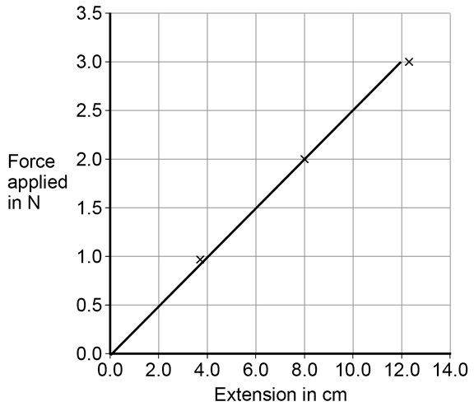

**. 1** Write down the equation that links the force applied and extension for a spring.

1. **mark]**

AO1

|  |  |
| --- | --- |
| **0** | **4** |

**. 2** Identify the pattern shown in **Figure 3**.

Explain your answer.

1. **marks]**

AO1 AO3

|  |  |
| --- | --- |
| **0** | **4** |

**. 3** Give **one** way the student could improve her investigation.

1. **mark]**

AO3

|  |  |
| --- | --- |
| **0** | **4** |

**. 4** Describe the relationship between work done and elastic potential energy in stretching aspring.

1. **marks]**

AO1

|  |  |
| --- | --- |
| **0** | **4** |

**. 5** Draw a line on **Figure 3** to show the results for a stiffer spring.

Explain the reason for the line you have drawn.

1. **marks]**

AO3

|  |  |
| --- | --- |
| **0** | **4** |

**. 6** Explain what would happen to the spring if the student kept adding weights?

**[2 marks]**

AO1

**Physics1F question 5 required practical activity - resistance in a wire**

|  |  |
| --- | --- |
| **0** | **5** |

A student wants to investigate how the current through a filament lamp affects its  resistance.

|  |  |
| --- | --- |
| **0** | **5** |

**. 1** Use the circuit symbols in the boxes to draw a circuit diagram that she could use.

**[2 marks]**

|  |  |  |  |  |
| --- | --- | --- | --- | --- |
| **12 V battery** | **variable**  **resistor** | **filament**  **lamp** | **voltmeter** | **ammeter** |
|  |  |  |  |  |

AO1

|  |  |
| --- | --- |
| **0** | **5** |

**. 2** Describe how the student could use her circuit to investigate how the current through a filament lamp affects its resistance.

**[4 marks]**

AO1

The student’s results are shown in **Figure 6**.

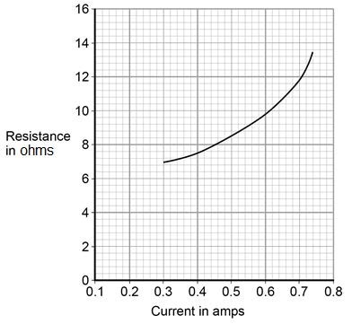

|  |  |
| --- | --- |
| **0** | **5** |

**. 3** Describe how the resistance of the filament lamp changes as the current through it increases.

**[1 mark]**

AO2

|  |  |
| --- | --- |
| **0** | **5** |

**. 4** Use **Figure 6** to estimate the resistance of the filament lamp when a current of

0.10 A passes through the lamp.

**[1 mark]**

Resistance = Ω

AO2

The current–potential difference graphs of three components are shown in **Figure 7**.

|  |  |
| --- | --- |
| **0** | **5** |

**. 5** Use answers from the box to identify each component.

AO1

**[3 marks]**

**diode filament lamp light dependent resistor**

**resistor at constant temperature thermistor**

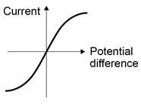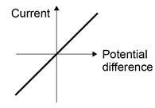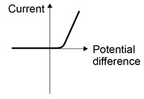

**Graph A**

**Graph B**

**Graph C**

**Physics required practical activity - Waves**

**Synergy ‒ paper 1H, questions 09.1, 09.4**

|  |  |
| --- | --- |
| **0** | **9** |

Some students did an investigation to study the behaviour of waves.

**Figure 8** shows a ripple tank that they used to model the behaviour of waves.

## Figure 8

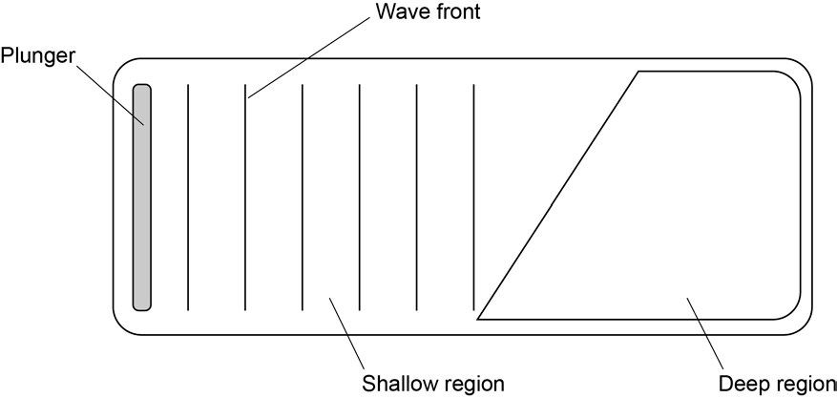

|  |  |
| --- | --- |
| **0** | **9** |

**. 1** Complete the wave fronts on **Figure 8** to show how the wave is refracted as it passes from the shallow region into the deep region.

1. **mark]**

|  |  |
| --- | --- |
| **0** | **9** |

**. 4** Some students investigate the properties of the waves generated in **Figure 8**.

Student **A** says ‘the waves move water from one end of the tank to the other’.

Student **B** says ‘that’s wrong. Only the waves move, not the water’.

Suggest what the students could do to decide which of them is correct.

1. **marks]**

**Physics paper 1H question 5**

The question is not based on a required practical activity. Students should be able to access the question without having performed the experiment as all the relevant information is provided in the question.

|  |  |
| --- | --- |
| **0** | **5** |

A student investigated the efficiency of a motor using the equipment in **Figure 4**.

## Figure 4

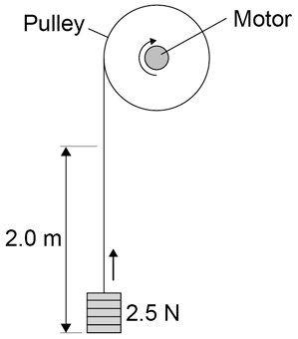

He used the motor to lift a weight of 2.5 N a height of 2.0 m.

He measured the speed at which the weight was lifted and calculated the efficiency of the energy transfer.

He repeated the experiment to gain two sets of data.

|  |  |
| --- | --- |
| **0** | **5** |

**. 1** Give **one** variable that the student controlled in his investigation.

1. **mark]**

AO3

|  |  |
| --- | --- |
| **0** | **5** |

**. 2** Give **two** reasons for taking repeat readings in an investigation.

1. **marks]**

1

2

**Figure**

**5**

shows a graph of the student’s results.

**Figure 5**

**0**

**5**

**.**

**3**

Give

**two**

conclusions that could be made from the data in

**Figure**

**5**

?

**[**

**2**

**mark**

**s**

**]**

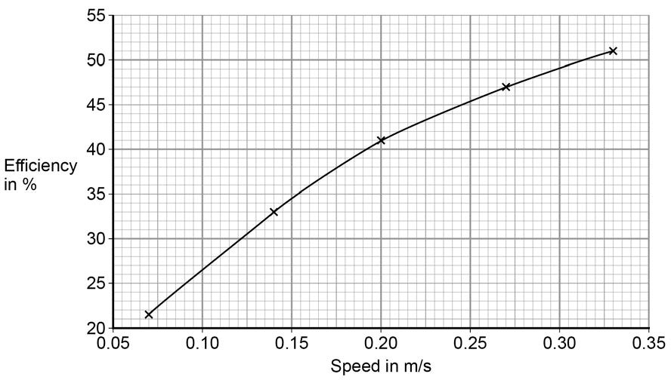

AO2

|  |  |
| --- | --- |
| **0** | **5** |

**. 4** Give the main way that the motor is likely to waste energy.

**[1 mark]**

AO2

|  |  |
| --- | --- |
| **0** | **5** |

**. 5** When the total power input to the motor was 5 W the motor could not lift the

2.5 N weight.

State the efficiency of the motor.

**[1 mark]**

Efficiency = %

AO2

**Physics required practical – Specific heat capacity**

**Physics paper 1F question 12**

|  |  |
| --- | --- |
| **1** | **2** |

A student investigated how much energy from the Sun was incident on the Earth’s surface at her location.

She put an insulated pan of water in direct sunlight and measured the time it took for the temperature of the water to increase by 0.6 °C.

The apparatus she used is shown in **Figure 14**.

## Figure 14

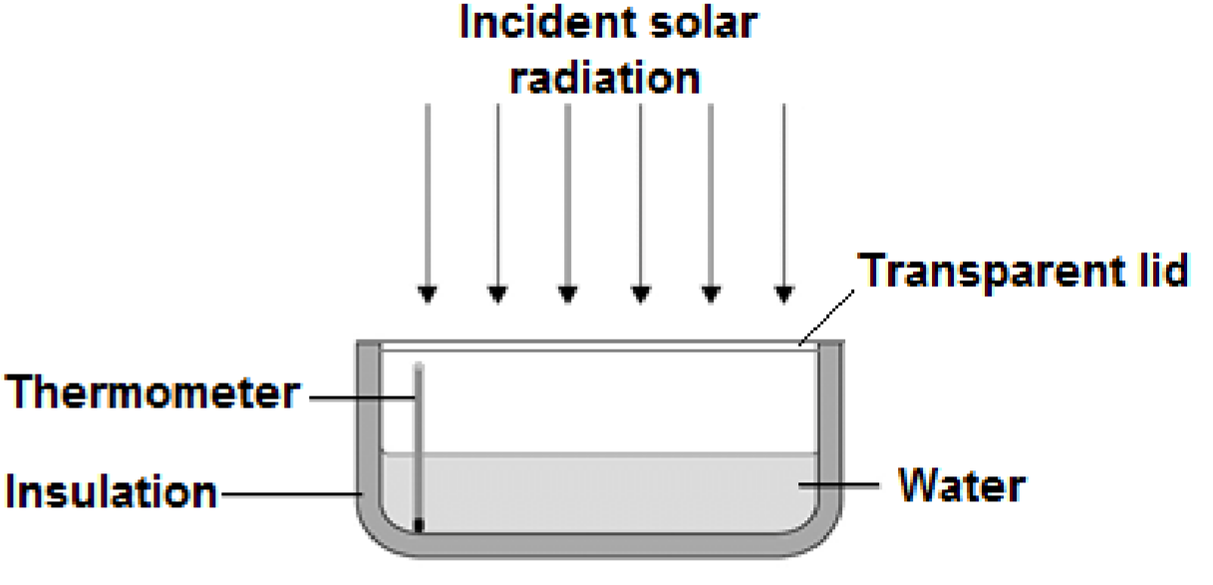

|  |  |  |  |
| --- | --- | --- | --- |
| **1** | **2** | **.** | **1** |

Choose the most appropriate resolution for the thermometer used by the student.

1. **mark]**

Tick **one** box.

|  |
| --- |
|  |

0.1 ⁰C

|  |
| --- |
|  |

0.5 ⁰C

|  |
| --- |
|  |

1.0 ⁰C

The energy transferred to the water was 1050 J.

The time taken for the water temperature to increase by 0.6 °C was 5 minutes.

AO3 The specific heat capacity of water is 4200 J/kg °C.

|  |  |
| --- | --- |
| **1** | **2** |

**. 2** Write down the equation which links energy transferred, power and time.

1. **mark]**

AO1

|  |  |
| --- | --- |
| **1** | **2** |

**. 3** Calculate the mean power supplied by the Sun to the water in the pan.

1. **marks]**

AO2

|  |  |
| --- | --- |
| **1** | **2** |

**. 4** Calculate the mass of water the student used in her investigation.

Use the correct equation from the Physics Equation Sheet.

1. **marks]**

AO2 Mass = Kg

|  |  |
| --- | --- |
| **1** | **2** |

**. 5** The student’s results can only be used as an estimate of the mean power at herlocation.

Give **one** reason why.

**[1 mark]**

AO3

**Physics ‒ paper 1F, question 06.1**

This is not a required practical activity, and the question is assessing the understanding of static charges. It is an extremely common activity that most students will experience but it is not essential that they have seen it first-hand.

|  |  |
| --- | --- |
| **0** | **6** |

A student rubs an acetate rod with a cloth.

**Figure 8** shows the charges on the acetate rod and cloth before and after rubbing.

## Figure 8

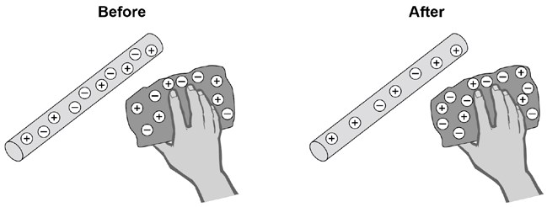

|  |  |
| --- | --- |
| **0** | **6** |

**. 1** Explain how rubbing an acetate rod with a cloth causes the rod and cloth to become charged.

**[4 marks]**

**Trilogy Physics 2H, questions 06.1, 06.2**

This is not a required practical activity. The context provides the background to the science concepts being assessed which are covered in the specification. It is not common for students to carry out this activity, but it would be likely that students would have seen the phenomenon demonstrated when this was taught.

|  |  |
| --- | --- |
| **0** | **6** |

A teacher used the equipment shown in **Figure 6**. to demonstrate the  motor effect.

## Figure 6

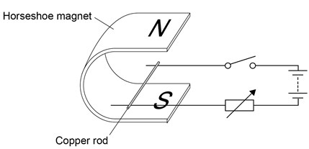

|  |  |
| --- | --- |
| **0** | **6** |

**. 1** Describe how Fleming’s left-hand rule can be used to determine the direction in which the rod will move when the switch is closed, and state the direction.

**[4 marks]**

AO1

|  |  |
| --- | --- |
| **0** | **6** |

**. 2** Increasing the current can increase the force acting on the copper rod.

Give **one** other way in which the size of the force acting on the copper rod could be increased.

**[1 mark]**

AO2

|  |  |
| --- | --- |
| **0** | **6** |

**. 3** The copper rod in **Figure 6** has a length of 7 cm and a mass of 4

×10–4 kg.

When there is a current of 1.12 A the resultant force on the copper rod is 0 N.

Calculate the magnetic flux density.

Gravitational field strength = 9.8 N/kg

**[5 marks]**

AO2

**Physics - paper 1F, question 04**

This is not a required practical and students do not need to have carried out the practical but when covering this part of the specification (4.3.1.2 and 4.3.2.3) it may have been referred to as a way of explaining the concepts. The question focuses on working scientifically skills and AO3

|  |  |
| --- | --- |
| **0** | **4** |

Two students investigated the change of state of stearic acid from liquid  to solid.

They measured how the temperature of stearic acid changed over 5 minutes as it changed from liquid to solid.

**Figure 4** shows the different apparatus the two students used.

## Figure 4

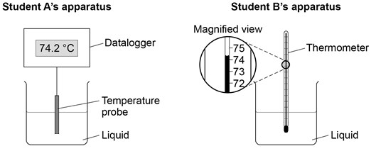

|  |  |
| --- | --- |
| **0** | **4** |

**. 1** Choose **two** advantages of using student **A**’s apparatus.

**[2 marks]**

Tick **two** boxes.

|  |
| --- |
|  |

Student **A**’s apparatus made sure the test was fair.

|  |
| --- |
|  |

Student **B**’s apparatus only measured categoric variables.

|  |
| --- |
|  |

Student **A**’s measurements had a higher resolution.

|  |
| --- |
|  |

Student **B** was more likely to misread the temperature.

AO1

|  |  |
| --- | --- |
| **0** | **4** |

**. 2** Student **B** removed the thermometer from the liquid each time he took a temperature reading.

What type of error would this cause?

**[1 mark]**

Tick **one** box.

|  |
| --- |
|  |

A systematic error

|  |
| --- |
|  |

A random error

|  |
| --- |
|  |

A zero error

AO3

Student **A**’s results are shown in **Figure 5**.

## Figure 5

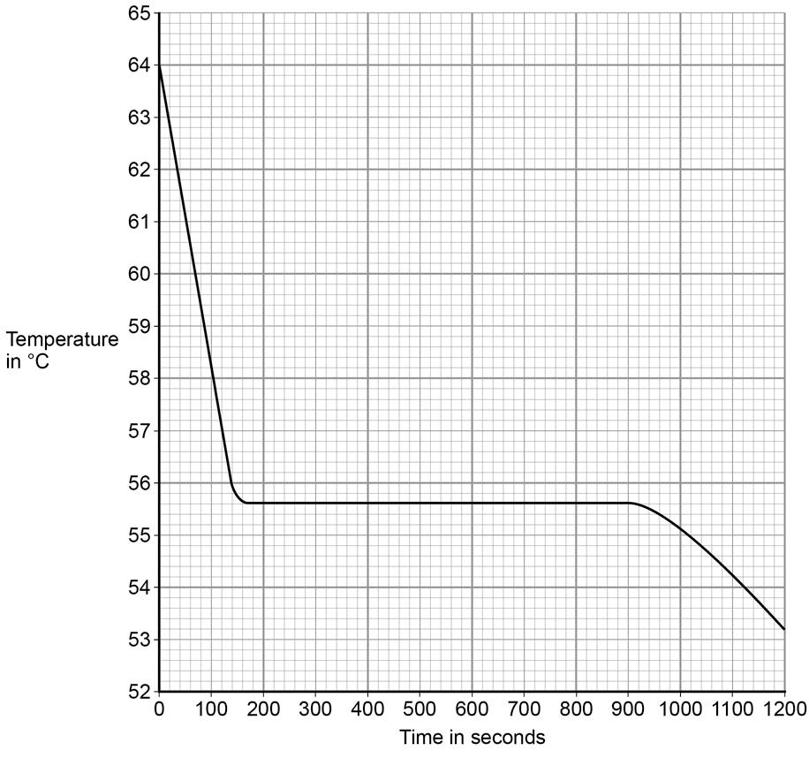

|  |  |
| --- | --- |
| **0** | **4** |

**. 3** What was the decrease in temperature between 0 and 160 seconds?

**[1 mark]**

Tick **one** box.

|  |
| --- |
|  |

8.2 °C

|  |
| --- |
|  |

8.4 °C

|  |
| --- |
|  |

53.2 °C

|  |
| --- |
|  |

AO3  55.6 °C

|  |  |
| --- | --- |
| **0** | **4** |

**. 4** Use **Figure 5** to determine the time taken for the stearic acid  to change from a liquid to a solid.

1. **mark]**

Time = seconds

AO3

|  |  |
| --- | --- |
| **0** | **4** |

**. 5** Calculate the energy transferred to the surroundings as 0.40 kg of stearic acid changed state from liquid to solid.

The specific latent heat of fusion of stearic acid is 199 000 J/kg.

Use the correct equation from the Physics Equations Sheet.

1. **marks]**

Energy =

J

AO2

|  |  |
| --- | --- |
| **0** | **4** |

**. 6** After 1200 seconds the temperature of the stearic acid continued to decrease. Explain why.

**[2 marks]**

AO3

**Synergy ‒ paper 2H, (Physics) question 06.6**

Note that although this is not a required practical activity, it would be helpful to students if they were able to observe radioactive sources.

|  |  |
| --- | --- |
| **0** | **6** |

**. 6** A teacher demonstrated an experiment to measure the count rate of a radioactive source.

**Figure 8** shows how the teacher set up the apparatus.

**Figure 8**

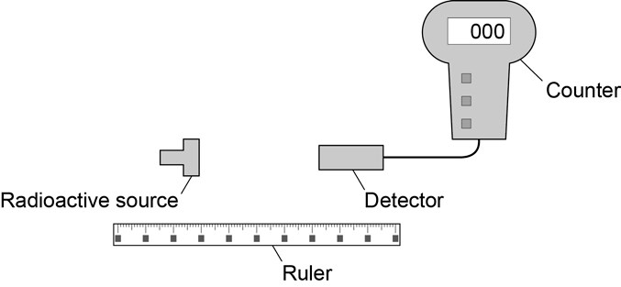

**Table 4** shows the results.

## Table 4

|  |  |
| --- | --- |
| **Distance in metres** | **Count rate in counts per minute** |
| 0.5 | 108 |
| 1.0 | 38 |
| 1.5 | 23 |
| 2.0 | 18 |

Suggest how the student could modify the experiment to determine the radiation type present in the source.

**[4 mark]**