A Level Physics:
Y e a r 1 1 t o 1 2 T r a n s i t i o n W o r k

Our Year 11 to 12 transition work has been designed to help you prepare for the A level physics course you will be starting in September. There is a particular focus on the core maths skills required and information specific to how we do things in A level physics, which may differ to the way you did them at GCSE, or how you do them in maths.

The work will be completed online via Isaac Physics. If you have not used Isaac Physics before, please visit https://isaacphysics.org/ and set up an account following the instructions below. You should use your school email address, if you have one.

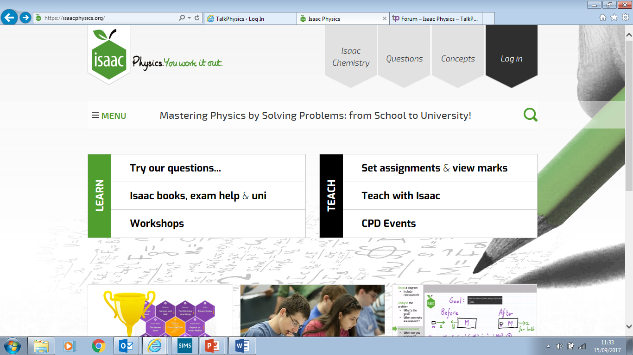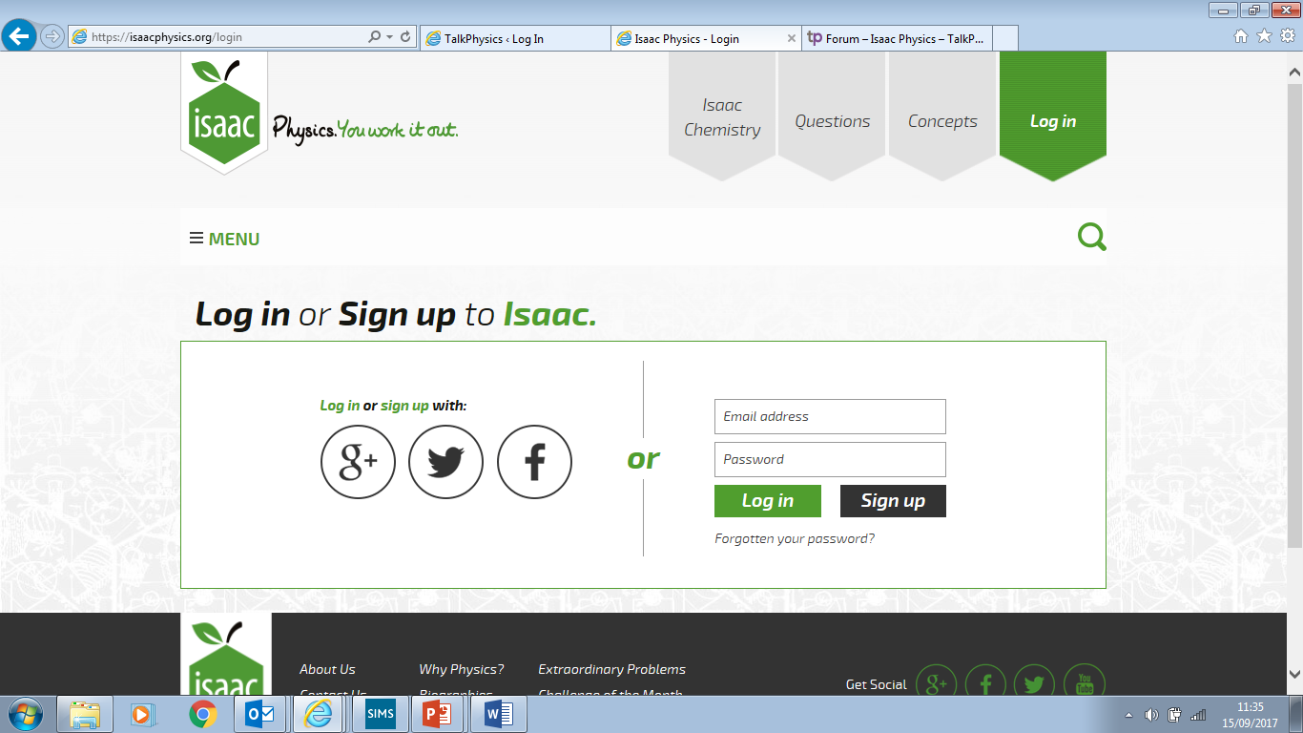
Click Log in in the right hand corner. Click Sign up and complete the relevant details.

In order to access the transition assignment, you will need to log in to Isaac Physics and click on Menu, followed by My Account and Teacher Connections. You will then be prompted to enter a code. Your class code is V989BN, click connect and then confirm.

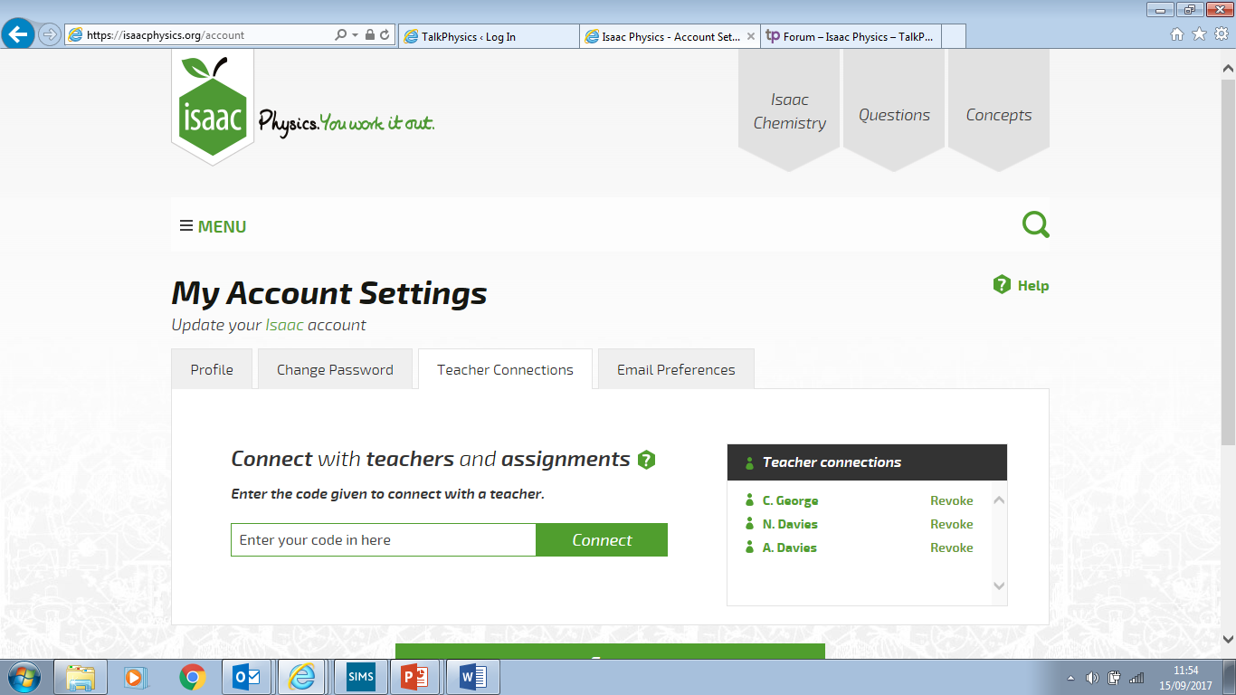

Your code is V989BN

You will then receive an email with a link to the assignment. Alternatively, you can click Menu, followed by My Assignments. The assignment should be completed online before September. On Isaac Physics, you can attempt questions as many times as you like.

If you require any help or have any questions, please contact me at ndavies@wilmslowhigh.com.

