* 1. To carry out the processing on the computer/To (fetch and) execute instructions'
     1. 3MHz is the clock speed. It indicates how many instructions may be processed in each second.
     2. The computer has 4 cores which are independent processors within the CPU working simultaneously.

1. 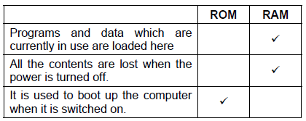  
   1. Joystick to precisely control the CCTV cameras to allow zoom/tilt/pan.  
      Keyboard to type commands into the system/control the cameras.
   2. A bank of monitors to show the output of multiple cameras.  
      Printer to print hard copy images from the recordings to use as evidence.
   3. Hard disk drive with large capacity to record the feeds from the cameras.  
      Rewriteable large optical drive to save recordings for a given day for archiving purposes.
   4. Stores parts of the operating system currently used by the computer. Stores programs that are currently running. Stores data that are currently used by the computer.
      1. A section of the hard disk is used to store items in RAM which are not being currently used.
      2. Used to allow more programs/data to be loaded when RAM is insufficient.
      3. The computer will be able to multitask more programs as there is more memory for programs/data to be loaded into. Programs will run faster due to less use of virtual memory.
   5. 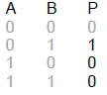
   6. 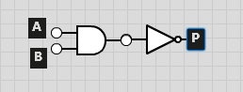
   7. Storage: Device used to store data in a binary format for processing later.  
      Input: Device used to enter data into the computer.  
      Output: Device used to present information/the result of processing to the user.
   8. Handheld: Solid State. Not sensitive to being moved around while used.  
      File Server: Magnetic. Very large capacity/relatively cheap.  
      School production: Optical. Cheap/portable/universally readable by most computers and dedicated video disc players.
   9. Input Devices.  
      Puff-suck switch: allows mobility impaired users to control eg clicking a mouse, by sucking or blowing through a tube. Simplified/Concept keyboards eg for Braille, or larger keys. Eye tracking input – camera used to follow the users eye movements and use these to control eg movement of mouse on screen.  
      Output Devices.  
      Braille printer – print documents on paper in Braille as raised bumps. Some Braillers have plastic bumps which can be raised or lowered by software, so output does not have to be on paper. Text to speech. Screen magnifiers.
   10. To carry out the processing on the computer/To (fetch and) execute instructions'
   11. Higher processor speed to increase the number of instructions the processor can carry out in a given time.  
       CPU with more cores which shares the load of running the game.  
       More RAM to increase the number of programs/amount of data that the computer can handle at the same time.
2. 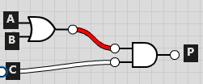
   1. TRUE  
      TRUE  
      FALSE  
      TRUE  
      1. A small block of very high speed memory acting as a buffer between the CPU and the main memory. Stores data/instructions which are used frequently by the CPU.
      2. So the CPU does not have to access the main memory which is slower than the cache.