**Do not do Q5 or Q8 – not on the AQA specification**

1. Jo buys a notebook computer which has a 3MHz quad-core central processing unit (CPU).
   1. State the purpose of the CPU.
   2. Describe what is meant by
      1. 3MHz CPU.
      2. Quad-core CPU.
2. A desk-top computer’s memory includes ROM and RAM.  
   Tick **one** box in each row to show whether each of the statements is true for ROM or RAM.  
   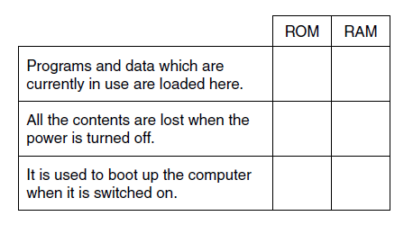
3. A shopping centre uses several remote-controlled CCTV cameras for security. An operator uses a computer to watch, control and record the output of the cameras. State (a) an input, (b) output and (c) storage device which will be needed by the computer. For each, explain the reason why it is needed.
4. Mina’s computer has 4GB of RAM.
   1. Describe the purpose of RAM in the computer.
   2. The computer also uses virtual memory.
      1. Explain what is meant by virtual memory.
      2. State why virtual memory is needed.
      3. Mina upgrades the computer to 6GB of RAM. Explain how this upgrade will affect the performance of the computer.
   3. The following logic circuit can be written as P = (NOT A) AND B  
      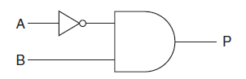  
      Complete the following truth table for the circuit given above.  
      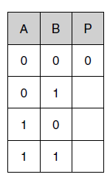
   4. Draw the circuit diagram which will represent the circuit P = NOT (A AND B)
   5. State what is meant by a storage device, an input device and an output device in a computer system.
   6. A secondary school is upgrading its computer equipment. Complete the table below to show whether magnetic, optical or solid state storage is most appropriate for each of the following uses. Give a reason for each case. The first one has been done for you.  
      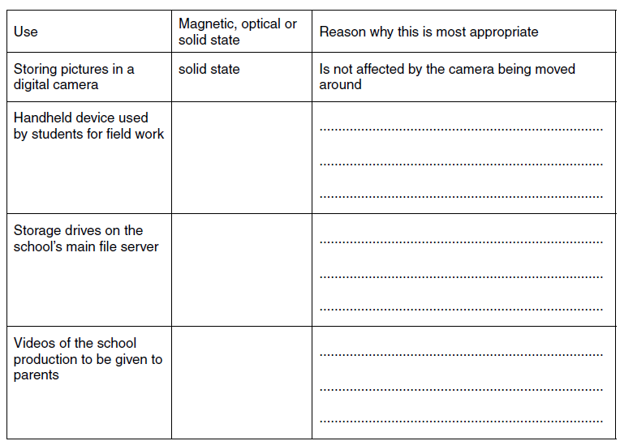
   7. The secondary school wants the computer systems to be more accessible to students with disabilities. Describe, with examples, input and output devices which are available for students with disabilities. The quality of written communication will be assessed in your answer to this question.
5. Mary’s computer has an 800MHz CPU and 1GB of RAM.
   1. Describe the purpose of the CPU.
   2. Mary wants to upgrade this computer so that she can play the latest games. Explain **two** ways by which the computer can be upgraded to improve its performance.
6. Draw the logic circuit for P = (A OR B) AND C  
   1. The table below contains statements about the functions of the CPU. Tick **one** box in each row to show whether the statement is true or false.  
      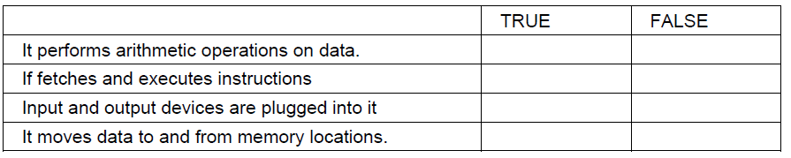
   2. Some CPUs have cache memory.
      1. Describe what is meant by cache memory.
      2. Explain why cache memory is needed.