1. A teacher uses a database to store the marks of pupils from all year 9 classes.
   1. PUPIL and CLASS are two entities used in this database.  
      Explain the term entity.
   2. The data for the first four pupils in the PUPIL table is shown below.  
      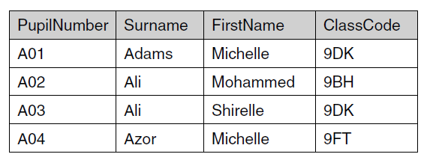
      1. State the primary key for the PUPIL table and explain your answer.
      2. The database also contains a CLASS table. The primary key for the CLASS table is ClassCode. Explain why ClassCode has also been included in the PUPIL table.
2. Mrs Smith runs a dog sitting service that looks after dogs whose owners are going away on holiday.  
   Mrs Smith uses a database with two tables:  
     
   • The table DOG stores the following data about each dog: DogID, name, sex, weight, date of arrival, date of departure.  
   • The table JOB stores the daily jobs that she needs to do with each dog.  
   1. The DOG table contains fields for the sex and weight of the dog.
      1. Describe a validation check that can be done on the sex field.
      2. Describe a different validation check that can be done on the weight field.
   2. An extract of the JOB table is shown below:  
      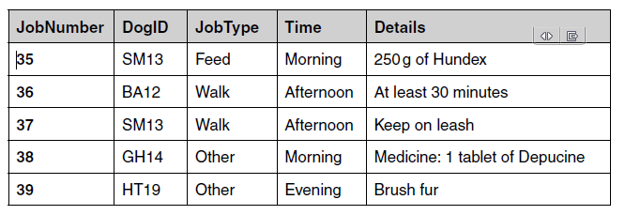  
      Explain why DogID has been included in this table.
   3. Mrs Smith uses a query to select jobs using the following criteria:  
      **(Time = “Afternoon”) OR (Time = “Evening”)**  
      List the JobNumbers of the jobs that will be selected from the extract shown.
   4. Mrs Smith wants to use database management software to create a report of all the jobs that she needs to perform on any given day, using data from the DOG and JOB tables.  
      Design a layout for the report.
3. A grocery shop uses a database with a DBMS to keep records of its stock.
   1. Explain what is meant by a DBMS.
   2. The database uses forms and reports.  
      Describe each of these and give **one** example of how it would be used in the shop’s database.
   3. Here is some data from the supermarket’s database.  
      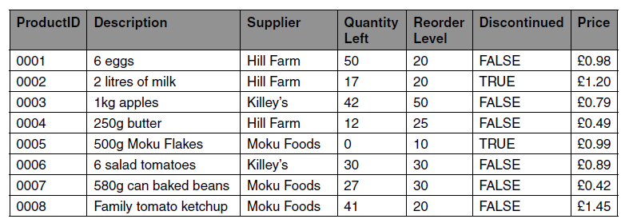
      1. State the ProductID of the products in the above sample which fit the following criteria.  
         **Supplier = Killey’s**
      2. State the ProductID of the products in the above sample which fit the following criteria.  
         **Price > £1.00 OR Supplier = Hill Farm**
      3. Write the criteria which can be used to select all products which are not discontinued and where the QuantityLeft is lower than the ReorderLevel.
4. A dentist uses a database to store the details of patients and their appointments.
   1. A database management system (DBMS) is used which includes forms, queries and reports.  
      Tick one box in each row to show whether each of the following statements best describes a form, a query or a report.  
      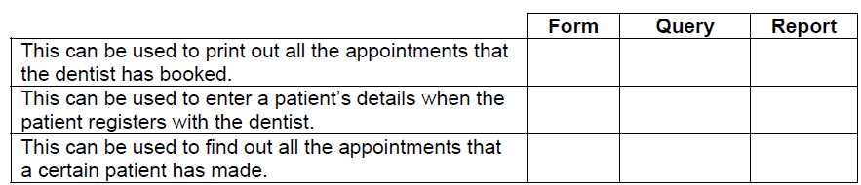
   2. When a patient makes an appointment, the start time of the appointment needs to be validated.  
      State **two** validation checks which can be carried out on the start time of an appointment.
   3. Justify the use of separate entities to store the patient and appointment data.
5. A television set top box contains a database of television channels and programmes.
   1. Describe what is meant by a database.
   2. Data about television channels are stored in the CHANNEL table. Part of this table is shown below.  
      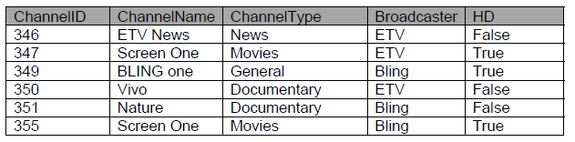  
      State the primary key for the CHANNEL table and give a reason for your choice.
   3. Data about programmes that will be broadcast are stored in the PROGRAMME table. The data about each programme includes the channel on which it would be broadcast.
      1. Explain how a foreign key can be used to connect the PROGRAMME table to the CHANNEL table.
      2. Explain why the programme data is stored in a separate table from the channel data.