Spanish A Level

Transition Booklet

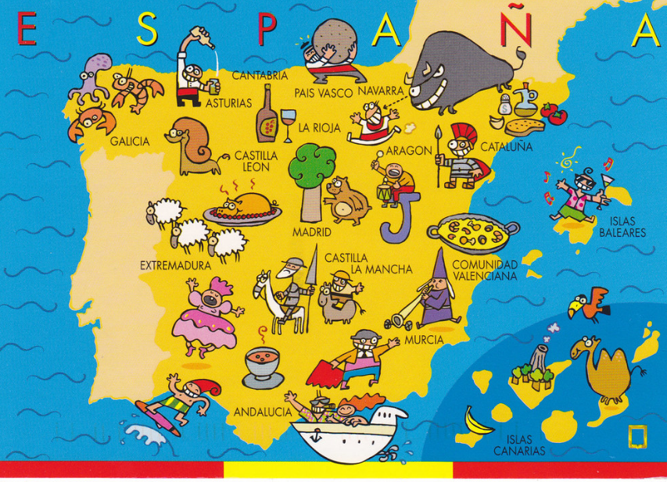

How to prepare for Spanish at A Level

The leap from GCSE to A Level is significant. This booklet contains links to a huge range of media, most of which is available for free online as well as tasks to complete before the start of term. In order to keep pace, it is vital that you work through the tasks.

For A level you need to know a lot about not only Spain but ALL Spanish speaking countries – geography, politics, famous people, history, technology, religion etc

This will give you a clear understanding of what the course involves and what to expect next year.

Exam board: AQA

Paper 1: Listening, Reading & Writing

Paper 2: Writing (Film/Novel)

Paper 3: Speaking

Textbook: AQA OUP

Course Specification: <http://filestore.aqa.org.uk/resources/spanish/specifications/AQA-7692-SP-2016.PDF>

Actividad 1: El curso

Read through the list of themes we will study and translate them into English. Use a dictionary to help if you need it. It is important to note that you will need to know details about these topics in Spain and Latin America so it will be really beneficial for you to start reading around this topics and keeping up to date with the News in these countries.

|  |  |
| --- | --- |
| **Aspects of Hispanic society**  **(in relation to any Spanish-speaking country or countries)** | |
| **Spanish** | **English Translation** |
| *Los valores tradicionales y modernos)* | • **Modern and traditional values** |
| *• Los cambios en la familia* |  |
| *• Actitudes hacia el matrimonio/el divorcio* |  |
| *• La influencia de la Iglesia Católica* |  |
| *El ciberespacio* | **• Cyberspace** |
| *• La influencia de internet* |  |
| *• Las redes sociales: beneficios y peligros* |  |
| *• Los móviles inteligentes en nuestra sociedad* |  |
| *La igualdad de los sexos* | • **Equal rights** |
| *• La mujer en el mercado laboral* |  |
| *• El machismo y el feminismo* |  |
| *• Los derechos de los gays y las personas transgénero* |  |

|  |  |
| --- | --- |
| **Artistic culture in the Spanish-speaking world**  **(in relation to any Spanish-speaking country or countries)** | |
| **Spanish** | **English Translation** |
| *La influencia de los ídolos* | **• Modern day idols** |
| *• Cantantes y músicos* |  |
| *• Estrellas de televisión y cine* |  |
| *• Modelos* |  |
| *La identidad regional en España* | **• Spanish regional identity** |
| *• Tradiciones y costumbres* |  |
| *• La gastronomía* |  |
| *• Las lenguas* |  |
| *El patrimonio cultural* | • **Cultural heritage** |
| *• Sitios turísticos y civilizaciones prehispánicas: Machu Picchu, la Alhambra, etc* |  |
| *• Arte y arquitectura* |  |
| *• El patrimonio musical y su diversidad* |  |
| **Multiculturalism in Hispanic society**  **(in relation to any Spanish-speaking country or countries)** | |
| **Spanish** | **English Translation** |
| *La inmigración* | • **Immigration** |
| *• Los beneficios y los aspectos negativos* |  |
| *• La inmigración en el mundo hispánico* |  |
| *• Los indocumentados - problemas* |  |
| *El racismo* | **• Racism** |
| *• Las actitudes racistas y xenófobas* |  |
| *• Las medidas contra el racismo* |  |
| *• La legislación anti-racista* |  |
| *La convivencia* | • **Integration** |
| *• La convivencia de culturas* |  |
| *• La educación* |  |
| *• Las religiones* |  |

|  |  |
| --- | --- |
| **Aspects of political life in the Hispanic world**  **(in relation to any Spanish-speaking country or countries)** | |
| **Spanish** | **English Translation** |
| Jóvenes de hoy, ciudadanos del mañana | **• Today’s youth, tomorrow’s citizens** |
| • Los jóvenes y su actitud hacia la política : activismo o apatía |  |
| • El paro entre los jóvenes |  |
| • Su sociedad ideal |  |
| Monarquías y dictaduras | **• Monarchies and dictatorships** |
| • La dictadura de Franco |  |
| • La evolución de la monarquía en España |  |
| • Dictadores latinoamericanos |  |
| Movimientos populares | • **Popular movements** |
| • La efectividad de las manifestaciones y las huelgas |  |
| • El poder de los sindicatos |  |
| • Ejemplos de protestas sociales (eg El 15-M, las Madres de la Plaza de Mayo, …) |  |

LISTEN

Podcasts

1. hoyhablamos.com – via Spotify,podcast or website. Really good site for listening. It does mention about a subscription but that is only if you want worksheets

2. news in slow Spanish – I think this podcast may be free on Spotify

3. Coffee break Spanish – on Spotify

3. Spanish Obsessed – on i tunes or the website

MUSIC

Check out these artists

Rosalia

David Bisbal

Alvaro Soler

Enrique Iglesias

Marc Antony

La Oreja de Van Gogh

Pablo Alborán

Juanes

Shakira

Aitana

Gypsy Kings

Alejandro Sanz

Pitbull (in Spanish)

Nicky Jam

Ricky Martin

J Balvin

**WATCH**

**The News.**

Click on [www.rtve.es/Noticias](http://www.rtve.es/Noticias) and then click on Telediario en 4 to watch four minute version of the news. Alternatively you can watch the entire news show which lasts 50 minutes.

Películas:

Watch a Spanish film (suggestions below)

* Volver (Pedro Almodóvar)
* Todo sobre mi madre (Pedro Almodóvar)
* ¡Ay Carmela! (Carlos Saura)
* Mar adentro (Alejandro Amenábar)
* The Motorcycle Diaries (Walter Salles)
* Ocho Apellidos Vascos (Emilio Martínez-Lázaro)
* El Laberinto del Fauno (Guillermo del Toro)
* María llena eres de gracia (Joshua Marston)
* Abel (Diego Luna)
* Las 13 Rosas (Emilio Martínez-Lázaroa)

You could maybe write a review or a “ficha informativa” of the films

Netflix:

Watch a Spanish-language series or film – See the Netflix Guide to help

Read…

Keep your own vocabulary book for new expressions you come across. You could order it alphabetically, by topic area based on what we are going to study or just use it as a diary and scribble away your Spanish development in it.

NEWSPAPERS AND MAGAZINES

Read a foreign language newspaper - El País has its own website [http://www.elpais.com/](http://www.elpais.com/%20) so that you can read the paper online. You do not have to read the paper cover to cover, just scan the headlines and pick out ONE article that grabs your attention.

Websites

Look at the [www.bbc.com/mundo](http://www.bbc.com/mundo) for BBC reporting in Spanish. Click on Videos for clips and reports in Spanish.

For Daily News:

News.yahoo.com/

[www.abc.es](http://www.abc.es)

[www.terra.es](http://www.terra.es)

Go to [www.donbalon.com](http://www.donbalon.com) for football website and related articles.

Go to [www.hola.com](http://www.hola.com) for a Spanish celebrity gossip magazine (note that some content requires subscription). This also has short clips in Spanish.

Websites for research

Once you actually start your A Level in September, you will realise that you are almost completing a Sociology A Level in Spanish. It is fascinating and you will learn all about the history and culture of Spanish speakers across the world, not just in Spain.

If you are searching for information, try switching to the Spanish [www.es.wikipedia.](http://www.es.wikipedia.) Remember that anyone can write on Wikipedia so you

must validate your research elsewhere and never quote from it! It is a good place to start though.

On-line dictionary

A good on-line dictionary is: <http://www.spanishdict.com/>

TIP When you look up a verb, click the Conjugation tab to see how the verb is conjugated in EVERY tense.

**TOP** **TIP:** **Don’t** **look** **up** **every** **word** **you** **are** **not** **sure** **of** **when** **reading** **an** **article/** **book**

Yes… you read that right. When you are reading articles etc, try not to look up every word as it will take you forever. Skim and scan the text to get the gist. Remember to use the context or the article, cognates and common sense to figure out what the article is saying. Pick out a couple of words that you like the look of, that you feel may be real hurdles to getting the idea of the text, look them up carefully and add them to your vocab booklet. The aim at this stage is to get the gist of the article, not be able to translate it completely. Translation is a whole different ball game and you will learn it soon enough.

You will be surprised how much more enjoyable reading will be if you really pay attention to this tip.

What should I know by now?

This is a common question asked by students about to start their A level. You should be able to:

|  |  |
| --- | --- |
| TOPIC | CONTENT |
| Recognise and use a range of tenses with **regular** verbs. | Regular –AR, -ER and -IR verbs:  Tenses: Present  Preterite  Imperfect  Near Future (form of ir + infinitive) Future (eg. Será)  Conditional (eg. sería) |
| Recognise and use a range of tenses with **irregular** verbs. | Common irregular verbs: **ser,** **estar,** **ir,** **tener,** **hacer**  Tenses: Present  Preterite  Imperfect  Near Future (form of ir + infinitive) Future (eg. Será)  Conditional (eg. sería) |
| Give opinions with reasons | • A range of opinion expressions  • Positive and negative reasons for opinions  • To be able to agree and disagree |

I hope this guide helps you to keep up with your Spanish. It is very important that you do 20 to 30 minutes every day so you don’t forget your Spanish. Vocabulary and grammar are key to success at A-level. Make sure you are confident with GCSE grammar and vocabulary.

In order for you to keep track of what you do every day and to make sure you do at least 20/30 minutes a day you could track your work in a table like this:

**TASKS**

Complete the tasks which I have uploaded (there will be more to come).

Complete the Task Log with what you have done which is on the next page

TASK LOG

|  |  |  |  |
| --- | --- | --- | --- |
| Week Commencing | Date | Website/source | Activity/Comment |
| 11 May | Monday 11  Tuesday 12  Wednesday 13  Thursday 14  Friday 15 | Monday.- Ocho apellidos vascos  Tuesday.- Grammar  Wednesday- Listening Ver-taal  Thursday- Vocab Quizlet  Friday.- Research/translation | Monday.- What a funny film.- I watched it in Spanish with English subtitles. I wrote a “ficha informativa” for my parents and friends about the film  Tuesday- I revised present tense regular and irregulars verbs- Have to go over the irregulars again  Wednesday- At first listening was difficult but I used the transcripts to help me. I love the trailers of films and adverts in this website!  Thursday- I have managed to do all unit 1 vocab again.- I got 75% |
|  |  |  |  |
|  |  |  |  |
|  |  |  |  |
|  |  |  |  |

Páginas web:

Familiarise yourself with some useful Spanish websites. Visit them every day.

[www.rtve.es](http://www.rtve.es)

[www.ver-taal.com](http://www.ver-taal.com)

<https://mfl.jimdo.com/resources/spanish/>

<http://www.spanishdict.com/>

<http://languagesresources.co.uk/SpanishA2Topics.html>

<https://www.languagesonline.org.uk/Hotpotatoes/spanishindex.html#Grammar>

<https://www.languagesonline.org.uk/Hotpotatoes/spanishindex.html#Vocabulary>

https://www.languagesonline.org.uk/Hotpotatoes/spanishindex.html#AS

<http://www.espanish.org.uk/>

<https://www.bbc.com/mundo>

<https://www.20minutos.es/>

<https://elpais.com/>

[www.dailymotion.com/es](http://www.dailymotion.com/es)

<https://www.youtube.com/channel/UCAL4AMMMXKxHDu3FqZV6CbQ?fbclid=IwAR1p4cRRZo9uW9CwBdfjaF3jWF-zuJNRYSO4w6K8AP8WlfA6AlNSKpHVHwQ>

<https://radiolingua.com/coffeebreakspanish/>  
<https://gb.ivoox.com/en/podcast-podcast-aprender-espanol-learn-spanish-podcast_sq_f1383122_1.html>  
<http://recursosdidacticos.es/textos/listado_audiolecturas.php>  
<https://www.profedeele.es/categoria/actividad/podcast/>  
<https://lang-8.com/>  
<http://www.trentu.ca/academic/modernlanguages/spanish/masarriba/>  
<https://eledeeli.wordpress.com/2015/07/26/paginas-webs-para-practicar-espanol/>  
<https://www.hoyhablamos.com/category/podcasts-aprender-espanol/>  
<https://superespanol.com/podcasts-para-aprender-espanol/>  
<https://www.spanishpodcast.net/listado-episodios/>  
<https://www.youtube.com/watch?v=VMDU8QaSKdk>  
<https://www.lengalia.com/es/aprender-espanol-gratis/podcasts.html>  
<https://www.hellotalk.com/>

<https://www.memrise.com/>

**Sign up to Twitter**

Sign up to Twitter for authentic text that you can quickly flick through. They will help you pick up the language even when lazily browsing twitter. Some ideas are:

**@Spain** - The official Twitter for tourism in Spain

**@LaFraseDelDia_** - Más que palabras. A Spanish site which tweets inspirational sayings for each day.

**@spanishlanguage** – Official Twitter account for Transparent Language Spanish. Learn the language with free resources, social media, and research-based software that works. Tweets expressions, phrases, words and articles in Spanish.

**@spanishaddicts** – El español de la calle (typical spoken spanish). Esto no son simples traducciones literales, es mucho más que eso. Spanish phrases, vocab, articles and more.

**@spanishxxx2** – Free Spanish Sentences Vocabulary Pronunciation Grammar Tests. Tweets vocab, articles, and quizzes.

**@muyinteresante** – Revista de ciencia, historia, tecnología, salud, psicología, innovación y curiosidades. A Spanish news organisation that tweets in Spanish only. Great for practicing your reading skills.

Follow *Pictoline* on social media

Join *MFL Clips with Subtitles* on Facebook

Don’t forget about Quizlet and keep practicing GCSE vocab

Also join Memrise and start learning vocab for A level Spanish

Música:

Listen to the radio in Spanish – listen online.

<http://www.los40.com/> is the website for the Spanish top 40.

<http://www.rtve.es/radio/radio3/>

<http://www.cadenadigital.com/>

<http://www.discomusicradio.com/>

Libros:

Try reading a (short) book in Spanish. You might want to start with something you’ve read in English before (Harry Potter etc) or try a bilingual book with parallel texts in both languages. Magazines are also good; choose things that are interesting to you. Take a look on [www.Amazon.es](http://www.Amazon.es) or

<https://www.amazon.co.uk/s?k=parallel+text+spanish&ref=nb_sb_noss_1>